**Welcome to New Bethel Baptist Church**

**Fifth Sunday of Easter, May 10, 2020**

**Prelude** Dr. Christina Romero-Ivanova

\***Gathering Hymn** *Shine, Jesus, Shine*  #431

**\*Call to Worship**

Leader: God is our Rock. We are living stones used to build

God’s house.

**Church: We have come to find refuge in the shelter of**

**God’s care.**

Leader: We have come to be nourished by God’s word.

**Church: We have come to give thanks for God’s faithful**

**love.**

Leader: We are God’s own people and are precious in

God’s sight.

**Unison: Come, let us worship the Lord.**

**\*Invocation and Lord’s Prayer** (*using “sins”*) John Huddleston

**Scripture Reading** 1 Peter 2:2-10 John Huddleston

**Worship Prayer**   Pastor Janet

**\*Hymn** *I Love You, Lord*#78

**Children’s Message** Julianne Thomas

**Scripture Reflection**  John 14:1-14 Pastor Janet

**\*Hymn** *I’ll Fly AwaywHH* #779

**Ministry Opportunities** John Huddleston

How to Give Tithes and Offerings

*Doxology #815

*Prayer John Huddleston

**Postlude** Dr. Christina Romero-Ivanova

**Update to the NBBC Website**

Pastor Janet’s e-mail messages, Daily Scripture Readings, Online Giving, Daily Thoughts, or other information about our “Online Ministry” is located on a new tab entitled *Weekly Online Ministry* on the church website, http://www.newbethelbapt.org

**\*\*\*\*\*\*\*\*\*\*\*\*\*\*\*\*\*\*\***

**Book Discussion Group**

Please join us each Thursday at 1 p.m. on Zoom for a discussion on the book *If Grace Is True*. I will send participants an e-mail invitation so you can join the group. You can purchase the book from Amazon for a minimal cost. ***Let me know ASAP if you would like an invitation so you can connect and join the conversation.***

Godspeed, Pastor Janet

**\*\*\*\*\*\*\*\*\*\*\*\*\*\*\*\*\*\*\***

**Thank You and Blessings!**

Today’s accompaniment is Phil Morgan on the trumpet.

**\*\*\*\*\*\*\*\*\*\*\*\*\*\*\*\*\*\*\***

**Daily Scripture Readings for This Week**

Monday, May 11: Psalm 102:1-17; Exodus 13:17-22; Acts 7:17-40

Tuesday, May 12: Psalm 102:1-17; Proverbs 3:5-12; Acts 7:44-56

Wednesday, May 13: Psalm 102:1-17; Proverbs 3:13-18;

John 8:31-38

Thursday, May 14: Psalm 66:8-20; Genesis 6:5-22; Acts 27:1-12

Friday, May 15: Psalm 66:8-20; Genesis 7:1-24; Acts 27:13-38

Saturday, May 16: Psalm 66:8-20; Genesis 8:13-19; John 14:27-29

Sunday, May 17, Sixth Sunday of Easter: Acts 17:22-31;

Psalm 66:8-20; 1 Peter 3:13-22; John 14:15-21

**Welcome to New Bethel Baptist Church**

**We are blessed by your presence!**

**Fifth Sunday of Easter, May 10, 2020**

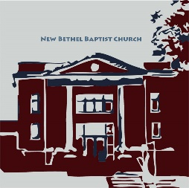

**Guests and Members:**  If you have questions or would like more information about New Bethel, please feel free to contact the church office. Thank you!

*An American Baptist*

*Congregation*

**\*\*\*\*\*\***

**All Are Welcome**

**Weekly Activities Online Only**

Wednesdays online Bible Study 10 a.m.

Wednesdays online Prayer meeting 7 p.m.

Thursdays online Book Discussion, *If Grace Is True,* 1 p.m.

10:30 a.m., Sunday Worship, live-stream only

**\*\*\*\*\*\***

**Contact Information**

New Bethel Baptist Church Website: www.newbethelbapt.org

8936 Southeastern Avenue E-mail: newbethelbapt@att.net

Indianapolis, IN 46239 Wi-fi password: NBBC8624381

317-862-4381 Instagram: NBBC.Wanamaker

YouTube: New Bethel Baptist

Church Wanamaker

https://facebook.com New Bethel Baptist.Wanamaker

Rev. Dr. Janet F. Hoover, Pastor

Jan Nagle, Secretary

Church Office Hours: contact Pastor or NBBC Secretary

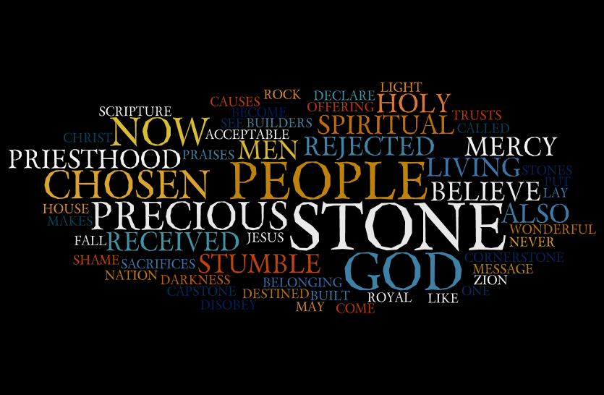

*We are not people*

*who protect our*

*own safety:*

*we are people*

*who protect our*

*neighbors’ safety.*

— Barbara Glasson

**Zoom Bible Study**

Bible Study is using Zoom. If you would like to join Bible Study, please contact Pastor Janet for an invitation via e-mail.

**\*\*\*\*\*\*\*\*\*\*\*\*\*\*\*\*\*\*\***

**Center for Congregations**

Due to Covid-19, the Center for Congregations is offering all of its workshops online and free-of-charge. To see what is being offered just go to the Center for Congregations website. Click on workshops at www.centerfor congregations.org to see your options.

**\*\*\*\*\*\*\*\*\*\*\*\*\*\*\*\*\*\*\***

*God's providence*

*is always one step*

*ahead of us.*

— Pope Francis

**\*\*\*\*\*\*\*\*\*\*\*\*\*\*\*\*\*\*\***

**ABC-GI News**

***Annual Gathering Date Change***

The day of the Annual Gathering has been changed to Sunday, August 2nd due to COVID-19 restrictions. We will still be hosted by Lebanon First. If you have already sent in your registration it will be held for the new date.

***

***ABC Camps Suspended***

“At this time, we have made the difficult decision to not proceed with our summer as scheduled and have prayerfully chosen to suspend all summer camps for 2020. We expect the spread of this disease will still be in effect during the summer, and we simply cannot put our camp family at risk. We will continue to monitor the situation closely until we can reopen our campgrounds to guests and camp family.”

**Happening This Week**

May 13 10 a.m., Online Bible Study, contact Pastor for

connection information to Zoom, weekly

scriptures in bulletin and on website

7 p.m., Online Prayer Meeting using Zoom,

connection information on website and in Daily Thoughts

14 1 p.m., Online Book Discussion, *If Grace Is True,*

contact Pastor for connection information to Zoom

May 17 Live-stream worship only

**\*\*\*\*\*\*\*\*\*\*\*\*\*\*\*\*\*\*\***

**Worship Music Copyright and Live-Streaming Permissions**

“Shine, Jesus, Shine” text and music by Graham Kendrick;

“I Love You, Lord” text and music by Laurie Klein;

“I’ll Fly Away” text and music by Albert E Brumley*;*

“Doxology” text by Thomas Ken and music by *Genevan Psalter.*

All above selections ©1997 Word/Integrity

Used by Permission. CCLI License #1631733

“Fill My Cup Lord” music by Richard Blanchard;

“Great Is Thy Faithfulness” music by Thomas Chisholm, William

M. Runyan;

“Sweet Hour of Prayer” music by William Bradbury, William W

Walford;

“To a Wild Rose” music by Edward MacDowell;

“Faith” music by Jim Brickman;

“Let All Things Now Living” music by Faye Lopez;

“Great Are You Lord” music by Steve and Vikki Cook;

“We Shall Behold Him” music by Dottie Rambo.

Live-Streaming: Christian Copyright Solutions, WorshipCast,

License #10868

**Website Updates**

Greetings,

I know many of you are still getting used to our Sunday Worship being online-only, and we have been working to make things as easy and “normal” for you as possible while we plan to be worshiping in this manner for at least several more weeks.

First of all, I also want to apologize for those of you who typically access the worship directly through YouTube and were unable to do so this past Sunday May 3rd. There was a setting that I had changed after the previous week’s worship due to some of the audio issues we had, and I did not catch that the setting did not go back to the default for this week. Once I saw a comment about not being able to access the video, I realized what the issue was. I was unable to change it since the stream had already started. I will double-checkto be sure you are able to access through YouTube directly in the future.

***“Sermons” is now “Online Worship” -*** On the website the tab formerly labeled “Sermons” that is used to access the weekly video, bulletin and other service info is now called “Online Worship”. The link is still the same: www.newbethelbapt.org/sermons, so you do not need to update any bookmarks you may have. If you are looking at the top of the page, the name is changed there to make it a bit clearer what that the function of this page is. The rest of the process is still the same as well. There was another minor name change on the website to the “Weekly Ministry Online” tab.

***Audio Sync Issues Addressed:*** the audio sync issue that was experienced the last Sunday of April seems to have affected most people to degrees varying from less than a second to nearly a whole paragraph. This could have been due to settings within the software we use to put the video and audio together, the connection to YouTube, or even that so many churches are using online worship now that the networks were just slowed down, and any combination of those. To address these issues, I have made a few adjustments to the software settings and we have added a direct network cable connection from the office to the sound booth to eliminate any potential connection issues within our control. The hope is that you do not notice this issue but know that we have taken steps eliminate any potential interference in getting the video and audio from the sanctuary out to YouTube and into your homes.

***Video Not Loading Correctly.*** Phil shared a tip whenever the video does not load on the weekly page in the website. He has found that if he goes out to the main page of the website (either by clicking the “New Bethel Baptist Church” in the upper left corner or typing www.newbethelbapt.org in the address bar), and then following the link back to the Online Worship (formerly Sermons) page, it would load correctly. If you experience something similar, please try this step to see if it resolves your issue as well.

***Unable to View Hymns During Stream*** Some people have mentioned they are unable to view the hymns and continue viewing or watching the stream. I have changed the file to open the hymns in a new web browser tab. This should allow the stream to continue. There has been some success with being able to open the hymns as a separate document if you first save it to your computer. To do this you will need to follow the link, and then in the upper right corner you will see a downward arrow. Click this and choose a place to save the file (I found it easy to save to the desktop). After the download is complete, minimize your browser and go to the file location you chose and open the file. It should open as a document. This process will likely take a few moments so you may want to allow for that prior to service. I will try to upload them in a different format as well that might make it easier to open during the stream and will also be working to test possibilities to get the lyrics shared directly into the stream.

Finally, we know that this has been different from our typical worship, and while we have been streaming for a little over a year now, this is the first time that we have had so many of you joining us in this manner. So we still have a bit of learning to do and if you are experiencing any issues, please let us know. This way if several people report the same issue, we are aware of it and can be sure to address it, or maybe offer some suggestions to you to help if needed.

Thank you,

Rob Thomas

this ordeal with my broken shoulder. I especially appreciate the prayers on the day of surgery. I was very

much in need that day. When the surgeon said the break was so bad that there was need of a plate and

screws, my bubble burst and I was really down that week. So, thank all of you for your prayers and many

thanks to Pastor Janet for her prayer the day of surgery. Don’t ever think your prayers aren’t needed;

because they are and they de(nitely help. Thank you also to my paent husband, who has been a rock

through all of this.

May God Bless you all, Sue