**Sunday, February 4, 2018**

**Prelude** Jaci Greig

**\*Gathering Hymn** *We Bow Down* #154

**\*Call to Worship**  Sue Winton

Leader: Christ our Lord unites his followers in Christian

love.

**People: His presence makes our fellowship a joyous**

**gathering.**Leader: When Christ is our life, our fellowship takes on the

nature of Christ, and we experience unity, love, and

humility toward one another.

**People: We gather to offer our best to God, who dwells**

**with us now and forever.**

Leader: We gather to praise our God, whose steadfast love

never weakens.

**Unison: May Christ live in us, that we may be like him.**

\***Invocation and Lord’s Prayer** *(using sins)*Andrew Clark

**Morning Prayer** Pastor Janet

**\*Hymn** *What a Friend We Have in Jesus* #630

**Discipleship Opportunities** Sue Winton

Giving of Tithes and OfferingUshers

*Doxology  **#**815

*Prayer Sue Winton

**Scripture and Message** Pastor Janet

Mark 1:29-39 “Distractions are...well...distractions”

**\*Hymn**  *The Servant Song* #424

**Birthdays/Anniversaries** Sue Winton

**Communion Hymn** *Come to the Table* #464

**Communion** Deacons and Pastor Janet

***\*Please stand if you are able****.**CCLI # 1631733*

**\*Closing Hymn** *Blest Be the Tie That Binds*#426

**Benediction** Pastor Janet

**Postlude** Jaci Greig

**\*\*\*\*\*\*\*\*\*\*\*\*\*\*\*\*\*\*\*\*\*\*\*\*\*\*\***

**Hearing Assistance Headsets**

Hearing assistance headsets are available for use during worship. Please see a Deacon if you would like to use one.

**\*\*\*\*\*\*\*\*\*\*\*\*\*\*\*\*\*\*\*\*\*\*\*\*\*\*\***

**Updated Mailboxes**

The mailboxes outside the church office have been updated. They

are in alphabetical order by Board or Committee name.

Jan Nagle, Church Secretary

**\*\*\*\*\*\*\*\*\*\*\*\*\*\*\*\*\*\*\*\*\*\*\*\*\*\*\***

**Prayer Chain**



John Caffrey (see Lisa Caffrey); Marilyn Gleason family; Nelson Hart (see Kevin Winton); John Huddleston; the Sandy Huddleston family; Olivia and Shane Huffman (see Laura Williams); Adrianne Hunter; Bob Hunter; Delores Jones (see Sherry Hiner); Tom McAvoy family; Don and Sally Parks family; Barbara and Charles Purtlebaugh; Cathy Rush (see Doug Hiner); Sue Stockwell; Laura Williams; Kevin Winton; Gerald Yentes (see Kevin Winton).

Remember our shut-ins and care facility residents: Virginia Compton; Ethel Humphrey; Dick and Betty Morgan; Betty Rabourn; Helen Walker; Billie Whittle; and Delcia Windsor.

Our Military:1st Lt. Matt Knox and Captain Robert Shoemaker

**Calendar**

Today Fellowship Time Refreshments

7 10 a.m., Bible Study, Romans

11:30 a.m., Chair Yoga in Fellowship Hall

6-7 p.m., God’s Bounty open to receive donations

8 1-6:30 p.m., God’s Bounty open to clients

10 8:15 a.m., Men’s Fellowship Breakfast at Wheatley’s

**\*\*\*\*\*\*\*\*\*\*\*\*\*\*\*\*\*\*\*\*\*\*\*\*\*\*\*\*\*\***

**Looking Ahead**

Feb 13 5:30-7 p.m., CE Board meets

6-7 p.m., Trustees and cemetery overseers meet

6-7 p.m., Deacon and Mission boards meet

7 p.m., Church Council meets

14 1-3 p.m., Euchre in Fellowship Hall

7 p.m., Ash Wednesday worship, Lent begins

**\*\*\*\*\*\*\*\*\*\*\*\*\*\*\*\*\*\*\*\*\*\*\*\*\*\*\*\*\*\***

*Love is beautiful when it’s professed,*

*but it’s only meaningful when it’s practiced.*

— Brené Brown

**\*\*\*\*\*\*\*\*\*\*\*\*\*\*\*\*\*\*\*\*\*\*\*\*\*\*\*\*\***



New Bethel Baptist Church

8936 Southeastern Avenue

Indianapolis, IN 46239

317-862-4381

[E-mail: newbethelbapt@att.net](mailto:E-mail:%20newbethelbapt@att.net)

Church Office Hours:

Tuesday-Friday, 9:30-noon, 1-3 p.m.

Rev. Janet Hoover, Senior Pastor

Jan Nagle, Church Secretary

Wi-Fi password: NBBC8624381

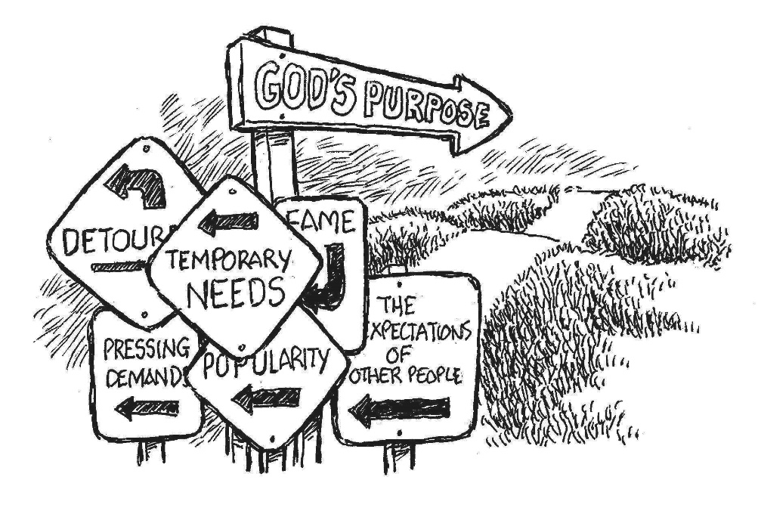

**Welcome to New Bethel Baptist Church**

**We are blessed by your presence!**

February 4, 2018

Guests and Members: Please sign the attendance register in your pew. Remember to include your address, e-mail, and telephone number. Please leave the signed sheet in the register.

If you have questions or would like more information about New Bethel, please contact the church office.

Thanks!

**Calling all Women! Save the Date!**

Do you want to become closer to God and your sisters in Christ, relax and be rejuvenated? Then the 2018 Women’s Retreat is for you. The retreat is April 21st-22nd at the Benedict Inn and Retreat Center in Beech Grove. Put these dates on your calendar. More information will be coming soon.

Barbara Fengya, Deacon

**\*\*\*\*\*\*\*\*\*\*\*\*\*\*\*\*\*\*\*\*\*\*\*\*\*\*\*\***

**Annual Report**

Oops! The Annual Report has a few errors. Please accept our apologies and make the following corrections:

Please make a notation in your book on pages 43-44 to include the following people and leadership positions: new CE Board members are John Huddleston, David Langham, and Lynsey Langham. Their terms end 2020. Assistant Treasurer is Lori Chapman with a term ending 2018.

Additionally, on page 18, the note near the top of the page should say “pages 43-44 in this Year Book.”

If you need a corrected copy of the Annual Report, or if you did not receive one, please let Jan know, and she will get you a copy.

Thank you,

Pastor Janet and Jan Nagle, Church Secretary

**\*\*\*\*\*\*\*\*\*\*\*\*\*\*\*\*\*\*\*\*\*\*\*\*\*\*\*\***

**Retired Ministers and Missionaries Offering**

January was the official month where we emphasized the Retired Ministers and Missionaries Offering. However, any additional gifts you wish to make at this time will be gratefully received.

Dick Juday, Board of Missions

**Chair Yoga**

At Chair Yoga, we stretch and get stronger and more flexible. Come join the class on Wednesdays at 11:30 a.m. in Fellowship Hall.

Thisexercise is designed for those who have difficulty standing ormoving easily from one position to another. Sessions are thirty minutes, and you will feel better. Wear comfortable clothing!

Barb Fengya, Deacon

**\*\*\*\*\*\*\*\*\*\*\*\*\*\*\*\*\*\*\*\*\*\*\*\*\*\*\*\***

**Thank You!**

* Thank you to Janet Fiddler, Carol Lucas, and Jeannine Toon for cleaning the kitchen.
* Thank you to everyone who helped set up Fellowship Hall for the Sandy Huddleston funeral dinner.
* Thank you to Liz Ballard for cleaning the sanctuary.

**\*\*\*\*\*\*\*\*\*\*\*\*\*\*\*\*\*\*\*\*\*\*\*\*\*\*\*\***

**From the Mailbox**

Previously Ann Clemmer sent word concerning the unbearable conditions in South Sudan brought on mainly by the despicable decisions of President Kiir.

U.S. Ambassador to the U.N., Nikki Haley, addressed the problem at a U.N. Security Council Briefing on the U.N. mission to South Sudan and the U.S. proposed response.

Her remarks are posted downstairs with the Clemmer family photos.

Jim and Wilma Waters

****

Thanks for the hugs, tears, emotional support, cards, visits, and the wonderful funeral dinner. Your love and support are greatly appreciated.

The Huddleston Family

**2018 Offering Envelopes – Get Yours Today!**

Pick up your 2018 offering envelopes in Fellowship Hall today.

Janet Smith, Financial Secretary

**\*\*\*\*\*\*\*\*\*\*\*\*\*\*\*\*\*\*\*\*\*\*\*\*\*\*\*\***

**From the Deacons**

The Deacons are beginning a new program to encourage and invite our young people to periodically participate in worship as Junior Lay Leaders. They will assist the adult Lay Leaders with the worship service.

Also, Lent begins with Ash Wednesday worship at 7 p.m. on February 14th. Additionally, you are invited and encouraged to participate in Lent by picking up a copy of the Lenten devotional booklets located on the coffee table in the CE hallway or on the table as you enter Fellowship Hall. Written by Kenneth Boa and John Allen Turner, *40 Days to Easter* provides scripture, thoughts for meditation, and a prayer for each scripture. As John Turner writes on Day 14: “Easter begins at Christmas. Joy to the world! For unto us a child is born; unto us a Son is given. Away in a manger, Silent night. This is where it begins, and yet we know the rest of the story. This baby was born for one purpose; to die.”

Sue Winton, Deacon Chair

**\*\*\*\*\*\*\*\*\*\*\*\*\*\*\*\*\*\*\*\*\*\*\*\*\*\*\*\***

**New Directories Soon**

We will have a new directory soon. If you have moved or changed your phone number, please send me an email to the church office at [newbethelbapt@att.net](mailto:newbethelbapt@att.net). It would help me if everyone would check the 2017 telephone directory to know that their information is correct or needs to be updated. If you have any questions, please do not hesitate to email me or call me at the church office.

Jan Nagle, Church Secretary

Greetings,

Jan Goodyear and Jay Kennedy, from the ABC-GI Region office, have been working on leadership and leadership development, and they are looking for a church to join them in the discussion; namely NBBC!

Their plan is to have four discussions over several weeks. Jan and Jay see these discussions as guided conversations, not a place to solve problems. They are not claiming to know all there is to know about leadership. They want and need input from us!

They further suggest and request that participants be present for all four sessions. They would like both elected and not-currently elected leaders to attend.

The four sessions would work as follows: session one would be three hours; and the others would be an hour and a half. The first session would be a teaching/training that covers healthy conversations, what leadership entails, etc. The others would focus on convictions (about leadership, communication, etc.), culture (church culture, values and traditions, etc.), and constructs (how to operate, what is helpful, etc.). They also want to do some follow-up with us at some point.

The first session would be Saturday, February 24th from 8:30-11:30 a.m. The remaining sessions are tentatively set for the next three Mondays from 6:30-8 p.m., beginning February 26th.

I am intrigued by this idea and think this would be a good Lenten study. I hope you agree. Please pray about your participation in these Lenten conversations on leadership and leadership development. Please consider this article to be your invitation to participate and contact me ASAP to RSVP.

We are called “to equip the saints for . . . ministry for building up the body of Christ until all of us come to the unity of the faith and of the knowledge of the Son of God, to maturity.” These discussions can help us fulfill our call . . . so come join the fun!

Godspeed, Pastor Janet