**Sunday, April 29, 2018**

**Prelude** Jaci Greig

**\*Gathering Hymn** *Come, Now Is the Time to Worship*

**\*Call to Worship**  Zach Huddleston

Leader: We gather in the name of the living Christ to

worship God.

**Church: Surely, God is in this place and calls us to**

**worship in spirit and in truth.**

**Leader: God’s love is for you and for all people**

**everywhere.**

**Church: That we may share God’s love and life, may we**

**be renewed in the refreshing Spirit of the living**

**Christ.**

**Leader: The living Christ is with us.**

**Unison: Praise the Lord!**

**\*Invocation and Lord’s Prayer *(using sins)* Zach Huddleston**

**America for Christ Mission Moment** Pat Darland

**Scripture Reading** John 10:11-18 John Huddleston

**Worship Prayer**  Pastor Janet

\***Hymn** *The Lord’s My Shepherd, I’ll Not Want* #694

**Children’s Message/No Children’s Church**

**Scripture Dialogue**  Pastor Janet

I John 3:16-24 “Resurrection: Safety and Security”

**\*Hymn** *It Is Well with My Soul* #705

**Discipleship Opportunities** John HuddlestonGiving of Tithes and Offerings

*Doxology #815

*Prayer John Huddleston

**\*Benediction** Pastor Janet

**\*Postlude** Jaci Greig

***\*Please stand if you are able.***  *CCLI # 1631733*

**April Is America for Christ Offering Month**

*Cultivating Leaders-Equipping Disciples-Healing Communities*

Today we conclude the formal collection of the AFC offering which is used for American Baptist missionary activities right here in the U.S. Pray that God’s wisdom and the Holy Spirit’s leading will result in perfect alignment between needs and resources so that the Gospel and Christian charity will go forth. And please give generously for these continuing needs. This is the last week to give and so far we have collected $670.

Pat Darland, Mission Chair

**\*\*\*\*\*\*\*\*\*\*\*\*\*\*\*\*\*\*\*\*\*\*\*\*\*\*\***

**Hearing Assistance Headsets**

Hearing assistance headsets are available for use during worship. Please see a Deacon if you would like to use one.

**\*\*\*\*\*\*\*\*\*\*\*\*\*\*\*\*\*\*\*\*\*\*\*\*\*\*\***

**Prayer Chain**

Tony Bates (see Liz Ballard); Scott and Aphiwan Coats and family; Virginia Compton and family; Ned Fox and family; Pat Hall; Shari Stevens Hall (see Jean McGee); Jim Hoskins (see Kevin Winton); Bob Hunter and family; Delores Jones (see Sherry Hiner); Linda Meisberger (see Lee Joyce); Denise and Zach Lail family (see Vicky Clark); Jane Leonberger family; Michelle Peak (see Kevin Winton); Barbara and Charlie Purtlebaugh; Ben Schuman; Lois Sheese (see Hunter family); Bob Sisk on his trip to DC; Sue Stockwell and Carolyn Neidhamer; Gay Stone; Don Toon; and victims of violence.

Remember our shut-ins and care facility residents: Ethel Humphrey; Dick and Betty Morgan; Betty Rabourn; Helen Walker; Billie Whittle; and Delcia Windsor.

Our Military:1st Lt. Matt Knox and Captain Robert Shoemaker

**Calendar**

Today America for Christ Offering Month

May 2 10 a.m., Bible Study, Romans

11:30 a.m., Chair Yoga in Fellowship Hall

5 8:15 a.m., Men’s Fellowship Breakfast at Wheatley’s

**\*\*\*\*\*\*\*\*\*\*\*\*\*\*\*\*\*\*\*\*\*\*\*\*\*\*\*\*\*\***

**Looking Ahead**

May 6 ABC-GI 2018 Annual Gathering (see article in

bulletin)

Hospitality Time: Deacons

12 25th Annual Fast Flash 5K/2K (see article in bulletin)

14 6:30 p.m., Mothers and Others Banquet (see article

in bulletin)

20 Pentecost Sunday

**\*\*\*\*\*\*\*\*\*\*\*\*\*\*\*\*\*\*\*\*\*\*\*\*\*\*\*\*\*\***

*You can give without loving,*

New Bethel Baptist Church

8936 Southeastern Avenue

Indianapolis, IN 46239

317-862-4381

Rev. Janet F. Hoover, Pastor

Jan Nagle, Secretary

Website: www.newbethelbapt.org

[E-mail: newbethelbapt@att.net](mailto:E-mail:%20newbethelbapt@att.net)

Wi-Fi password: NBBC8624381

Church Office Hours: Tuesday-Friday, 9:30-12 & 1-3 p.m.

**From the NBBC Webmaster**

Greetings Friends!

*but you cannot love without giving.*

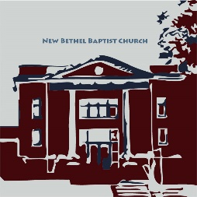— Amy Carmichael



**Welcome to New Bethel Baptist Church**

**We are blessed by your presence!**

**April 29, 2018**

Guests and Members: Please sign the attendance register in your pew. Remember to include your address, e-mail, and telephone number. Please leave the signed sheet in the register.

If you have questions or would like more information about New Bethel, please contact the church office. Thanks!

**Thank You!**

* Thank you to everyone who lets the church secretary know when they are in the building and when they leave.
* Thank you to everyone who took the time to make any changes to their addresses, e-mails, or phone numbers.
* The Worship Ministry Team wants to thank everyone at the Quarterly Business Meeting who voted to change the name of the Worship Team and to approve of the Musician Job Description.
* Thank you to our youth who serve as Junior Lay Leaders during worship service on Sundays.
* Thank you to those who spoke so beautifully on the American For Christ Mission this month.
* Thank you to those who write articles for the bulletin and put fliers on the bulletin board so we all know what is going on in our community.
* Thank you to Linda Hayward for doing a revision on the Wallsmith and Means scholarship forms.

**\*\*\*\*\*\*\*\*\*\*\*\*\*\*\*\*\*\*\*\*\*\*\*\*\*\*\*\***

**God’s Bounty Donation Opportunity**

There are several ways you can donate to God’s Bounty!

Located in the lower hallway near the coffee table and on the landing in the Narthex are stands with God’s Bounty bags and monthly need lists. Here’s what you can do:

1. Take a bag and a list.
2. Purchase either the monthly list items or your own choice of items to donate.
3. Take your filled bag to God’s Bounty and leave the bag by the front door, or take the bag to God’s Bounty on Wednesdays from 6-7 p.m.
4. Bags are returned to NBBC by the pantry staff for re-use.

You can also make a monetary donation through your regular giving, or you can volunteer at the pantry on Wednesday evenings from 6-7 p.m. and/or Thursdays from 1-6:30 p.m.

**Mothers and Others Banquet**

The annual Mothers and Others Banquet is May 14th at 6 p.m. We are having a purse auction again this year. Please clean out your closets for all those old purses you no longer use. You may place new items inside the purses or donate those items and give them to Ruth Ann Mills.

Please fill out the form instead of buying tickets. Please place your form and check into the tithing bag.

Thanks!

Ruth Ann Mills and Bobbie Cicenas

*Note: Older and younger gentlemen are needed to serve and clean-up after the banquet. If you would like to volunteer, please see either Bobbie or Ruth Ann.* 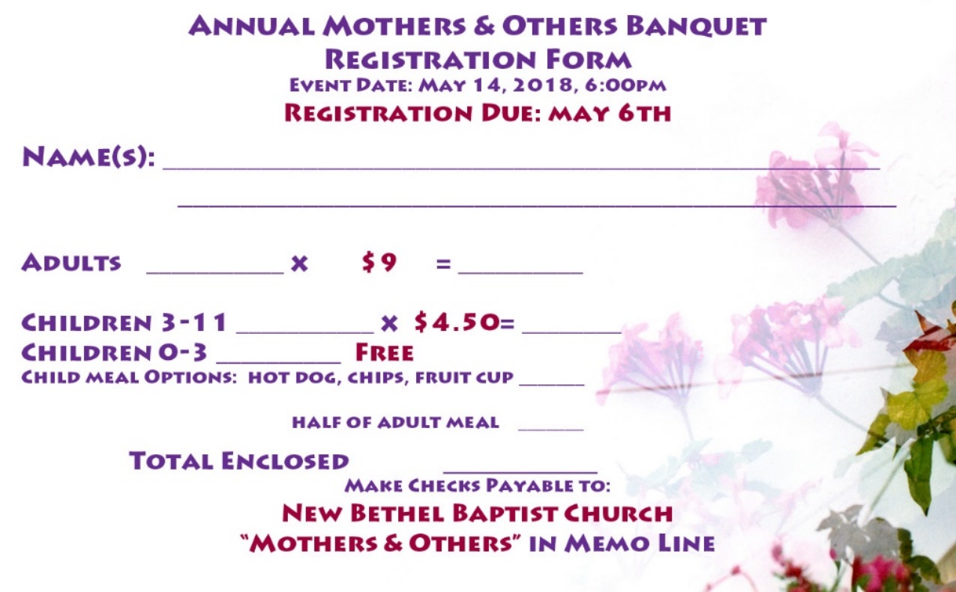

**ABC-USA International Ministries**

ABC-USA is hosting a young adult mission trip to Costa Rica from June 19th to July 8th.

Join International Ministries staff, missionaries, and our Costa Rican brothers and sisters in sustainable farming/construction projects; learn about the state of a country pioneering creation care, and dialogue cross-culturally how love of nature is an expression of love for God and neighbor.

Return with your peers to Green Lake, Wisconsin, where you will examine your experiences in a retreat format and present them at the 2018 World Mission Conference. This event is . . .

* Designed for ages 19-29
* June 19th - July 8th Costa Rica and Wisconsin
* $2,000 total includes *airfare, room and board, ground transportation, insurance, leadership (*Houston, Texas, to San Jose, Costa Rica, to Appleton, Wisconsin)
* Other expenses include passport, travel to Houston, Texas, and travel from Appleton, Wisconsin
* Limited, six-person team
* Contact Emily Ferrin at Efferin@international ministries.org or call 610-768-2245
* Non-refundable deposit of $200 due with application
* Final payments due May 1st.

**\*\*\*\*\*\*\*\*\*\*\*\*\*\*\*\*\*\*\*\*\*\*\*\*\*\*\*\***

*For it is in giving that we receive.*

*—* St Francis of Assisi

**\*\*\*\*\*\*\*\*\*\*\*\*\*\*\*\*\*\*\*\*\*\*\*\*\*\*\*\***

**What Is in a Name?**



We have been using the title of “Fellowship Time” for refreshments after Communion on the first Sunday of each month. That is going to be changed to “Hospitality Time” instead.

**Quarterly Business Meeting Information**

Thank you to all who participated in the Quarterly Business meeting on April 15th. This will hopefully set the stage for a very productive second half of the year. I would like to recap some of the New Business items that were taken care of during the meeting.

Dick Juday will be leading a team that will take a look at the Constitution and the Administrative Manual. The goal is not to make large changes but to update the current document. The process will not be a quick process.

The Worship Ministry Team presented two changes for the Administrative Handbook. One is an official change to the name of the team to be Worship Ministry Team. The second was creation and clarification for the Musician Job Description. The update now has a description covering all musicians not just the organist that was in the handbook.

As Spring has finally arrived (maybe), it will soon be time to begin looking at the 2019 budget. The changes recommended by the Church Council and passed by you will hopefully allow for a smooth and accurate budget process for all.

Blessings,

Kevin Winton, Moderator

**\*\*\*\*\*\*\*\*\*\*\*\*\*\*\*\*\*\*\*\*\*\*\*\*\*\*\*\***

**Scholarship Time Is Coming Soon**

Applications for Wallsmith and Means scholarships are located on the bulletin board in the CE hallway. Any church member’s children or grandchildren enrolled in secondary education may apply.

Students must complete an application and write a short page about themselves and their studies. Submit your application to Ruth Ann Mills or the church office. The deadline is May 31st.

Ruth Ann Mills,

Sunday School Superintendent

**ABC-GI Annual Gathering Information Needed**

There is still time to sign up for the May 6th American Baptist Churches of Greater Indianapolis (ABC-GI) annual meeting.

The region office needs your list of congregation members who will be attending. Your name, e-mail and what workshop/challenge conversation choice you would like to attend.

The flyer for the Annual Gathering is on the bulletin board in the CE hallway and it gives you the schedule for that day and the address for the Lynhurst Church where the Gathering will be held.

There is a sign up sheet on the bulletin board by the nursery that you may use. This needs to be done this week.

**\*\*\*\*\*\*\*\*\*\*\*\*\*\*\*\*\*\*\*\*\*\*\*\*\*\*\*\***

**First NBBC Women’s Retreat Summary**

The first NBBC Women’s Retreat was April 21st and 22nd at the Benedict Conference Center and Inn in Beech Grove. Nineteen women participated in the retreat. Becky Foust shared ideas about Mindfulness. We learned to focus on the positive. “If you think you can, you can. If you think you can’t, you can’t.”

Crafts were led by Bobbie Cicenas and Linda Hayward. After lunch Pastor Janet introduced and led us on a labyrinth walk/meditation adventure. Amy Egler, a friend of Becky Foust’s, told us about her Prayer Mission Trip to Israel. Yoga, dinner and a movie about Mother Teresa’s life capped off Saturday’s activities.

On Sunday we joined the Benedictine nuns for a Prayer Service and Mass. All in all, the retreat was a peaceful, restful time away from our everyday cares. Thank you to those who help plan the retreat (Janie Bryant, Vicky Clark, Bobbie Cicenas, Linda Hayward, Becky Foust, Sue Winton and Laura Williams).

Also, thanks to all who brought snacks. No one went hungry! Finally, a big thanks goes to the Board of Christian Education for their financial support.

Barbara Fengya

**Ministry Opportunities**



There are many opportunities for you to use your faith, knowledge, and skills to serve at New Bethel Baptist Church. Choose a ministry that ignites your imagination and volunteer today!

* Lead Children’s Church
* Give the Children’s Message
* Run the Power Point presentation or the Sound System
* Be a Greeter, an Usher
* Be a Worship Lay Leader
* Count the tithes and offerings

If you would like to serve, please contact me at 317-862-4381, and I will direct you to the right person.

Jan Nagle, Church Secretary

**\*\*\*\*\*\*\*\*\*\*\*\*\*\*\*\*\*\*\*\*\*\*\*\*\*\*\*\***

**Missionary Information**

We received an e-mail from Ann and Bruce Borquist to thank us for walking with them on this journey – your loving prayers and financial support through IM’s Spring Matching Fund.

They are in Kuala Lumpur, where they have been conducting a training in servant leadership with leaders of seven different Myanmar refugee communities.

If you would like to read the e-mail, it is located on the bulletin board outside the nursery.

**\*\*\*\*\*\*\*\*\*\*\*\*\*\*\*\*\*\*\*\*\*\*\*\*\*\*\*\***

**25th Annual Fast Flash 5K/2K**

This event is to benefit the Franklin Township Education Foundation. The information sheet is on the bulletin board by the nursery.

Barbara Fengya

Greetings to the Saints,



You may recall that some weeks ago we had a guest (Mandy Scherger) during Sunday School hour. Mandy talked about English Language Learners and the diversity of the student population in Franklin Township. Having a different type of program during Sunday School was also well-received, and because of that, we are going to try it again, too.

Upon request, the subject matter will be a training session about making hospital visits. The entire congregation is invited to participate. The date of the training is not yet set, though May 20th or 27th appear to be the likely dates.

“[Now](http://biblehub.com/greek/1161.htm) [to Him who](http://biblehub.com/greek/3588.htm) [is able](http://biblehub.com/greek/1410.htm) [to do](http://biblehub.com/greek/4160.htm) [infinitely](http://biblehub.com/greek/5228.htm) [more than](http://biblehub.com/greek/5228.htm) [all](http://biblehub.com/greek/3956.htm) [we ask](http://biblehub.com/greek/154.htm) [or](http://biblehub.com/greek/2228.htm) [imagine,](http://biblehub.com/greek/3539.htm) [according to](http://biblehub.com/greek/2596.htm) [His](http://biblehub.com/greek/3588.htm) [power](http://biblehub.com/greek/1411.htm) [that](http://biblehub.com/greek/3588.htm) [is at work](http://biblehub.com/greek/1754.htm) [within](http://biblehub.com/greek/1722.htm) [us,](http://biblehub.com/greek/1473.htm) to Him be the glory in the church and in Christ Jesus throughout all generations, forever and ever. Amen” (Ephesians 3:20-21).

Grace and peace,

Pastor Janet

**\*\*\*\*\*\*\*\*\*\*\*\*\*\*\*\*\*\*\*\*\*\*\*\*\*\*\*\***

**Christian Condolences**

We offer Christian sympathy to the Leonberger family upon the death of Jane Leonberger who passed on April 22, 2018. Her husband Bert (WC) was the artist who painted the beautiful picture of Christ that hangs in our sanctuary.

***

We offer Christian sympathy to the Compton family upon the death of Virginia Compton who passed on April 23, 2018.

***

We offer Christian sympathy to the Fox family upon the death of Ned Fox who passed away this week.

**From the Mailbox**



To All the Church Family, Thank you for your lovely birthday cards.

Frances Lewis

**\*\*\*\*\*\*\*\*\*\*\*\*\*\*\*\*\*\*\*\*\*\*\*\*\*\*\*\***

**Cleaning Needs**

We have an excellent facility, and we need your help to maintain the inside of the church.

A form listing tasks by quarter is posted on the bulletin board between the sanctuary and Fellowship Hall. It has space for you to volunteer for a specific cleaning task.

If you see something that hasn’t been cleaned for a while, or you see something that could be changed, or if you simply have a concern please tell a trustee and we will do our best to make it happen.

Our trustees are Mike Fengya, Scott Knox, Phil or Jan Nagle and Charlie Purtlebaugh, and Jim Winton. You may tell any of these people your concerns for cleaning that needs to be done in the church.

Please review the list and sign for the task and day you choose. Cleaning can be done any time after church on Sunday, and before the next worship service.

Greg West, Trustee Chair

**\*\*\*\*\*\*\*\*\*\*\*\*\*\*\*\*\*\*\*\*\*\*\*\*\*\*\*\***

**Church Phone Directory Update**

Please note the address change and add it to your directory:

First Lt. Matthew Knox

2 Wildwood Road

Lawton, OK 73507