**Sunday, May 13, 2018**

**Prelude** Jaci Greig

**\*Gathering Hymn** *Majesty* #10

**\*Call to Worship**  Don Parks

Leader: We gather in the name of the living Christ to

worship God.

**Church: Surely, God is in this place and calls us to**

**worship in spirit and in truth.**

Leader: God’s love is for you and for all people

everywhere.

**Church: That we may share God’s love and life, may we**

**be renewed in the refreshing Spirit of the living Christ.**

Leader: The living Christ is with us.

**Unison: Let us praise and worship the Lord!**

**\*Invocation and Lord’s Prayer *(using sins)* Don Parks**

**Blessing of the Magnolia Trees** Sue Winton

**Worship Prayer**  Pastor Janet

\***Hymn**  *Faith Is the Victory* #727

**Children’s Message/No Children’s Church**

**Scripture Reflection**  Pastor Janet

Acts 1:1-11 “Resurrection: Presence and Power”

**\*Hymn** *Praise Him! Praise Him!* #12

**Discipleship Opportunities** Don ParksGiving of Tithes and Offerings Ushers

*Doxology #815

*Prayer  Don Parks

**\*Benediction** Pastor Janet

**\*Postlude** Jaci Greig

***\*Please stand if you are able.***  *CCLI # 1631733*

**Mother’s Day Gift**

Mr. Rogers might say “It’s a beautiful day for Mothers,” and we welcome each lady worshiping with us today.

As a continuing memorial to all mothers, grandmothers, aunts, and special ladies, we will be planting two Magnolia Ann trees today (unless it rains).

These trees were recommended for their beautiful flowers which bloom around Easter. If possible, we will plant them today, so anyone wishing to take part in the tree planting is invited to the front lawn following worship.

Have a Wonderful Day,

Board of Deacons

**\*\*\*\*\*\*\*\*\*\*\*\*\*\*\*\*\*\*\*\*\*\*\*\*\*\***

**Prayer Chain**

Tony Bates (see Liz Ballard); Lori Chapman and daughter Hannah; Tony Cline family (see Kyle Winton); Scott and Aphiwan Coats and family; Virginia Compton family; Edith Francis family (See Iree); Ned Fox family; Pat Hall; Shari Stevens Hall (see Jean McGee); Jim Hoskins (see Kevin Winton); Bob Hunter and family; Delores Jones (see Sherry Hiner); Linda Meisberger (see Lee Joyce); Denise and Zach Lail family (see Vicky Clark); Jane Leonberger family; Tim Morgan (see Becky Foust); Michelle Peak (see Kevin Winton); Barbara and Charlie Purtlebaugh; Ben Schuman; Lois Sheese (see Hunter family); Sue Stockwell and Carolyn Neidhamer; Gay Stone; Vivian Thomas (see Rob Thomas); Don Toon; and victims of violence.

Remember our shut-ins and care facility residents: Ethel Humphrey; Dick and Betty Morgan; Betty Rabourn; Helen Walker; Billie Whittle; and Delcia Windsor.

Our Military:1st Lt. Matt Knox and Captain Robert Shoemaker

**Calendar**

Today Mother’s Day

14 6 p.m., Mothers and Others Banquet

15 7 p.m., Linda Znachko at Pleasant View Baptist

Church, see article inside

16 No Bible Study

11:30 a.m., Chair Yoga in Fellowship Hall

1-3 p.m., Euchre Club in Fellowship Hall

19 8:15 a.m., Men’s Fellowship Breakfast at Wheatley’s

**\*\*\*\*\*\*\*\*\*\*\*\*\*\*\*\*\*\*\*\*\*\*\*\*\*\*\*\*\*\***

**Looking Ahead**

May 20 Pentecost Sunday; wear red

**\*\*\*\*\*\*\*\*\*\*\*\*\*\*\*\*\*\*\*\*\*\*\*\*\*\*\*\*\*\*\***

**Hearing Assistance Headsets**

Hearing assistance headsets are available for your use during worship. Please see a Deacon or a sound operator to use one.

**\*\*\*\*\*\*\*\*\*\*\*\*\*\*\*\*\*\*\*\*\*\*\*\*\*\*\*\*\*\***

New Bethel Baptist Church

8936 Southeastern Avenue

Indianapolis, IN 46239

317-862-4381

Rev. Janet F. Hoover, Pastor

Jan Nagle, Secretary

Website: www.newbethelbapt.org

[E-mail: newbethelbapt@att.net](mailto:E-mail:%20newbethelbapt@att.net)

Wi-Fi password: NBBC8624381

Church Office Hours: Tuesday-Friday, 9:30-noon & 1-3 p.m.

**From the NBBC Webmaster**

Greetings Friends!

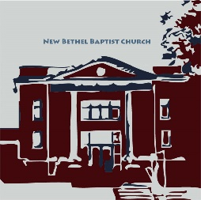

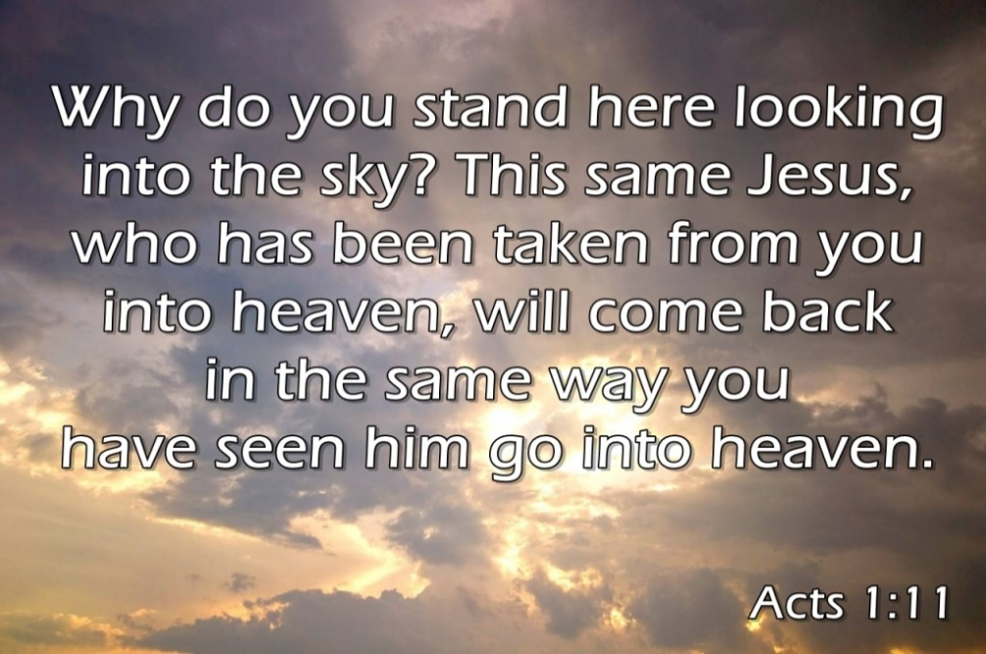

**Welcome to New Bethel Baptist Church**

**We are blessed by your presence!**

**May 13, 2018**

Guests and Members: Please sign the attendance register in your pew. Remember to include your address, e-mail, and telephone number. Please leave the signed sheet in the register.

If you have questions or would like more information about New Bethel, please contact the church office. Thanks!

**Christian Condolences**

Christian sympathy is extended to Iree Francis and family upon the death of Iree’s sister-in-law Edith who died May 5, 2018.

**\*\*\*\*\*\*\*\*\*\*\*\*\*\*\*\*\*\*\*\*\*\*\*\*\*\*\*\***

**Well Done, Thy Good and Faithful Servants!**

Kudos and thanks to Ainslie Winton for leading a NBBC clothing drive to help families who lost everything due to a fire. Kudos to father Kyle for supporting Ainslie and transporting the donated items. And kudos to those at NBBC who donated items for the families. Again . . . Well done, thy good and faithful servants!

**\*\*\*\*\*\*\*\*\*\*\*\*\*\*\*\*\*\*\*\*\*\*\*\*\*\*\*\***

**Congratulations!**

Congratulations to our three 2018 graduates. They are as follows: Rebecca Foust, fiancé of Kyle Winton, received her Ph.D. from the IU School of Nursing; Rose Gilmore, daughter of Laura Williams who is Kevin Winton’s fiancé, earned two bachelor degrees from IUPUI — one in Biology and one in Chemistry; and Jessica Winton, daughter of Kevin Winton, received her bachelor’s degree in Biology from Purdue University.

Congratulations and Godspeed to these young women as they venture forth and experience life to the fullest!

**\*\*\*\*\*\*\*\*\*\*\*\*\*\*\*\*\*\*\*\*\*\*\*\*\*\*\*\*\*\*\***

**Scholarship Applications Available**

Applications for the Wallsmith and Means scholarships are located on the bulletin board in the CE hallway. Any church member’s child or grandchild enrolled in secondary education may apply.

Students must complete an application and write a short page about themselves and their studies. The submission deadline is May 31st. Applications may be given to me or to the church office.

Ruth Ann Mills, Sunday School Superintendent

**Pastor on Vacation**

Pastor Janet is on vacation May 15th-28st. In her absence, please contact the Chair of Deacons, Sue Winton, at 317-358-7762 or the church office for immediate pastoral needs or concerns.

Rev. Tom Bridges, former pastor of Greenwood First Baptist, will fill the pulpit on May 20th, and Scott Smith, former pastor of Arlington Baptist will fill the pulpit on Sunday, May 27th. Both will handle pastoral emergencies during their respective weeks.

Best wishes to Saskia and Zach Hoover on the adoption of their son, Andres. Proud grandmother, Pastor Janet, will be there for the final adoption hearing.

**\*\*\*\*\*\*\*\*\*\*\*\*\*\*\*\*\*\*\*\*\*\*\*\*\*\*\*\***

**Update from the Pastor**

Some weeks ago during Sunday School, guest Mandy Scherger talked about English Language Learners and the diversity of the student population in Franklin Township. Upon request, the next special Sunday School training and information session will address making hospital visits. Everyone is invited to attend. The date of the training is not yet set. Because of my travel schedule, June 10th is likely to be the earliest date.

I am sorry to miss being with you on Pentecost Sunday, but . . . be sure to wear RED (and have fun)! 😊

Grace and peace, Pastor Janet

**\*\*\*\*\*\*\*\*\*\*\*\*\*\*\*\*\*\*\*\*\*\*\*\*\*\*\*\***

**From the Mailbox**



Linda Znachko, founder of “He Knows Your Name” ministry, will speak at Pleasant View Baptist Church, 12442 Southeastern Avenue, on Tuesday, May 15th at 7 p.m. Everyone is invited to attend. For more information, please see the flyer on the bulletin board in the CE hallway.