**Sunday, July 8, 2018**

**Prelude** Bob Cook

**\*Gathering Hymn** *They’ll Know We Are Christians #*429

**\*Call to Worship**  Braxton Winton

**Leader: We come into the presence of Love today,**

**Church: who calls us into community**

**Leader: who calls us God’s people**

**Church: To worship**

**Leader: To sing**

**Church: To pray**

**Leader: To imagine together**

**Church: How God can use us**

**Leader: To spread love**

**Church: To spread justice**

**Unison: To spread peace in the world. Amen**

**Invocation and Lord’s Prayer *(using sins)* Braxton Winton**

**Special Music *El Shaddai*  Julianne Thomas**

***arr John Thompson and Michael Card***

**Worship Prayer**  Pastor Janet

\***Hymn** *Little Is Much When God Is in It* vs 1-2 #661

**Children’s Message and Children’s Church**

**Scripture Reflection** Ephesians 3:20 OGHS Pastor Janet

**\*Hymn** *In Christ There Is No East or West #428*

**Ministry Opportunities** Braxton Winton

Giving of Tithes and Offerings Ushers

*Doxology #815

*Prayer  Braxton Winton

**\*Benediction**  PastorJanet

**\*Postlude** Bob Cook

***\*Please stand if you are able.***  *CCLI # 1631733*

**Lot Being Re-painted**

On July 9th, our parking space lines will be re-painted. These areas may not be used for twenty-four hours. Please park elsewhere during these times. Thank you for your cooperation.

Greg West, Trustee Chair

**\*\*\*\*\*\*\*\*\*\*\*\*\*\*\*\*\*\*\*\*\*\*\*\*\***

**Trustees Are Looking for . . .**

We are in need of a janitor for the church. Presently, we are updating the job description but thought it wise to get the process started by asking if anyone in the congregation is interested in the job. Please contact me at 317-513-7590 or the church office.

Greg West, Trustee Chair

**\*\*\*\*\*\*\*\*\*\*\*\*\*\*\*\*\*\*\*\*\*\*\*\*\***

**Prayer Chain**

Linwood Carlson family; Hannah and Lori Chapman; Paul Downer; Matt English family (see Kevin Winton); Terri Griffo (see Lori Chapman); Pat Hoover; Adrianne and Bob Hunter; immigrant families; Piper Lyon family (see Kevin Winton); Mann family (see Kevin Winton); Ruth Ann Mills; Carolyn Neidhamer family (see Sue Stockwell); Kent Pettet (see Barbara Fengya); Barbara and Charlie Purtlebaugh; Kevin Rose (see Pastor Janet); Steve Stenger (see John Huddleston); Thai soccer team and their rescuers; victims of oppression and violence; Terry Woodbury family (see Becky Day).

Remember our shut-ins and care facility residents: Ethel Humphrey; Dick and Betty Morgan; Betty Rabourn; Helen Walker; Billie Whittle; and Delcia Windsor.

Our Military:1st Lt. Matt Knox and Captain Robert Shoemaker

**Calendar**

Today One Great Hour of Sharing Offering month

July 10 5:30-7 p.m., CE Board meets

6 p.m., Trustees meet to work on budget

6-7 p.m., Deacon and Mission boards meet

7 p.m., Church Council meets

11 No Wednesday Bible Study until further notice

11:30 a.m., Chair Yoga in Fellowship Hall this week

1-3 p.m., Euchre Club, Fellowship Hall

14 8:15 a.m., Men’s Fellowship Breakfast at Wheatley’s

3-8 p.m., Family Fun Day at the Youth Center

**\*\*\*\*\*\*\*\*\*\*\*\*\*\*\*\*\*\*\*\*\*\*\*\*\*\*\*\*\*\***

**Looking Ahead**

22 Congregational dialogue sermon

29 CE Sunday

**\*\*\*\*\*\*\*\*\*\*\*\*\*\*\*\*\*\*\*\*\*\*\*\*\*\*\*\*\*\*\***

**Hearing Assistance Headsets**

Hearing assistance headsets are available for your use during

worship. Please see a Deacon or a sound operator to use one.

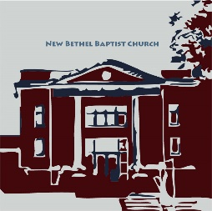**\*\*\*\*\*\*\*\*\*\*\*\*\*\*\*\*\*\*\*\*\*\*\*\*\*\*\*\*\*\***

New Bethel Baptist Church

8936 Southeastern Avenue

Indianapolis, IN 46239

317-862-4381

Rev. Janet F. Hoover, Pastor

Jan Nagle, Secretary

Website: www.newbethelbapt.org

[E-mail: newbethelbapt@att.net](mailto:E-mail:%20newbethelbapt@att.net)

Wi-Fi password: NBBC8624381

Church Office Hours: Tuesday-Friday, 9:30-noon & 1-3 p.m

.

**From the NBBC Webmaster**

Greetings Friends!

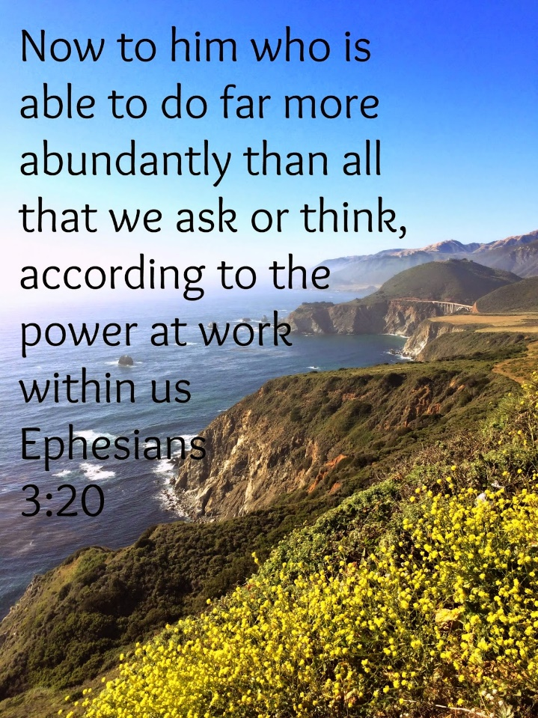

**Welcome to New Bethel Baptist Church**

**We are blessed by your presence!**

**July 8, 2018**

Guests and Members: Please sign the attendance register in your pew. Remember to include your address, e-mail, and telephone number. Please leave the signed sheet in the register.

If you have questions or would like more information about New Bethel, please contact the church office. Thanks!

**Thank You!**

* Thank you to everyone who cooked, served, and cleaned for the funeral dinner for the family of Carolyn Neidhamer.
* Thank you to Assistant Treasurer Lori Chapman for taking care of church finances during Janie Bryant’s well-deserved vacation.
* Thank you to Liz Ballard and Bobbie Cicenas for covering the office last week during Jan Nagle’s well-deserved vacation.
* Thank you to Sherry Hiner for her faithfulness as one of NBBC’s tithes and offering counters.
* Thank you to all who supported the Strawberry Festival and Craft Fair! Gross receipts totaled about $1,000!

**\*\*\*\*\*\*\*\*\*\*\*\*\*\*\*\*\*\*\*\*\*\*\*\*\*\*\*\*\*\*\***

**I Need Help!**

I need historical records from 2000-2014. Does anyone have any Board, Council, or Congregational Business meeting minutes for these years? If so, please make me a copy so that I can have them in the office.

Also, if anyone has a copy of the Constitution, please bring it to the office.

Jan Nagle, Church Secretary

**\*\*\*\*\*\*\*\*\*\*\*\*\*\*\*\*\*\*\*\*\*\*\*\*\*\*\*\***

**Sunday School Is for Adults Too**

Please join the Discussion Class on Sunday mornings at 9:15 a.m. in the Library/Discussion Classroom in the Christian Education wing. We are studying the missionary journeys of Paul. We will gain a better understanding of Paul's missionary travels as we go with Paul from Damascus to Turkey to Greece. It will be the next best thing to traveling to the Holy Land yourself. See me for more information.

Barbara Fengya

**Invitation from the Christian Education Board**

**to**

**Family Fun Day**

Come join in the fun and fellowship on Saturday July 14th from 3-8 p.m. for the Second Annual Family Fun Day at the Youth Center! And . . . the Center now has electricity and air conditioning!

We will have food (hot dogs, s’mores, baked beans, etc.) and games (corn hole, water games, Yard Yatzee, etc.) for all ages. The theme for the kids is “Jesus is the Light,” and the kids will end up with a glow in the dark craft. We will also build a bonfire.

We need your help with the games. Will you help? See me soon so I know who is helping that day and when. Thanks!

Let’s get everyone out to enjoy this event! Bring your children and grandchildren and great children for a fun afternoon and evening at New Bethel Baptist Church!

Thank you,

Lisa Caffrey, CE Board Member

**\*\*\*\*\*\*\*\*\*\*\*\*\*\*\*\*\*\*\*\*\*\*\*\*\*\*\*\***

**Invitation from the Worship Team**

You are invited to share your talents in worship this summer. If you want to play an instrument, do liturgical dance, or sing during special music time this summer, please see Julianne Thomas. You can contact her at 317-840-3587 or at jrthomas07@live.com. We look forward to the blessing of your talent during worship this summer.

God Bless, Worship Ministry Team

**Thank You!**

* Thank you to everyone who cooked, served, and cleaned for the funeral dinner for the family of Carolyn Neidhamer.
* Thank you to Assistant Treasurer Lori Chapman for taking care of church finances during Janie Bryant’s well-deserved vacation.
* Thank you to Liz Ballard and Bobbie Cicenas for covering the office last week during Jan Nagle’s well-deserved vacation.
* Thank you to Sherry Hiner for her faithfulness as one of NBBC’s tithes and offering counters.
* Thank you to all who supported the Strawberry Festival and Craft Fair! Gross receipts totaled about $1,000!

**\*\*\*\*\*\*\*\*\*\*\*\*\*\*\*\*\*\*\*\*\*\*\*\*\*\*\*\*\*\*\***

**I Need Help!**

I need historical records from 2000-2014. Does anyone have any Board, Council, or Congregational Business meeting minutes for these years? If so, please make me a copy so that I can have them in the office.

Also, if anyone has a copy of the Constitution, please bring it to the office.

Jan Nagle, Church Secretary

**\*\*\*\*\*\*\*\*\*\*\*\*\*\*\*\*\*\*\*\*\*\*\*\*\*\*\*\***

**Sunday School Is for Adults Too**

Please join the Discussion Class on Sunday mornings at 9:15 a.m. in the Library/Discussion Classroom in the Christian Education wing. We are studying the missionary journeys of Paul. We will gain a better understanding of Paul's missionary travels as we go with Paul from Damascus to Turkey to Greece. It will be the next best thing to traveling to the Holy Land yourself. See me for more information.

Barbara Fengya

**Invitation from the Christian Education Board**

**to**

**Family Fun Day**

Come join in the fun and fellowship on Saturday July 14th from 3-8 p.m. for the Second Annual Family Fun Day at the Youth Center! And . . . the Center now has electricity and air conditioning!

We will have food (hot dogs, s’mores, baked beans, etc.) and games (corn hole, water games, Yard Yatzee, etc.) for all ages. The theme for the kids is “Jesus is the Light,” and the kids will end up with a glow in the dark craft. We will also build a bonfire.

We need your help with the games. Will you help? See me soon so I know who is helping that day and when. Thanks!

Let’s get everyone out to enjoy this event! Bring your children and grandchildren and great children for a fun afternoon and evening at New Bethel Baptist Church!

Thank you,

Lisa Caffrey, CE Board Member

**\*\*\*\*\*\*\*\*\*\*\*\*\*\*\*\*\*\*\*\*\*\*\*\*\*\*\*\***

**Invitation from the Worship Team**

You are invited to share your talents in worship this summer. If you want to play an instrument, do liturgical dance, or sing during special music time this summer, please see Julianne Thomas. You can contact her at 317-840-3587 or at jrthomas07@live.com. We look forward to the blessing of your talent during our worship service this summer.

God Bless, Worship Ministry Team