**Sunday, September 16, 2018**

**Prelude**  Jaci Greig

**\*Gathering Hymn** *Awesome God* #179

**\*Call to Worship**  Julianne Thomas

**Leader: Out of grace and mercy we come from birth into**

**life:**

**Church: With the Spirit of God within us.**

**Leader: From the life of God, the universe unfolded into**

**being**

**Church: With the Spirit of God within it.**

**Leader: From the heart of God, creation goes on till the end**

**of time.**

**Church: With the Spirit of God within it and with our**

**spirit within it.**

**Leader: Let us embrace the God who enfolds us**

**Unison: May we delight in the Lord our God in our**

**worship.**

**\*Invocation and Lord’s Prayer *(using sins)* Julianne Thomas**

**Scripture Reading Matthew 5:43-6:15 Julianne Thomas**

**Special Music *Farther Along* Bob Sisk**

**Worship Prayer** Pastor Janet

**\*Hymn** *Worthy of Worship* #153

**Children’s Message and Children’s Church**

**Scripture Reflection Pastor Janet**

Matthew 6:9-13 “The Lord’s Prayer, Part IV”

**\*Hymn** *How Great Thou Art* #147

***\*Please stand if you are able.***  *CCLI # 1631733*

**Ministry Opportunities** Julianne Thomas

Giving of Tithes and Offerings Ushers

*Doxology #815

*Prayer  Julianne Thomas

**Baptism** **of Tony Bates** Pastor Janet

**\*Benediction**  Pastor Janet

**\*Postlude**  Jaci Greig

**\*\*\*\*\*\*\*\*\*\*\*\*\*\*\*\*\*\*\*\*\*\*\*\*\***

**Congratulations!**

Congratulations to Tony Bates on his baptism today and his decision to give his life to Christ! God be with you always!

**\*\*\*\*\*\*\*\*\*\*\*\*\*\*\*\*\*\*\*\*\*\*\*\*\***

**Prayer Chain**

Linwood Carlson family; Lori Chapman, Hannah, and family; Denise Davison (see Barbara Fengya); Father Doyle; flood victims; Maize Gascon; Evan Griffo family (see Lori chapman); Jennifer Hiner; Carl Houston family (see Bob Sisk); Adrianne and Bob Hunter; hurricane Florence victims; immigrant families; John and Carolyn Kanouse family (see Barbara Fengya); Nativity Catholic Church; Lucas Aivary McGee-Navarre family (see Jean McGee); Nicaraguan citizens; Jay Piety (see Carol and Jack Lucas); Chris Price (see Kevin Winton); Barbara and Charlie Purtlebaugh; Kevin Rose (see Pastor Janet); Jay Sides (see Nancy Starke); Jack Stone (see Kevin Stone); Kim Weaver Tolber (see Barbara Fengya); victims of abuse, oppression, and violence; wild fires in the U.S.; Delcia Windsor

Remember our shut-ins and care facility residents: Ethel Humphrey; Dick and Betty Morgan; Betty Rabourn; Helen Walker; Billie Whittle; and Delcia Windsor.

Our Military:1st Lt. Matt Knox and Captain Robert Shoemaker.

**Calendar**

Today 1-3 Youth meet at Zion UCC

19 11:30 a.m., Chair Yoga in Fellowship

1-3 p.m., Euchre Club, Fellowship Hall

22 8:15 a.m., Men’s Fellowship Breakfast at Wheatley’s

**\*\*\*\*\*\*\*\*\*\*\*\*\*\*\*\*\*\*\*\*\*\*\*\*\*\*\*\*\*\***

**Looking Ahead**

22 Private wedding ceremony of Rebecca Foust and

Kyle Winton

30 Wedding reception for Rebecca and Kyle Winton

after worship (see article inside)

Oct 3 10 a.m., Bible Study, Romans

6 American Baptist Women’s Ministries (see article

inside)

7 11:30 a.m.-12:30 p.m., Flu Clinic, see Liz Ballard

11 9-2:30 p.m., Senior Adult Day (see article in inside)

20 9-3 p.m., Sacred Conversations (see article inside)

**\*\*\*\*\*\*\*\*\*\*\*\*\*\*\*\*\*\*\*\*\*\*\*\*\*\*\*\*\*\*\***

**Hearing Assistance Headsets**

Hearing assistance headsets are available for your use during

worship. Please see a Deacon or a sound operator to use one.

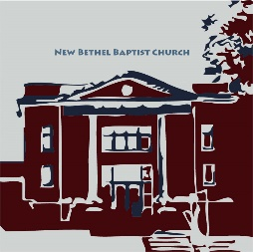

New Bethel Baptist Church

8936 Southeastern Avenue

Indianapolis, IN 46239

317-862-4381

Rev. Janet F. Hoover, Pastor

Jan Nagle, Secretary

Website: www.newbethelbapt.org

[E-mail: newbethelbapt@att.net](mailto:E-mail:%20newbethelbapt@att.net)

Wi-Fi password: NBBC8624381

Church Office Hours: Tuesday-Friday, 9:30-noon & 1-3 p.m.

.

**From the NBBC Webmaster**

Greetings Friends!

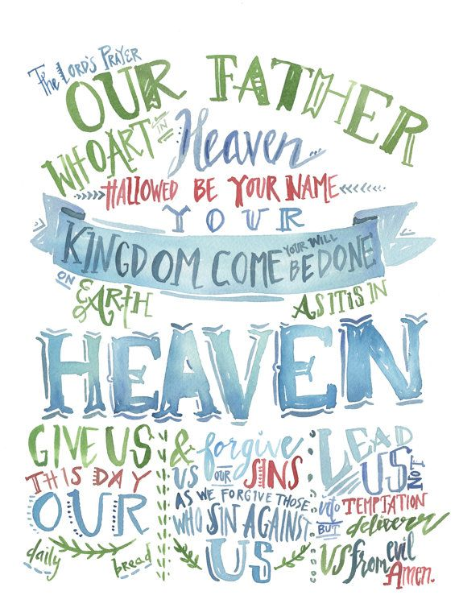

**Welcome to New Bethel Baptist Church**

**We are blessed by your presence!**

**September 16, 2018**

Guests and Members: Please sign the attendance register in your pew. Remember to include your address, e-mail, and telephone number. Please leave the signed sheet in the register.

If you have questions or would like more information about New Bethel, please contact the church office. Thanks!

**Thank You!**

* Thank you to Janie Bryant for helping with the office computer!
* Thank you to Julianne and Rob for the dramatic reading of the Lord’s Prayer last week.
* Thank you to the Trustees for working so well together on the 2019 proposed budget.
* Thank you to our Treasurer and Moderator who put in a lot of time and effort to make sure ministry happens.

**\*\*\*\*\*\*\*\*\*\*\*\*\*\*\*\*\*\*\*\*\*\*\*\*\*\*\*\*\*\*\***

**Sacred Conversations**

Sacred Conversations is an opportunity to discuss the topic of race from our shared faith perspective with persons from multiple ethnicities. The event, sponsored by ABC-GI Multicultural Ministries Team, is Saturday, October 20th from 9 a.m.-3 p.m. at Oasis of Hope Baptist Church, 1701 East 25th Street, 46218.

In order to ensure a racial balance of participants, please confirm your intentions to participate as soon as possible. There is a suggested $10 donation for lunch. Please contact the ABC-GI office at [office@abcgi.org](mailto:office@abcgi.org) or call 317-484-9327 to confirm your attendance and/or to ask questions.

Rev. Joan C. Friesen

Executive Minister, ABC-GI

**\*\*\*\*\*\*\*\*\*\*\*\*\*\*\*\*\*\*\*\*\*\*\*\*\*\*\*\*\*\*\***

**Gentle Reminder: Giving**

It's easy to simply resume giving to the church after returning from vacations or time away for other reasons, but not catching up for your absences has a direct effect on the cash flow for paying our bills. Please be aware that warmer, summer months are typically the time for major maintenance on the facility, additional grounds keeping expenses, and higher utilities bills. Please give generously.

Janie Bryant, Treasurer

**The Lord’s Prayer**

For your convenience, copies of the Lord’s Prayer have been placed in the pews. Feel free to take a copy home with you!

**\*\*\*\*\*\*\*\*\*\*\*\*\*\*\*\*\*\*\*\*\*\*\*\*\***

**Address Update**

Delcia Windsor had a heart attack in August and is now in Arlington Place, Room 328. The address is 1635 North Arlington, 46218, and the phone at the reception desk is 317-353-6000.

**\*\*\*\*\*\*\*\*\*\*\*\*\*\*\*\*\*\*\*\*\*\*\*\*\***

**American Baptist Women’s Ministries Event**

Saturday, October 6th, First Baptist Church located at 99 West Main Street, Greenwood, will be hosting this event. Please check the bulletin board outside the nursery for details.

**\*\*\*\*\*\*\*\*\*\*\*\*\*\*\*\*\*\*\*\*\*\*\*\*\***

*The wound is the place where the Light enters you.*

— Rumi

**\*\*\*\*\*\*\*\*\*\*\*\*\*\*\*\*\*\*\*\*\*\*\*\*\***

**Senior Adult Day Coming**

On October 11th from 9-2:30 p.m., Muncie First Baptist Church will host this year’s Senior Adult Day. A Time for Harvest Highlights “A Surprise is Coming!” featuring Dr. Kay Bales; Dr. Marilyn Buck, Indiana Attorney General’s Office; Investigator Tammara Weaver; and Attorney Damon Grove.

Lunch is provided. The fee is $10 per person if received by October 3rd or $12 at the door. Reservations are required. Send your reservation to Carol McVey, Registrar, Senior Adult Day, 1200 Deer Run, Martinsville, IN 46151.

Make check payable to American Baptist Churches Senior Adult Day. Please see the sign- up sheet on the bulletin board.

**Youth Fundraiser**

The Youth Group is having a pizza fundraiser! Pizza sales will continue to the end of September, cash or check is due at time of order. Please see a youth member to place your order. If you would like to sell pizzas, please see us for an order form. The youth will assemble the pizzas, and will be available for pickup on Sunday, October 14th. We ask that you pick up your pizza that day to avoid our needing to use freezer storage space at our churches.

Prices are as follows:

$10 each for Sausage, Pepperoni, cheese, or veggie (bell

peppers, onion, and tomato)

$12 each for Sausage and Pepperoni Combo

$14 each for Supreme

*(Note: we are unable to make substitution or changes on toppings.)*

Thank you for your support of this important ministry.

Julianne and Rob Thomas, Youth Leaders

**\*\*\*\*\*\*\*\*\*\*\*\*\*\*\*\*\*\*\*\*\*\*\*\*\***

**God’s Bounty Accepts Pizza Donations**

If you purchase pizza(s) for God’s Bounty, please follow these procedures: purchase pizza(s), pick up at NBBC, freeze, bring pizza(s) to the pantry the following Wednesday between 6-7 p.m. We will gratefully accept them in this manner. Thank you!

Janie Bryant, President, God’s Bounty Board of Directors

**\*\*\*\*\*\*\*\*\*\*\*\*\*\*\*\*\*\*\*\*\*\*\*\*\***

**Remember Attending Camp Tippy?**

Come join 55 and older adults for the “Young at Heart Camp” on October 24th-26th for a time of ministry, fun, and fellowship! For registration information call Camp Tippy at: 574-834-4184 or visit the website at: camptippy.org. The cost is $80. Please see the bulletin board by the nursery for more information.

**ABC-GI Region Invitations**

Emerson Avenue Baptist Church presents *Souls and Spoons*, concert/chili dinner today. Dinner at 4 p.m., and music at 5 p.m. This event is free and open to the public. Emerson Avenue Baptist Church, 308 North Emerson Avenue. Child care is available.

***

**One Christian Church Offers “Grief Share” Group**

**Sessions from September 14th to December 7th**



Whether your grief is fresh or recurring, Grief Share Groups are designed to help you with your journey.

One Christian Church, 2901 East Banta Road, hosts the group. (Note: One Christian Church is the merger of Southport and Woodland Baptist churches.)The sessions are Fridays from September 14th-December 7th at 6:30 p.m. in the church library on the upper level. The group is open to all. The cost is $20 for the workbook and can be paid during class. Scholarships are available. Please park in the North Lot (off Banta road) and enter via the courtyard to the doorway in the corner. If you would like more information, please call Jan Nordsiek, Grief Share Group Facilitator, at 317-787-8236.

**\*\*\*\*\*\*\*\*\*\*\*\*\*\*\*\*\*\*\*\*\*\*\*\*\***

**2019 Budget Schedule and Process**

Church Council leaders determined the following 2019 Budget schedule and process:

* October 9th, Final draft budget to Council
* October 21st, the 2019 proposed budget published and available to the congregation
* October 28th and November 4th, Budget Question and Answer sessions in the sanctuary following worship
* November 11th, vote on proposed 2019 budget during Quarterly Business Meeting; vote on Nominating Committee slate of officers and leaders.

**Christian Theological Seminary Event**

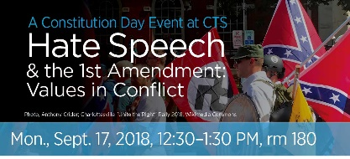CTS is celebrating Constitution Day with a public event about the constitutional restraints on free speech and the definition and prohibition of hate speech. CTS trustee and retired attorney Donald Knebel will lead the event. As part of the presentation, participants will have a chance to rule what speech should be protected and what should be prohibited under the Constitution. Join us for this engaging and educational event! This event is free and open to the public.

**\*\*\*\*\*\*\*\*\*\*\*\*\*\*\*\*\*\*\*\*\*\*\*\*\***

**You Are Invited**

Kyle and Becky Winton would like everyone to join them in the Fellowship Hall after worship on September 30th to celebrate their marriage. In lieu of gifts, Kyle and Becky ask that you please make a donation to New Bethel or to God’s Bounty.

**\*\*\*\*\*\*\*\*\*\*\*\*\*\*\*\*\*\*\*\*\*\*\*\*\***

**Franklin Central Homecoming Royalty in Our Midst!**

Don and Jeannine Toon are the 2018 Grand Marshalls for the Franklin Central Homecoming Parade. The parade is Thursday, September 27th at 5:30 p.m. in downtown Wanamaker. Come join in the fun!

The Franklin Central Homecoming Dinner will be Friday September 28th from 5-7 p.m. at the Old Franklin Central High School. The tickets are pre-sale only and cost $15. A fried chicken dinner will be catered by Keith Little, FCHS graduate. See me for tickets or buy tickets online at the Franklin Township Education Foundation website. The Homecoming Game vs. Fishers High School will be Friday, September 28th at 7 p.m.

Barbara Fengya

Greetings to the Saints,

More than 400 other pastors and I recently attended the OneCOP

Indianapolis/Marion County launch meeting. (FYI: Ron Rockey of the local Presbyterian Church also attended.)

OneCOP is a police-sponsored program that partners congregations with their area policemen and women. One goal of the partnership is to develop relationships between the two groups and work together on initiatives that improve the welfare of residents and/or officers.

I have additional information about the program to offer to one of you who would be our “Congregational Coordinator.” Before we can participate in the program, we have to have this “Congregational Coordinator” position filled.

Who amongst you would like to volunteer to lead this ministry?

Please pray about this and let me know as soon as possible. This strikes me as an exciting opportunity for us, and I hope you agree. Call me, and we will talk about this exciting opportunity.

Other news and notes:

* On September 30th during Sunday School, I will lead a training session on hospital visitation. This training is at the request of a member, and everyone is invited to attend even if you typically do not attend Sunday School. The training will be in Fellowship Hall and begin at 9:15 a.m.
* September 30th is also a Conversation Sunday. This means that during the sermon time, we will have more of a free-form time together discussing prayer. Please think and pray about specific aspects of prayer you would like to discuss.

Grace and Peace,

Pastor Janet



**Notice from the Deacon Board**

*This is the day the Lord has made; Let us rejoice and be glad in it.*

Psalm 118:24.

As the months of this year pass there has been more and more in the news about crimes against our children, our youth, our young adults and others. In our growing concern to protect the children of this church, whom we love, the Board of Deacons at their meeting this past Tuesday established a document giving steps to be taken to prevent harm coming to our children. We have had a first step in place for many months as we began locking the parking lot entrance to the children’s Sunday school rooms at 10:30 each Sunday morning.

One addition is that we will begin having background checks on anyone who works with or is involved with our children in any way. If you have, in the past several years been on a field trip with a child or grandchild, you very likely had a background check required by the school prior to the trip. Most schools have been doing this for several years.

Also, there will be two adults in each room where children are gathered. This includes Sunday school, Children’s Church, and other activities involving children.

This document is designed to protect adults as well as the children. The document will be filed with the church insurance company and should protect us from being sued and losing all assets the church has. It will also protect the adults who work with our children.

If you would like to see this document, you are invited to do so. Copies are located on the table outside the church office.

The current document will be refined and updated in the following weeks as we peruse other documents of this type and glean pertinent information from them that relates to our purposes.

Sue Winton, Chair

Board of Deacons