**Welcome to New Bethel Baptist Church**

**We are blessed by your presence!**

**Sunday, February 10, 2019**

**Guests and Members:**

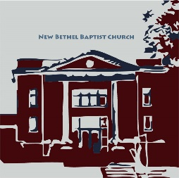Please sign the attendance register in your pew. Remember to include your address, e-mail, and telephone number. Please leave the signed sheet in the register. If you have questions or would like more information about New Bethel, please feel free to contact the church office. Thank you!

*An American Baptist*

*Congregation*

**\*\*\*\*\*\***

**All Are Welcome**

**Weekly Activities**

9:15 a.m., Sunday School Wednesday Bible Study, 10 a.m.

10:30 a.m., Sunday Worship Wednesday Chair Yoga, 11:30 a.m.

2nd/3rd Wednesday Euchre, 1-3 p.m.

**\*\*\*\*\*\***

**Contact Information**

New Bethel Baptist Church Website: www.newbethelbapt.org

8936 Southeastern Avenue E-mail: newbethelbapt@att.net

Indianapolis, IN 46239 Wi-fi password: NBBC8624381

https://facebook.com317-862-4381 New Bethel Baptist, Wanamaker

Rev. Janet F. Hoover, Pastor

Jan Nagle, Secretary

Church Office Hours: Tuesday-Friday, 9:30-noon & 1-3 p.m.

**Sunday, February 10, 2019**

**Prelude**  Dr. Christina Romero-Ivanova

**\*Gathering Hymn** *We Bring the Sacrifice of Praise* #213

**\*Call to Worship**

Leader: Come, let us worship the Lord our God,

**People: that we might discern the will of our Maker.**

Leader: Come, let us worship the Lord our God,

**People: that we might recall the bondage from which**

**God has delivered us.**

Leader: Come, let us worship the Lord our God,

**People: that we might become the people God is calling**

**us to be.**

**Unison: May our worship reignite our sense of call and**

**unity, and teach us to find our place in**

**God’s called community.**

**Invocation and Lord’s Prayer** (*using sins*)Rob Thomas

**RMMO Mission Moment** Liz Ballard

**Morning Prayer**  Pastor Janet

**\*Hymn** *Grace Greater than Our Sin*#344

**Scripture Reading** Jeremiah 1:4-10 Rob Thomas

**Children’s Sermon/Children’s Church**

**Scripture Reflection** Pastor Janet

I Corinthians 13:1-13 “Hard Road to Joy”

**\*Hymn** *The Bond of Love* #423and *The Servant Song* #424

**Ministry Opportunities**

Giving of Tithes and Offerings Ushers

*Doxology #815

*PrayerRob Thomas

**\*Benediction** Pastor Janet

**\*Postlude**  Dr. Christina Romero-Ivanov

***\*Please stand if you are able.***  *CCLI # 1631733*

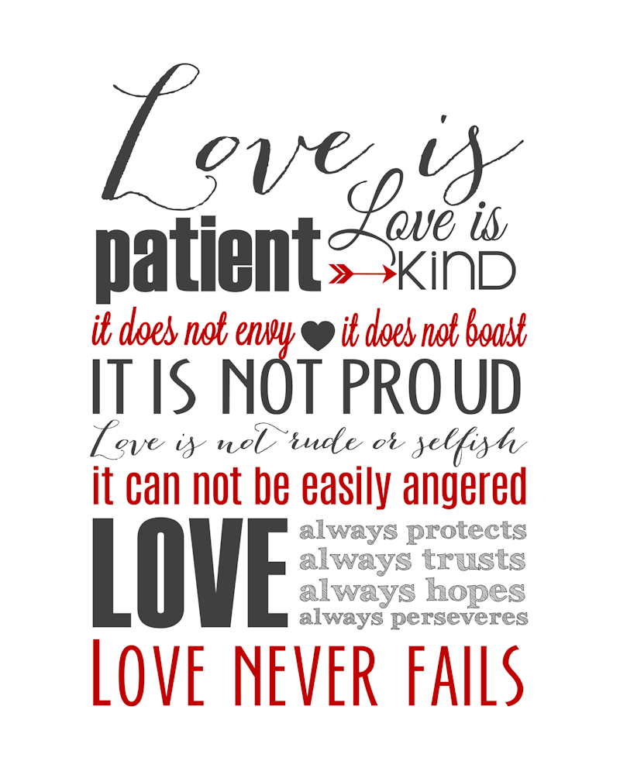**Thank You**

I would like to thank each of you for welcoming me into your church and hearts. You are a blessing from God, and I feel honored to be at New Bethel. Happy Valentine’s Day to each of you!

The candy bouquets in the sanctuary are my way of saying thank you. Inside you will find a coupon that invites you and your family to choose a favorite song from the hymnal. Using the coupon (you can put this on the piano before worship begins or hand it to me) will give you the opportunity to hear your song played in the prelude, offertory, or postlude.

With love in Christ,

Dr. Christina Romero-Ivanova

**\*\*\*\*\*\*\*\*\*\*\*\*\*\*\*\*\*\*\*\*\*\*\*\*\*\*\*\*\*\***

**Congratulations!**

Congratulations to Braxton and Ainslie Winton for winning school science and music competitions and going onto State to compete!

**\*\*\*\*\*\*\*\*\*\*\*\*\*\*\*\*\*\*\*\*\*\*\*\*\*\*\*\*\*\***

**Happening This Week**

12 5:30-7 p.m., CE Board meets

6:30 p.m., Trustees meet

6-7 p.m., Deacon and Mission boards meet

7 p.m., Church Council meets

13 1-3 p.m., Euchre in Fellowship Hall

No Bible Study and No Chair Yoga

16 8:15 a.m., Men’s Fellowship Breakfast, Wheatley’s

**\*\*\*\*\*\*\*\*\*\*\*\*\*\*\*\*\*\*\*\*\*\*\*\*\*\*\*\*\*\*\***

**Looking Ahead**

17 ABC-GI Executive Minister Rev. Friesen at NBBC

19 Women’s Retreat Planning Committee Meeting

March 3 Strategic Planning Team meets after worship

April 19 NBBC hosts Community Good Friday worship

*If you are going down a road*

*and don't like what's in front of you*

*and look behind you*

*and don't like what you see,*

*get off the road.*

*Create a new path!*

— [Maya Angelou](https://www.azquotes.com/author/440-Maya_Angelou)

**Retired Ministers and Missionaries Offering**

“Extending Our Hands to Our Neighbors” is the theme for RMMO, an offering that has been extended into February. This is our first mission of the new year, and by giving, you help our retired ministers and missionaries.

Please use an envelope in your pew for your giving, and thank you for being so generous!

Pat Darland, Mission Chair

**\*\*\*\*\*\*\*\*\*\*\*\*\*\*\*\*\*\*\*\*\*\*\***

**ABC-USA Call to Reflection, Prayer, and Reconciliation**

American Baptists have accepted the invitation to participate in an initiative with the National Institute for Civil Discourse. At the November Board Meeting of the Board of General Ministries, leaders voted to join our ecumenical partners in **A National Call for Reflection, Prayer, and Reconciliation.**

This call to action invites faith leaders from across the country to pray and seek ways to engage their congregations and community leaders in civility conversations. This call to prayer is a direct response to the enmity in language prevalent in our country.

**\*\*\*\*\*\*\*\*\*\*\*\*\*\*\*\*\*\*\*\*\*\***

**“Change Your Brain”**

Your brain can form new cells and neural connections and improve its capabilities as you age. A free workshop will teach you how.

Workshop attendees will receive information about nutrition, the environment, and mind-body connections, as well as behaviors to embrace and limit. Attendees will also learn specific, doable exercises to improve memory, reduce stress, strengthen cognition, and generally enhance their lives!

Hosted by Hope Community Church in Lawrence, the workshop is at the Sterrett Center, 8950 Otis Avenue on Tuesday, February 19th from 7-8:30 p.m.

**New Letterhead Template**

I recently created a new NBBC letterhead. If you need one to conduct church business, please contact me.

Jan Nagle, Church Secretary

**\*\*\*\*\*\*\*\*\*\*\*\*\*\*\*\*\*\*\*\*\*\***

**Sign up for the Kroger Community Rewards Program**

If you have a Kroger Plus card, you can sign up online to help NBBC receive financial rewards. If you shop at Kroger but don’t have a Plus Card, get your card and register. Printed instructions to sign up online and instructions to sign up without a computer are located on the table outside the office door. If you need assistance, please contact the church office for help. Let’s support New Bethel!

**\*\*\*\*\*\*\*\*\*\*\*\*\*\*\*\*\*\*\*\*\*\***

**Hearing Assistance Headsets**

Hearing assistance headsets are available for your use during

worship. Please see a Deacon or a sound operator to use one.

**\*\*\*\*\*\*\*\*\*\*\*\*\*\*\*\*\*\*\*\*\*\***

**Prayer Chain**

The Shirley Gephart family; Jennifer Hiner; homeless veterans; Bonita Hopkins; Pat Hoover; Adrianne and Bob Hunter; immigrant families; Harry Liggett (see Kevin Winton); Tim Morgan (see Becky Winton); the Michal Phelps family; Barbara and Charlie Purtlebaugh; NBBC; NBBC snowbirds; the Jack Stone family; victims of abuse, oppression, and violence; Karen Young.

Remember our shut-ins and care facility residents: Betty Burton; Ethel Humphrey; Lee Joyce; Frances Lewis; Betty and Dick Morgan; Helen Walker; Billie Whittle; and Delcia Windsor.

And our military and missionaries:Capt. Matt Knox; Capt. Robert Shoemaker; the Borquists; Clemmers; Coates, and Clarissa Hunter.

**Women's Retreat - Save the Date**

The 2nd New Bethel Women's Retreat will be April 6th and 7th at the Benedict Inn in Beech Grove. If you would like to help with the planning, join us on Tuesday, February 19th at 6:30 p.m. in the Discussion Classroom. See Barbara Fengya for more information.

**\*\*\*\*\*\*\*\*\*\*\*\*\*\*\*\*\*\*\*\*\*\***

**Social Media News**



Greetings,

It came up during the recent business meeting that maybe we haven’t clearly explained all the ways that New Bethel has ventured into the digital world and the ways we use them.

1. First and foremost, our website: [**www.newbethelbapt.org**](http://www.newbethelbapt.org) This is our permanent home online and where we direct people to go for the most in-depth information. While updated routinely, this tends to be a good spot for permanent information.
2. Next our Facebook page: **@newbethelbaptist.wanamaker**  Facebook is a great platform to act as a hub for directing traffic, so to speak. We post our own content and share some other posts from throughout the Christian community. We also share things that come out with short notice, such as when we cancelled worship due to weather for example.
3. Our next site that we joined was YouTube: *search* for **New Bethel Baptist Church Wanamaker**. Currently we post our Scripture Reflections each week, typically available by Tuesday or Wednesday at the latest.
4. And our newest addition (we joined February 3rd) is Instagram: **NBBC.Wanamaker**. Instagram is a photo-based social media site where users share photos or short video clips. If you’re not on Instagram, don’t worry; we will likely share everything posted to Facebook, as they are linked.

So why is having a digital footprint so important in today’s world?

First, it is the way most people make decisions today. “Where are we going to eat?” “I don’t know, ‘Hey Google/Siri, what restaurants are close by?’” Sound familiar? It could also be considered the current day form of evangelism and getting out into the community without knocking on doors or standing at the bus stop. Those methods are still used, but more and more, social media is used instead.

So how can you help?

* Step 1 is to ***Like, Follow,* or *Subscribe*** to any of the above platforms you already use and the hard part is done. More subscribers will open some other options to us, including creating a custom URL address for YouTube instead of the randomly assigned one we currently have.
* Step 2 is to “Share” our posts whenever you can, hit the “Like” button or leave a comment, even an “Amen” works. Facebook, in particular, will move posts to the top for more people to see whenever a new like or comment is received.
  + For example: an average post of ours is seen by about thirty-five people and gets about three likes. A recent post that was shared just three times and got eight likes from our followers was seen by more than 225 people. Now just imagine if fifteen or twenty or even fifty people shared a post or an event.
* Step 3: If you are on a board or committee that has an upcoming event, remember to get me the info at least a month in advance. I will get a Facebook Event created, along with a flyer to be printed and posted across all of our sites so that it has a consistent look and feel.

Thank you for reading, now go out and “***Like, Share, Comment,* and *Subscribe!”***

Rob Thomas

 @newbethelbaptist.wanamaker  NBBC.Wanamaker

Search: New Bethel Baptist Church Wanamaker