**Welcome to New Bethel Baptist Church**

**We are blessed by your presence!**

**Sunday, March 3, 2019**

**Guests and Members:**

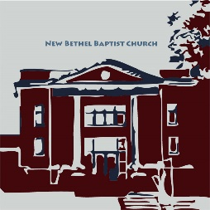Please sign the attendance register in your pew. Remember to include your address, e-mail, and telephone number. Please leave the signed sheet in the register. If you have questions or would like more information about New Bethel, please feel free to contact the church office. Thank you!

*An American Baptist*

*Congregation*

**\*\*\*\*\*\***

**All Are Welcome**

**Weekly Activities**

9:15 a.m., Sunday School Wednesday Bible Study, 10 a.m.

10:30 a.m., Sunday Worship Wednesday Chair Yoga, 11:30 a.m.

2nd/3rd Wednesday Euchre, 1-3 p.m.

**\*\*\*\*\*\***

**Contact Information**

New Bethel Baptist Church Website: www.newbethelbapt.org

8936 Southeastern Avenue E-mail: newbethelbapt@att.net

Indianapolis, IN 46239 Wi-fi password: NBBC8624381

https://facebook.com317-862-4381 New Bethel Baptist, Wanamaker

Rev. Janet F. Hoover, Pastor

Jan Nagle, Secretary

Church Office Hours: Tuesday-Friday, 9:30-noon & 1-3 p.m.

**Sunday, March 3, 2019**

**Prelude**  Contemporary Taped Selections

**\*Gathering Hymn** *Humble Thyself in the Sight of the Lord* #622

**\*Call to Worship**

Leader: All who are thirsty, come!

**People: God is the fountain for our lives.**

Leader: All who are hungry, come!

**People: Jesus feeds us with goodness and grace.**

Leader: Rich, poor, young, old, stranger and friend, come!

**People: The Holy Spirit invites everyone to God’s Table.**

**Unison: Let us worship our Lord and our God in thanksgiving and unity!**

**Invocation and Lord’s Prayer** (*using sins*)Zach Huddleston

**Scripture Reading** Exodus 34:29-35 Zach Huddleston

**Morning Prayer**  Pastor Janet

**\*Hymn** *In This Very Room*#612

**Scripture Reflection** Pastor Janet

Luke 9:28-36, 37-43a  “Sit and Wonder”

**\*Hymn** *Sunshine in My Soul* #747

**Ministry Opportunities**

Birthdays and Anniversary BlessingZach Huddleston

Giving of Tithes and Offerings Ushers

*Doxology #815

*PrayerZach Huddleston

**Communion Hymn** *In Remembrance* #461

**Communion** Pastor Janet and the Deacons

**\*Closing Hymn** *Blest Be the Tie That Binds*  #426

**\*Postlude**  Dr. Christina Romero-Ivanova

***\*Please stand if you are able.***  *CCLI # 1631733*

**From the Mailbox**

*Note: You may recall that NBBC recently collected and sent money to New Bethel Missionary Baptist Church. The note below is from the church.*

On behalf of our pastor, Rev. Jack L. Reed, our officers and our membership, we wish to express our sincere gratitude for your generous contribution to our re-building fund. Your generosity has touched us deeply.

In December of 2018 we suffered a devastating fire. While some see it as a tragedy, we choose to see it as an opportunity to continue to grow in God’s grace and in the knowledge of our Savior.

The morning after the fire we met one of your members on our parking lot who had come to offer prayers and condolences. His compassion was tangible. What a tremendous spirit your congregation of members have. We are currently meeting in the school gym right across the street. Although it is a slight inconvenience, we count it all joy!

Once the proverbial dust has settled, and we are back in the sanctuary, I would love to visit you and your congregation. It would be a pleasure to meet you and personally thank you for the love you have shown us.

Thank you again for showing us that we are not only share a name, we share in the love of Christ.

Sincerely,

Eric A. Yancy, M.D., Chairman of Trustees,

on behalf of Rev. Jack L. Reed, Pastor, and the Membership

of New Bethel Missionary Baptist Church, Indianapolis

**\*\*\*\*\*\*\*\*\*\*\*\*\*\*\*\*\*\*\*\*\*\***

**Hearing Assistance Headsets**

Hearing assistance headsets are available for your use during

worship. Please see a Deacon or a sound operator to use one.



***For a brief while,***

***Peter, James, and John were permitted to see Jesus in his glory.***

***For that brief while,***

***they had no need of faith.***

***The vision vanished.***

***The memory of it did not prevent them from all***

***forsaking Jesus when he was arrested,***

***or keep Peter from denying that he had ever known him.***

— W.H. Auden

**Happening This Week**

Today Hospitality Time after worship

Strategic Planning meeting after worship

6 10 a.m., Bible Study Romans

11:30 a.m., Chair Yoga

7 p.m., Ash Wednesday worship

9 8:15 a.m., Men’s Fellowship Breakfast, Wheatley’s

**\*\*\*\*\*\*\*\*\*\*\*\*\*\*\*\*\*\*\*\*\*\*\*\*\*\*\*\*\*\*\***

**Looking Ahead**

10 Legacy Committee meets after worship

12 5:30-7 p.m., CE Board meets

6:30 p.m., Trustees meet

6-7 p.m., Deacon and Mission boards meet

7 p.m., Church Council meets

13 1-3 p.m., Euchre in Fellowship Hall

18 7 p.m., Maundy Thursday worship

19 7 p.m., NBBC hosts Community Good Friday

worship

20 Easter Egg Hunt (time to be determined)

21 Easter Sunrise worship at Zion (time to be

determined)

Easter Sunday worship

Apr 6-7Women’s Retreat

May 5 ABC-GI Annual Gathering (see information in

bulletin)

**\*\*\*\*\*\*\*\*\*\*\*\*\*\*\*\*\*\*\*\*\*\*\***

|  |  |  |
| --- | --- | --- |
| **2019 Finances and**  **Attendance** | **Month of**  **February** | **2019**  **Year-to-Date** |
| Tithes/Offerings | $ 8,120.99 | $ 18,175.42 |
| Expenses Paid | 10,908.85 | 20,691.71 |
| Budget Needs | 12,779.00 | 25,558.00 |
| Average Weekly | 42 | 47 |

***Secret Place***

Copies of the Spring *Secret Place* devotionals have arrived and are in the CE hall book rack by the nursery. If you’d like to donate to defray the cost, please leave your money in the basket. Thanks.

**\*\*\*\*\*\*\*\*\*\*\*\*\*\*\*\*\*\*\*\*\*\***

**Thank You!**

* Thank you to the trustees for replacing the hardware in the office closet.
* Thank you to John and Zach Huddleston for painting the walls by the coffee table and around the church office! Did you notice the creative artwork by the mailboxes? We appreciate their time and effort to create a beautiful hallway.
* Thank you to the Financial Secretary, Lori Chapman, for clarifying the tithing numbers!

**\*\*\*\*\*\*\*\*\*\*\*\*\*\*\*\*\*\*\*\*\*\***

**Prayer Concerns and Joys**

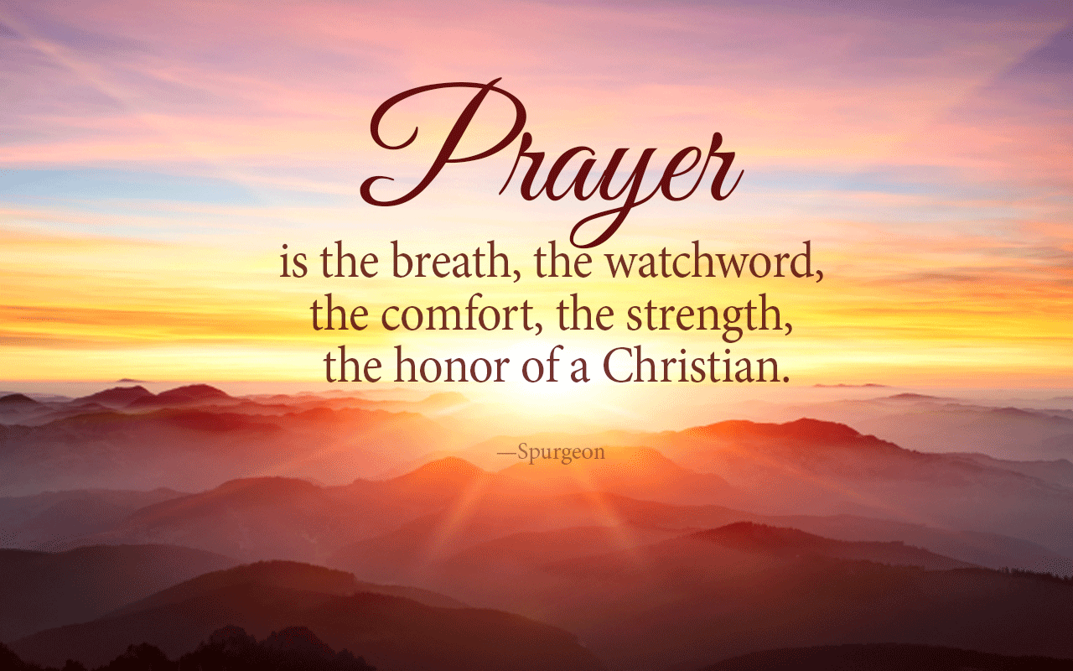The Fengya family; Matt Fuqua (see Lisa Caffrey); Jennifer Hiner; homeless veterans; Bonita Hopkins; Isabel Hoover (see Pastor Janet); Pat Hoover; John Huddleston; Adrianne and Bob Hunter; immigrant families; Harry Liggett (see Kevin Winton); Tim Morgan (see Becky Winton); Barbara and Charlie Purtlebaugh; NBBC; NBBC snowbirds; the Don Roorda family (see Jim and Wilma Waters); victims of abuse, oppression, and violence.

Remember our shut-ins and care facility residents: Betty Burton; Ethel Humphrey; Lee Joyce; Frances Lewis; Betty and Dick Morgan; Helen Walker; Billie Whittle; and Delcia Windsor.

And our military and missionaries:Capt. Matt Knox; Capt. Robert Shoemaker; the Borquists; Clemmers; Coates, and Clarissa Hunter.

**Lenten Season Information**

Dear Brothers and Sisters in Christ,

In consultation with the Pastor, the Moderator, and the Chair of Deacons, the Worship Ministry Team has been discussing the purpose of Lent and planning our Lenten worship. We hope our plans will help make this Lenten season meaningful for us.

Lent is a time to reflect on Jesus Christ’s ministry, life, suffering, and death, and on Easter Sunday, we celebrate Jesus’ resurrection.

In our discussion of Lent, we looked at what we could do during worship to help us focus on the purpose of Lent. We discussed ways to help us think about the difficult aspects of Christ’s life, specifically Jesus’ suffering and death.

New Bethel has been blessed to have a visual reminder in the portrait of the resurrected Jesus present with us each week during worship. However, as we begin a time of reflection on the difficult task that lay before Christ, which is to meet the full force of human sin and to suffer and die on the cross, we determined that the visual reminder of Jesus’ triumph over death that we currently have could be a distraction.

The idea and plan we thought that would be meaningful and poignant would be to cover the portrait of Jesus at the front of the sanctuary and to place our large, wooden cross in the middle of the choir loft. We hope you agree.

Our hope and prayer are that by covering the portrait during Lent, we will be able to focus on the cross and on the uncomfortable aspects of Christ’s life and impending death in order to grow deeper in relationship with him and therefore deeper in our faith.

The portrait will be covered with a purple cloth from March 6th through April 18th, Maundy Thursday, when we will cover it with a black cloth. Then during our worship celebration on Easter morning, we will once again uncover the portrait and reveal our risen Savior.

Additionally, we will begin our Sunday Lenten worship with what could be seen as a “reverse Advent” liturgy. (Liturgy is the work of the people.”) Akin to Advent, we will have congregation members lead scripture, the Call to Worship, and prayer. The part that makes this a “reverse Advent” liturgy is that instead of lighting a candle each week, one candle will be extinguished each week.

The Lenten season begins with Ash Wednesday. We hope you will join us for worship Wednesday March 6th at 7 p.m. as we begin this time of reflection of the life, death, and suffering of Jesus Christ.

Julianne Thomas, Worship Ministry Team Chair

* * *

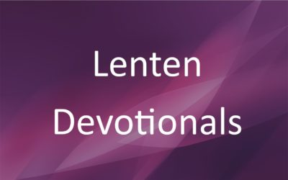The Deacons have Lenten devotionals for your use during the forty days of Lent, which begins on Ash Wednesday. You may get your copy from the coffee table on the lower level or from the table in the narthex as you leave the sanctuary.

The season of Lent begins on Ash Wednesday, which is March 6th. Lent is a period of penitential reflection and continues for forty days. These forty days (excluding Sundays) represent the forty days of Jesus’ fasting and temptation in the wilderness. Thus, came the custom of fasting during Lent.

Violet, or purple, is the color of penitence and mourning so it is the appropriate color for the church accoutrements during these forty days. The color of the clothes changes to green after Pentecost which begins the fiftieth day following Easter.

The Ash Wednesday worship will begin at 7 p.m., so come spend an hour of reflection on the beginning of Jesus’ walk into his final days on earth.

Sue Winton, Deacon Chair

**Blanket Ministry**

Beginning each Communion Sunday, the blanket albums will be available on the table in Fellowship Hall for all to look at and see all the recipients with their blankets over the years. These albums with pictures are updated as new blankets are created.

Liz Ballard, Coordinator

**\*\*\*\*\*\*\*\*\*\*\*\*\*\*\*\*\*\*\*\*\*\***

*Our days are happier*

*when we give people*

*a bit of our heart*

*rather than*

*a piece of our mind.*

*— source unknown*

**\*\*\*\*\*\*\*\*\*\*\*\*\*\*\*\*\*\*\*\*\*\***

**Save the Date — ABC-GI Annual Gathering**

Chin Evangelical Baptist Church

5610 South Meridian

Indianapolis, IN 46217

More information to follow as we receive it.

**\*\*\*\*\*\*\*\*\*\*\*\*\*\*\*\*\*\*\*\*\*\***

**Chair Yoga Is Beginning This Week!**

Please join us as we begin a new year!

We stretch, get stronger, and more flexible at chair yoga! Join the class Wednesdays at 11:30 a.m. in Fellowship Hall. Theexercise is designed for those who have difficulty standing ormoving easily. Each session is aboutthirty minutes, and you will feel better when youleave. Wear comfortable clothing!

Barb Fengya

Yoga Leader

**From The ABC-GI Region Office**

You and your congregation are invited to be a part of the 2019 “Offering of Letters” through which BREAD FOR THE WORLD has helped to marshal the resources of our nation in combating hunger around our global.

Bread for the World is a non-denominational effort that invites congregations to share in helping to eradicate hunger by an ‘offering’ of letters to their Congressional representatives in support of our government providing both hunger relief and long-term self- sufficiency as together we seek to help our world overcome the causes and consequences of hunger. This effort is a great companion to efforts such as OGHS and other work we do to impact the needs of those facing food insufficiency.

Our own Senator Todd Young was especially helpful in this effort for 2018 and with your encouragement through the ‘Offering of Letters,’ our congressional delegation, as a whole, can once again help lead the way in this effort.

The focus for 2019 is upon accelerating progress toward ending hunger by increasing funding for global child nutrition programs. We will aim to protect and increase funding, as well as strengthen U.S. leadership and commitment to maternal and child nutrition.

The campaign will launch at the end of January and materials for promotion will be available by mid-February. While this Offering of Letters can be shared at any time, a delegation from our Indiana ‘Bread’ team will be personally delivering letters to our representatives in Washington during the month of May.

Please contact Rev. Tom Bridges at 317-507-3160 or sermonstew@gmail.com and he will seek to work with you and/or your Missions team or other groups in making a Bread event successful in your congregation.

*Please pray about this concern and consider how you and NBBC might participate. Godspeed, PJ*