**Welcome to New Bethel Baptist Church**

**We are blessed by your presence!**

**1st Sunday of Lent, March 10, 2019**

**Guests and Members:**

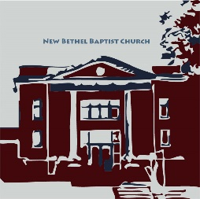Please sign the attendance register in your pew. Remember to include your address, e-mail, and telephone number. Please leave the signed sheet in the register. If you have questions or would like more information about New Bethel, please feel free to contact the church office. Thank you!

*An American Baptist*

*Congregation*

**\*\*\*\*\*\***

**All Are Welcome**

**Weekly Activities**

9:15 a.m., Sunday School Wednesday Bible Study, 10 a.m.

10:30 a.m., Sunday Worship Wednesday Chair Yoga, 11:30 a.m.

2nd/3rd Wednesday Euchre, 1-3 p.m.

**\*\*\*\*\*\***

**Contact Information**

New Bethel Baptist Church Website: www.newbethelbapt.org

8936 Southeastern Avenue E-mail: newbethelbapt@att.net

Indianapolis, IN 46239 Wi-fi password: NBBC8624381

https://facebook.com317-862-4381 New Bethel Baptist, Wanamaker

Rev. Janet F. Hoover, Pastor

Jan Nagle, Secretary

Church Office Hours: Tuesday-Friday, 9:30-noon & 1-3 p.m.

**1st Sunday of Lent, March 10, 2019**

**Prelude**  Dr. Christina Romero-Ivanova

**\*Gathering Hymn** *Humble Thyself in the Sight of the Lord* #622

**Lenten Celebration** Don and Sally Parks

**\***Call to Worship

East: Today we begin our Lenten journey, a journey that will take us to Jerusalem with Jesus.

**West: Will we embrace the reality of God with us as we travel to new places?**

East: What good news do we have for the poor?

**West: Our God cares for those who suffer from want and calls his followers to do likewise.**

**Unison: Come, let us worship our extravagantly generous God, who calls us to bring good news to the poor.**

Scripture Reading Luke 4:14-21 *New American Standard*

Prayer and Candle Extinguishing

**\***Hymn*Spirit of the Living God*#389

**Scripture Reading, Reflection**

Deuteronomy 26:1-11 Zach Huddleston and Pastor Janet

**Hymn** *Come, Thou Fount of Every Blessing vs 1, 3* #11

**Scripture Reading, Reflection**

Romans 10:8b-13 Zach Huddleston and Pastor Janet

**Hymn** *Come, Thou Almighty King vs 1, 2, 4*#8

**Children’s Message/Children’s Church**

**Scripture Reading, Reflection** Luke 4:1-13 Pastor Janet

**\*Hymn** *Our Great Savior (see power-point for revised lyrics)* #17

**Morning Prayer** Pastor Janet

***\*Please stand if you are able.***  *CCLI # 1631733*

**Ministry Opportunities** Zach Huddleston

Giving of Tithes and Offerings Ushers

*Doxology #815

*PrayerZach Huddleston

**\*Benediction** Pastor Janet

**\*Postlude**  Dr. Christina Romero-Ivanova

**\*\*\*\*\*\*\*\*\*\*\*\*\*\*\*\*\*\*\*\*\*\***

**Hearing Assistance Headsets**

Hearing assistance headsets are available for your use during

worship. Please see a Deacon or a sound operator to use one.

**\*\*\*\*\*\*\*\*\*\*\*\*\*\*\*\*\*\*\*\*\*\***

***Secret Place***

Copies of the Spring *Secret Place* devotionals have arrived and are in the CE hall book rack by the nursery. If you’d like to donate to help defray the cost, please leave your money in the basket. Thanks.

**\*\*\*\*\*\*\*\*\*\*\*\*\*\*\*\*\*\*\*\*\*\***

**Daily Scripture Readings for This Week**

Monday, March 11: Psalm 17; 1 Chronicles 21:1-17; 1 John 2:1-6

Tuesday, March 12: Psalm 17; Zechariah 3:1-10; 2 Peter 2:4-21

Wednesday, March 13: Psalm 17; Job 1:1-22; Luke 21:34-22:6

Thursday, March 14: Psalm 27; Genesis 13:1-7, 14-18;

Philippians 3:2-12

Friday, March 15: Psalm 27; Genesis 14:17-24; Philippians 3:17-20

Saturday, March 16: Psalm 27; Psalm 118:26-29;

Matthew 23:37-39



*Our weakness,*

*our story of struggle,*

*even the truth about the cost*

*of our choice to follow God —*

*these are the greatest gifts we have*

*to give to others in their journey.*

—Rick Richardson

**Lenten Season Information**

Dear Brothers and Sisters in Christ,

In consultation with the Pastor, the Moderator, and the Chair of Deacons, the Worship Ministry Team has been discussing the purpose of Lent and planning our Lenten worship. We hope our plans will help make this Lenten season meaningful.

Lent is a time to reflect on Jesus Christ’s ministry, life, suffering, and death, and on Easter Sunday, we celebrate Jesus’ resurrection.

In our discussion of Lent, we looked at what we could do during worship to help us focus on the purpose of Lent. We discussed ways to help us think about the difficult aspects of Christ’s life, specifically Jesus’ suffering and death.

New Bethel has been blessed to have a visual reminder in the portrait of the resurrected Jesus present with us each week during worship. However, as we begin a time of reflection on the difficult task that lay before Christ, which is to meet the full force of human sin and to suffer and die on the cross, we determined that the visual reminder of Jesus’ triumph over death that we currently have could be a distraction.

The idea and plan we thought that would be meaningful and poignant was to cover the portrait of Jesus at the front of the sanctuary, which was done at Ash Wednesday worship. You will notice that we also placed our large, wooden cross in the middle of the choir loft. We hope you agree with our actions.

Our hope and prayer are that by covering the portrait during Lent, we will be able to focus on the cross and on the uncomfortable aspects of Christ’s life and impending death in order to grow deeper in relationship with him and therefore deeper in our faith.

The portrait will be covered until April 18th, Maundy Thursday, when we will cover it with a black cloth. Then during our worship celebration on Easter morning, we will once again uncover the portrait and reveal our risen Savior.

Additionally, we are beginning our Sunday Lenten worship with what could be seen as a “reverse Advent” liturgy. (Liturgy is the work of the people.”) Akin to Advent, we will have congregation members lead scripture, the Call to Worship, and prayer. The part that makes this a “reverse Advent” liturgy is that instead of lighting a candle each week, one candle will be extinguished each week.

Julianne Thomas,

Worship Ministry Team Chair

* * *

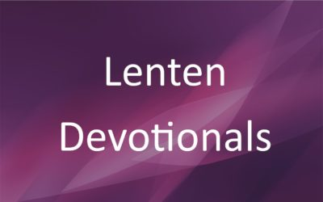The Deacons have Lenten devotionals for your use during the forty days of Lent, which began on Ash Wednesday. You may get your copy from the coffee table on the lower level or from the table in the narthex outside the sanctuary.

Lent is a period of penitential reflection and continues for forty days. These forty days (excluding Sundays) represent the forty days of Jesus’ fasting and temptation in the wilderness. Thus, came the custom of fasting during Lent.

Violet, or purple, is the color of penitence and mourning so it is the appropriate color for the church accoutrements during these forty days. The color of the clothes changes to green after Pentecost which begins the fiftieth day following Easter.

Sue Winton,

Deacon Chair

**Shalom, from Your Strategic Planning Ministry Team!**

*For surely, I know the plans I have for you, says the Lord, plans for your welfare and not for harm, to give you a future with hope*.

Jeremiah 29:11 NRSV

This verse comes to mind as we discern how God wants us to proceed in strategic planning ministries for NBBC.

As you might recall, Pastor Janet and I attended a meeting at the Center for Congregations about Engaging Young Adults. This was an introduction to a matching grant — up to $30,000 — from the Lilly Endowment and administered by the Center for Congregations. “Matching” means that NBBC would match the monies provided by the Lilly Endowment. The Strategic Planning Team (SPT) is looking at the possibility of whether NBBC should consider applying to be part of this great opportunity.

By now some of you may have been asked the following questions about why NBBC would like to Engage Young Adults from our wider community:

1. What about Engaging Young Adults interests or excites

NBBC?

2. What do you feel NBBC has to offer young adults?

3. What challenges and/or opportunities do you foresee?

(If you have not yet been contacted and you would like to offer your responses, please contact a member of the Strategic Planning Team and offer your feedback and ideas. Members of the Team are Janie Bryant, Barbara Fengya, Linda Hayward, Zachary Huddleston, Kevin Stone, Rob Thomas or me.)

Thank you for taking the time to pray and answer these questions with your honest opinion as we need to hear from you, our Church!

We are excited about this and other areas to engage not just young adults but other folks from our community.

Now is a very important and exciting time to be a part of NBBC as we strive to be a vital ministry here in Franklin Township and beyond!!

*I'm about to do a new thing; now it springs forth,*

*do you not perceive it*?

Isaiah 43:19 NRSV

Graciously submitted,

John Huddleston, Strategic Planning Ministry Team Coordinator

**\*\*\*\*\*\*\*\*\*\*\*\*\*\*\*\*\*\*\*\*\*\*\*\*\*\*\*\*\*\*\***

**Happening This Week**

Today Legacy Committee meets after worship

11 5:30 p.m., Strategic Planning Team meets

12 5:30-7 p.m., CE Board meets

6-7 p.m., Deacon and Mission boards meet

6:30 p.m., Trustees meet

7 p.m., Church Council meets

13 10 a.m., Bible Study Romans

11:30 a.m., Chair Yoga

1-3 p.m., Euchre in Fellowship Hall

16 8:15 a.m., Men’s Fellowship Breakfast, Wheatley’s

**\*\*\*\*\*\*\*\*\*\*\*\*\*\*\*\*\*\*\*\*\*\*\*\*\*\*\*\*\*\*\***

**Looking Ahead**

31 Quarterly Business Meeting after worship

Apr 6-7Women’s Retreat at Benedict Inn, Beech Grove

7 Hospitality Time after worship

18 7 p.m., Maundy Thursday worship

19 7 p.m., NBBC hosts Community Good Friday

worship

May 5 ABC-GI Annual Gathering (see article inside)

**Christian Condolences**

New Bethel offers Christian sympathy to the Carol and Jack Lucas family,upon the death of Mary Bell, Carol’s stepmother.

**\*\*\*\*\*\*\*\*\*\*\*\*\*\*\*\*\*\*\*\*\*\***

**Thank You!**

* Thank you to Rob Thomas for all the work and time you spend as the Webmaster!
* Thank you to the Deacons for the unleavened (no yeast) bread that was served for Communion last week.
* Thank you to the Worship Ministry Team for the planning and completion of our Ash Wednesday worship.
* Thank you to those who participated in the Ash Wednesday worship.

**\*\*\*\*\*\*\*\*\*\*\*\*\*\*\*\*\*\*\*\*\*\***

*Be still and know that I am God!*

*I am exalted among the nations, I am exalted in the earth.*  
 — Psalm 46:10

**\*\*\*\*\*\*\*\*\*\*\*\*\*\*\*\*\*\*\*\*\*\***

**ABC-GI Annual Gathering**

The Annual Gathering of the American Baptist Churches of Greater Indianapolis is Sunday, May 5th. The event is being hosted by Chin Evangelical Baptist Church, 5610 South Meridian Street, Indianapolis, IN 46217.

This year’s theme is “Food for Thought: Practicing Intentional Hospitality.” At our gathering, we will come together as American Baptists for worship, conversation and . . . ice cream!

Please see the bulletin board by the nursery for the registration form. Sign up today! (Your reservation will be sent to the Region Office by Jan Nagle, Church Secretary.)

**Chair Yoga Has Begun Again for 2019!**

Please join us for Chair Yoga as we begin a new year!

We stretch, get stronger, and more flexible at chair yoga! Join the class Wednesdays at 11:30 a.m. in Fellowship Hall. Theexercise is designed for those who have difficulty standing ormoving easily. Each session is aboutthirty minutes, and you will feel better when youleave. Wear comfortable clothing!

Barb Fengya Yoga Leader

**\*\*\*\*\*\*\*\*\*\*\*\*\*\*\*\*\*\*\*\*\*\***

*Do not be overcome by evil but overcome evil with good.*

*—*Romans 12:21

**\*\*\*\*\*\*\*\*\*\*\*\*\*\*\*\*\*\*\*\*\*\***

**Prayer Concerns and Joys**

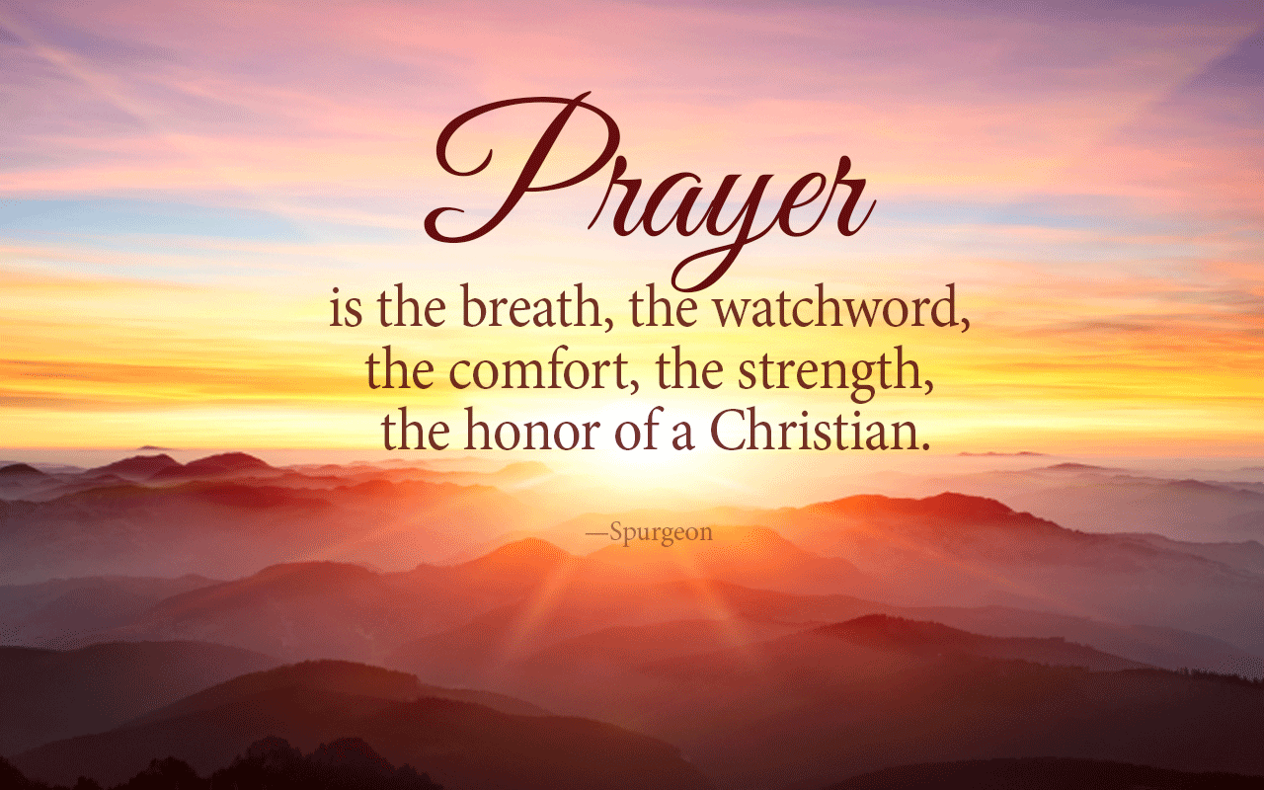Shirley Ashman (see Sherry Hiner); Mary Bell, (see Carol Lucas); The Fengya family; Janet Fiddler; Matt Fuqua (see Lisa Caffrey); Jennifer Hiner; homeless veterans; Bonita Hopkins; Isabel Hoover (see Pastor Janet); Pat Hoover; John Huddleston; Adrianne and Bob Hunter; immigrant families; Harry Liggett (see Kevin Winton); Tim Morgan (see Becky Winton); Barbara and Charlie Purtlebaugh; NBBC; NBBC snowbirds; the Don Roorda family (see Jim and Wilma Waters); Theresa Royalty; victims of abuse, oppression, and violence.

Remember our shut-ins and care facility residents: Betty Burton; Ethel Humphrey; Lee Joyce; Frances Lewis; Betty and Dick Morgan; Helen Walker; Billie Whittle; and Delcia Windsor.

And our military and missionaries:Capt. Matt Knox; Capt. Robert Shoemaker; the Borquists; Clemmers; Coates, and Clarissa Hunter.