**Welcome to New Bethel Baptist Church**

**We are blessed by your presence!**

**3rd Sunday of Lent, March 24, 2019**

**Guests and Members:**

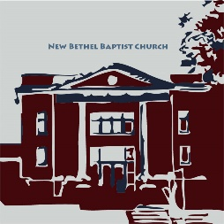Please sign the attendance register in your pew. Remember to include your address, e-mail, and telephone number. Please leave the signed sheet in the register. If you have questions or would like more information about New Bethel, please feel free to contact the church office. Thank you!

*An American Baptist*

*Congregation*

**\*\*\*\*\*\***

**All Are Welcome**

**Weekly Activities**

9:15 a.m., Sunday School Wednesday Bible Study, 10 a.m.

10:30 a.m., Sunday Worship Wednesday Chair Yoga, 11:30 a.m.

2nd/3rd Wednesday Euchre, 1-3 p.m.

**\*\*\*\*\*\***

**Contact Information**

New Bethel Baptist Church Website: www.newbethelbapt.org

8936 Southeastern Avenue E-mail: newbethelbapt@att.net

Indianapolis, IN 46239 Wi-fi password: NBBC8624381

https://facebook.com317-862-4381 New Bethel Baptist, Wanamaker

Rev. Janet F. Hoover, Pastor

Jan Nagle, Secretary

Church Office Hours: Tuesday-Friday, 9:30-noon & 1-3 p.m.

**3rd Sunday of Lent, March 24, 2019**

**Prelude**  Dr. Christina Romero-Ivanova

**\*Gathering Hymn** *Humble Thyself in the Sight of the Lord* #622

**Lenten Celebration** Bob Sisk and Jerry Thomas

Scripture Reading Luke 4:14-21 *New Revised Standard*

**\***Call to Worship

East: We continue our Lenten journey to Jerusalem with Jesus.

**West: Will we embrace the reality of God with us as we travel to new places?**

East: Blindness frightens us, yet Jesus says our sight needs to be retrieved, recovered, and healed.

**West: Will we see how we want to see, or can we begin to see with the eyes of love?**

**Unison: In our gathering, let us be open to the blessing of sight-filled love that God would give us this day.**

Prayer and Candle Extinguishing

**\***Hymn*Lead Me, Lord*#689

**Morning Prayer** Pastor Janet

**Scripture Reading, Reflection**

Isaiah 55:1-9 Sue Winton and Pastor Janet

**Hymn** *God Will Take Care of You*  #692

**Children’s Message/Children’s Church**

**Scripture Reading, Reflection**

1 Corinthians 10:1-13 Sue Winton and Pastor Janet

**Hymn** *Find Us Faithful*#456

**Scripture Reading, Reflection** Luke 13:1-9 Pastor Janet

**\*Hymn** *Near to the Heart of God* #617

***\*Please stand if you are able.***  *CCLI # 1631733*

**Ministry Opportunities** Sue Winton

Giving of Tithes and Offerings Ushers

*Doxology #815

*PrayerSue Winton

**Benediction** Liturgical DancersFootsteps of Hope

*Amazing Grace,* Vocal Julianne Thomas

**Postlude**  Dr. Christina Romero-Ivanova

**\*\*\*\*\*\*\*\*\*\*\*\*\*\*\*\*\*\*\*\*\*\***

**Hearing Assistance Headsets**

Hearing assistance headsets are available for your use during worship. Please see a Deacon or a sound operator to use one.

**\*\*\*\*\*\*\*\*\*\*\*\*\*\*\*\*\*\*\*\*\*\***

*Create in me a clean heart, O God,*

*and put a new and right spirit within me.*

— Psalm 51:10

**\*\*\*\*\*\*\*\*\*\*\*\*\*\*\*\*\*\*\*\*\*\***

**Daily Scripture Readings for This Week**

Monday, March 25: Psalm 39; Jeremiah 11:1-17; Romans 2:1-11

Tuesday, March 26: Psalm 39; Ezekiel 17:1-10; Romans 2:12-16

Wednesday, March 27: Psalm 39; Numbers 13:17-27;

Luke 13:18-21

Thursday, March 28: Psalm 32; Joshua 4:1-13;

2 Corinthians 4:16-5:5

Friday, March 29: Psalm 32; Joshua 4:14-24; 2 Corinthians 5:6-15

Saturday, March 30: Psalm 32; Exodus 32:7-14; Luke 15:1-10

Sunday, March 31: Psalm 63:1-8; Isaiah 55:1-9; Luke 13:1-9;

1 Corinthians 10:1-13

*Infuse your life with action.*

*Don’t wait for it to happen.*

*Make it happen.*

*Make your own future.*

*Make your own hope.*

*Make your own love.*

*And whatever your beliefs, honor your creator.*

*Not by passively waiting for grace to come down from upon high,*

*but by doing what you can to make grace happen . . .*

*yourself,*

*right now,*

*right down here on earth.*

*—* Bradley Whitford

***Strategic planning is an organization's process of defining its strategy, or direction, and making decisions on allocating its resources to pursue this strategy.***



**Shalom from Your Strategic Planning Ministry Team!**

*For surely, I know the plans I have for you,*

*says the Lord,*

*plans for your welfare*

*and not for harm,*

*to give you a future with hope*.

Jeremiah 29:11 NRSV

This verse comes to mind as we discern how God wants us to proceed in strategic planning ministries for NBBC.

As you might recall, Pastor Janet and I attended a meeting at the Center for Congregations about Engaging Young Adults.

This meeting was an introduction to a matching grant — up to $30,000 — from the Lilly Endowment and administered by the Center for Congregations.

“Matching” means that NBBC would match the monies provided by the Lilly Endowment.

The Strategic Planning Team (SPT) is looking at the possibility of whether NBBC should consider applying to be part of this great opportunity.

By now some of you may have been asked the following questions about why NBBC would like to Engage Young Adults from our wider community:

1. What about Engaging Young Adults, ages 19-35

interests or excites NBBC?

2. What do you feel NBBC has to offer young adults?

3. What challenges and/or opportunities do you foresee?

(If you have not yet been contacted and you would like to offer your responses, please contact a member of the Strategic Planning Team and offer your feedback and ideas. Members of the Team are Janie Bryant, Barbara Fengya, Linda Hayward, Zachary Huddleston, Kevin Stone, Rob Thomas, or me.)

Thank you for taking the time to pray and answer these questions with your honest opinion as we need to hear from you, our Church!

We are excited about this and other areas to engage not just young adults but other folks from our community.

Now is a very important and exciting time to be a part of NBBC as we strive to be a vital ministry here in Franklin Township and beyond!!

*I'm about to do a new thing;*

*now it springs forth,*

*do you not perceive it*?

Isaiah 43:19 NRSV

Graciously submitted,

John Huddleston

  Strategic Planning Ministry Team Coordinator

**Thank You!**

* Thank you to the Worship Team Ministry for the focus on the cross during Lent.
* Thank you for the new LED bulbs in the sanctuary that lighten up the room and are cost effective!

**\*\*\*\*\*\*\*\*\*\*\*\*\*\*\*\*\*\*\*\*\*\***

*All human nature vigorously resists grace*

*because grace changes us*

*and the change is painful . . .*

*—*Flannery O’Connor

**\*\*\*\*\*\*\*\*\*\*\*\*\*\*\*\*\*\*\*\*\*\***

**Happening This Week**

25 5:30 p.m., Strategic Planning meets

27 10 a.m., Bible Study, Lent scriptures from bulletin

11:30 a.m., Chair Yoga

30 8:15 a.m., Men’s Fellowship Breakfast, Wheatley’s

**\*\*\*\*\*\*\*\*\*\*\*\*\*\*\*\*\*\*\*\***

**Looking Ahead**

31 Quarterly Business Meeting after worship (see

article in bulletin)

1-3 p.m., Youth meet at Zion

April America for Christ Offering Month

Apr 6-7Women’s Retreat at Benedict Inn, Beech Grove

7 Hospitality Time - Volunteer

14 1-3 p.m., Youth meet at Zion

20 10-11:30 a.m., Easter Egg Hunt at NBBC

1-3 p.m., Youth rehearsal at Zion

27 4-6 p.m., Fellowship Hall and kitchen reserved

May 5 ABC-GI Annual Gathering (see article in bulletin)

June 8 12-5 p.m., Bryce Huddleston graduation party in

Fellowship Hall

**Welcome to the Footsteps of Hope Liturgical Dancers**

This morning we extend a warm New Bethel welcome to Footsteps of Hope liturgical dancers Andrea Buselli, Debbie Masten, and Vania VanKirk. Footsteps comes to us from Hope Covenant Church, Indianapolis. We are grateful for their gift of creative ministry!

**\*\*\*\*\*\*\*\*\*\*\*\*\*\*\*\*\*\*\*\*\*\*\***

**Address Update**

Effective March 29th, Becky Day has a new home and address. Please correct your church directory to the following:

Crestwood Village

1223 North Edmondson Avenue

Building 2, Apt. 3C

Indianapolis, IN 46219

**\*\*\***

Helen Walker is presently residing with her daughter, Barbara Walker-Zazas. Helen’s new address is:

5649 Bradston Way

Indianapolis, IN 46237

**\*\*\*\*\*\*\*\*\*\*\*\*\*\*\*\*\*\*\*\*\*\*\*\***

**Bulletin Board Postings**

Get your copy of the latest Borquist Journal downstairs in the CE hallway. In a country so peaceful that police seldom carry guns, Ann writes about the effect of the unexpected horror in New Zealand and the response of her and Bruce.

Clarissa Hunter sent an update, which is on the bulletin board in the CE hallway.

Please take a moment to read these interesting articles.

**5th Sunday — March 31st — Schedule**

In recent months, we have had a Scripture Dialogue on the 5th Sunday during the sermon time in worship. Because we are in Lent, this is not going to happen in March.

However, during Sunday School on March 31st, we will gather for a special conversation, and all are invited to attend. Zach Huddleston and Dick Juday are collaborating and teaching on hospitality: what it is, examples of it, how NBBC can offer a more generous welcome to strangers, visitors, and guests.

You won’t want to miss this event! All of us can learn more about how we can make others feel more at home at NBBC. Please join us in Fellowship Hall and offer your input and ask any questions you may have.

**\*\*\*\*\*\*\*\*\*\*\*\*\*\*\*\*\*\*\*\*\*\***

**Notes from the Moderator**

Please join us on March 31st in Fellowship Hall after worship for the first Quarterly Business Meeting of 2019. If able, please bring snacks and appetizers to share prior to the meeting. The church will provide table service and drinks.

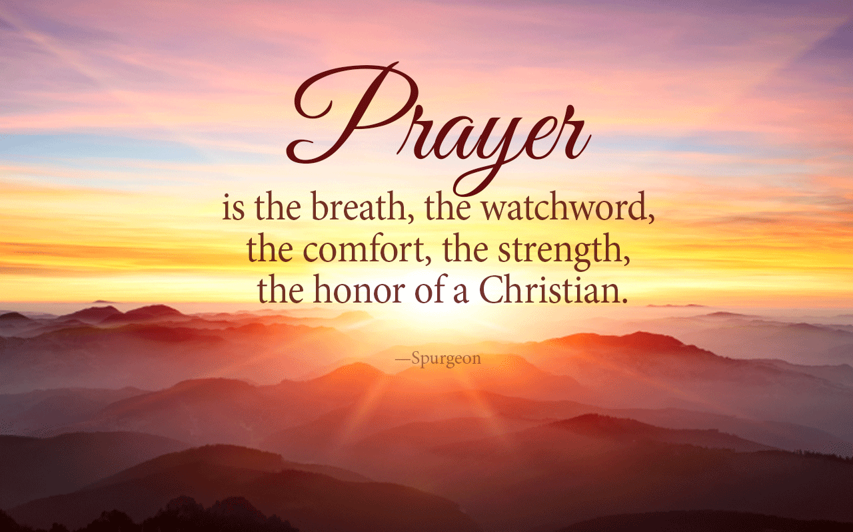New business will include the establishment of an Event Ministry Team for New Bethel. The Council recently discussed this possibility and determined that the purpose of the Event Team would be to develop ideas, plan and organize events, and implement the plan under the auspices of the Church Council and Pastor.

Events would include overseeing large gatherings within the church, managing community focused activities, and creating outreach opportunities.

Please let Pastor Hoover, Jan Nagle, or me know if you would like to participate on this Team.

Thank you, Kevin Winton,

Moderator

**Holy Week Schedule**

April 18th 7 p.m., Maundy Thursday Worship, NBBC

April 19th 7 p.m., Good Friday worship, NBBC hosts

April 21st Easter Sunday!

 6:45 a.m., Youth lead Zion Sunrise worship

9:30 a.m., Easter Sunday School 10:30 a.m., NBBC Easter Worship

**\*\*\*\*\*\*\*\*\*\*\*\*\*\*\*\*\*\*\*\*\*\***

*I have confidence in the Father to believe*

*that when he gives us the capacity*

*to do anything He does not make a blunder.*

— Lucy Stone

**\*\*\*\*\*\*\*\*\*\*\*\*\*\*\*\*\*\*\*\*\*\***

**Prayer Concerns and Joys**

Shirley Ashman (see Sherry Hiner); Mary Bell, (see Carol Lucas); The Fengya family; Janet Fiddler; Matt Fuqua (see Lisa Caffrey); Harley Ham (see Adrianne or Bob Hunter); Jennifer Hiner; homeless veterans; Bonita Hopkins; Pat Hoover; John Huddleston; Adrianne and Bob Hunter; immigrant families; Harry Liggett (see Kevin Winton); Tim Morgan (see Becky Winton); Barbara and Charlie Purtlebaugh; NBBC; NBBC snowbirds; the Don Roorda family (see Jim and Wilma Waters); Theresa Royalty; victims of abuse, oppression, and violence; New Zealand mosques.

Remember our shut-ins and care facility residents: Betty Burton; Ethel Humphrey; Lee Joyce; Frances Lewis; Betty and Dick Morgan; Helen Walker; Billie Whittle; and Delcia Windsor.

And our military and missionaries:Capt. Matt Knox; Capt. Robert Shoemaker; the Borquists; Clemmers; Coates, and Clarissa Hunter.

**Easter Lily Order Form**

If you would like to purchase an Easter lily and honor a loved one or friend on Easter Sunday, please complete this form to secure your lily(s).

I would like to order _____Easter Lily(s) for Easter Sunday, April 21st.

My name _____________________________

I want the card(s) to say:

_____________________________________

1. ________________________________________________
2. ________________________________________________
3. ________________________________________________
4. ________________________________________________

Each Lily costs $10. Please enclose the correct amount for your lily(s) with this form and make checks payable to New Bethel Baptist Church.

Total amount enclosed _______________________________

Please place your completed form and money in an envelope and drop it in an offering bag.

The last day to order your lily(s) is April 14th.

Thank you,

Liz Ballard

Flower Committee

**ABC-GI Annual Gathering**

The Annual Gathering of the American Baptist Churches of Greater Indianapolis is Sunday, May 5th. The event is being hosted by Chin

Evangelical Baptist Church, 5610 South Meridian Street, Indianapolis, IN 46217. This year’s theme is “Food for Thought: Practicing Intentional Hospitality.” At our gathering, we will come together as American Baptists for worship, conversation and . . . ice cream! Please see the bulletin board by the nursery for the registration form. Sign up today! (Your reservation will be sent to the Region Office by Jan Nagle, Church Secretary.)

**\*\*\*\*\*\*\*\*\*\*\*\*\*\*\*\*\*\*\*\*\*\***

**Good Friday Community Music Schedule**

Singers and players are needed and wanted for this year’s Good Friday worship service at NBBC. Rehearsals for the community vocal and the bell/chime choirs are as follows:

March 24 3 p.m., Vocal choir rehearsal at NBBC

March 26 7:30 p.m., Bell/chime rehearsal at Zion UCC

**\*\*\*\*\*\*\*\*\*\*\*\*\*\*\*\*\*\*\*\*\*\***

**Volunteers Needed for Mother’s and Others Banquet**

We need help to plan this year’s Mother’s and Other’s banquet. If you are interested, please talk to Liz Ballard or Bobbie Cicenas.

**\*\*\*\*\*\*\*\*\*\*\*\*\*\*\*\*\*\*\*\*\*\***

**Invitation to a Stephen’s Ministry Workshop**

On Saturday, April 27th in Columbus, Indiana, First Christian Church will host a training event for Stephen’s Ministry, a Christian care-giving ministry. The information and registration form are located on the bulletin board in the CE hallway.