**Welcome to New Bethel Baptist Church**

**We are blessed by your presence!**

**Sunday, April 28, 2019**

**Guests and Members:**

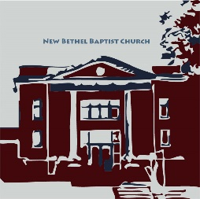 Please sign the attendance register in your pew. Remember to include your address, e-mail, and telephone number. Please leave the signed sheet in the register. If you have questions or would like more information about New Bethel, please feel free to contact the church office. Thank you!

*An American Baptist*

*Congregation*

**\*\*\*\*\*\***

**All Are Welcome**

**Weekly Activities**

9:15 a.m., Sunday School Wednesday Bible Study, 10 a.m.

10:30 a.m., Sunday Worship Wednesday Chair Yoga, 11:30 a.m.

2nd/3rd Wednesday Euchre, 1-3 p.m.

**\*\*\*\*\*\***

**Contact Information**

New Bethel Baptist Church Website: www.newbethelbapt.org

8936 Southeastern Avenue E-mail: newbethelbapt@att.net

Indianapolis, IN 46239 Wi-fi password: NBBC8624381

https://facebook.com317-862-4381 New Bethel Baptist.Wanamaker

YouTube: New Bethel Baptist

Church Wanamaker

Rev. Janet F. Hoover, Pastor Instagram: NBBC.Wanamaker

Jan Nagle, Secretary

Church Office Hours: Tuesday-Friday, 9:30-noon & 1-3 p.m.

**2nd Sunday in Easter, April 28, 2019**

**Prelude** Dr. Christina Romero-Ivanova

**\*Gathering Hymn** *We Have Come into His House* #224

**\*Call to Worship**  Zach Huddleston

Leader: Come, let us praise the Lord, let us worship our

risen Savior, for death has given away to life, despair

has been overwhelmed by hope.

**People: Grief has been replaced by joy, and darkness**

**has been dispelled by light!**

Leader: Alleluia! Christ is risen!

**Unison: He is risen, indeed! Alleluia!**

**Invocation and Lord’s prayer** (using sins) Zach Huddleston

**Scripture Reading** Revelation 1:4-8 Zach Huddleston

**Worship Prayer** Pastor Janet

**\*Hymns** *Alleluia*#359

**Children’s Story/Children’s Church**

**Mission Moment** Kevin Stone

**Scripture Reflection** John 20:19-31 Pastor Janet

**\*Hymn** *Because He Lives* #358

**Ministry Opportunities** Zach Huddleston

Giving of Tithes and Offerings Ushers

*Doxology #815

*PrayerZach Huddleston

\***Benediction** Pastor Janet

**Postlude**  Dr. Christina Romero-Ivanova

***\*Please stand if you are able.***  *CCLI # 1631733*

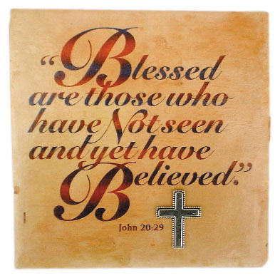**Happening This Week**

April America for Christ Offering Month

29 Church Office open

May 1 10 a.m., Bible Study, scriptures from bulletin

11:30 a.m., Chair Yoga

May 2 Church Office closed

4 8:15 a.m., Men’s Fellowship Breakfast, Wheatley’s

**\*\*\*\*\*\*\*\*\*\*\*\*\*\*\*\*\*\*\*\***

**Looking Ahead**

5 Hospitality Time – Discussion Classroom

ABC-GI Annual Gathering (see article in bulletin)

8 1-3 p.m., Euchre Club in Fellowship Hall

11 4:30-8 p.m., CE sponsored Parents Night Out

14 5:30-7 p.m., CE Board meets

6-7 p.m., Deacon and Mission boards meet

6:30 p.m., Trustees meet

7 p.m., Church Council meets

June 8 12-5 p.m., Bryce Huddleston graduation party in

Fellowship Hall

**\*\*\*\*\*\*\*\*\*\*\*\*\*\*\*\*\*\*\*\*\*\***

**Daily Scripture Readings for This Week**

Monday, April 29: Psalm 122; Esther 7:1-10; Revelation 1:9-20

Tuesday, April 30: Psalm 122; Esther 8:1-17; Revelation 2:8-11

Wednesday, May 1: Psalm 122; Esther 9:1-5, 18-23; Luke 12:4-12

Thursday, May 2: Psalm 30; Isaiah 5:11-17; Revelation 3:14-22

Friday, May 3: Psalm 30; Isaiah 6:1-4; Revelation 4:1-11

Saturday, May 4: Psalm 30; Genesis 18:1-8; Luke 14:12-14

Sunday, May 5: Acts 9:1-6, (7-20); Psalm 30; Revelation 5:11-14;

John 21:1-19

*For what I received I passed on to you as of first importance:*

*that Christ died for our sins according to the Scriptures,*

*that he was buried, that he was raised on the third day*

*according to the Scriptures, and that he appeared to*

*Cephas, and then to the Twelve.*

*After that, he appeared to more than five hundred*

*of the brothers and sisters at the same time,*

*most of whom are still living,*

*though some have fallen asleep.*

– 1 Corinthians 15:3-6

**Reg ister Today — ABC-GI Annual Gathering**

The Annual Gathering of the American Baptist Churches of Greater Indianapolis is Sunday, May 5th.

The Chin Evangelical Baptist Church, 5610 South Meridian Street, Indianapolis, IN 46217, is hosting the event.

This year’s theme is “Food for Thought: Practicing Intentional Hospitality.” At our gathering, we will come together as American Baptists for worship, conversation, and . . . ice cream!

Please see the bulletin board by the nursery for the registration form. Sign up today! The fee has been paid by NBBC. Your reservation will be sent to the Region Office by Jan Nagle, Church Secretary.

**\*\*\*\*\*\*\*\*\*\*\*\*\*\*\*\*\*\*\*\***

**New Bulletin Board Postings**

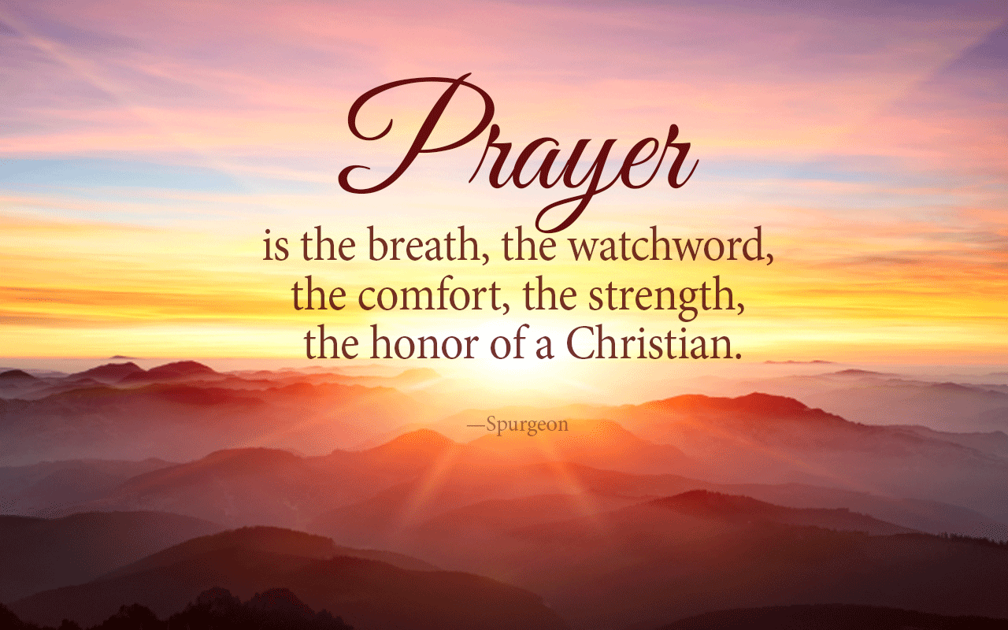If you missed Pastor Janet’s article about the state of the church and John Huddleston’s article about the Strategic Planning Ministry Team’s work, stop at one of the bulletin boards and read this information.

If you would like your own copy of one or both of the articles, please contact Jan Nagle in the church office.

.

**\*\*\***

Clarissa Hunter has sent an update with pictures of Croatia, Hungary, current projects, and health.

Please take a moment to read her articles about her ministry which are located on the bulletin board in the CE hall.

**\*\*\*\*\*\*\*\*\*\*\*\*\*\*\*\*\*\*\*\***

**Hearing Assistance Headsets**

Hearing assistance headsets are available for your use during worship. Please see a Deacon or a sound operator to use one.

**Thank You and Blessings!**

* Thank you for the special worship music, and for those who participated in redressing the sanctuary for Easter Sunday.
* Thank you to all who purchased lilies in memory of their loved ones.
* Thank you to everyone who helped with the Easter Egg hunt this year. Even though the weather was not what we hoped for, the kids had fun!
* Thank you to John and Zach Huddleston for all the fresh paint in the CE hallway and in Fellowship Hall.

**\*\*\*\*\*\*\*\*\*\*\*\*\*\*\*\*\*\*\*\*\*\***

**Prayer Concerns and Joys**

Mary Bell (see Carol Lucas); Christy Dammann’s grandmother and family; “collective memory” of the Notre Dame Cathedral in Paris; Patty Dammann; Janet Fiddler; Jaimie Flemming (see Andrew Clark); Kyle Gephart and family (see Julianne and Rob Thomas); Harley Ham (see Adrianne or Bob Hunter); Maurice Harbert family (see Ruth Ann Mills); Jennifer Hiner; homeless veterans; Bonita Hopkins; Pat Hoover; the Bruce Houston family (see Bob Sisk); Adrianne and Bob Hunter; immigrant families; the Francis Lewis family; Barbara and Charlie Purtlebaugh; NBBC; NBBC Strategic Planning Team; Sri Lanka congregations; the Don Reed family (see Carol Lucas); Theresa Royalty; victims of abuse, oppression, and violence; Jim and Wilma Waters; New Zealand mosques.

Remember our shut-ins and care facility residents: Betty Burton; Ethel Humphrey; Lee Joyce; Betty and Dick Morgan; Helen Walker; Billie Whittle; and Delcia Windsor.

And our military and missionaries:Capt. Matt Knox; Capt. Robert Shoemaker; the Borquists; Clemmers; Coates, and Clarissa Hunter.

**ABC-GI Event**

Need some help with your church’s finances?

“Three Practical Ways of Increasing Giving” is the topic of a special learning event on May 8th at 7 p.m. The event is hosted by First Baptist Church of Indianapolis. This is for any church leader with interest in funding ministry.

To reserve your space and materials, please call the church office. Jan will place reservations with the region office.

**\*\*\*\*\*\*\*\*\*\*\*\*\*\*\*\*\*\*\*\*\*\***

*Surely he took up our pain and bore our suffering,*

*yet we considered him punished by God, stricken by him, and afflicted. But he was pierce for our transgressions, he was crushed for our iniquities; the punishment that brought us peace was on him, and by his wounds we are healed.*  
 — Isaiah 53:4-5

**\*\*\*\*\*\*\*\*\*\*\*\*\*\*\*\*\*\*\*\*\*\***

**God’s Bounty Donation Opportunity**

There are several ways you can donate to God’s Bounty!

Located in the lower hallway near the coffee table and on the landing in the Narthex are stands with God’s Bounty bags and monthly need lists. Here’s what you can do:

1. Take a bag and a list.
2. Purchase either the monthly list items or your own choice of

items to donate.

1. Take your filled bag to God’s Bounty and leave the bag by

the front door, or take the bag to God’s Bounty on

Wednesdays from 6-7 p.m.

1. Bags are returned to NBBC by the panty staff for re-use.

And remember, you can always make a monetary donation through your regular giving or you can volunteer on Wednesday evenings from 6-7 p.m. or Thursdays from 1-6:30 p.m.

**America for Christ**

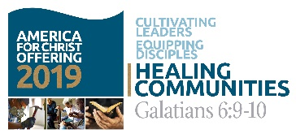

Thank you to Dick and Donna Juday for bringing the Coats missionaries to talk with the Sunday School classes and for their brief message during worship last

Sunday.

Pat Darland, Mission Chair

**\*\*\*\*\*\*\*\*\*\*\*\*\*\*\*\*\*\*\*\*\*\***

*I believe in Christianity*

*as I believe that the sun has risen:*

*not only because I see it,*

*but because by it I see everything else.*

— C.S. Lewis

**\*\*\*\*\*\*\*\*\*\*\*\*\*\*\*\*\*\*\*\*\*\***

**Social Media Insights**

Do you practice digital emotional intelligence? There are a lot of ways to do this, but one of the easiest is to check in with yourself before hitting “send” on an email, Facebook post, tweet, or text.  
  
Take ten seconds to ponder these questions before you send:

* Am I feeling defensive? Reactive? Angry?
* What is my emotional state?
* Would I say this to someone in person?
* Is there a chance my tone could be misinterpreted or that I have misinterpreted theirs?

It’s easy to compose a reactive response, forgetting that there is a human being on the other end of the screen. Emotional intelligence is a powerful muscle to build, especially with more and more interactions happening digitally.

In the long term, practicing digital emotional intelligence can set you up for more positive in-person interactions.

Source: the Gottman Institute

**Free Event at Christian Theological Seminary**

[](https://pushbackpoverty2019.eventbrite.com/)You are invited to join us on May 2nd for the Faith & Action Spring Conference.

Together, we’ll discover and share ways to “Push Back Poverty” in Indianapolis.

This year’s event is at Eastern Star Church, 5750 E 30th Street, Indianapolis, IN 46218. The church’s phone number is (317) 591-5050.

Join us for a morning of insights by keynote speaker Father Greg Boyle. Father Boyle is a dynamic storyteller, Jesuit priest, and founder of Homeboy Industries in Los Angeles.

Homeboy Industries is the largest gang intervention, rehabilitation, and re-entry program in the world. Boyle’s book, *Tattoos on the Heart: The Power of Boundless Compassion,* is a New York Times bestseller.

Attendees will also hear from previous Faith & Action Project grant recipients, who will discuss their programs and how the grants have helped them scale up and increase their impact.

At noon, the Faith & Action Project will hold an informational meeting for organizations interested in applying for 2019 Faith & Action Project grants.

Plan to attend and join the city’s effort to Push Back Poverty, and be sure to invite friends from your church, colleagues and co-workers, peers in service organizations and on boards, and anyone else who might be interested.

For more information on the Faith & Action Project go to http://www.cts.edu/faith-action-project/

Please note that attendance at the Spring Conference is a prerequisite for organizations wanting to apply for a Faith & Action grant.

The complete morning schedule is as follows:

7:30 a.m., Welcome and registration

8:30 a.m., Keynote Speaker Father Greg Boyle

9:15 a.m., Moderated discussion with Father Greg

10 a.m., Break

10:15 a.m., Grantee video and testimonials

10:30 a.m., Conversation with past grantees

11:50 a.m., Closing remarks

12:00 p.m. Adjourn and Grant information meeting

12:20 p.m. Adjournment from Grant information meeting

***

Note the poverty statistics below in Indianapolis

As compared to the United States.

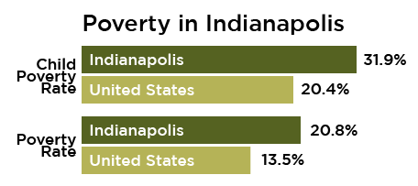

*************************

**NBBC Holy Week Worship Attendance**

Maundy Thursday worship attendance was 50.

Good Friday worship attendance was 106.

Easter Egg Hunt number of children participating was 30.