**Welcome to New Bethel Baptist Church**

**We are blessed by your presence!**

**Sunday, May 12, 2019**

**Guests and Members:**

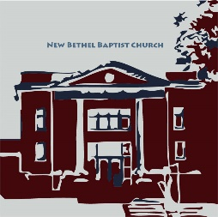 Please sign the attendance register in your pew. Remember to include your address, e-mail, and telephone number. Please leave the signed sheet in the register. If you have questions or would like more information about New Bethel, please feel free to contact the church office. Thank you!

*An American Baptist*

*Congregation*

**\*\*\*\*\*\***

**All Are Welcome**

**Weekly Activities**

9:15 a.m., Sunday School Wednesday Bible Study, 10 a.m.

10:30 a.m., Sunday Worship Wednesday Chair Yoga, 11:30 a.m.

2nd/3rd Wednesday Euchre, 1-3 p.m.

**\*\*\*\*\*\***

**Contact Information**

New Bethel Baptist Church Website: www.newbethelbapt.org

8936 Southeastern Avenue E-mail: newbethelbapt@att.net

Indianapolis, IN 46239 Wi-fi password: NBBC8624381

https://facebook.com317-862-4381 New Bethel Baptist.Wanamaker

YouTube: New Bethel Baptist

Church Wanamaker

Rev. Janet F. Hoover, Pastor Instagram: NBBC.Wanamaker

Jan Nagle, Secretary

Church Office Hours: Tuesday-Friday, 9:30-noon & 1-3 p.m.

**4th Sunday in Easter, May 12, 2019**

**Prelude** Dr. Christina Romero-Ivanova

**\*Gathering Hymn** *Shine, Jesus, Shine* #431

**\*Call to Worship**  Zach Huddleston

Leader: Frayed and frazzled, our lives jangling with tension

and anxiety.

**People: We gather to find that place of peace which God**

**offers to us.**

Leader: Awash in worries and doubts, drowning in a sea of

fears.

**People: We gather beside the still waters where Jesus**

**offers us a cup of grace.**

Leader: Wandering as if lost in a wilderness,

**Unison: we gather so the Spirit can restore our souls**

**and show us the path to the kingdom.**

**\*Invocation and Lord’s prayer** (using sins) Zach Huddleston

**Scripture Reading** Acts 9:36-43 Zach Huddleston

**Mother’s Day Tribute** Sue Winton, Chair of Deacons

**\*Hymns** *The Lord’s My Shepherd, I’ll Not Want*#694

**Children’s Message**

**Scripture Reflection** Revelation 7:9-17 Pastor Janet

“This Is Why There Is Hope”

**\*Hymn** *Have the Mind That Was in Jesus* (see Power Point)

**Ministry Opportunities** Zach Huddleston

Giving of Tithes and Offerings Ushers

*Doxology #815

*PrayerZach Huddleston

**\*Benediction** Pastor Janet

**Postlude**  Dr. Christina Romero-Ivanova

***\*Please stand if you are able.***  *CCLI # 1631733*

**Happening This Week**

Today Happy Mother’s Day!

14 Church office closed

5:30-7 p.m., CE Board meets

6-7 p.m., Deacon and Mission boards meet

6:30 p.m., Trustees meet

7 p.m., Church Council meets

15 10 a.m., Bible Study, scriptures from bulletin

No Chair Yoga in Fellowship Hall

1-3 p.m., Euchre Club in Fellowship Hall

18 8:15 a.m., Men’s Fellowship Breakfast, Wheatley’s

**\*\*\*\*\*\*\*\*\*\*\*\*\*\*\*\*\*\*\*\***

**Looking Ahead**

22 No Bible Study

June 8 12-5 p.m., Bryce Huddleston graduation party in

Fellowship Hall

30 Noon-4 p.m., Strawberry Festival

July 14 After worship, congregational business meeting

16 9:30 a.m.-1 p.m., Church reserved

**\*\*\*\*\*\*\*\*\*\*\*\*\*\*\*\*\*\*\*\*\*\***

**Daily Scripture Readings for This Week**

Monday, May 13: Psalm 100; Ezekiel 37:15-28; Revelation 15:1-4

Tuesday, May 14: Psalm 100; Ezekiel 45:1-9; Acts 9:32-35

Wednesday, May 15: Psalm 100; Jeremiah 50:17-20; John 10:31-42

Thursday, May 16: Psalm 148; Ezekiel 2:8-3:11;

Revelation 10:1-11

Friday, May 17: Psalm 148; Daniel 7:13-14; Revelation 11:15

Saturday, May 18: Psalm 148; Daniel 7:27; Revelation 11:16-19

Sunday, May 19: Acts 11:1-18; Psalm 148; Revelation 21:1-6;

John 13:31-35



*The beginning of love is the will to let those*

*we love be perfectly themselves,*

*the resolution not to twist them to fit our own image.*

*If in loving them we do not love what they are,*

*but only their potential likeness to ourselves,*

*then we do not love them:*

*we only love the reflection of ourselves we find in them.*

— Thomas Merton

**New Bulletin Board Postings**

An article from the *Indianapolis Star* about declining church membership during the last twenty years is posted on the CE hallway bulletin board. Please take a moment to read it.

**\*\*\*\*\*\*\*\*\*\*\*\*\*\*\*\*\*\*\*\*\*\***

**Hearing Assistance Headsets**

Hearing assistance headsets are available for your use during worship. Please see a Deacon or a sound operator to use one.

**\*\*\*\*\*\*\*\*\*\*\*\*\*\*\*\*\*\*\*\*\*\*\*\***

**Mission Work Update**

During the month of April, we had a total donation amount of $935 for the America for Christ offering. Thank you to everyone who gave so generously.

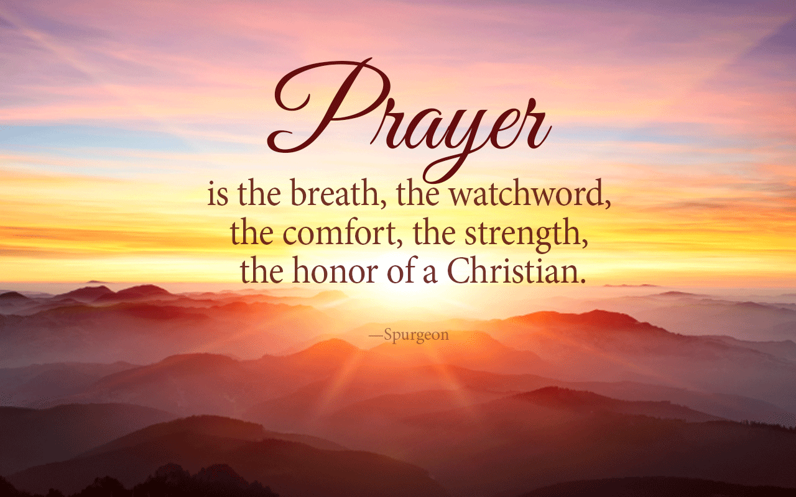

Pat Darland, Mission Chair

**\*\*\*\*\*\*\*\*\*\*\*\*\*\*\*\*\*\*\*\***



**Thank You and Blessings!**

* Thank you to Janie Bryant for sharing the church laptop that she uses for her work until the office laptop could be replaced!
* Thank you to the Flower Committee for their tender and steadfast care of God’s creation.
* Thank you to the Blanket Committee for wrapping and covering so many in God’s grace.

**\*\*\*\*\*\*\*\*\*\*\*\*\*\*\*\*\*\*\*\***

**Prayer Concerns and Joys**

“Collective memory” of the Notre Dame Cathedral in Paris; Colorado school shooting; Patty Dammann; Amanda Eilert (see Julianne Thomas); Janet Fiddler; Jaimie Flemming (see Andrew Clark); Kyle Gephart and family (see Julianne and Rob Thomas); Maurice Harbert family (see Ruth Ann Mills); Joyce (see Alyssa Tandy); Jennifer Hiner; homeless veterans; Bonita Hopkins; Pat Hoover; Adrianne and Bob Hunter; immigrant families; the Francis Lewis family; Karlee Losacco (see Barbara and Mike Fengya); Barbara and Charlie Purtlebaugh; NBBC; NBBC Strategic Planning Ministry Team; synagogue shooting in California; Sri Lanka congregations; Theresa Royalty; Kathy Stricker (see Barbara Fengya); victims of abuse, oppression, and violence; UNC Charlotte shooting; Jim and Wilma Waters; New Zealand mosques.

Remember our shut-ins and care facility residents: Betty Burton; Ethel Humphrey; Lee Joyce; Betty and Dick Morgan; Helen Walker; Billie Whittle; and Delcia Windsor.

And our military and missionaries:Capt. Matt Knox; Capt. Robert Shoemaker; the Borquists; Clemmers; Coates, and Clarissa Hunter.

**Happy Mother’s Day!**

Happy Mother’s Day to all the women, men, boys, and girls who have ever “mothered” another.

The Deacons have a small thank you to all mothers today. Enjoy the day!

**\*\*\*\*\*\*\*\*\*\*\*\*\*\*\*\*\*\*\*\*\***

*Good Friday and Easter*

*free us to think about other things*

*far beyond our own personal fate,*

*about the ultimate meaning of all life,*

*suffering, and events;*

*and we lay hold of a great hope.*

—Dietrich Bonhoeffer

**\*\*\*\*\*\*\*\*\*\*\*\*\*\*\*\*\*\*\*\*\***

***Secret Place***

Copies of the Summer *Secret Place* devotionals have arrived and are in the CE hall book rack by the nursery.

If you would like to help defray the costs, please leave your money in the basket.

**\*\*\*\*\*\*\*\*\*\*\*\*\*\*\*\*\*\*\*\*\*\***

**Telephone Directory Updates**

I will be updating the phone directory and will have the new version available for the congregation on June 9th. If there are no changes in your address, phone, or e-mail, then we are good.

However, if you do have a change in address, phone, or e-mail, please send it to the church office by June 6th.

Thank you

Jan Nagle, Church Secretary

**Strategic Planning Ministry Team (SPMT) Update**

*Forget about what’s happened; don’t keep going over old history. Be alert, be present. I’m about to do something brand new. It’s bursting out! Don’t you see it?* — Isaiah 43:18-19

**Good News! We have completed the application for the**

**Engaging Young Adults Initiative matching grant!**

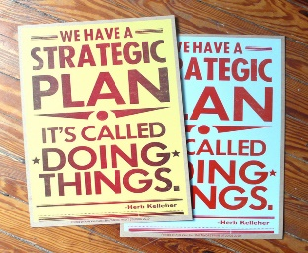

Our completed application contains valuable insights into the culture, life, and values of New Bethel Baptist Church.

We invite you to get a copy of the completed application and read it.

Copies of the application are in Fellowship Hall and outside the church office.

If you have any questions about the grant, the application, or the process, please contact one of the following SPMT members: Janie Bryant, Barbara Fengya, John Huddleston, Zachary Huddleston, Pastor Janet, or Rob Thomas.

*Then Jesus went to work on his disciples. “Anyone who intends to come with me has to let me lead. You’re not in the driver’s seat; I am. Don’t run from suffering; embrace it. Follow me and I’ll show you how. Self-help is no help at all. Self-sacrifice is the way, my way, to finding yourself, your true self. What kind of deal is it to get everything you want but lose yourself? What could you ever trade your soul for?”* — Matthew 16:24-26

Thank you for all your support and input! We have a solid application and look forward to hearing from the Center for Congregations on June 1st. Please continue to pray for your SPMT and for our church. Thank you also to the SPMT members — well done thy good and faithful servants!

Blessings,

John M. Huddleston,

SPMT Coordinator