**Welcome to New Bethel Baptist Church**

**Sunday, September 29, 2019**

**Prelude** Dr. Christina Romero-Ivanova

**\*Gathering Hymn** *We Are a People on a Journey*

See Power Point

**\*Call to Worship Zach Huddleston**  
Leader: The word has come for us from the Father:   
**People: who promises to shelter us under the wings of**

**hope and grace.**  
Leader: The word has come to us from Jesus:  
**People: who encourages us to remember the good news**

**we have received.**

**Leader: The word flows to us from the Spirit:**

**People: who reminds us to place our hope and trust in**

**God.**

**Unison: Come let us worship our Lord.**

**\*Invocation and Lord’s Prayer** *(*using *sins)* Zach Huddleston

**Scripture Reading** Jeremiah 32:1-3a, 6-15 Zach Huddleston

**Worship Prayer** Pastor Janet

**\*Hymn** *Bind Us Together* #425

**Scripture Reflection** Luke 16:19-31 Pastor Janet

**\*Hymn** *Go Out with Joy* See Power Point

**Ministry Opportunities** Zach Huddleston

Christian Education Lisa Caffrey

Deacons Kyle Winton

Giving of Tithes and Offerings Ushers

*Doxology #815

*PrayerZach Huddleston

**\*Benediction** Pastor Janet

**Postlude** Dr. Christina Romero-Ivanova

***\*Please stand if you are able.***  *CCLI # 1631733*

**Congratulations!**

God’s blessing to Adrianne and Bob Hunter! Their granddaughter, Erin Hunter Timm, had a six-pound baby boy on September 20th. His name is Bennett Lee Timm. Mother and baby are doing fine!

**\*\*\*\*\*\*\*\*\*\*\*\*\*\*\*\*\*\*\*\***

**Hearing Assistance Headsets**

Hearing assistance headsets are available for your use during worship. Please see a Deacon or a sound operator to use one.

**\*\*\*\*\*\*\*\*\*\*\*\*\*\*\*\*\*\*\*\***

**Daily Scripture Readings for This Week**

Monday, September 30: Psalm 119:49-56 & Jeremiah 32:16-35 *OR*

Psalm 62 & Amos 6:8-14; Revelation 3:14-22

Tuesday, October 1: Psalm 119:49-56 & Jeremiah 32:36-44 *OR*

Psalm 62 & Hosea 10:9-15; James 5:1-6

Wednesday, October 2: Psalm 119:49-56 & Jeremiah 33:1-13

*OR* Psalm 62: & Hosea 12:2-14; Matthew 19:16-22

Thursday, October 3: Lamentations 3:19-26 & Jeremiah 52:1-11

*OR* Psalm 37:1-9 & 2 Kings 18:1-8, 28-36;

Revelation 2:8-11

Friday, October 4: Lamentations 3:19-26 & Jeremiah 52:12-30

*OR* Psalm 37:1-9 & 2 Kings 19:8-20, 35-37;

Revelation 2:12-29

Saturday, October 5: Lamentations 3:19-26 & Lamentations 1:7-15

*OR* Psalm 37:1-9 & Isaiah 7:1-9; Matthew 20:29-34

Sunday, October 6: Lamentations 1:1-6 & Lamentations 3:19-26

*OR* Psalm 137; Habakkuk 1:1-4, 2:1-4 *OR* Psalm 37:1-9 &

2 Timothy 1:1-14; Luke 17:5-10

**Welcome to New Bethel Baptist Church**

**We are blessed by your presence!**

**Sunday, September 29, 2019**

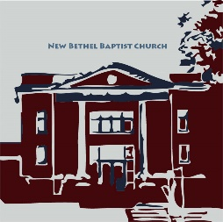**Guests and Members:** Please sign the attendance register in your pew. Remember to include your address, e-mail, and telephone number. Please leave the signed sheet in the register. If you have questions or would like more information about New Bethel, please feel free to contact the church office. Thank you!

*An American Baptist*

*Congregation*

**\*\*\*\*\*\***

**All Are Welcome**

**Weekly Activities**

9:15 a.m., Sunday School Wednesday Bible Study; 10 a.m.

10:30 a.m., Sunday Worship 2nd/3rd Wednesday Euchre, 1-3 p.m.

**\*\*\*\*\*\***

**Contact Information**

New Bethel Baptist Church Website: www.newbethelbapt.org

8936 Southeastern Avenue E-mail: newbethelbapt@att.net

Indianapolis, IN 46239 Wi-fi password: NBBC8624381

317-862-4381 Instagram: NBBC.Wanamaker

New Bethel Baptist.Wanamaker

https://facebook.com YouTube: New Bethel Baptist

Church Wanamaker

Rev. Janet F. Hoover, Pastor

Jan Nagle, Secretary

Church Office Hours: Tuesday-Friday, 9:30-noon & 1-3 p.m.



*When you talk,*

*you are only repeating*

*what you already know.*

*But if you listen,*

*you may learn*

*something new.*

* *Dalai Lama*

**Thank You and Blessings**

* Thank you, Kevin Stone, for washing all the dishes over and over and over again for CHAT!
* Thank you to Bryce, Ryan, and Zach Huddleston for helping with janitorial jobs, power washing the facility, and placing the new freezer in the kitchen.

**\*\*\*\*\*\*\*\*\*\*\*\*\*\*\*\*\*\*\***

**Prayer Concerns and Joys**

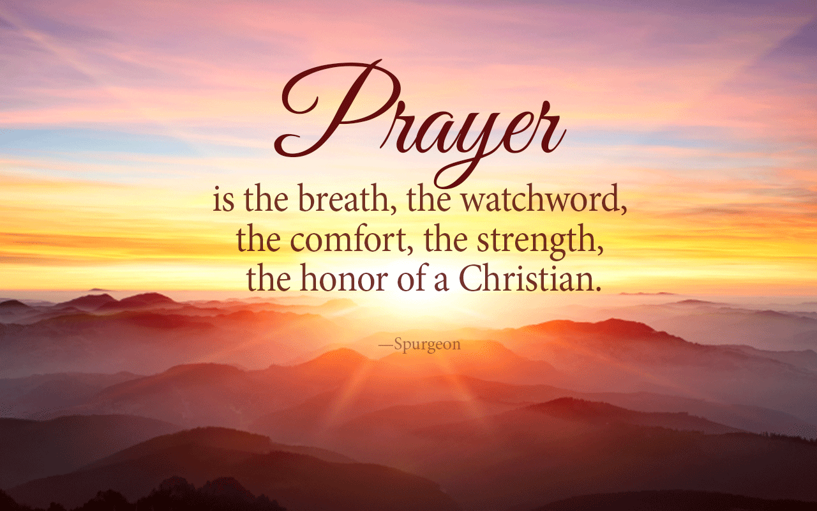Barb Abbott (see Pastor Janet); Kim Bartram (see Kevin Winton); Mr. Bauer (see Kevin Winton); the Ann Beretta family (see Kevin Winton); Jenny Brown (see Sally Parks); Lisa Caffrey; Lori and Hannah Chapman; church finances; Greg Clark; Patty Dammann; El Paso and Dayton mass shootings; Event Team; fires in the Amazon; Christine, Jim, & Tim Foust (see Becky Winton); Mrs. Gearhart (see Kevin Winton); Helen Guthrie (see Liz Ballard); Bill Hacker (see Kevin Winton); the Higgins family (see Kevin Winton); homeless veterans; Don and Pat Hoover; Bryce, John, & Roger Huddleston; Adrianne & Bob Hunter; immigrant families; the Ryan Jones family (see Sherry Hiner); Albert & Candy Kennedy (see Barb Fengya); Jennifer LaMar (see Kevin Winton); Law family (see Julianne Thomas); Jenny Louzon (see Kevin Winton); Messy Church; the Betty Morgan family; Phil Nagle; NBBC Leaders; Laverne Padrick (see Sue Winton); Ernestine Proctor (see Sue Stockwell); Barbara & Charlie Purtlebaugh; Bill Roth Sr. (see Kevin Winton: Theresa Royalty; Michael Schoppenhorst (see Jean McGee); Sue Skelton; Johnathan Sotomayor (see Kevin Winton); Texas shootings; SPMT; Gary Starr (see Janet Fiddler); refugee children & families; victims of abuse, oppression, & violence; Kevin Winton.

Our shut-ins and care facility residents: Betty Burton; Ethel Humphrey; Lee Joyce; Dick Morgan; Helen Walker; Billie Whittle; Delcia Windsor.

Our military and missionaries:Capt. Matt Knox and Capt. Robert Shoemaker; the Borquists, Clemmers, Coats, and Clarissa Hunter.

**DAMAR**

In October, Damar will be opening an Independent Learning Center on campus. There will be a library, movie room, and game room. To give clients the best possible experience, Damar is holding a book, movie, game drive. We are accepting gently used children's, teen, and young adult books; "G," "PG," DVD, and Blu-Ray movies; complete children's board games and puzzles, and "E" for Everyone rated games from XBOX 360, XBOX ONE, Nintendo Wii, and Nintendo Switch. Please bring donations on Sunday, October 6th.

Kyle Winton, Deacon

**\*\*\*\*\*\*\*\*\*\*\*\*\*\*\*\*\*\*\***

**Happening This Week**

September 30 5:30 p.m., SPMT meets

October 2 10-11:30 a.m., Bible Study (bulletin scripture list)

5 8:15 a.m., Men’s Fellowship Breakfast, Wheatley’s

**\*\*\*\*\*\*\*\*\*\*\*\*\*\*\*\*\*\*\***

**Looking Ahead**

October World Mission Offering month

6 Hospitality Time – Trustees

11:30-12:30 p.m., Flu Shots in Fellowship Hall

2 p.m., CROP Walk (see article in bulletin)

8 5:30 p.m., Trustees meet

6-7 p.m., CE, Deacons, and Mission boards meet

7 p.m., Church Council meets

10 10 a.m.-2:30 p.m., Sr. Adult Day (see article)

13 Deacon Sunday

20 Deacons “Sing Sunday”

23 5:30 p.m., SPMT meets

24 6 p.m., Church Council meets, final budget review

26 6:30-8 p.m., Trunk ‘n Treat

November 3 Q&A proposed 2020 budget discussion in sanctuary

following worship

10 Q&A proposed 2020 budget discussion in sanctuary

following worship

13 CHAT dinner

17 Quarterly Business Meeting, voting on budget, slate

**Update from Clarissa Hunter**

There is an update from Clarissa Hunter on the bulletin board in the CE Hallway. Please take a moment to read Clarissa’s latest news.

********************

**Directory Updates**

Kevin and Laura Winton have moved to 7606 Giroud Drive, Indianapolis, 46259; Dick Morgan’s new phone number is 317-452-9034; Bobbie and Don Cicenas correct zip code is 46163.

********************

**From the Mailbox**

Hello New Bethel Baptist Church:

Thank you for supporting the growth of Christian student leaders at Purdue University. It is exciting work.

Yours sincerely,

Amy Pajet, Purdue University, The Found

********************

**Senior Adult Day:**

***Preserving Our Past, Protecting Our Future***

Senior Adult Day is October 10th from 9-2:30 p.m. Richmond First Baptist Church will host this year’s event.

The theme is *Preserving Our Past, Protecting Our Future,* and the morning topic is “Genealogy” by Leah Huddleston. The afternoon speaker is Jerry Toschlog (“The Bald BeeMan”).

Lunch is provided. The fee is $10 per person if received by October 1st or $12 at the door. Reservations are required and limited to 200.

If you plan to attend, please sign the sheet on the bulletin board by the nursery, and the church office will submit the registrations and fees. To pay for your participation, please make your check payable to NBBC.

**From ABC-GI: An Opportunity to Minister**

The Senior Adult Committee needs two churches to host the 2020 April and October Senior Adult gatherings. These gatherings are opportunities for fellowship, hearing about the wider church family, having inspiring programs, singing, praising, and eating! The Senior Adult committee works with host churches. If interested, please contact Terry Harke at 765-702-3631 or 765-284-2852. *(Any NBBC Senior Adults want to lead our hosting of this event?)*

**\*\*\*\*\*\*\*\*\*\*\*\*\*\*\*\*\*\*\*\***

**CHAT Report**

CHAT was a great success! Thank you to our volunteers and planners for this inaugural community event. Attendance was fifty-seven, and fifteen were outside the NBBC family. We also thank speakers Constable Jeff Duhamell and Franklin Township Trustee Don Brunson for talking about the needs in our community and the services available. Free will donations were $561, which more than paid for the dinner expenses. Our next CHAT is Wednesday, November 13th. The menu is beans and cornbread. Plan to come and see old friends and meet new ones!

Janie Bryant and Jan Nagle, Event Team Co-chairs

**\*\*\*\*\*\*\*\*\*\*\*\*\*\*\*\*\*\*\*\***

**Annual CROP Hunger Walk**

NBBC is a heroic part of the national CROP Hunger Walk’s history. Because of our involvement, more families have food on their tables right now. Fewer children are going hungry. The world has hope. This year, the CROP Walk turns fifty, and NBBC will be playing an important role to get the word out early about the walk to increase our walkers and donations. We are all touched by hunger: our communities, our neighbors, even our own families may struggle with it at some point. But when you fight back, there is hope. We have a single goal: a world where no one goes hungry. Please put Sunday, October 6th on your calendar if you can join us in the walk and how much you can dedicate to this cause.

Kevin Stone, NBBC CROP Walk Coordinator

To all the prayer warriors at New Bethel Bapst Church: I want to thank you for helping me get through

this ordeal with my broken shoulder. I especially appreciate the prayers on the day of surgery. I was very

much in need that day. When the surgeon said the break was so bad that there was need of a plate and

screws, my bubble burst and I was really down that week. So, thank all of you for your prayers and many

thanks to Pastor Janet for her prayer the day of surgery. Don’t ever think your prayers aren’t needed;

because they are and they de(nitely help. Thank you also to my paent husband, who has been a rock

through all of this.

May God Bless you all, Sue