**Welcome to New Bethel Baptist Church**

**Sunday, October 6, 2019**

**Prelude** Contemporary Taped Selections

**\*Gathering Hymns**

*He’s Got the Whole World in His Hands* vs. 1 #586

*All Who Are Thirsty* See Power Point

**\*Call to Worship Andrew Clark**  
Leader: God is our Rock and our Salvation.   
**People: God is our Maker and Redeemer.**  
Leader: God is our Provider and Helper.  
**People: God is our Shepherd and Savior.**

**Unison: Let us worship God in prayer and praise.**

**\*Invocation and Lord’s Prayer** *(*using *sins)* **Andrew Clark**

**Scripture Reading** Exodus 17:1-7 **Andrew Clark**

**Worship Prayer** Pastor Janet

**\*Hymn** *As the Deer* #548

**Scripture Reflection** John 4:3-42 Pastor Janet

**\*Hymn** *Come, Thou Fount of Every Blessing* #11

**Ministry Opportunities Andrew Clark**  
Birthday and Anniversary Blessings

Giving of Tithes and Offerings Ushers

*Doxology #815

*Prayer**Andrew Clark**

**Communion Hymn** *Come, Share the Lord* #462

**Communion** Pastor Janet and the Deacons

**\*Closing Hymn** *Blest Be the Tie That Binds* #426

**Postlude** Dr. Christina Romero-Ivanova

***\*Please stand if you are able.***  *CCLI # 1631733*

**October Is World Mission Offering Month**

****October is the time for giving to the World Mission offering. When we give to this mission, we are able to impact thousands of lives. We acknowledge God as our creator and sharing God’s message of hope, love, and healing to a world that is hurting. Please give generously.

Thank you,

Pat Darland, Mission Board Co-Chair

**\*\*\*\*\*\*\*\*\*\*\*\*\*\*\*\*\*\*\*\***

**Hearing Assistance Headsets**

Hearing assistance headsets are available for your use during worship. Please see a Deacon or a sound operator to use one.

**\*\*\*\*\*\*\*\*\*\*\*\*\*\*\*\*\*\*\*\***

**Daily Scripture Readings for This Week**

Monday, October 7: Psalm 137 & Lamentations 1:16-22 *OR*

Psalm 3 & Habakkuk 1:5-17; James 1:2-11

Tuesday, October 8: Psalm 137 & Lamentations 2:13-22 *OR*

Psalm 3 & Habakkuk 2:5-11; John 5:1-5, 13-21

Wednesday, October 9: Psalm 137 & Lamentations 5:1-22 *OR*

Psalm 3 & Habakkuk 2:12-20; Mark 11:12-14, 20-24

Thursday, October 10: Psalm 66:1-12 & Jeremiah 25:1-14

*OR* Psalm 111 & Leviticus 14:33-53; 2 Timothy 1:13-18

Friday, October 11: Psalm 66:1-12 & Jeremiah 27:1-22 *OR* Psalm

111 & Numbers 4:34-5:4, 2; 2 Timothy 2:1-7

Saturday, October 12: Psalm 66:1-12 & Jeremiah 28:1-17 *OR*

Psalm 111 & Numbers 12:1-15; Luke 5:12-16

Sunday, October 13: Jeremiah 29:1, 4-7 *OR* Psalm 66:1-12 &

2 Kings 5:1-3, 7-15c *OR* Psalm 111 and 2 Timothy 2:8-15;

Luke 17:11-19

**Welcome to New Bethel Baptist Church**

**We are blessed by your presence!**

**Sunday, October 6, 2019**

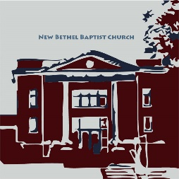**Guests and Members:** Please sign the attendance register in your pew. Remember to include your address, e-mail, and telephone number. Please leave the signed sheet in the register. If you have questions or would like more information about New Bethel, please feel free to contact the church office. Thank you!

*An American Baptist*

*Congregation*

**\*\*\*\*\*\***

**All Are Welcome**

**Weekly Activities**

9:15 a.m., Sunday School Wednesday Bible Study; 10 a.m.

10:30 a.m., Sunday Worship 2nd/3rd Wednesday Euchre, 1-3 p.m.

**\*\*\*\*\*\***

**Contact Information**

New Bethel Baptist Church Website: www.newbethelbapt.org

8936 Southeastern Avenue E-mail: newbethelbapt@att.net

Indianapolis, IN 46239 Wi-fi password: NBBC8624381

317-862-4381 Instagram: NBBC.Wanamaker

New Bethel Baptist.Wanamaker

https://facebook.com YouTube: New Bethel Baptist

Church Wanamaker

Rev. Janet F. Hoover, Pastor

Jan Nagle, Secretary

Church Office Hours: Tuesday-Friday, 9:30-noon & 1-3 p.m.



*Beloved community is formed*

*not by the eradication of difference*

*but by its affirmation,*

*by each of us*

*claiming the identities and*

*cultural legacies that shape*

*who we are and*

*how we live in the world.*

—Bell Hooks

**From the Mailbox**

Dear Church Family,

Thank you for the prayer blanket. It will be a nice and welcomed reminder of God's loving, comforting, and healing presence. Each time I wrap myself in the blanket I will be reminded of my church family’s love and prayers for me.

Blessings, Lori Chapman

**\*\*\***

Thank you to John, Ryan, and Zach Huddleston for adding new mulch and flowers to the flowerbed and for power washing the facility.

Liz Ballard, Chair of the Flower Committee

**\*\*\*\*\*\*\*\*\*\*\*\*\*\*\*\*\*\*\***

**Prayer Concerns and Joys**

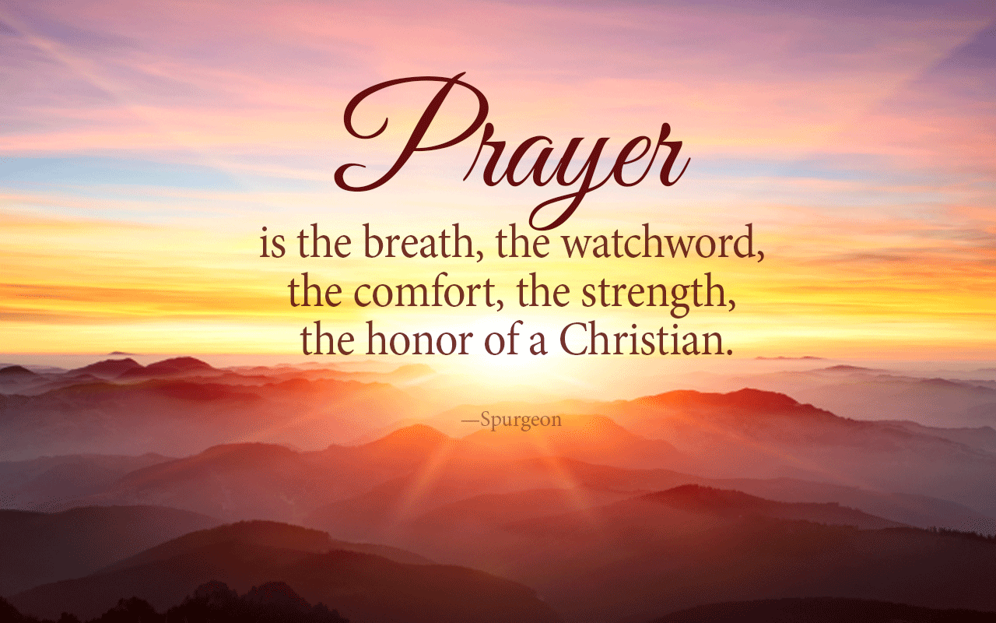Barb Abbott (see Pastor Janet); Kim Bartram (see Kevin Winton); Mr. Bauer (see Kevin Winton); the Ann Beretta family (see Kevin Winton); Lori and Hannah Chapman; Greg Clark; Linda Collier (see Lisa Caffrey); Patty Dammann; Mrs. Gearhart (see Kevin Winton); Dick Griffith (see Sue Winton); homeless veterans; Bryce, John, & Roger Huddleston; Adrianne & Bob Hunter; immigrant families; NBBC Event Team, finances, leaders, Messy Church, SPMT; Isaac James Oldham family; Laverne Padrick (see Sue Winton); Barbara & Charlie Purtlebaugh; Bill Roth Sr. (see Kevin Winton); Sue Skelton; Johnathan Sotomayor (see Kevin Winton); refugee children & families; victims of abuse, oppression, & violence.

Our shut-ins and care facility residents: Betty Burton; Ethel Humphrey; Lee Joyce; Dick Morgan; Theresa Royalty; Helen Walker; Billie Whittle; Delcia Windsor.

Our military and missionaries:Capt. Matt Knox and Capt. Robert Shoemaker; the Borquists, Clemmers, Coats, and Clarissa Hunter.

**Senior Adult Day**

***Preserving Our Past, Protecting Our Future***

Senior Adult Day is October 10th from 9-2:30 p.m. Richmond First Baptist Church will host this year’s event.

The theme is *Preserving Our Past, Protecting Our Future,* and the morning topic is “Genealogy” by Leah Huddleston. The afternoon speaker is Jerry Toschlog (“The Bald BeeMan”). Lunch is provided. The fee is $12 per person at the door. Reservations are limited to 200.

**\*\*\*\*\*\*\*\*\*\*\*\*\*\*\*\*\*\*\***

**Franklin Township Inclusion Club**

There was an article in last week’s *Informer* about a new ministry that Oriel Estrada-McBride began in Franklin Township. NBBC recently hosted one of the events for the club. Please see the article on the bulletin board in the CE Hallway.

********************

**Correction to the “Looking Ahead” Calendar**

Worship content for October 13th and 20th are now correct on the bulletin calendar. Please take note of the changes.

**\*\*\*\*\*\*\*\*\*\*\*\*\*\*\*\*\*\*\***

|  |  |  |
| --- | --- | --- |
| 2019 Finances and Attendance | Month of September | Year-to-Date |
| Tithes/Offerings | $20,220.50 | $107,062.55 |
| Expenses Paid | $10,094.68 | $110,924.70 |
| Gain/(Loss) | $10,125.82 | ($3,862.15) |
| Budget Needs | $12,779.16 | $115,012.44 |
| Average Weekly Worship Attendance | 50 | 51 |

*A man is rich in the proportion*

*to the number of things*

*which he can afford to let alone.*

— Henry David Thoreau

**\*\*\*\*\*\*\*\*\*\*\*\*\*\*\*\*\*\*\***

**Happening This Week**

October World Mission Offering Month

Today Hospitality Time in Fellowship Hall following

11:30-12:30 p.m., Flu Shots in Fellowship Hall

2 p.m., CROP Walk

7 6 p.m., CHAT meeting

8 5:30 p.m., Trustees meet

6-7 p.m., CE, Deacons, and Mission boards meet

7 p.m., Church Council meets

9 No Bible Study for the next two weeks

10 10 a.m.-2:30 p.m., Sr. Adult Day (see article)

12 8:15 a.m., Men’s Fellowship Breakfast, Wheatley’s

**\*\*\*\*\*\*\*\*\*\*\*\*\*\*\*\*\*\*\***

**Looking Ahead**

Oct 13 **Deacons “Sing Sunday”**

16 No Bible Study

20 **Deacons Sunday**

23 5:30 p.m., SPMT meets

24 6 p.m., Church Council meets, final budget review

26 6:30-8 p.m., Trunk ‘n Treat

Nov 3 Q&A proposed 2020 budget discussion in sanctuary

following worship

10 Q&A proposed 2020 budget discussion in sanctuary

following worship

13 5:30-7 p.m., CHAT dinner

17 Quarterly Business Meeting, voting on budget, slate

**Christian Theological Seminary Counseling Center**

According to Mental Health America, the organization that led the efforts to designate October 10th as National Depression Screening Day, clinical depression affects nineteen million Americans. One in four women and one in ten men will experience it.

Certain medical conditions may be associated with depression, complicating treatment. Do you know what they are, and could you recognize clinical depression in yourself or others?

Individuals who participate in depression screenings at the Christian Theological Seminary (CTS) Counseling Center will complete a brief questionnaire that will be reviewed by a member of the CTS Counseling Center team. The individual will then have the opportunity to meet with a CTS Counseling Center team member for a one-on-one assessment of their screening results. In addition, participants will receive educational brochures that will provide them with additional information on mental health and support resources.

Free depression screenings in October by appointment only

Weekdays: Monday-Thursday, 8 a.m. - 8 p.m.; Friday, 8 – noon

CTS Counseling Center

1050 West 42nd Street,

Indianapolis, Indiana 46208

**Pastor Appreciation Month**

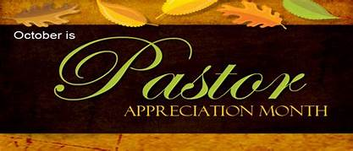October is Pastor Appreciation Month. How would you show your appreciation for Pastor Janet?

Give it a thought and maybe after she returns from her well deserved vacation, you could show her how much she is appreciated here at NBBC!

**\*\*\*\*\*\*\*\*\*\*\*\*\*\*\*\*\*\*\***

*The environment is God’s creation….*

*It seems to me that saving it*

*would be top priority for the church.*

*Would it be better if instead of*

*an environmental crisis*

*we call it a creation crisis?*

— Author Unknown

**\*\*\*\*\*\*\*\*\*\*\*\*\*\*\*\*\*\*\***

**From ABC-GI: An Opportunity to Minister**

The Senior Adult Committee is looking for two churches to host the 2020 April and October gatherings.

Senior Adult gatherings are great opportunities for fellowship, hearing what’s happening in the wider church family, inspiring programs, and of course, singing, praising, and eating!

The Senior Adult committee works with the host church in planning the day. If interested, please contact Terry Harke, a member of the Senior Adult committee, at 765-702-3631 or 765-284-2852.

(*Perhaps some Senior Adults at NBBC would be willing to lead our hosting of this event?)*

*For just as each of us has one body*

*with many members,*

*and these members do not all*

*have the same function,*

*so in Christ we, though many,*

*form one body,*

*and each member*

*belongs to all the others.*

— Romans 12:4-5 (NIV)

*******************

**Strategic Planning Ministry Team Note**

*Understand this,*

*my dear brothers and sisters:*

*You must all be quick to listen,*

*slow to speak,*

*and slow to get angry.*

— James 1:19 NLT

Thank you for coming to the 5th Sunday Discussion in Fellowship Hall! We appreciated and enjoyed the discussion with you! It seemed to us as though you would like to discuss the survey results a little further, so we are looking into more discussions around that. Stay tuned for more information.

Also, as we stated, we are now in the listening phase. We will be listening to the 20- to 30-year-olds. Please be in prayer for the SPMT!

If you would like to participate in this with us, or if know someone you would like us to listen to, please contact one of the SPMT Members.

Blessings,

John M Huddleston

Strategic Planning Ministry Team Coordinator

To all the prayer warriors at New Bethel Bapst Church: I want to thank you for helping me get through

this ordeal with my broken shoulder. I especially appreciate the prayers on the day of surgery. I was very

much in need that day. When the surgeon said the break was so bad that there was need of a plate and

screws, my bubble burst and I was really down that week. So, thank all of you for your prayers and many

thanks to Pastor Janet for her prayer the day of surgery. Don’t ever think your prayers aren’t needed;

because they are and they de(nitely help. Thank you also to my paent husband, who has been a rock

through all of this.

May God Bless you all, Sue