**Welcome to New Bethel Baptist Church**

**Sunday, March 15, 2020**

**Prelude** Dr. Christina-Romero Ivanova

\***Gathering Hymns** *We Bow Down* #154

*Jesus, Name Above All Names* (sing one time) #86

*Fairest Lord Jesus* (vs 1, 2, & 3 only) #87

\***Call to Worship** Andrew Clark

Leader: Let’s sing to God,

**People: for God is here.**

Leader: Let’s sing of love,

**People: for love is here.**

Leader: Let’s sing and rejoice,

**Unison: for here our souls are restored.**

\***Invocation and Lord’s Prayer** (*using “sins”; pew prayer card)*

**Scripture Reading** Luke 4:14-21 Andrew Clark

**Lenten Meditation** Ryan Huddleston

**Worship Prayer** Rev. Joan C. Friesen

**\*Hymn** *The Solid Rock*  #526

**Mission Moment** Kevin Stone

**Children’s Story/Children’s Church**

**Scripture Reflection**  1 Corinthians 13:1-7 Rev. Joan C. Friesen

\***Hymn**  *All Who Are Thirsty* See Power Point

*(If you would like to join this church, rededicate your life to*

*Christ, claim faith and be baptized, or have prayer, please go*

*forward and meet the pastor during the singing of this hymn.)*

**Ministry Opportunities** Andrew Clark

Giving of Tithes and Offerings

*Doxology #815

*Prayer Andrew Clark

**\*Benediction** Rev. Joan C. Friesen

**\*Postlude** Dr. Christina-Romero Ivanova

***\*Please stand if you are able*** *CCLI 1631733*

**Welcome, Rev. Joan C. Friesen**

We welcome Rev. Joan C. Friesen today. Rev. Friesen is filling in for Pastor Janet while she is on vacation. We are glad to see you, Rev. Friesen!

**\*\*\*\*\*\*\*\*\*\*\*\*\*\*\***

**Thank You and Blessings!**

* Thank you to those volunteers who cover the sound board and power point.
* Thank you to those who continue faithfully give tithes and offerings to the church to support the ministries of New Bethel.

**\*\*\*\*\*\*\*\*\*\*\*\*\*\*\***

**America for Christ Offering**

March is the month for our America for Christ Offering. This mission is what it says: America for Christ. They help those in America and Puerto Rico when disaster happens, help our neighbors in time of need, and spread the gospel to show Christian love for all, showing how to love your neighbor as yourself.

Pat Darland, Mission Chair

**\*\*\*\*\*\*\*\*\*\*\*\*\*\*\***

**Lenten Worship Focus Is on the Cross**

*Again this year, we have covered the picture of the resurrected Jesus that we may focus on the cross during the Lenten season to better appreciate what Jesus sacrificed to make us right with God.*

**\*\*\*\*\*\*\*\*\*\*\*\*\*\*\***

**New Phone Directory List**

Today is the deadline for making changes in the new 2020 church phone directory that is located in Fellowship Hall. Please review, make any needed changes, or write a check by your name if your information is correct. Please return any of the original copies.

Jan Nagle, Church Secretary

**Welcome to New Bethel Baptist Church**

**We are blessed by your presence!**

**Sunday, March 15, 2020**

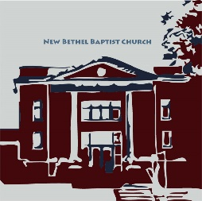**Guests and Members:** Please sign the attendance register in your pew. Remember to include your address, e-mail, and telephone number. Please leave the signed sheet in the register. If you have questions or would like more information about New Bethel, please feel free to

contact the church office. Thank you!

*An American Baptist*

*Congregation*

**\*\*\*\*\*\***

**All Are Welcome**

**Weekly Activities**

9:15 a.m., Sunday School Wednesday Bible Study, 10 a.m.

10:30 a.m., Sunday Worship 2nd/3rd Wednesday Euchre, 1-3 p.m.

**\*\*\*\*\*\***

**Contact Information**

New Bethel Baptist Church Website: www.newbethelbapt.org

8936 Southeastern Avenue E-mail: newbethelbapt@att.net

Indianapolis, IN 46239 Wi-fi password: NBBC8624381

317-862-4381 Instagram: NBBC.Wanamaker

YouTube: New Bethel Baptist

Church Wanamaker

https://facebook.com New Bethel Baptist.Wanamaker

Rev. Dr. Janet F. Hoover, Pastor

Jan Nagle, Secretary

Church Office Hours: Tuesday-Friday, 9:30-noon & 1-3 p.m.

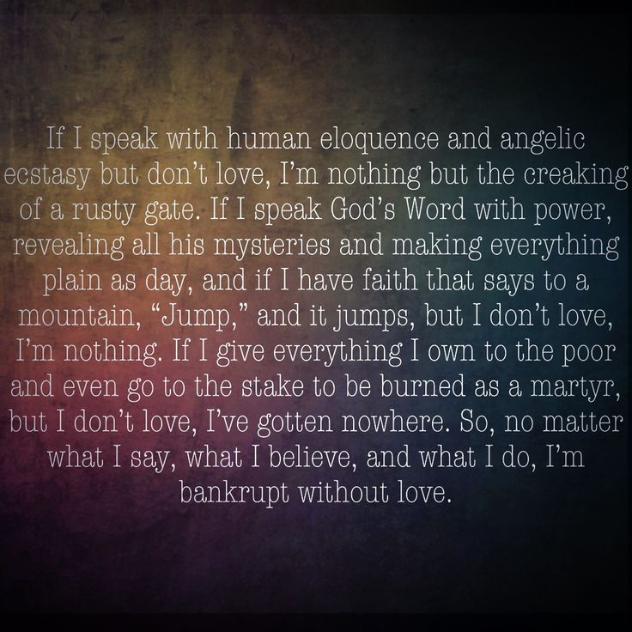

*Finally, all of you,*

*be like-minded,*

*be sympathetic,*

*love one another,*

*be compassionate*

*and humble.*

— 1 Peter 3:8 (NIV)

**Lenten Devotionals**

It’s March, and likely winter is still to come. But with Easter on April 12th, can warmer weather be far behind? The Deacons are providing a Lenten devotional for your use. There is a scripture leading into the meditation, followed by two to three verses suggested for you to read to dig deeper. There are a few booklets available on the table in Fellowship Hall near the elevator, and on the stand just inside the west door into the sanctuary.

Sue Winton, Deacon Board Chair

**\*\*\*\*\*\*\*\*\*\*\*\*\*\*\*\*\*\*\***

**Secret Place**

Copies of the Spring Secret Place devotionals are in the CE hall book rack. If you’d like to help defray the cost, please leave your money in the basket.

**\*\*\*\*\*\*\*\*\*\*\*\*\*\*\*\*\*\*\***

**Prayer Concerns and Joys**

Charlie Bass (see Barbara Fengya or Kevin Winton); Briner family (see Kevin Winton); Greg Clark (see Vicky Clark); Hailey Clark; Joann Hart (see Kevin Winton); homeless veterans; Bryce, John, and Roger Huddleston; Adrianne & Bob Hunter; immigrants and refugees; Kaylynn and Anita Land (see Sally Parks); Lebanon family (see Kevin Winton); Mattingly family (see Kevin Winton); Nashville United Methodist Church (see Kyle Winton); NBBC; Michelle Rethmeyer family (see Steve Rethmeyer); Carol Royalty (see Theresa Royalty); Alan Seal (see John Huddleston); Sue Skelton; Gay Stone; Tennessee tornado victims; Harry Toon; victims of abuse, oppression, & violence; U.S. government public servants; Ainslie Winton; Laura Winton.

Our shut-ins and care facility residents: Margaret Barker; Betty Burton; Ethel Humphrey; Lee Joyce; Dick Morgan; Theresa Royalty; Helen Walker; Billie Whittle; Delcia Windsor.

Our military and missionaries:Capt. Matt Knox and Capt. Robert Shoemaker; the Borquists, Clemmers, Coats, and Clarissa Hunter.

**From the Mailbox**

Think you have had a hard day; read the last page of the latest journal from the Clemmers, posted downstairs by the nursery. Teaching disciples to make disciples across many barriers is keeping the Borquists really busy in New Zealand. In addition, Bruce is preparing to defend his thousand-page doctoral dissertation. Ann is serving as interim pastor for three months in their local church in New Zealand.

Jim and Wilma Waters

**\*\*\*\*\*\*\*\*\*\*\*\*\*\*\*\*\*\*\***

**Assistance Headsets**

Hearing assistance headsets are available for your use during worship. Please see a Deacon or a sound operator to use one.

**\*\*\*\*\*\*\*\*\*\*\*\*\*\*\*\*\*\*\***

**Happening This Week**

March America for Christ Offering Month

18 10 a.m., Bible Study, weekly scriptures in bulletin

1-3 p.m., Euchre in Fellowship Hall

19 2-4 p.m., Clothing Pantry Open

Senior Movie (see article in bulletin)

**\*\*\*\*\*\*\*\*\*\*\*\*\*\*\*\*\*\*\***

**Looking Ahead**

28 10-2 p.m., Crafts and Christ in Fellowship Hall

April 2 9 a.m.-2:30 p.m., Senior Adult Day (see article in

bulletin)

5 Deacons meet, following worship

10 8 p.m., Good Friday Worship at Acton United

Methodist Church

May 2 Third Annual Women’s Retreat

3 ABC-GI Annual Gathering

**Daily Scripture Readings for This Week**

Monday, March 16: Psalm 81; Genesis 24:1-27; 2 John 1:1-13

Tuesday, March 17: Psalm 81; Genesis 29:1-14;

1 Corinthians 10:1-4

Wednesday, March 18: Psalm 81; Jeremiah 2:4-13;

John 7:14-31, 37-39

Thursday, March 19: Psalm 23; 1 Samuel 15:10-21;

Ephesians 4:25-32

Friday, March 20: Psalm 23; 1 Samuel 15:22-31; Ephesians 2:1-9

Saturday, March 21: Psalm 23; 1 Samuel 15:32-34; John 1:1-9

Sunday, March 22, Fourth Sunday of Lent: 1 Samuel 16:1-13;

Psalm 23; Ephesians 5:8-14; John 9:1-41

**\*\*\*\*\*\*\*\*\*\*\*\*\*\*\*\*\*\*\***

**Save the Date!**

The Third Annual Women’s Retreat will be Saturday May 2nd, 8 a.m. and ending by noon on Sunday, May 3rd at the Benedict Inn in Beech Grove. All ladies are invited and welcome to attend. More details will follow as they develop but plan now to attend, and put these dates on your calendar!

Sue Winton, Chair of Deacons

**\*\*\***

There will be a Community Leaders Meeting, on Thursday, April 16th from 5:45-7:30 p.m. in the Franklin Township Civic League. This will include a potluck dinner. Any questions please call or text me at 703-919-1428.

Oriel Estrada-McBride, MSW

**\*\*\*\*\*\*\*\*\*\*\*\*\*\*\*\*\*\*\***

**It’s Candy Time!**

The Easter Egg Hunt will be on April 11th, and it’s time to pick up and fill your bag(s) of empty eggs in the CE hallway by the Homebuilders classroom. The bags are numbered with how many eggs in a bag. Deadline is April 5th for filled eggs. This year we are adding a new game to the egg hunt and we need big and little jellybeans and lots of them!

Thank you, CE Board

**Free Senior Movie Series**

Franciscan Health Senior Promise, the Historic Artcraft Theatre, and the Swartz Family Community Mortuary/Memorial Center offer a Senior Movie Series of films released from 1939 and 1962. People fifty-five years and older may pick up free tickets early at the Swartz Family Community Mortuary/Memorial Center. They will receive a free popcorn and drink. The movie *Mr. Smith Goes to Washington* (1939) will be shown Thursday, March 19th at 1:30 p.m. The Historic Artcraft Theatre is at 57 North Main Street, Franklin, Indiana.

**\*\*\*\*\*\*\*\*\*\*\*\*\*\*\*\*\*\*\***

**Crafts and Christ!**

Calling all crafters and those wanting to learn a new craft! On Saturday March 28th we will have our first “Crafts and Christ” from 10-2 p.m., in Fellowship Hall. This is a time to fellowship together as we craft. For our first event, we will be making sleeping mats from plastic bags for the homeless. This is a craft that anyone and everyone can participate in. If you would like to come but aren't sure about participating in the service project, feel free to bring whatever craft project you are currently working on! Soup will be provided, and we invite those attending to bring a snack.

God Bless, Julianne Thomas and Becky Winton

**\*\*\*\*\*\*\*\*\*\*\*\*\*\*\*\*\*\*\***

**Senior Adult Day Invitation**

On Thursday, April 2nd from 9-2:30 p.m., Warren First Baptist Church will host Senior Adult Day at 727 North Wayne Street, Warren, Indiana. Lunch is provided. Senior Safety Protection will be presented by the Huntington Sheriff’s Department.

Entertainment will be Vaudeville with Scott Nedberg and Larry Bower from the radio station WBCL. Reservations are required. The fee is $10 per personand $12 at the door. If you wish to attend, please let the church office know by March 27th, and I will make your reservation. Make your check payable to New Bethel Baptist Church.

Jan Nagle, Church Secretary

*Please read carefully about how to livestream worship.*

Livestream Info

As you may remember, we have been livestreaming our worship services for just over a year now. So what does that mean? Livestreaming is basically a broadcasting of our worship directly onto YouTube. There is a slight delay of about 30 seconds as the video is processed and transmitted to YouTube, and similar to what a live sporting event has. So if you are sick, out of town or otherwise unable to make it on Sunday morning, you can pull out your phone, laptop or other device to access YouTube and join us in worship no matter where you are.

“How do I do that?” It is easy — just follow the directions below.

We typically post the link for the livestream on Facebook either Friday or Saturday, so if you follow us on Facebook you can find the post and click on the link and it will take you right to the video. The other option is to log into YouTube and search for our channel “New Bethel Baptist Church Wanamaker” and shortly before worship begins the video will be available. Until the service starts you will see something like this

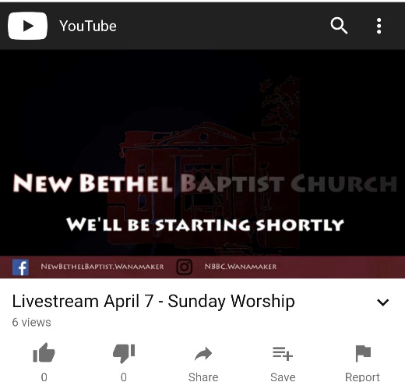

The easiest way to find our newest videos, including livestreams, on YouTube is to Subscribe. You will need a YouTube or Google account to subscribe, so if you have a g-mail account, you’re all set! If not, it’s free to set one up.

Then if you are already on the channel, click on Subscribe. If you are watching one of our videos of our Scripture Reflections, you will see a screen like the one here.

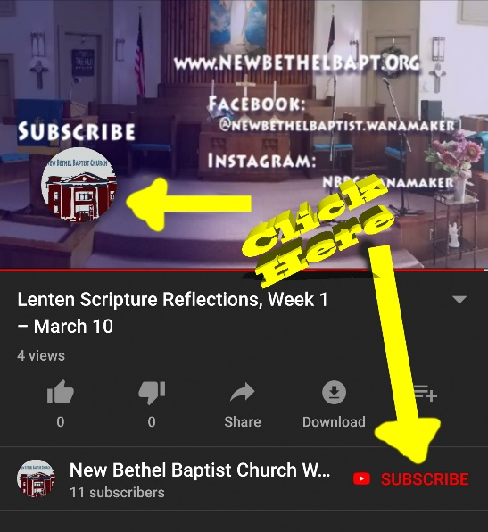

You can click on the church’s logo to subscribe at the end of the video or click on the red “Subscribe” next to our channel name at any point during the video. The screenshots are from the YouTube app on my phone, but the appearance is very similar on a computer.

This is still a new ministry and we are still working on how much info we display on the screen during the service. We are also not showing the hymns since a specific CCLI license is needed to stream music.

Hopefully you are able to join us in person, but if not you now have the option to join us in spirit and follow along. YouTube also automatically posts a replay to our channel as well, so if you would like to watch the full service later in the week, you can do that as well.

If you have any questions, please let me know and I will do my best to answer them.

Rob Thomas

all the prayer warriors at New Bethel Baptist Church: I want to thank you for helping me get through

this ordeal with my broken shoulder. I especially appreciate the prayers on the day of surgery. I was very

much in need that day. When the surgeon said the break was so bad that there was need of a plate and

screws, my bubble burst and I was really down that week. So, thank all of you for your prayers and many

thanks to Pastor Janet for her prayer the day of surgery. Don’t ever think your prayers aren’t needed;

because they are and they de(nitely help. Thank you also to my paent husband, who has been a rock

through all of this.

May God Bless you all, Sue