**Welcome to New Bethel Baptist Church**

**Easter Sunday, April 12, 2020**

**Prelude** Dr. Christina Romero-Ivanova

**\*Call to Worship** John 20:1-18 Pastor Janet

Leader: The night is far gone. There is dew on the grass.

**Church: We walk with Mary to the tomb.**

Leader: Lost in our grief, we feel abandoned . . . alone . . .

unaware that angels minister to us. We weep with Mary, for all seems lost.

**Church: The stone is rolled back. Only his grave clothes**

**remain.**

Leader: Overcome by our loss, we feel abandoned . . . alone

. . . unaware that angels minister to us. . . . A flicker

of hope ignites in the soul . . . wavering in the wind . . . challenging the triumph of darkness.

**Church: Yet, surely there is no cheating death?**

Leader: Gently, lovingly, angels question our tears . . . for

God is stronger than death. . . . Out of the shadows of the tomb, the light of Christ shines forth in glory, overcoming the darkness of sin and death.

**Church: In the depths of our souls, the light of Christ**

**brings *us* back to the land of the living.**

Leader: As the light of Christ dawns, we find that we are

not alone.

**Unison: The light shines in the darkness and the**

**darkness did not overcome it.**

**Easter Meditation and Prayer** Julianne

Leader: The light which the world tried to extinguish cannot be put out. Today we light the candles again, proclaiming the transforming power of God. As the light returns, we give thanks that God’s transforming love has been, is now, and will ever be at work within us. Today we celebrate new life, new joy, new possibilities. Christ is alive and living among us! Let us pray . . .

Gracious God, as we light the candles, we acknowledge that there is still pain and suffering in the world, but we place our trust in God and in the way shown by Jesus Christ. We see that in the midst of darkness, there is light; in the pain of death, there is life; in the face of what appear to us to be overwhelming odds, you are at work in us and in the world, working for justice and peace, compassion and love, and life abundant. We thank you that Christ is risen; that Christ is risen in us, that wherever we gather in his name, our Lord is with us.

**Church: Alleluia, Christ is risen; Christ is risen indeed!**

**\*Hymns** *Christ Arose*#357

*Christ the Lord Is Risen Today*  #367

**Worship Prayer** Pastor Janet

**Children’s Story** Julianne Thomas

**Scripture Reflection**  Matthew 28:1-10 Pastor Janet

**\*Hymn** *He Lives* #368

**Ministry Opportunities** Julianne Thomas

How to Give Tithes and Offerings

*Doxology #815

*Prayer Julianne Thomas

**\*Responsive Benediction** Pastor Janet

Leader: The One who was dead lives again.

**Church: Loose in the world is the life-giving renewing**

**power of love.**

Leader: God’s power of new life works within us.

**Church: We, too, can rise from the dark tomb of**

**sorrow, the icy hold of fear, the sure death of not**

**caring.**

Leader: We, too, can rise to life!

**Church: May praise rise within us: Alleluia! Alleluia!**

**Alleluia! Christ the Lord is Risen!**

Leader: Be at peace, love, and serve the Lord!

**\*Postlude** Dr. Christina Romero-Ivanova

**\*\*\*\*\*\*\*\*\*\*\*\*\*\*\***

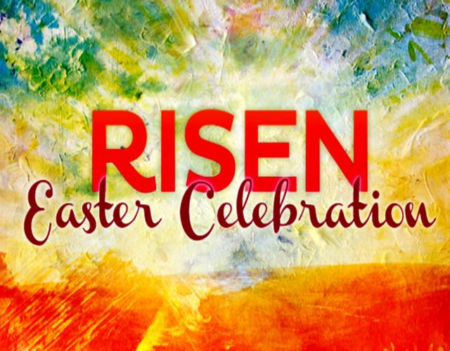**Welcome to New Bethel Baptist Church**

**We are blessed by your presence!**

**Easter Sunday, April 12, 2020**

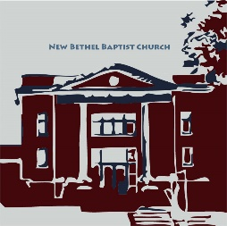

**Guests and Members:**  If you have questions or would like more information about New Bethel, please feel free to contact the church office. Thank you!

*An American Baptist*

*Congregation*

**\*\*\*\*\*\***

**All Are Welcome**

**Weekly Activities Online Only**

Wednesdays online Bible Study 10 a.m.

Wednesdays online Prayer meeting 7 p.m.

10:30 a.m., Sunday Worship, live-stream only

**\*\*\*\*\*\***

**Contact Information**

New Bethel Baptist Church Website: www.newbethelbapt.org

8936 Southeastern Avenue E-mail: newbethelbapt@att.net

Indianapolis, IN 46239 Wi-fi password: NBBC8624381

317-862-4381 Instagram: NBBC.Wanamaker

YouTube: New Bethel Baptist

Church Wanamaker

https://facebook.com New Bethel Baptist.Wanamaker

Rev. Dr. Janet F. Hoover, Pastor

Jan Nagle, Secretary

Church Office Hours: contact Pastor or NBBC Secretary

*Choose Inner Peace.  
Nothing is worth losing your inner peace.  
Take action as circumstances require,  
but never surrender your inner peace.*

*Stop. Breathe deeply.*

*Close your eyes and breathe deeply again.  
Then, and only then, take action -  
from a peaceful heart.*

*—* Jonathan Lockwood Huie

**Thank You and Blessings!**

*** Thank you to everyone who is participating in Zoom Bible Study and Prayer Meetings . . . keep coming back!

**\*\*\*\*\*\*\*\*\*\*\*\*\*\*\*\*\*\*\***

**Happening This Week**

All NBBC face-to-face meetings cancelled until

further notice

Apr 15 10 a.m., Online Bible Study using Zoom, weekly

scriptures in bulletin and on NBBC website

7 p.m., Online Prayer Meeting using Zoom

19 Live-stream worship only

**\*\*\*\*\*\*\*\*\*\*\*\*\*\*\*\*\*\*\***

**Daily Scripture Readings for This Week**

Monday, April 13: Psalm 118:1-2, 14-24; Exodus 14:10-31; 15:20-

21; Colossians 3:5-11

Tuesday, April 14: Psalm 118:1-2, 14-24; Exodus 15:1-18;

Colossians 3:12-17

Wednesday, April 15: Psalm 118:1-2, 14-24; Joshua 3:1-17;

Matthew 28:1-10

Thursday, April 16: Psalm 16; Song of Solomon 2:8-15;

Colossians 4:2-5

Friday, April 17: Psalm 16; Song of Solomon 5:9-6:3;

1 Corinthians 15:1-11

Saturday, April 18: Psalm 16; Song of Solomon 8:6-7;

John 20:11-20

Second Sunday of Easter April 19: Acts 2:14a, 22-32; Psalm 16;

1 Peter 1:3-9; John 20:19-31

**How to Live-Stream Worship**

Greetings,

As Pastor Janet's e-mail dated March 18th mentioned, we have made a few changes to the livestream, including our ability to stream our hymns through the livestream feed. Part of the terms of the livestream include that we are to post the stream to our website as the primary platform for viewing.

What this means for you is that this is actually much more simple to access, as there is only one link you will need to save. Each week you will just need to go to the church website

(www.newbethelbapt.org) and click on the “Sermons” tab at the top of the page. The most current week should be the first one you see. Click on the title (this week says "Fifth Sunday of Lent - March 29, 2020") and that will take you to the week's page.

Right now, you will see the video viewer shown there with our church sign. If you click on the play button prior to the start of our stream it will let you know when we plan to start and give you the option to set a reminder if you have a YouTube or Google account, if not just check back at 10:30 a.m. on Sunday morning and join our worship!

I will try to send out each week's individual link, but as long as you go to the church page and “Sermons” tab, you should be able to access the stream.

Once we have the links for online giving, we will post those somewhere easy to get to on the website as well so that the church's website can be your go-to for all of the weekly activities.

Please let us know if you have any questions!

Rob Thomas

all the prayer warriors at New Bethel Baptist Church: I want to thank you for helping me get through

this ordeal with my broken shoulder. I especially appreciate the prayers on the day of surgery. I was very

much in need that day. When the surgeon said the break was so bad that there was need of a plate and

screws, my bubble burst and I was really down that week. So, thank all of you for your prayers and many

thanks to Pastor Janet for her prayer the day of surgery. Don’t ever think your prayers aren’t needed;

because they are and they de(nitely help. Thank you also to my paent husband, who has been a rock

through all of this.

May God Bless you all, Sue