**Welcome to New Bethel Baptist Church**

**Second Sunday of Easter, April 19, 2020**

**Prelude** Dr. Christina Romero-Ivanova

\***Gathering Hymns**

*Alleluia* #359

*Victory Chant* #374

**\*Call to Worship**

Leader: All the doubt in the world cannot wash away our

inheritance from God . . . an inheritance of love, refuge, and strength.

**Church: Come into God’s presence with joy.**

Leader: In God, we have an inheritance that is

imperishable.

**Church: Come into God’s presence with hope.**

Leader: In Christ, we have an inheritance that cannot be

defiled.

**Church: Come into God’s presence with longing.**

Leader: In the Spirit, we have an inheritance that never

fades.

**Church: Come into God’s presence with love.**

**Unison: In God, we have an inheritance that brings new**

**life.**

**\*Invocation and Lord’s Prayer** (*using “sins”*) Julianne Thomas

**Scripture Reading** John 20:19-31 Julianne Thomas

**Worship Prayer** Pastor Janet

**\*Hymn** *His Eye Is on the Sparrow*#624

**Children’s Story** Julianne Thomas

**Scripture Reflection**  1 Peter 1:3-9 Pastor Janet

**\*Hymn** *At Calvary* #492

**Ministry Opportunities** Julianne Thomas

How to Give Tithes and Offerings

*Doxology #815

*Prayer Julianne Thomas

**\*Responsive Benediction** Pastor Janet

Leader: Through Christ, God has given us a new birth into a

living hope.

**Church: God has given us an inheritance that is**

**imperishable, undefiled, and unfading—an inheritance protected by the power of God.**

Leader: Rejoice, therefore, even if for a while we suffer

various trials.

**Church: For life is stronger than death, love is stronger**

**than hate, joy is stronger than sorrow, and**

**Unison: the promises of God are sure. Amen.**

**\*Postlude** Dr. Christina Romero-Ivanova

**\*\*\*\*\*\*\*\*\*\*\*\*\*\*\***

**March Giving and Disbursements**

Thank you all for your continued financial support during this unprecedented COVID-19 virus pandemic. As difficult as it is to be distanced from family, friends, and church family, we all must stay safe and well. Our temporary giving process is working well so please continue to give as you can. For the month of March, our giving and disbursements are as follows:

March Giving: $16,773.36 *

March Disbursements: $ 9,903.90

Net Sub-Total: $ 6,869.36

Less EYA Grant funds: $ 5,000.00

Actual Difference: $ 1,869.36

* Includes a $5,000 check from the Center for Congregations for our Engaging Young Adults initiative. These are designated funds for our EYA program.

If you have any questions, please contact me at 317-519-3347 or

e-mail me at njb46239@gmail.com

Janie Bryant, Treasurer

**Welcome to New Bethel Baptist Church**

**We are blessed by your presence!**

**Easter Sunday, April 19, 2020**

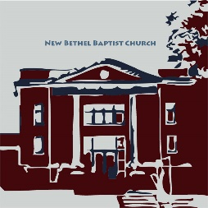

**Guests and Members:**  If you have questions or would like more information about New Bethel, please feel free to contact the church office. Thank you!

*An American Baptist*

*Congregation*

**\*\*\*\*\*\***

**All Are Welcome**

**Weekly Activities Online Only**

Wednesdays online Bible Study 10 a.m.

Wednesdays online Prayer meeting 7 p.m.

10:30 a.m., Sunday Worship, live-stream only

**\*\*\*\*\*\***

**Contact Information**

New Bethel Baptist Church Website: www.newbethelbapt.org

8936 Southeastern Avenue E-mail: newbethelbapt@att.net

Indianapolis, IN 46239 Wi-fi password: NBBC8624381

317-862-4381 Instagram: NBBC.Wanamaker

YouTube: New Bethel Baptist

Church Wanamaker

https://facebook.com New Bethel Baptist.Wanamaker

Rev. Dr. Janet F. Hoover, Pastor

Jan Nagle, Secretary

Church Office Hours: contact Pastor or NBBC Secretary

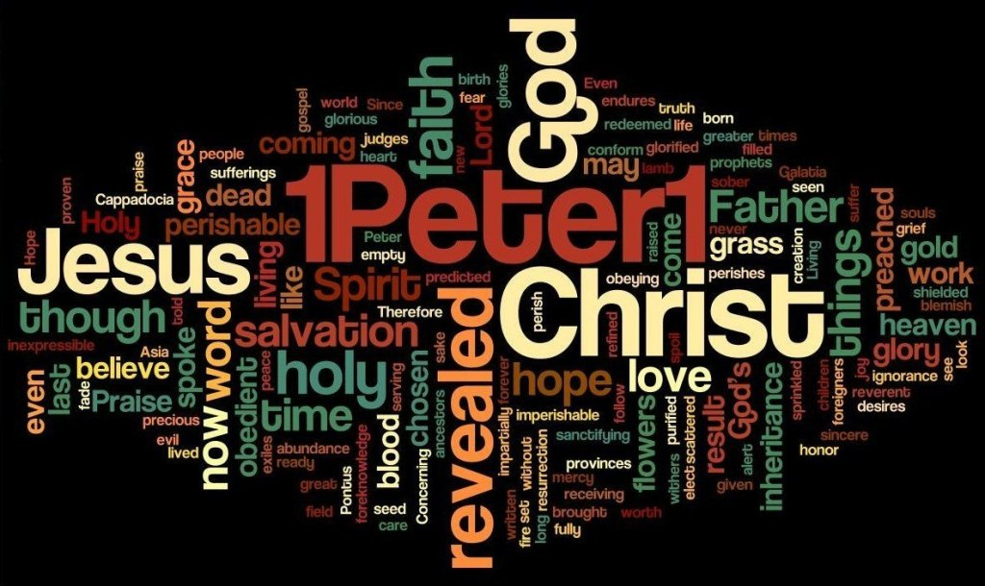

*What happens when this is all over?*

*Will we be changed?*

*Will we heed the lessons of a global pandemic,*

*realize we are all connected to each other,*

*fight for systems that keep our own selves safe*

*by protecting the most vulnerable among us?*

*Will we fight for a world*

*where we could actually touch the miracle of a savior*

*who died for the world and then rose again?*

*Or will we only ever*

*be able to glimpse it,*

*but not hold on?*

— Abby Norman

**How to Live-Stream Worship**

Greetings,

As Pastor Janet's e-mail dated March 18th mentioned, we have made a few changes to the livestream, including our ability to stream our hymns through the livestream feed. Part of the terms of the livestream include that we are to post the stream to our website as the primary platform for viewing.

What this means for you is that this is actually much more simple to access, as there is only one link you will need to save. Each week you will just need to go to the church website

(www.newbethelbapt.org) and click on the “Sermons” tab at the top of the page. The most current week should be the first one you see. Click on the title (this week says "Fifth Sunday of Lent - March 29, 2020") and that will take you to the week's page.

Right now, you will see the video viewer shown there with our church sign. If you click on the play button prior to the start of our stream it will let you know when we plan to start and give you the option to set a reminder if you have a YouTube or Google account, if not just check back at 10:30 a.m. on Sunday morning and join our worship!

I will try to send out each week's individual link, but as long as you go to the church page and “Sermons” tab, you should be able to access the stream. This week's link is: [http://www.newbethelbapt.org/sermons/Second Sunday of Easter](http://www.newbethelbapt.org/sermons/Second%20Sunday%20of%20Easter)-sunday-april-19-2020/

Once we have the links for online giving, we will post those somewhere easy to get to on the website as well so that the church's website can be your go-to for all of the weekly activities.

Please let us know if you have any questions!

Rob Thomas

**Daily Scripture Readings for This Week**

Monday, April 20: Psalm 114; Judges 6:36-40;

1 Corinthians 15:12-20

Tuesday, April 21: Psalm 114; Jonah 1:1-17;

1 Corinthians 15:19-28

Wednesday, April 22: Psalm 114; Jonah 2:1-10; Matthew 12:38-42

Thursday, April 23: Psalm 116:1-4, 12-19; Isaiah 25:1-5;

1 Peter 1:8b-12

Friday, April 24: Psalm 116:1-4, 12-19; Isaiah 26:1-4;

1 Peter 1:13-16

Saturday, April 25: Psalm 116:1-4, 12-19; Isaiah 25:6-9;

Luke 14:12-14

Third Sunday of Easter April 26: Acts 2:14a, 36-41;

Psalm 116:1-4, 12-19; 1 Peter 1:17-23; Luke 24:13-35

**\*\*\*\*\*\*\*\*\*\*\*\*\*\*\*\*\*\*\***

**Thank You and Blessings!**

* Thank you to everyone who has stepped up to enhance our Online worship each week.
* Thank you to everyone who join in worship with live streaming.
* Thank you to Kevin Winton for his Daily Thoughts.

**\*\*\*\*\*\*\*\*\*\*\*\*\*\*\*\*\*\*\***

**Happening This Week**

All NBBC face-to-face meetings cancelled until

further notice

Apr 22 10 a.m., Online Bible Study, weekly scriptures in

bulletin and on NBBC website

7 p.m., Online Prayer Meeting using Zoom

26 Live-stream worship only

all the prayer warriors at New Bethel Baptist Church: I want to thank you for helping me get through

this ordeal with my broken shoulder. I especially appreciate the prayers on the day of surgery. I was very

much in need that day. When the surgeon said the break was so bad that there was need of a plate and

screws, my bubble burst and I was really down that week. So, thank all of you for your prayers and many

thanks to Pastor Janet for her prayer the day of surgery. Don’t ever think your prayers aren’t needed;

because they are and they de(nitely help. Thank you also to my paent husband, who has been a rock

through all of this.

May God Bless you all, Sue