**Welcome to New Bethel Baptist Church**

**Third Sunday of Easter, April 26, 2020**

**Prelude** Dr. Christina Romero-Ivanova

\***Gathering Hymns**

*Alleluia* #359

*Victory Chant* #374

**\*Call to Worship**

Leader: Christ is here, ready to be revealed. Watch and wait

for the new growth that is coming.

**Church: Stay with Christ and Christ will stay with you.**

Leader: Listen for God, and God will speak.

**Church: See the Spirit, and the Spirit will be revealed.**

Leader: For the Spirit is already here, inviting us to stay.

**Unison: Come, though we are apart, let us worship our**

**Lord together.**

**\*Invocation and Lord’s Prayer** (*using “sins”*) Julianne Thomas

**Scripture Reading** 1 Peter 1:17-23 Julianne Thomas

**Worship Prayer Scripture** Psalm 116:1-19Pastor Janet

**\*Hymn** *I’d Rather Have Jesus*#506

**Children’s Story** Julianne Thomas

**Scripture Reflection**  Luke 24:13-35 Pastor Janet

**\*Hymn** *He Keeps Me SingingwHH* #746

**Ministry Opportunities** Julianne Thomas

How to Give Tithes and Offerings

*Doxology #815

*Prayer Julianne Thomas

**\*Benediction**  Pastor Janet

**Postlude** Dr. Christina Romero-Ivanova

**Attendance for March 2020**

Since March was part actual church attendance and part live streaming, the attendance count is about 278 total attendance with an average of fifty-six people each week.

**\*\*\*\*\*\*\*\*\*\*\*\*\*\*\***

**A New Virtual Gathering**

I am starting a virtual Book Discussion Group beginning May 7th at 1 p.m. We will use Google Hang-outs, and I will send participants an e-mail with an invitation before 1 p.m. on that day. Our first book is by Philip Gulley and Jim Mulholland and is titled *If Grace Is True.* You can purchase the book from Amazon for a minimal cost. It is a great book for discussion, and I look forward to our conversations. I have already heard from a few folks, so ***let me know ASAP if you would like an invitation so you can connect and join the conversation.***

Godspeed, Pastor Janet

**\*\*\*\*\*\*\*\*\*\*\*\*\*\*\*\*\*\*\***

**Christian Condolences**

New Bethel offers Christian sympathy to Lisa and family, upon the death of her step-father on April 24th.

**\*\*\*\*\*\*\*\*\*\*\*\*\*\*\***

**Daily Scripture Readings for This Week**

Monday, April 27: Psalm 134; Genesis 18:1-14; 1 Peter 1:23-25

Tuesday, April 28: Psalm 134; Proverbs 8:32-9:6; 1 Peter 2:1-3

Wednesday, April 29: Psalm 134; Exodus 24:1-11; John 21:1-14

Thursday, April 30: Psalm 23; Exodus 2:15b-25; 1 Peter 2:9-12

Friday, May 1: Psalm 23; Exodus 3:16-22, 4:18-20;

1 Peter 2:13-17

Saturday, May 2: Psalm 23; Ezekiel 34:1-16; Luke 15:1-7

Sunday, May 3, Fourth Sunday of Easter: Acts 2:42-47; Psalm 23;

1 Peter 2:19-25; John 10:1-10

**Welcome to New Bethel Baptist Church**

**We are blessed by your presence!**

**Third Sunday of Easter, April 26, 2020**

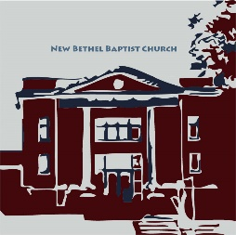

**Guests and Members:**  If you have questions or would like more information about New Bethel, please feel free to contact the church office. Thank you!

*An American Baptist*

*Congregation*

**\*\*\*\*\*\***

**All Are Welcome**

**Weekly Activities Online Only**

Wednesdays online Bible Study 10 a.m.

Wednesdays online Prayer meeting 7 p.m.

Thursdays online Book Discussion, beginning May 7th, 1 p.m.

10:30 a.m., Sunday Worship, live-stream only

**\*\*\*\*\*\***

**Contact Information**

New Bethel Baptist Church Website: www.newbethelbapt.org

8936 Southeastern Avenue E-mail: newbethelbapt@att.net

Indianapolis, IN 46239 Wi-fi password: NBBC8624381

317-862-4381 Instagram: NBBC.Wanamaker

YouTube: New Bethel Baptist

https://facebook.com Church Wanamaker

New Bethel Baptist.Wanamaker

Rev. Dr. Janet F. Hoover, Pastor

Jan Nagle, Secretary

Church Office Hours: contact Pastor or NBBC Secretary

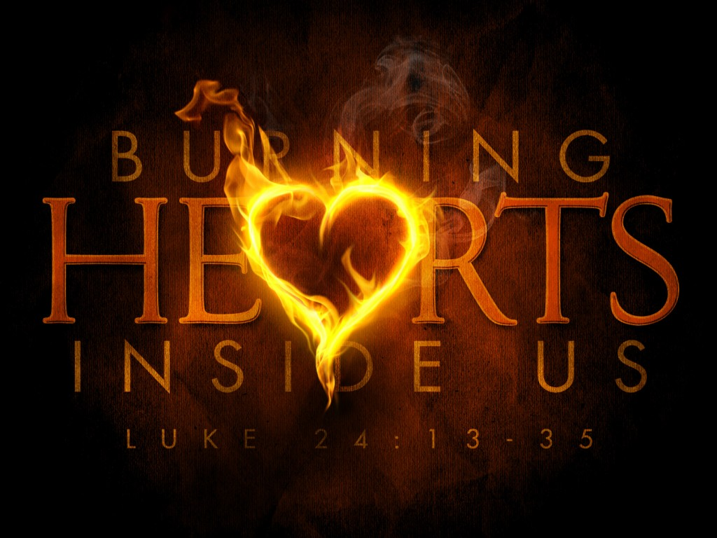

*it is a serious thing*

*just to be alive*

*on this fresh morning*

*in this broken world*

*—* Mary Oliver

**How to Live-Stream Worship**

Greetings,

We have made a few changes to our livestream, including the ability to live-stream our hymns. Part of the terms of the livestream include that we are to post the live-stream to our website as the primary platform for viewing.

What this means for you is that this is actually simpler to access online worship, as there is only one link you will need to save. Each week you just go to www.newbethelbapt.org (the church website) and click on the “Sermons” tab at the top of the page. The most current week should be the first one you see. Click on the correct date and that will take you to the week's page.

Right now, you will see the video viewer shown with our church sign. If you click on the play button prior to the start of our stream, it will let you know when we plan to start and give you the option to set a reminder if you have a YouTube or Google account. If not, just check back at 10:30 a.m. and join worship!

I will try to send out each week's individual link, but as long as you go to the church page and “Sermons” tab, you should be able to access worship.

This week's link is: [http://www.newbethelbapt.org/sermons/Third Sunday of Easter](http://www.newbethelbapt.org/sermons/Third%20Sunday%20of%20Easter)-sunday-april-26-2020/

Please let us know if you have any questions!

Rob Thomas

**\*\*\*\*\*\*\*\*\*\*\*\*\*\*\*\*\*\*\***

**Other Additions to the NBBC Website**

If you are looking for Pastor Janet’s e-mail messages, Daily Scripture Readings, Online Giving, Daily Thoughts, or other information about our “Online Ministry,” please look at the new tab entitled *Weekly Online Ministry* on the church website, http://www.newbethelbapt.org

**From Zoom to Google Hang-outs**

The online Bible Study has changed from Zoom to Google Hang-outs due to problems with Zoom. If you would like to join the Bible Study, please contact Pastor Janet for connection information.

**\*\*\*\*\*\*\*\*\*\*\*\*\*\*\*\*\*\*\***

**Happening This Week**

Apr 29 10 a.m., Online Bible Study, contact Pastor for

connection information to Google Hang-outs,

weekly scriptures in bulletin and on website

7 p.m., Online Prayer Meeting using Zoom

May 3 Live-stream worship only

7 1 p.m., Online Book Discussion, *If Grace Is True*

**\*\*\*\*\*\*\*\*\*\*\*\*\*\*\*\*\*\*\***

**Worship Music Copyright and Live-Streaming Permissions**

“Alleluia, Alleluia! Give Thanks” text and music by Donald Fishel;

“Victory Chant” text and music by Joseph Vogels;

“I’d Rather Have Jesus” text by Rhea F. Miller and music by George

Beverly Shea;

“He Keeps Me Singing” text and music by Luther B. Bridges;

“Doxology” text by Thomas Ken and music by *Genevan Psalter.*

All above selections ©1997 Word/Integrity

Used by Permission. CCLI License #1631733

“Turn Your Eyes Upon Jesus” music by Helen Lemmet;

“We Have This Hope” music by Wayne Hooper;

“Mountain Suite Overture” music by Bill George and Dino Kartsonakis;

“Window of the Seasons” music by Dino Kartsonaki and Cheri Bonar;

“Praise to the Lord, the Almighty” music by Lobe Den Herren;

“To God Be the Glory” music by William H. Doane.

Live-Streaming: Christian Copyright Solutions, WorshipCast,

License #10868

this ordeal with my broken shoulder. I especially appreciate the prayers on the day of surgery. I was very

much in need that day. When the surgeon said the break was so bad that there was need of a plate and

screws, my bubble burst and I was really down that week. So, thank all of you for your prayers and many

thanks to Pastor Janet for her prayer the day of surgery. Don’t ever think your prayers aren’t needed;

because they are and they de(nitely help. Thank you also to my paent husband, who has been a rock

through all of this.

May God Bless you all, Sue