**Welcome to New Bethel Baptist Church**

**Palm/Passion Sunday, April 5, 2020**

**Prelude** Dr. Christina Romero-Ivanova

**\*Gathering Hymn** *We Have Come into His House* #224

**\*Call to Worship** Julianne Thomas

Leader: This is the day that the Lord has made.

**People: Let us rejoice and be glad in it.**

Leader: Blessed is the one who comes in the name of the

Lord.

**People: God’s steadfast love endures forever.**

Leader: The stone that the builders rejected has become the

chief cornerstone.

**People: This is the Lord’s doing. It is marvelous in our**

**eyes.**

Leader: Bind the festival procession with branches.

**People: Jesus is the gate of the Lord. The righteous**

**enter through him.**

Leader: This is the day that the Lord has made.

**Unison: Let us rejoice and be glad in it.**

**\*Invocation and Lord’s Prayer** (*using “sins”)*

**\*Hymn** *This Is the Day* #209

**Lenten Meditation** Julianne Thomas

**Scripture Reading** Matthew 21:1-11 Pastor Janet

**\*Hymn** *All Glory, Laud and Honor* #300

**Worship Prayer** Pastor Janet

**\*Hymn** *In the Name of the Lord* #299

**Scripture Reflection**  Matthew 26:14-27:66 Pastor Janet

**\*Hymns** *Be Still, My Soul* #712

**Ministry Opportunities** Julianne Thomas

How to Give Tithes and Offerings

*Doxology #815

*Prayer Julianne Thomas

**Communion Hymn** *In Remembrance* #461

**Communion** Pastor Janet

**\*Closing Hymn** *Blest Be the Tie That Binds* #426

**Birthdays and Anniversary Blessings**

**\*Postlude** Dr. Christina Romero-Ivanova

**\*\*\*\*\*\*\*\*\*\*\*\*\*\*\***

**Thank You and Blessings!**

* Thank you to . . . (you know who you are) for the new and improved microphone Pastor used last week.
* Thank you to everyone who participated in the virtual prayer meeting and in Bible Study—keep coming back!
* Thank you to everyone who has worked diligently to correct the computer problems we are currently facing.
* Thank you, God, for the sunny days we have experienced, and we joyfully look forward to a lot more!
* Thank you to the Deacons who are working faithfully to stay in touch with their flocks.
* Thank you to our “techies” for their willingness to help our members with computer issues.
* Thank you to our “sew-ers” who are making face masks.

**\*\*\*\*\*\*\*\*\*\*\*\*\*\*\***

**Lenten Worship Focus Is on the Cross**

*Again, this year, we have covered the picture of the resurrected Jesus that we may focus on the cross during the Lenten season to better appreciate what Jesus sacrificed to make us right with God*

**Welcome to New Bethel Baptist Church**

**We are blessed by your presence!**

**Palm/ Passion Sunday, April 5, 2020**

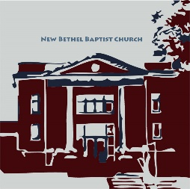**Guests and Members:**  If you have questions or would like more information about New Bethel, please feel free to contact the church office. Thank you!

*An American Baptist*

*Congregation*

**\*\*\*\*\*\***

**All Are Welcome**

**Weekly Activities Online Only**

Wednesdays online Bible Study 10 a.m.

Wednesdays online Prayer meeting 7 p.m.

10:30 a.m., Sunday Worship, live-stream only

**\*\*\*\*\*\***

**Contact Information**

New Bethel Baptist Church Website: www.newbethelbapt.org

8936 Southeastern Avenue E-mail: newbethelbapt@att.net

Indianapolis, IN 46239 Wi-fi password: NBBC8624381

317-862-4381 Instagram: NBBC.Wanamaker

YouTube: New Bethel Baptist

Church Wanamaker

https://facebook.com New Bethel Baptist.Wanamaker

Rev. Dr. Janet F. Hoover, Pastor

Jan Nagle, Secretary

Church Office Hours: contact Pastor or NBBC Secretary

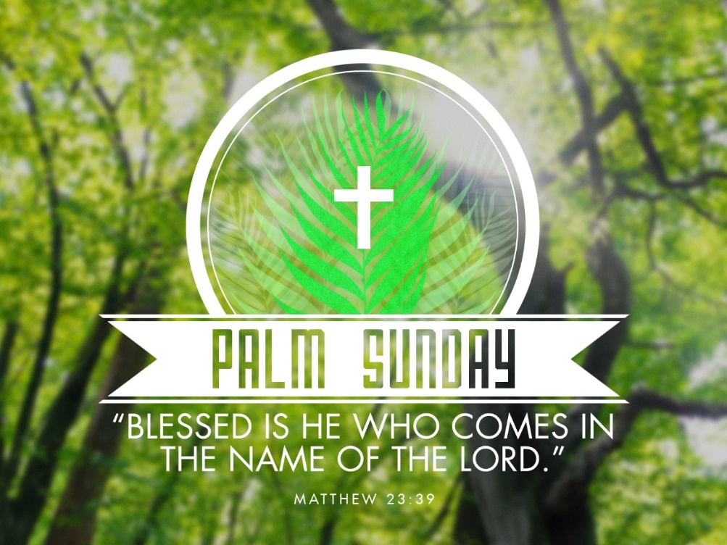

*Remember finally,*

*that the ashes that*

*were on your forehead*

*are created from*

*the burnt palms*

*of last Palm Sunday.*

*New beginnings*

*invariably come from*

*old false things*

*that are allowed to die.*

— Richard Rohr

**New Phone Directory**

We are currently updating the phone directory and will provide new information as soon as possible.

Jan Nagle, Church Secretary

**\*\*\*\*\*\*\*\*\*\*\*\*\*\*\*\*\*\*\***

**Happening This Week**

All NBBC face-to-face meetings cancelled until

further notice

Apr 8 10 a.m., Online Bible Study using Zoom, weekly

scriptures in bulletin and on NBBC website

7 p.m., Online Prayer Meeting using Zoom

9 Maundy Thursday

10 Good Friday

12 Live-stream worship only

**\*\*\*\*\*\*\*\*\*\*\*\*\*\*\*\*\*\*\***

**Looking Ahead**

May 2 Pending date for Third Annual Women’s Retreat

**\*\*\*\*\*\*\*\*\*\*\*\*\*\*\*\*\*\*\***

*Let every man and woman count himself immortal.*

*Let him catch the revelation of Jesus in his resurrection.*

*Let him say not merely, "Christ is risen,"*

*but "I shall rise."*

* Phillips Brooks

**\*\*\*\*\*\*\*\*\*\*\*\*\*\*\*\*\*\*\***

**Daily Scripture Readings for This Week**

Monday, April 6: Isaiah 42:1-9; Psalm 36:5-11; Hebrews 9:11-15;

John 12:1-11

Tuesday, April 7: Isaiah 49:1-7; Psalm 71:1-14

1 Corinthians 1:18-31; John 12:20-36

Wednesday, April 8: Isaiah 50:4-9a; Psalm 70; Hebrews 12:1-3;

John 13:21-32

Maundy Thursday, April 9: Exodus 12:1-14; Psalm 116:1-2, 12-19;

1 Corinthians 11:23-26; John 13:1-17, 31b-35

Good Friday, April 10: Isaiah 52:13-53:12; Psalm 22;

Hebrews 10:16-25 or Hebrews 4:14-16, 5:7-9;

John 18:1-19:42

Holy Saturday, April 11: Job 14:1-14 or Lamentations 3:1-9, 19-24;

Psalm 31:1-4, 15-16; 1 Peter 4:1-8; Matthew 27:57-66 or John 19:38-42

***Easter Sunday, April 12***

Easter Vigil Scriptures:

* Genesis 1:1-2:4a and Psalm 136:1-9, 23-26
* Genesis 7:1-5, 11-18, 8:6-18, 9:8-13 and Psalm 46
* Genesis 22:1-18 and Psalm 16
* Exodus 14:10-31, 15:20-21, 15:1b-13, 17-18
* Isaiah 55:1-11, 12:2-6
* Proverbs 8:1-8, 19-21, 9:4b-6 and Psalm 19
* Ezekiel 36:24-28 and Psalm 42, 43
* Ezekiel 37:1-14 and Psalm 143
* Zephaniah 3:14-20 and Psalm 98
* Romans 6:3-11 and Psalm 114; Matthew 28:1-10

Easter Morning, Resurrection of the Lord, Scripture Readings:

* Acts 10:34-43 or Jeremiah 31:1-6; Psalm 118:1-2, 14-24
* Colossians 3:1-4 or Acts 10:34-43
* John 20:1-18 or Matthew 28:1-10

Easter Evening Scripture Readings:

* Isaiah 25:6-9; Psalm 114; 1 Corinthians 5:6b-8
* Luke 24:13-49

**How to Live-stream Worship**

Greetings,

As Pastor Janet's email dated March 18th mentioned, we have made a few changes to the livestream, including our ability to stream our hymns through the livestream feed. Part of the terms of the livestream include that we are to post the stream to our website as the primary platform for viewing.

What this means for you is that this is actually much more simple to access, as there is only one link you will need to save. Each week you will just need to go to the church website

(www.newbethelbapt.org) and click on the “Sermons” tab at the top of the page. The most current week should be the first one you see. Click on the title (this week says "Fifth Sunday of Lent - March 29, 2020") and that will take you to the week's page.

Right now, you will see the video viewer shown there with our church sign. If you click on the play button prior to the start of our stream it will let you know when we plan to start and give you the option to set a reminder if you have a YouTube or Google account, if not just check back at 10:30 a.m. on Sunday morning and join our worship!

I will try to send out each week's individual link, but as long as you go to the church page and “Sermons” tab, you should be able to access the stream. This week's link is: <http://www.newbethelbapt.org/sermons/palm>-sunday-april-5-2020/

Once we have the links for online giving, we will post those somewhere easy to get to on the website as well so that the church's website can be your go-to for all of the weekly activities.

Please let us know if you have any questions!

Rob Thomas

all the prayer warriors at New Bethel Baptist Church: I want to thank you for helping me get through

this ordeal with my broken shoulder. I especially appreciate the prayers on the day of surgery. I was very

much in need that day. When the surgeon said the break was so bad that there was need of a plate and

screws, my bubble burst and I was really down that week. So, thank all of you for your prayers and many

thanks to Pastor Janet for her prayer the day of surgery. Don’t ever think your prayers aren’t needed;

because they are and they de(nitely help. Thank you also to my paent husband, who has been a rock

through all of this.

May God Bless you all, Sue