**Welcome to New Bethel Baptist Church**

**Sixth Sunday of Easter, May 17, 2020**

**Prelude** Dr. Christina Romero-Ivanova

\***Gathering Hymn** *Shine, Jesus, Shine*  #431

**\*Call to Worship**

Leader: God made the world and everyone in it.

**Church: Our life and breath come from God.**

Leader: God made all nations under heaven.

**Church: We are all God’s offspring.**

Leader: Search for God in our time of worship.

**Church: The Spirit of truth dwells among us.**

**Leader: Bask in this awareness.**

**Unison: In the Lord, we live and breathe and have our**

**being.**

**\*Invocation and Lord’s Prayer** (*using “sins”*) Julianne Thomas

**Scripture Reading** 1 Peter 3:13-22 Julianne Thomas

**Worship Prayer**   Pastor Janet

**\*Hymn** *All People That on Earth Do Dwell*#101

**Children’s Message** Julianne Thomas

**Scripture Reflection**  John 14:15-21 Pastor Janet

**\*Hymn** *Here I Am, LordwHH* #589

**Ministry Opportunities** Julianne Thomas

How to Give Tithes and Offerings

*Doxology #815

*Prayer Julianne Thomas

**\*Benediction** Pastor Janet

**Postlude** Dr. Christina Romero-Ivanova

**Christian Condolences**

New Bethel offers Christian sympathy to the Willsey family, upon the death of Florabel Willsey on May 11th. Florabel would’ve been 100 years old on June 10th.

**\*\*\*\*\*\*\*\*\*\*\*\*\*\*\*\*\*\*\***

**Update to the NBBC Website**

Pastor Janet’s e-mail messages, Daily Scripture Readings, Online Giving, Daily Thoughts, or other information about our “Online Ministry” is located on a new tab entitled *Weekly Online Ministry* on the church website, http://www.newbethelbapt.org

**\*\*\*\*\*\*\*\*\*\*\*\*\*\*\*\*\*\*\***

**Thank You and Blessings!**

Today’s music accompanist is Phil Morgan on the trumpet.

**\*\*\*\*\*\*\*\*\*\*\*\*\*\*\*\*\*\*\***

**Daily Scripture Readings for This Week**

Monday, May 18: Psalm 93; Genesis 9:8-17; Acts 27:39-44

Tuesday, May 19: Psalm 93; Deuteronomy 5:22-33; 1 Peter 3:8-12

Wednesday, May 20: Psalm 93; Deuteronomy 31:1-13;

John 16:16-24

Thursday, May 21, Ascension of the Lord: Acts 1:1-11; Psalm 47 or

Psalm 93; Ephesians 1:15-23; Luke 24:44-53

Friday, May 22: Psalm 93; 2 Kings 2:1-12; Ephesians 2:1-7

Saturday, May 23: Psalm 93; 2 Kings 2:13-15; John 8:21-30

Sunday, May 24, Seventh Sunday of Easter: Acts 1:6-14;

Psalm 68:1-10, 32-35; 1 Peter 4:12-14; 5:6-11; John 17:1-11

**Welcome to New Bethel Baptist Church**

**We are blessed by your presence!**

**Sixth Sunday of Easter, May 17, 2020**

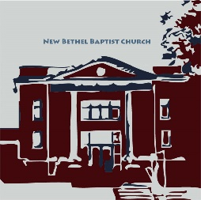

**Guests and Members:**  If you have questions or would like more information about New Bethel, please feel free to contact the church office. Thank you!

*An American Baptist*

*Congregation*

**\*\*\*\*\*\***

**All Are Welcome**

**Weekly Activities Online Only**

Wednesdays online Bible Study 10 a.m.

Wednesdays online Prayer meeting 7 p.m.

Thursdays online Book Discussion, *If Grace Is True,* 1 p.m.

10:30 a.m., Sunday Worship, live-stream only

**\*\*\*\*\*\***

**Contact Information**

New Bethel Baptist Church Website: www.newbethelbapt.org

8936 Southeastern Avenue E-mail: newbethelbapt@att.net

Indianapolis, IN 46239 Wi-fi password: NBBC8624381

317-862-4381 Instagram: NBBC.Wanamaker

YouTube: New Bethel Baptist

Church Wanamaker

https://facebook.com New Bethel Baptist.Wanamaker

Rev. Dr. Janet F. Hoover, Pastor

Jan Nagle, Secretary

Church Office Hours: contact Pastor or NBBC Secretary

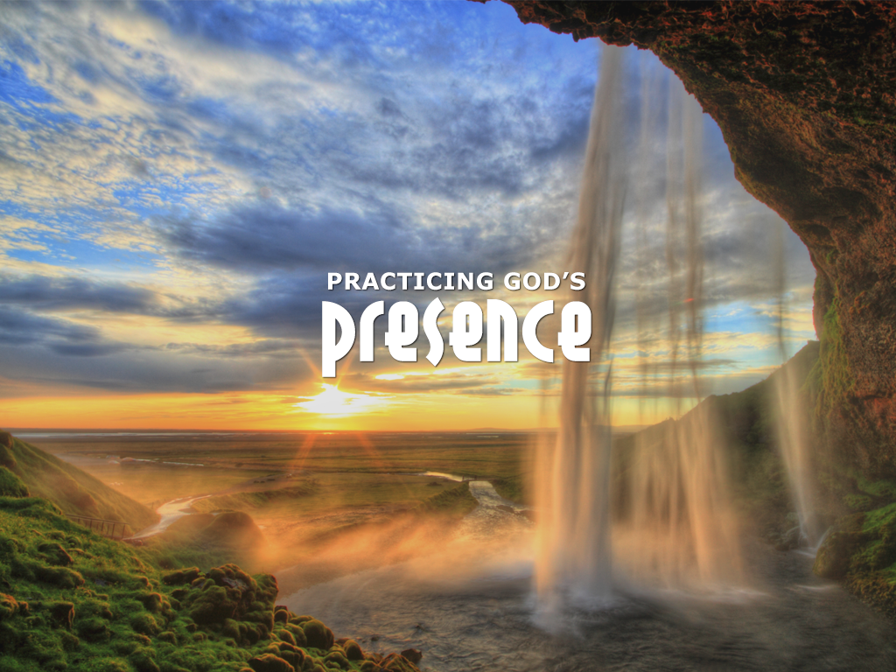

*Once you see the basic truth . . .*

*that we are all God’s children*

*and therefore absolutely equal,*

*the rest of it is just common sense.*

—Beatrice Bruteau

**Center for Congregations**

Due to Covid-19, the Center for Congregations is offering all of its workshops online and free-of-charge. To see what is being offered just go to the Center for Congregations website. Click on workshops at www.centerfor congregations.org to see your options.

**\*\*\*\*\*\*\*\*\*\*\*\*\*\*\*\*\*\*\***

*Liminal space is where we are*

*betwixt and between,*

*having left one room or*

*stage of life*

*but not yet entered*

*the next.*

* Richard Rohr

**\*\*\*\*\*\*\*\*\*\*\*\*\*\*\*\*\*\*\***

**ABC-GI News**

***Annual Gathering Date Change***

The day of the Annual Gathering has been changed to Sunday, August 2nd due to COVID-19 restrictions. We will still be hosted by Lebanon First. If you have already sent in your registration it will be held for the new date.

***

***ABC Camps Suspended***

“At this time, we have made the difficult decision to not proceed with our summer as scheduled and have prayerfully chosen to suspend all summer camps for 2020. We expect the spread of this disease will still be in effect during the summer, and we simply cannot put our camp family at risk. We will continue to monitor the situation closely until we can reopen our campgrounds to guests and camp family.”

**Happening This Week**

May 20 10 a.m., Online Bible Study, contact Pastor for

connection information to Zoom, weekly

scriptures in bulletin and on website

7 p.m., Online Prayer Meeting using Zoom,

connection information on website and in Daily Thoughts

21 1 p.m., Online Book Discussion, *If Grace Is True,*

contact Pastor for connection information to Zoom

May 24 Live-stream worship only

**\*\*\*\*\*\*\*\*\*\*\*\*\*\*\*\*\*\*\***

**Worship Music Copyright and Live-Streaming Permissions**

“Shine, Jesus, Shine” text and music by Graham Kendrick;

“All People That on Earth Do Dwell” text by William Kether and *Scottish*

*Psalter* and music by Genevan Psalter;

“Here I Am, Lord” text and music by Daniel L. Schutte*;*

“Doxology” text by Thomas Ken and music by *Genevan Psalter.*

All above selections ©1997 Word/Integrity

Used by Permission. CCLI License #1631733

“The Saviour Is Waiting” music by Ralph Carmichael;

“Pass It On” music by Kurt Kaiser;

“In His Time” music by Diane Ball;

“Spirit Song” music by John Wimber;

“Seek Ye First” music by Karen Lafferty;

“Jesus, Name Above All Names” music by Naida Hearn;

“Mountain Suite Overture” music by Jim Brickman;

“Faith” music by Jim Brickman.

Live-Streaming: Christian Copyright Solutions, WorshipCast,

License #10868

**Zoom Bible Study and Book Discussion Group**

Bible Study is using Zoom. If you would like to join Bible Study on Wednesdays at 10 a.m., please contact Pastor Janet for an invitation via e-mail. Also, please join us each Thursday at 1 p.m. on Zoom for a discussion on the book *If Grace Is True*. I will send participants an e-mail invitation to join the group. Let me know if you would like an invitation so you can connect and join the conversation.

Godspeed, Pastor Janet

**\*\*\*\*\*\*\*\*\*\*\*\*\*\*\*\*\*\*\***

**Website Updates**

Greetings,

I know many of you are still getting used to our Sunday worship being online-only, and we have been making changes so things can be as easy and “normal” for you as possible while we plan to be worshiping in this manner for at least several more weeks.

***Apologies*** to those who access worship through YouTube and were unable to do so on Sunday May 3rd. I had changed a setting that did not go back to the default and was unable to change it since the stream had already started. In the future, I will double-check to be sure you are able to access through YouTube directly.

***“Online Worship”*** has replaced the “Sermons” tab that you use to access the weekly video, bulletin, and other information. The link is still the same (www.newbethelbapt.org/sermons), and the rest of the process is still the same.

***Audio sync issue*** was in varying degrees and could have been due to settings within the software, the connection to YouTube, or even just that so many churches are using online worship or any combination.

***Video not loading correctly*** Phil shared a tip for whenever the video does not load on the weekly page in the website. He has found that if he goes out to the main page of the website (either by clicking “New Bethel Baptist Church” in the upper left corner or typing www.newbethelbapt.org in the address bar), and then follows the link back to the “Online Worship” (formerly “Sermons”) page, it would load correctly. If you experience something similar, please try this step to see if it resolves your issue as well.

***Viewing the hymns*** is done by going to the website, click on the “Online Worship” tab, open the current Sunday, scroll to download files, click on notes, and the hymns will appear as a file at the bottom of your screen. Open the file to see the hymns. This might take a few moments to do, so you might allow a few minutes before service to download the hymn files and bulletin. I am also going to try to upload them in a different format, and I am working on a way to display them on screen during the stream itself. I need to do a bit of testing to make sure we can get that to work.

Finally, we know that this has been different from our typical worship, and while we have been streaming for a little over a year now, this is the first time that we have had so many of you worshipping in this manner. So we still have a bit of learning to do and if you are experiencing any issues, please let us know. This way if several people report the same issue, we are aware of it and can be sure to address it or maybe offer some suggestions to you to help.

Thank you,

Rob Thomas

*Note: A longer version of this article is in Daily Thoughts, Issue #38, dated May 9th.*

this ordeal with my broken shoulder. I especially appreciate the prayers on the day of surgery. I was very

much in need that day. When the surgeon said the break was so bad that there was need of a plate and

screws, my bubble burst and I was really down that week. So, thank all of you for your prayers and many

thanks to Pastor Janet for her prayer the day of surgery. Don’t ever think your prayers aren’t needed;

because they are and they de(nitely help. Thank you also to my paent husband, who has been a rock

through all of this.

May God Bless you all, Sue