**Welcome to New Bethel Baptist Church**

**Fourth Sunday of Easter, May 3, 2020**

**Prelude** Dr. Christina Romero-Ivanova

\***Gathering Hymn** *Shine, Jesus, Shine*  #431

**\*Call to Worship**

Leader: Do you need a guide?

**Church: The Lord is our shepherd.**

Leader: Do you need a doorway to new life?

**Church: The Lord is our gate.**

Leader: Do you need rest?

**Church: The Lord restores our souls.**

Leader: Do you need care?

**Church: The Lord is our shepherd.**

**Unison: Come, let us worship.**

**\*Invocation and Lord’s Prayer** (*using “sins”*) Julianne Thomas

**Scripture Reading** 1 Peter 2:19-25 Julianne Thomas

**Worship Prayer**  Psalm 23  Pastor Janet

**\*Hymn** *Jesus Is Lord of All*#519

**Scripture Reflection**  John 10:1-10 Pastor Janet

**\*Hymn** *Joyful, Joyful, We Adore TheewHH* #90

**Ministry Opportunities** Julianne Thomas

How to Give Tithes and Offerings

*Doxology #815

*Prayer Julianne Thomas

**Communion Hymn** *Come to the Table* #464

**Communion**  Pastor Janet

**\*Closing Hymn** *Blest Be the Tie That Binds* #426

**Birthdays and Anniversary Blessings** Julianne Thomas

**Postlude** Dr. Christina Romero-Ivanova

**Worship Attendance for April 2020**

The month of April was live-streaming worship only and attendance was about 316 with an average of about seventy-nine people each week. Twenty-four households live-streamed worship on Maundy Thursday.

**\*\*\*\*\*\*\*\*\*\*\*\*\*\*\***

**A New Virtual Gathering**

I am starting a virtual Book Discussion Group beginning May 7th at 1 p.m. We will use Zoom, and I will send participants an e-mail invitation before 1 p.m. on that day. Our first book is by Philip Gulley and Jim Mulholland and is titled *If Grace Is True.* You can purchase the book from Amazon for a minimal cost. It is a great book for discussion, and I look forward to our conversations. I have already heard from a few folks, so ***let me know ASAP if you would like an invitation so you can connect and join the conversation.***

Godspeed, Pastor Janet

**\*\*\*\*\*\*\*\*\*\*\*\*\*\*\*\*\*\*\***

Today’s accompaniment is Phil Morgan on the trumpet.

**\*\*\*\*\*\*\*\*\*\*\*\*\*\*\*\*\*\*\***

**Daily Scripture Readings for This Week**

Monday, May 4: Psalm 100; Ezekiel 34:17-23; 1 Peter 5:1-5

Tuesday, May 5: Psalm 100; Ezekiel 34:23-31; Hebrews 13:20-21

Wednesday, May 6: Psalm 100; Jeremiah 23:1-8;

Matthew 20:17-28

Thursday, May 7: Psalm 31:1-5, 15-16; Genesis 12:1-3; Acts 6:8-15

Friday, May 8: Psalm 31:1-5, 15-16; Exodus 3:1-12; Acts 7:1-16

Saturday, May 9: Psalm 31:1-5, 15-16; Jeremiah 26:20-24;

John 8:48-59

Sunday, May 10, Fifth Sunday of Easter: Acts 7:55-60;

Psalm 31:1-5, 15-16; 1 Peter 2:2-10; John 14:1-14

**Welcome to New Bethel Baptist Church**

**We are blessed by your presence!**

**Fourth Sunday of Easter, May 3, 2020**

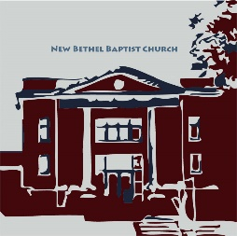

**Guests and Members:**  If you have questions or would like more information about New Bethel, please feel free to contact the church office. Thank you!

*An American Baptist*

*Congregation*

**\*\*\*\*\*\***

**All Are Welcome**

**Weekly Activities Online Only**

Wednesdays online Bible Study 10 a.m.

Wednesdays online Prayer meeting 7 p.m.

Thursdays online Book Discussion, beginning May 7th, 1 p.m.

10:30 a.m., Sunday Worship, live-stream only

**\*\*\*\*\*\***

**Contact Information**

New Bethel Baptist Church Website: www.newbethelbapt.org

8936 Southeastern Avenue E-mail: newbethelbapt@att.net

Indianapolis, IN 46239 Wi-fi password: NBBC8624381

317-862-4381 Instagram: NBBC.Wanamaker

YouTube: New Bethel Baptist

https://facebook.com Church Wanamaker

New Bethel Baptist.Wanamaker

Rev. Dr. Janet F. Hoover, Pastor

Jan Nagle, Secretary

Church Office Hours: contact Pastor or NBBC Secretary

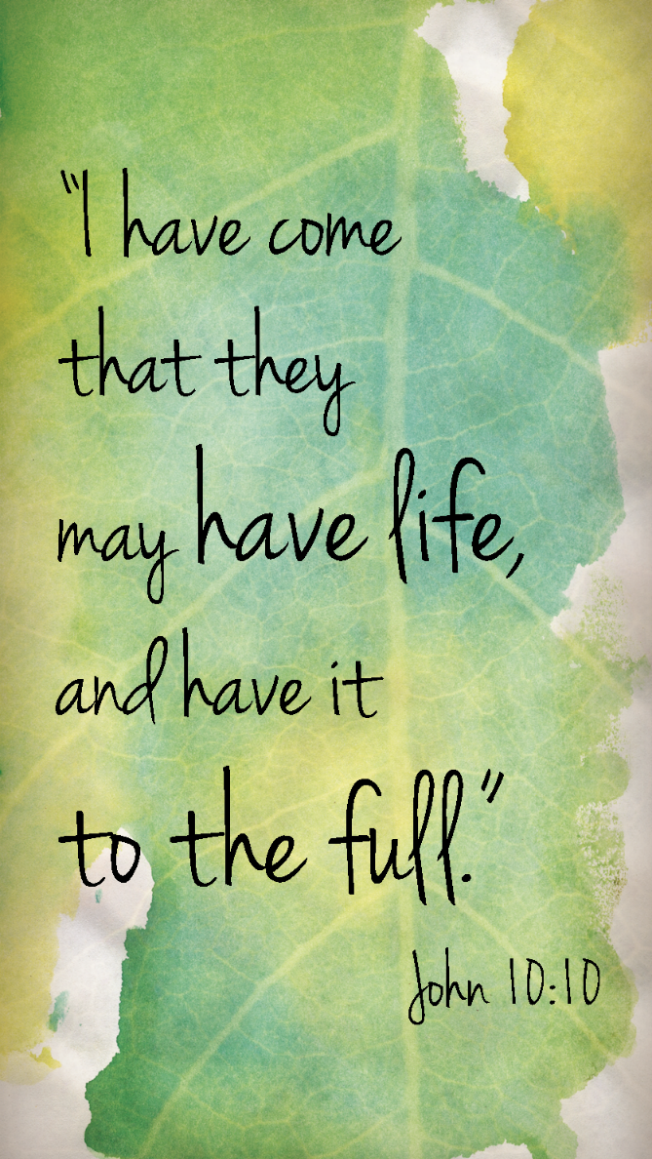

*Life, if well lived,*

*is long enough.*

**—** Seneca

**How to Live-Stream Worship**

Greetings,

We have made a few changes to our livestream, including the ability to live-stream our hymns. The hymns are available as a document on the church website (see address below).

Part of the terms of the livestream include that we are to post the live-stream to our website as the primary platform for viewing.

What this means for you is that this is actually simpler to access online worship, as there is only one link you will need to save.

Each week, go to www.newbethelbapt.org (the church website) and click on the “Sermons” tab at the top of the page. The most current week should be the first one you see. Click on the correct date and that will take you to the week's page.

;

Right now, you will see the video viewer shown with our church sign. If you click on the play button prior to the start of worship, it will let you know when we plan to start and give you the option to set a reminder if you have a YouTube or Google account. If not, just check back at 10:30 a.m. and join worship!

Again, to access weekly worship, go to the church website, and select the current week’s date to get to this week’s page.

Please let us know if you have any questions!

Rob Thomas

**\*\*\*\*\*\*\*\*\*\*\*\*\*\*\*\*\*\*\***

**Update to the NBBC Website**

If you are looking for Pastor Janet’s e-mail messages, Daily Scripture Readings, Online Giving, Daily Thoughts, or other information about our “Online Ministry,” please look at the new tab entitled *Weekly Online Ministry* on the church website, http://www.newbethelbapt.org

**Happening This Week**

May 6 10 a.m., Online Bible Study, contact Pastor for

connection information to Zoom, weekly

scriptures in bulletin and on website

7 p.m., Online Prayer Meeting using Zoom

7 1 p.m., Online Book Discussion, *If Grace Is True,*

contact Pastor for connection information to Zoom

May 10 Live-stream worship only

**\*\*\*\*\*\*\*\*\*\*\*\*\*\*\*\*\*\*\***

**Worship Music Copyright and Live-Streaming Permissions**

“Shine, Jesus, Shine” text and music by Graham Kendrick;

“Jesus Is Lord of All” text and music by LeRoy McClard;

“Joyful, Joyful, We Adore Thee” text by Henry van Dyke and music by

Ludwig van Beethoven; melody from *Ninth Symphony;*

“He Keeps Me Singing” text and music by Luther B. Bridges;

“Doxology” text by Thomas Ken and music by *Genevan Psalter;*

“Come to the Table” text by Claire Cloninger and music by Martin J.

Nystrom;

“Blest Be the Tie That Binds” text by John Fawcett and music by Johann

G. Naegeli; arranged by Lowell Mason.

All above selections ©1997 Word/Integrity

Used by Permission. CCLI License #1631733

“Joyful, Joyful, We Adore Thee” music by Ludwig van Beethoven;

“I Sing the Mighty Power of God” music by Gesangebuch der Herzogl;

“Christ the Lord Is Risen Today” music by Lyra Davidica;

“We Gather Together” music by Kremser;

“Majesty” music by Jack Hayford;

“Sweet Spirit” music by Doris Akers;

“Heaven Came Down and Glory Filled My Soul” music by John Peterson;

“In Times Like These” music by Ruth Caye Jones.

Live-Streaming: Christian Copyright Solutions, WorshipCast,

License #10868

**April Giving and Disbursements**

Thank you all for your continued financial support during this unprecedented COVID-19 virus pandemic. As difficult as it is to be distanced from family, friends, and church family, we all must stay safe and well. Our temporary giving process is working well so please continue to give as you can. For the month of April, our giving and disbursements were as follows:

April Giving: $ 9,917.44

April Disbursements: $10,332.20

Actual Difference: $ (-414.76)

If you have any questions, please contact me at 317-519-3347 or

e-mail me at njb46239@gmail.com

Janie Bryant, Treasurer

**\*\*\*\*\*\*\*\*\*\*\*\*\*\*\*\*\*\*\***

**ABC-GI News**

**Annual Gathering Date Change**

The day of the Annual Gathering has been changed to Sunday, August 2nd due to COVID-19 restrictions. We will still be hosted by Lebanon First. If you have already sent in your registration it will be held for the new date.

***

**ABC Camps Suspended**

“At this time, we have made the difficult decision to not proceed with our summer as scheduled and have prayerfully chosen to suspend all summer camps for 2020. We expect the spread of this disease will still be in effect during the summer, and we simply cannot put our camp family at risk. We will continue to monitor the situation closely until we can reopen our campgrounds to guests and camp family.”

**Zoom Bible Study**

The online Bible Study has settled on using Zoom. If you would like to join Bible Study, please contact Pastor Janet for an invitation via e-mail.

**\*\*\*\*\*\*\*\*\*\*\*\*\*\*\*\*\*\*\***

**Center for Congregations**

Dur to Covid-19, the Center for Congregations is offering all of its workshops online and free-of-charge. To see what is being offered just go to the Center for Congregations website. Click on workshops at www.centerfor congregations.org to see your options.

this ordeal with my broken shoulder. I especially appreciate the prayers on the day of surgery. I was very

much in need that day. When the surgeon said the break was so bad that there was need of a plate and

screws, my bubble burst and I was really down that week. So, thank all of you for your prayers and many

thanks to Pastor Janet for her prayer the day of surgery. Don’t ever think your prayers aren’t needed;

because they are and they de(nitely help. Thank you also to my paent husband, who has been a rock

through all of this.

May God Bless you all, Sue