**Welcome to New Bethel Baptist Church**

**Seventh Sunday of Easter, May 24, 2020**

**Prelude** Dr. Christina Romero-Ivanova

\***Gathering Hymn** *Shine, Jesus, Shine*  #431

**\*Call to Worship**

Leader: Rejoice and sing to God.

**Church: We sing of the Risen Christ.**

Leader: Clap your hands and shout with joy.

**Church: We rejoice in the living God.**

Leader: Celebrate this day.

**Church: We celebrate with the Spirit who calls us here.**

Leader: Be glad and rejoice!

**Unison: In our joy, we reveal God’s glory and the**

**Lord’s loving** **presence.**

**\*Invocation and Lord’s Prayer** (*using “sins”*) Julianne Thomas

**Scripture Reading** I Peter 4:12-14, 5:6-11 Julianne Thomas

**Worship Prayer**   Pastor Janet

**\*Hymn** *Day by Day* #718

**Children’s Message** Julianne Thomas

**Scripture Reflection**  John 17:1-11 Pastor Janet

**\*Hymn** *He Leadeth Me* #690

**Ministry Opportunities** Julianne Thomas

How to Give Tithes and Offerings

*Doxology #815

*Prayer Julianne Thomas

**\*Benediction** Pastor Janet

**Postlude** Dr. Christina Romero-Ivanova

**Christian Condolences**

New Bethel offers Christian sympathy to the Nagle family upon the death of Phil Nagle on May 17th. Due to Covid-19 concerns, no funeral service is planned at this time.

**\*\*\*\*\*\*\*\*\*\*\*\*\*\*\*\*\*\*\***

**Update to the NBBC Website**

Pastor Janet’s e-mail messages, Daily Scripture Readings, Online Giving, Daily Thoughts, or other information about our “Online Ministry” is located on a new tab entitled *Weekly Online Ministry* on the church website, http://www.newbethelbapt.org

**\*\*\*\*\*\*\*\*\*\*\*\*\*\*\*\*\*\*\***

**Thank You and Blessings to . . .**

* Our God’s Bounty volunteers
* Our Deacons for tracking their flocks.
* Trustees for caring for our lawn.

**\*\*\*\*\*\*\*\*\*\*\*\*\*\*\*\*\*\*\***

**Daily Scripture Readings for This Week**

Monday, May 25, 2020: Psalm 99; Leviticus 9:1-11, 22-24;

1 Peter 4:1-6

Tuesday, May 26, 2020: Psalm 99; Numbers 16:41-50;

1 Peter 4:7-11

Wednesday, May 27, 2020: Psalm 99; 1 Kings 8:54-65;

John 3:31-36

Thursday, May 28, 2020: Psalm 33:12-22; Exodus 19:1-9a;

Acts 2:1-11

Friday, May 29, 2020: Psalm 33:12-22; Exodus 19:16-25;

Romans 8:14-17

Saturday, May 30, 2020: Psalm 33:12-22; Exodus 20:1-21;

Matthew 5:1-12

Sunday, May 31, 2020, Day of Pentecost: Acts 2:1-21 or

Numbers 11:24-30; Psalms 104:24-34, 35b;

First Corinthians 12:3b-13 or Acts 2:1-21;

John 20:19-23 or John 7:37-39

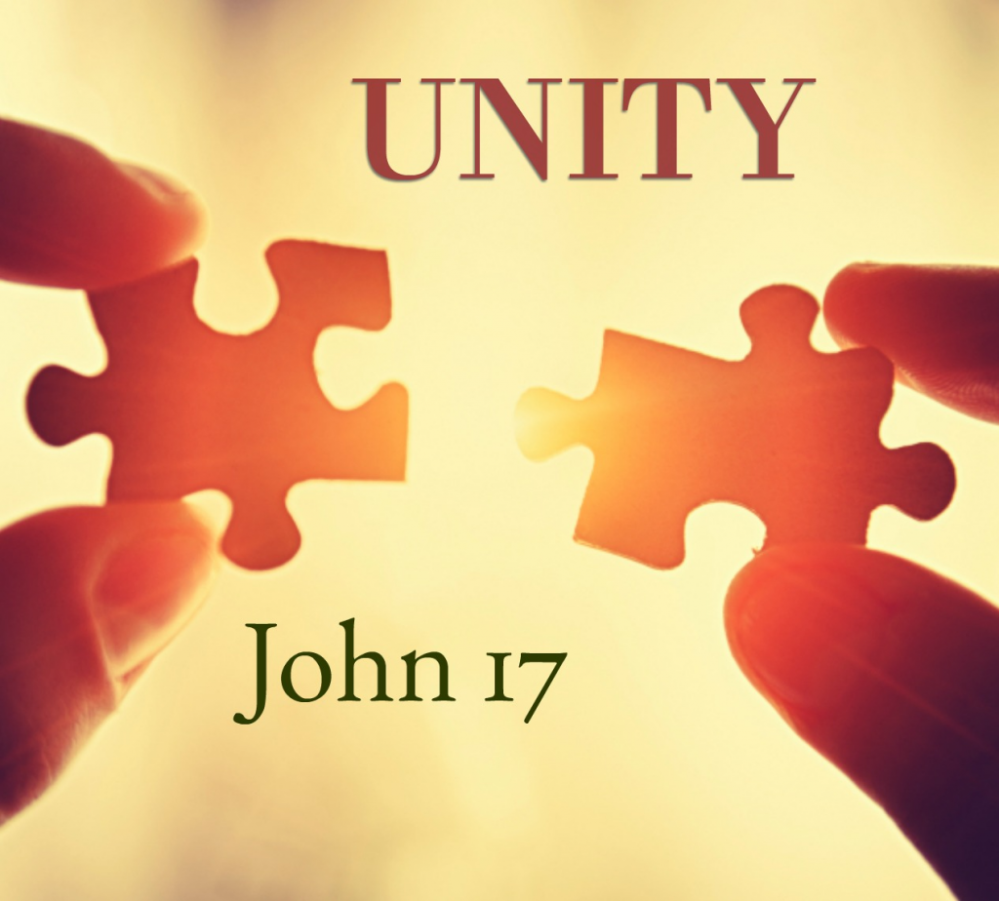**Welcome to New Bethel Baptist Church**

**We are blessed by your presence!**

**Sixth Sunday of Easter, May 17, 2020**

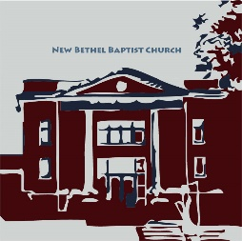

**Guests and Members:**  If you have questions or would like more information about New Bethel, please feel free to contact the church office. Thank you!

*An American Baptist*

*Congregation*

**\*\*\*\*\*\***

**All Are Welcome**

**Weekly Activities Online Only**

Wednesdays online Bible Study 10 a.m.

Wednesdays online Prayer meeting 7 p.m.

Thursdays online Book Discussion, *If Grace Is True,* 1 p.m.

10:30 a.m., Sunday Worship, live-stream only

**\*\*\*\*\*\***

**Contact Information**

New Bethel Baptist Church Website: www.newbethelbapt.org

8936 Southeastern Avenue E-mail: newbethelbapt@att.net

Indianapolis, IN 46239 Wi-fi password: NBBC8624381

317-862-4381 Instagram: NBBC.Wanamaker

YouTube: New Bethel Baptist

Church Wanamaker

https://facebook.com New Bethel Baptist.Wanamaker

Rev. Dr. Janet F. Hoover, Pastor

Jan Nagle, Secretary

Church Office Hours: contact Pastor or NBBC Secretary

*When you have vision, it affects your attitude.*

*Your attitude is optimistic rather than pessimistic.*

*This is nothing more than having a strong belief*

*in the power of God;*

*Having confidence in others around you who are*

*in similar battles with you;*

*and*

*Yes, having confidence in yourself,*

*By the grace of God.*

* Charles R. Swindoll

**Covid-19 Causes Changes**

The Center for Congregations is offering all of its workshops online and free-of-charge. To see what is being offered just go to the Center for Congregations website. Click on workshops at www.centerfor congregations.org to see your options.

**\*\*\***

The Lions Club has officially canceled the Old Settlers Day street fair for this year.

**\*\*\***

NBBC’s Strawberry Festival is cancelled for this year.

**\*\*\***

The day of the ABC-GI Annual Gathering has been changed to Sunday, August 2nd. We will be hosted by Lebanon First. If you have already sent in your registration it will be held for the new date.

***

**Happening This Week**

May 24 Live-stream worship only

27 10 a.m., Online Bible Study, contact Pastor for

connection information to Zoom, weekly

scriptures in bulletin and on website

7 p.m., Online Prayer Meeting using Zoom, general

connection information on website and in Daily Thoughts and contact John Huddleston for the password

28 1 p.m., Online Book Discussion, *If Grace Is True,*

contact Pastor for connection information to Zoom

31 Pentecost Sunday! Wear and decorate your worship

space in RED!

June 7 Communion Sunday

Live-stream worship only

**Zoom Bible Study and Book Discussion Group**

Bible Study is using Zoom. If you would like to join Bible Study on Wednesdays at 10 a.m., please contact Pastor Janet for an invitation via e-mail. Also, please join us each Thursday at 1 p.m. on Zoom for a discussion on the book *If Grace Is True*. I will send participants an e-mail invitation to join the group. Let me know if you would like an invitation so you can connect and join the conversation.

Godspeed, Pastor Janet

**\*\*\*\*\*\*\*\*\*\*\*\*\*\*\*\*\*\*\*\*\*\***

**Congratulations to . . .**

Roger Huddleston and his bride Debra on their nuptials and to Lisa Caffrey on her new job. Godspeed and prayers to all!

**Worship Music Copyright and Live-Streaming Permissions**

“Shine, Jesus, Shine” text and music by Graham Kendrick;

“Day by Day” text by Carolina Berg (translated by Andrew Skoog)

and music by Oscar Ahnfelt;

“He Leadeth Me” text by Joseph Gilmore and music by William

Bradbury;

“Doxology” text by Thomas Ken and music by *Genevan Psalter.*

All above selections ©1997 Word/Integrity

Used by Permission. CCLI License #1631733

“He Looked Beyond My Fault” by Dottie Rambo;

“A Quiet Place” by Ralph Carmichael;

“Faith” by Jim Brickman;

“In the Garden” by Austin Miles;

“Sweet Hour of Prayer” by William Bradbury and William Walford;

“Angel’s Blessing” by Jim Brickman;

“Majesty” by Jack Hanford;

“In His Time” by Diane Ball.

Live-Streaming: Christian Copyright Solutions, WorshipCast,

License #10868

**Twelve Ways to Love Your Neighbor During COVID-19**

by Molly Stillman

1. If you have the ability to sew, make masks for those who need them.
2. Coordinate a neighborhood “social distancing” gathering. In our neighborhood, we’ve had nights where we just bring out a chair at the end of our driveway and laugh and talk with each other. It’s a great way to connect with neighbors while still staying safe!
3. Become a pen pal for a grand-friend. My kids and I have been writing letters of encouragement to people who are in nursing homes, assisted living facilities, etc. just trying to brighten their day!
4. Send a random postcard or , , , snail mail to a friend who you know could use a pick-me-up. I know that I love being on the receiving end of snail mail… sending a letter or note to someone telling them why you are grateful for them could be just the message they need to hear at that moment!
5. Call and check in on friends or family members you haven’t spoken to in a while. I’ll be honest, I’m not great at talking on the phone, but checking in on friends and family right now has been something I’ve really looked forward to.
6. Contact your local food bank or food distribution center to find out what immediate needs they have.
7. Reach out to your local church and find out if there is a family (or two) that could use an extra blessing or if they have any immediate needs.
8. Offer to go grocery shopping or pickup groceries for a neighbor who is elderly, disabled, immune-compromised, a single parent, [those] out of work, etc.
9. Send a gift card to a local restaurant or restaurant delivery service to someone you know could use a blessing of a meal. This is really a double blessing because not only are you supporting a local business that could be hurting right now, but you are also blessing a family!
10. Take some sidewalk chalk and walk around your neighborhood and write encouraging verses of scripture, quotes, etc. to encourage others as they go about their day!
11. Offer to cut your neighbor’s grass or do any yard work that might need to be done.
12. Sponsor a child in poverty. The health systems of even the highest-income nations . . . have been pushed to the limits by this pandemic. And lower-income nations are far less equipped to deal with the consequences. There has never been a better time to connect with a child through a sponsorship program – I personally sponsor a child with Compassion International and love what they’re doing to respond to this deep need in developing countries.

**\*\*\*\*\*\*\*\*\*\*\*\*\*\*\*\*\*\*\***

**Website Updates**



Greetings,

I know many of you are still getting used to our Sunday worship being online-only, and we have been making changes so things can be as easy and “normal” for you as possible while we plan to be worshiping in this manner for at least several more weeks.

***Apologies*** to those who access worship through YouTube and were unable to do so on Sunday May 3rd. I had changed a setting that did not go back to the default and was unable to change it since the stream had already started. In the future, I will double-check to be sure you are able to access through YouTube directly.

***“Online Worship”*** has replaced the “Sermons” tab that you use to access the weekly video, bulletin, and other information. The link is still the same (www.newbethelbapt.org/sermons), and the rest of the process is still the same.

***Audio sync issue*** was in varying degrees and could have been due to settings within the software, the connection to YouTube, or even just that so many churches are using online worship or any combination.

***Video not loading correctly*** Phil shared a tip for whenever the video does not load on the weekly page in the website. He has found that if he goes out to the main page of the website (either by clicking “New Bethel Baptist Church” in the upper left corner or typing www.newbethelbapt.org in the address bar), and then follows the link back to the “Online Worship” (formerly “Sermons”) page, it would load correctly. If you experience something similar, please try this step to see if it resolves your issue as well.

***Viewing the hymns*** is done by going to the website, click on the “Online Worship” tab, open the current Sunday, scroll to download files, click on notes, and the hymns will appear as a file at the bottom of your screen. Open the file to see the hymns. This might take a few moments to do, so you might allow a few minutes before service to download the hymn files and bulletin. I am also going to try to upload them in a different format, and I am working on a way to display them on screen during the stream itself. I need to do a bit of testing to make sure we can get that to work.

Finally, we know that this has been different from our typical worship, and while we have been streaming for a little over a year now, this is the first time that we have had so many of you worshipping in this manner. So we still have a bit of learning to do and if you are experiencing any issues, please let us know. This way if several people report the same issue, we are aware of it and can be sure to address it or maybe offer some suggestions to you to help.

Thank you,

Rob Thomas

*Note: A longer version of this article is in Daily Thoughts, Issue #38, dated May 9th.*

**Audio/Visual Grant Project Update**

New Bethel will soon welcome new technology and equipment to improve and enhance your worship experience! After much discussion amongst your lay-leaders, we have decided to hire Designed Sound & Audio to make the updates to our system.

This means that NBBC will soon be the owner of new equipment: a camcorder, two wireless mics, a computer, needed internet and electrical components, and a fancy-dancy camera.

The new wireless mics are set such that there will be no interference from others using radio signals in our area, such as the police.

The new camcorder will replace our ten-year-old camera. The old camcorder is still usable, but the technology has advanced so much that the old one is nearly obsolete.

The computer is needed to keep Rob from having to use his personal computer to run the audio/visual equipment.

The camera will hang in the sanctuary. It will be *especially* helpful when we reopen our facility and have some of you live-streaming from home and some of you in the sanctuary for worship. Also, the camera has programmable settings, meaning that it will not have to be adjusted manually throughout worship. Additionally, it will be easier to train new folks for running the camera.

This project = ~$8,000. The Center for Congregations Grant is worth $5,000, making our expense about $3,000.

I did not mention replacing the broken speakers. We tested the one we want, and it was great — no squeals or squeaks! But we need about $4,000 more to replace the speakers, and your leaders decided to wait on that purchase. In the meantime, you will notice two Fellowship Hall “speakers” on the platform in the sanctuary. This will be our “look” and sound until new speakers are purchased.

Let me know if you have questions or if you have about $4,000 looking for a place to call home! 😊

Blessings, Pastor Janet

this ordeal with my broken shoulder. I especially appreciate the prayers on the day of surgery. I was very

much in need that day. When the surgeon said the break was so bad that there was need of a plate and

screws, my bubble burst and I was really down that week. So, thank all of you for your prayers and many

thanks to Pastor Janet for her prayer the day of surgery. Don’t ever think your prayers aren’t needed;

because they are and they de(nitely help. Thank you also to my paent husband, who has been a rock

through all of this.

May God Bless you all, Sue