**Welcome to New Bethel Baptist Church**

**Sunday, June 21, 2020**

**Prelude** Dr. Christina Romero-Ivanova

\***Gathering Hymn** *Joy of My Desire*  #744

**\*Call to Worship**

Leader: Great are the works of the Father’s hands.

**People: Wondrous are the blessings of Jesus’ love.**

Leader: Powerful are the works of the Holy Spirit.

**Unison: We are here to worship you, O God, for you**

**alone can save us.**

**\*Invocation and Lord’s Prayer** (*using “sins”*) Karen Pappas

**Scripture Reading** Genesis 21:8-21 Karen Pappas

**Worship Prayer**   Julianne Thomas

**\*Hymn** *Spirit of God, Descend upon My Heart*#390

**Children’s Message** Karen Pappas

**Scripture Reflection**  Matthew 10:24-39 Julianne Thomas

**\*Hymn** *Amazing Grace* #343

**Ministry Opportunities** Karen Pappas

How to Give Tithes and Offerings

*Doxology #815

*Prayer Karen Pappas

**Benediction** Julianne Thomas

**Postlude** Dr. Christina Romero-Ivanova

**Update to the NBBC Website**

Find Pastor Janet’s e-mail messages, Daily Scripture Readings, Online Giving, Today’s Thoughts, and other information about our online ministry on a tab entitled “Weekly Online Ministry” on the church website — http://www.newbethelbapt.org

**\*\*\*\*\*\*\*\*\*\*\*\*\*\*\*\*\*\*\***

**Christian Condolences**

New Bethel offers Christian sympathy to Clarke Burton and family, upon the death of Clarke’s mother Betty Burton on June 19th.

**\*\*\*\*\*\*\*\*\*\*\*\*\*\*\*\*\*\*\***

**Daily Scripture Readings for This Week**

Monday, June 22, 2020: Psalm 86:11-17; Genesis 16:1-15;

Revelation 2:1-7 or Psalm 6; Micah 7:1-7

Tuesday, June 23, 2020: Psalm 86:11-17; Genesis 25:12-18;

Revelation 2:8-11 or Psalm 6; Jeremiah 26:1-12

Wednesday, June 24, 2020: Psalm 86:11-17; Jeremiah 42:18-22;

Matthew 10:5-23 or Psalm 6; Jeremiah 38:1-13

Thursday, June 25, 2020: Psalm 13; Micah 7:18-20;

Galatians 5:2-6 or Psalm 89:1-4; Jeremiah 25:1-7

Friday, June 26, 2020: Psalm 13; 2 Chronicles 20:5-12;

Galatians 5:7-12 or Psalm 89:1-4, 15-18; Jeremiah 25:8-14; Luke 17:1-4

Saturday, June 27, 2020: Psalm 13; Genesis 26:23-25;

Luke 17:1-4 or Psalm 89:1-4, 15-18; Jeremiah 28:1-4

Sunday, June 28, 2020: Genesis 22:1-14; Psalm 13;

Jeremiah 28:5-9; Psalm 89:1-4, 15-18; Romans 6:12-23; Matthew 10:40-42

**Welcome to New Bethel Baptist Church**

**We are blessed by your presence!**

**Sunday, June 21, 2020**

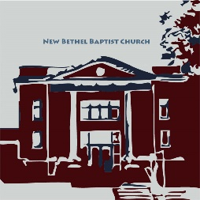

**Guests and Members:**  If you have questions or would like more information about New Bethel, please feel free to contact the church office. Thank you!

*An American Baptist*

*Congregation*

**\*\*\*\*\*\***

**All Are Welcome**

**Weekly Activities Online Only**

Wednesdays online Bible Study 10 a.m.

Wednesdays online Prayer meeting 7 p.m.

Thursdays online Book Discussion, *If Grace Is True,* 1 p.m.

10:30 a.m., Sunday Worship, live-stream only

**\*\*\*\*\*\***

**Contact Information**

New Bethel Baptist Church Website: www.newbethelbapt.org

8936 Southeastern Avenue E-mail: newbethelbapt@att.net

Indianapolis, IN 46239 Wi-fi password: NBBC8624381

317-862-4381 Instagram: NBBC.Wanamaker

YouTube: New Bethel Baptist

Church Wanamaker

https://facebook.com New Bethel Baptist.Wanamaker

Rev. Dr. Janet F. Hoover, Pastor

Jan Nagle, Secretary

Church Office Hours: contact Pastor or NBBC Secretary



*Darkness cannot drive out darkness;*

*only light can do that.*

*Hate cannot drive out hate;*

*only love can do that.*

— Martin Luther King Jr.

**Covid-19 Causes Changes**

The Center for Congregations is offering all of its workshops online and free-of-charge. To see what is being offered just go to the Center for Congregations website. Click on workshops at www.centerfor congregations.org to see your options.

**\*\*\*\*\*\*\*\*\*\*\*\*\*\*\*\*\*\*\*\*\*\***

**ABCGI 2020**

VIRTUAL Annual Gathering

Sunday, August 2, 6 pm

Hosted online by New Era Church

([www.nne.org](http://www.nne.org))

A downloadable worship guide will be posted soon. Stay Tuned for more details.

**\*\*\*\*\*\*\*\*\*\*\*\*\*\*\*\*\*\*\*\*\*\***

**Thank You and Blessings to . . .**

* Thank you to those who have contacted your deacon with a response to last week’s survey.
* Thank you to Lisa for presenting the Children’s Message last week on live streaming.

**\*\*\*\*\*\*\*\*\*\*\*\*\*\*\*\*\*\*\*\*\*\***

**Happening This Week**

Today Father’s Day

Live-stream worship only

June 24 10 a.m., Online Bible Study, contact Pastor for

connection information to Zoom, weekly

scriptures in bulletin and on website

7 p.m., Online Prayer Meeting using Zoom, general

connection information on website and in Today’s Thoughts; contact John Huddleston for the password

25 1 p.m., Online Book Discussion, *If Grace Is True,*

contact Pastor for connection information to zoom

**Zoom Bible Study and Book Discussion Group**

To join Bible Study on Wednesdays at 10 a.m. or the discussion of the book *If Grace Is True* on Thursdays at 1 p.m., please contact me for connection information.

Godspeed, Pastor Janet

**\*\*\*\*\*\*\*\*\*\*\*\*\*\*\*\*\*\*\*\*\*\***

*Were there no God,*

*we would be in this glorious world*

*with grateful hearts, and no one to thank.*

— Christina Rossetti, 1830 – 1894

**\*\*\*\*\*\*\*\*\*\*\*\*\*\*\*\*\*\*\*\*\*\***

**Worship Music Copyright and Live-Streaming Permissions**

“Joy of My Desire” text and music by Jennifer Randolph;

“Spirit of God, Descend upon My Heart’’ text by George Croly

and music by Frederick C. Atkinson;

“Amazing Grace” text by John Newton and John P. Rees

and music by Edwin O. Excell;

“Doxology” text by Thomas Ken and music by *Genevan Psalter;*

All above selections ©1997 Word/Integrity

Used by Permission. CCLI License #1631733

“Faith” by Jim Brickman;

“Mountain Suite Overture” by Dino Kartsonakis;

“He Looked Beyond My Faults and Saw My Needs” by Bill George

and Dino Kartsonakis;

“To a Wild Rose” by Edward Macdowell;

“Let All Things Now Living” by Faye Lopez;

“Come and Sing Praises” by Morris Chapman and Greg Massanari;

“Sweet Hour of Prayer” by William Bradbury;

“Side by Side” by Jeff Wood.

Live-Streaming: Christian Copyright Solutions, WorshipCast,

License #10868

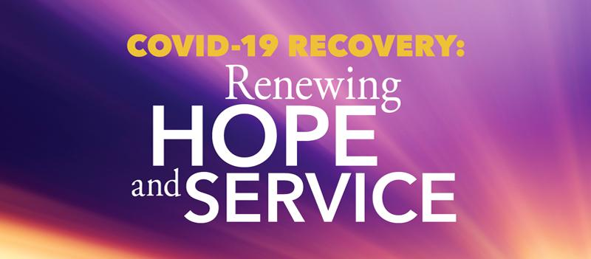

**Help those affected by COVID-19 across United States, Puerto Rico**

Help ABHMS to help those affected by COVID-19 across the United States and Puerto Rico by raising $1,000,000 through its One Great Hour of Sharing (OGHS) "COVID-19 Recovery: Renewing Hope and Service" campaign, on behalf of American Baptist Churches USA.

Cristal and Javier, a married couple in Puerto Rico, have been working remotely since the quarantine began. They find that they are saving on expenses such as gasoline and dining at restaurants. They are also members of a small church with limited financial resources. They've decided to coordinate with their pastor to identify fellow parishioners in need, mostly elderly members. Each week they will redirect the money they are saving to supply the needs of their brothers and sisters. In a moment like this, they are blessed and use their situation to bless others.

To give to OGHS for support of relief initiatives across the United States and Puerto Rico, donations can be made online, via your church or check payable to American Baptist Home Mission Societies and mailed to the attention of Leda Carter at American Baptist Home Mission Societies, 1075 First Ave., King of Prussia, PA 19406. Write "OGHS-COVID Recovery: US & PR" on the memo line.

One hundred percent of donations go to relief efforts; no dollars are retained for administrative costs.

To hear more stories of how American Baptists are being affected by the Coronavirus, listen to a new podcast every week on abhms.org or ministrElife.org.

**An Update From The Moderator**

Dear Friends,

I ran into a high school classmate at Kroger. We had not crossed paths for at least two decades and immediately reached out to shake hands out of habit without considering the guidelines set out by the Health and Hospital Board. We did get a couple of concerned looks from other shoppers. I did not realize how much I miss the simple act of shaking hands with a friend. We are working on a plan to safely and responsibly reopen the doors of New Bethel Baptist Church.

The Church Council is working to follow guidelines and protocol established by the CDC, Gov. Holcomb’s office, and the Marion County Health and Hospital Board. A church setting is unique as we gather in a confined area for an extended period of time and lift our voices in song. In talks with my school superintendent, we discussed the responsibility of making a decision that could have a major health impact on the community. The goal is to be able to continue to worship and keep all safe and healthy. Looking forward to a large celebration when we return to gather together.

We hope all understand the decision to remain closed at least through the month of July. Please continue to communicate with each other via email, text, and phone calls, as well as continue to worship with us on Sunday mornings. God will continue to work through us and bless each of us. Please look at the questions listed below. Please call your Deacon Flock Shepherd or your Deacon Chair Sue Winton with your response to the following:

**When would you be comfortable returning to a church setting**

**with masks required to attend worship?**

**a) Would you worship in the sanctuary if there were no singing**

**during the service?**

**b) Do you plan to wait to attend service until there is a vaccine**

**for COVID – 19?**

**c) I am ready now**

Peace and Good Health, Kevin Winton