**Welcome to New Bethel Baptist Church**

**Sunday, June 28, 2020**

**Prelude** Dr. Christina Romero-Ivanova

\***Gathering Hymn** *Joy of My Desire*  #744

**\*Call to Worship**

Leader: Our hearts are weighed down by our attachments in

this life.

**People: As we worship, may we exhale our junk and**

**inhale the Holy Spirit.**

Leader**:** May we move beyond our past that holds us

captive.

**People: May we shed the fog of self-interest.**

Leader: May we find our authentic selves as the people of

God.

**Unison: May we drink of the salvation, grace, and**

**generosity of our Lord.**

**\*Invocation and Lord’s Prayer** (*using “sins”*) Karen Pappas

**Scripture Reading** Genesis 22:1-14 Karen Pappas

**Worship Prayer**   Pastor Janet

**\*Hymn** *Fill Me Now*#383

**Children’s Message** Julianne Thomas

**Scripture Reflection**  Romans 6:12-23 Pastor Janet

**\*Hymn** *In Christ There Is No East or West* #428

**Ministry Opportunities** Karen Pappas

How to Give Tithes and Offerings

*Doxology #815

*Prayer Karen Pappas

**Benediction** Pastor Janet

**Postlude** Dr. Christina Romero-Ivanova

**Correction to Condolences**

We are sorry for the omission that was made last week concerning the Betty Burton family. New Bethel also offers Christian sympathy to Betty’s daughter Jacqueline Cecile Burton.

**\*\*\*\*\*\*\*\*\*\*\*\*\*\*\*\*\*\*\***

**Update to the NBBC Website**

Find Pastor Janet’s e-mail messages, Daily Scripture Readings, Online Giving, Today’s Thoughts, and other information about our online ministry on a tab entitled “Weekly Online Ministry” on the church website — http://www.newbethelbapt.org

**\*\*\*\*\*\*\*\*\*\*\*\*\*\*\*\*\*\*\***

*The Bible contains a very meaningful expression:*

*the Spirit makes all things new.*

— Oscar A. Romero

**\*\*\*\*\*\*\*\*\*\*\*\*\*\*\*\*\*\*\***

**Daily Scripture Readings for This Week**

Monday, June 29, 2020: Psalm 47; Genesis 22:15-18;

1 Thessalonians 4:9-12 or Psalm 119:161-168;

1 Kings 21:1-16

Tuesday, June 30, 2020: Psalm 47; 1 Kings 18:36-39; 1 John 4:1-6

or Psalm 119:161-168; 1 Kings 21:17-29

Wednesday, July 1, 2020: Psalm 47; Isaiah 51:1-3;

Matthew 11:20-24 or Psalm 119:161-168; Jeremiah 18:1-11

Thursday, July 2, 2020: Psalm 45:10-17; Genesis 25:19-27;

Romans 7:1-6 or Psalm 145:8-14; Zechariah 1:1-6

Friday, July 3, 2020: Psalm 45:10-17; Genesis 27:1-17;

Romans 7:7-20 or Psalm 145:8-14; Zechariah 2:6-13

Saturday, July 4, 2020: Psalm 45:10-17; Genesis 27:18-29;

Luke 10:21-24 or Psalm 145:8-14; Zechariah 4:1-7

Sunday, July 5, 2020: Genesis 24:34-38, 42-49, 58-67;

Psalm 45:10-17 or Song of Solomon 2:8-13;

Zechariah 9:9-12 and Psalm 145:8-14; Romans 7:15-25a; Matthew 11:16-19, 25-30

**Welcome to New Bethel Baptist Church**

**We are blessed by your presence!**

**Sunday, June 28, 2020**

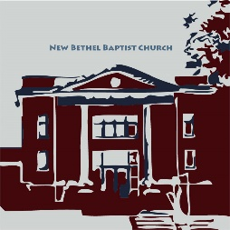

**Guests and Members:**  If you have questions or would like more information about New Bethel, please feel free to contact the church office. Thank you!

*An American Baptist*

*Congregation*

**\*\*\*\*\*\***

**All Are Welcome**

**Weekly Activities Online Only**

Wednesdays online Bible Study 10 a.m.

Thursdays online Book Discussion, *If Grace Is True,* 1 p.m.

10:30 a.m., Sunday Worship, live-stream only

**\*\*\*\*\*\***

**Contact Information**

New Bethel Baptist Church Website: www.newbethelbapt.org

8936 Southeastern Avenue E-mail: newbethelbapt@att.net

Indianapolis, IN 46239 Wi-fi password: NBBC8624381

317-862-4381 Instagram: NBBC.Wanamaker

YouTube: New Bethel Baptist

Church Wanamaker

https://facebook.com New Bethel Baptist.Wanamaker

Rev. Dr. Janet F. Hoover, Pastor

Jan Nagle, Secretary

Church Office Hours: contact Pastor or NBBC Secretary

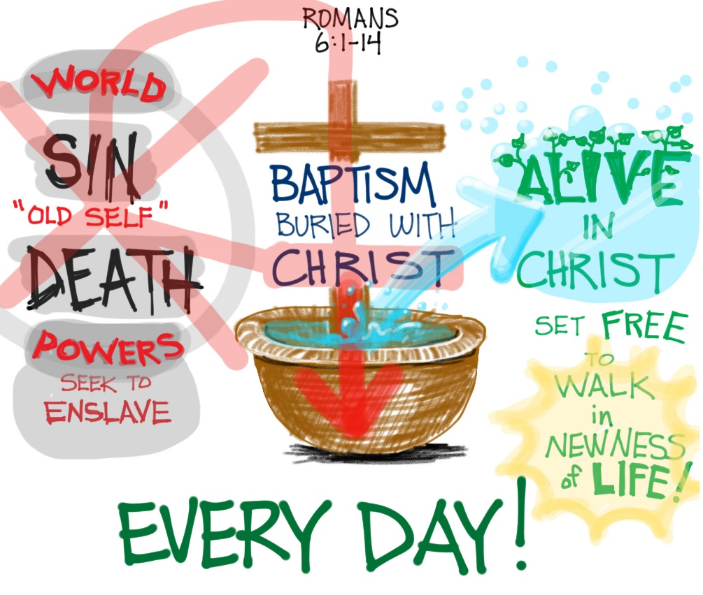

*Our worst days are never so bad*

*that you are beyond the reach of God's grace.*

*And your best days are never so good*

*that you are beyond the need of God's grace.*

— Jerry Bridges

**Covid-19 Causes Changes**

The Center for Congregations is offering all of its workshops online and free-of-charge. To see what is being offered just go to the Center for Congregations website. Click on workshops at www.centerfor congregations.org to see your options.

**\*\*\*\*\*\*\*\*\*\*\*\*\*\*\*\*\*\*\*\*\*\***

**ABC-GI 2020 Annual Gathering**

The 2020 ABC-GI Annual Gathering will be a virtual gathering, hosted on Sunday, August 2nd at 6 p.m.by New Era Church at [www.nne.org](http://www.nne.org)

A downloadable worship guide will be available soon. Stay tuned for more details.

**\*\*\*\*\*\*\*\*\*\*\*\*\*\*\*\*\*\*\*\*\*\***

*Hold everything in your hands lightly,*

*otherwise it hurts when*

*God pries your fingers open.*

—Corrie Ten Boom

**\*\*\*\*\*\*\*\*\*\*\*\*\*\*\*\*\*\*\*\*\*\***

**Happening This Week**

Today Live-stream worship only

July 1 10 a.m., Online Bible Study, contact Pastor for

connection information to Zoom, weekly

scriptures in bulletin and on website

2 1 p.m., Online Book Discussion, *If Grace Is True,*

contact Pastor for connection information to zoom

4 July 4th Holiday

6-11 Church Secretary on vacation, please contact Pastor

Janet with any questions

**Zoom Bible Study and Book Discussion Group**

To join Bible Study on Wednesdays at 10 a.m. or the discussion of the book *If Grace Is True* on Thursdays at 1 p.m., please contact me for connection information.

Godspeed,

Pastor Janet

**\*\*\*\*\*\*\*\*\*\*\*\*\*\*\*\*\*\*\*\*\*\***

**Thank You and Blessings to . . .**

* Thank you to Julianne for leading us in worship last week.
* Thank you to Karen for presenting the Children’s Message last week.

**\*\*\*\*\*\*\*\*\*\*\*\*\*\*\*\*\*\*\*\***

**Worship Music Copyright and Live-Streaming Permissions**

“Joy of My Desire” text and music by Jennifer Randolph;

“Fill Me Now’’ text by Elwood H. Stokes and music by John R. Sweney;

“In Christ There Is No East or West” text by John Oxenham and music by

Alexander R. Reinagle;

“Doxology” text by Thomas Ken and music by *Genevan Psalter.*

All above selections ©1997 Word/Integrity

Used by Permission. CCLI License #1631733

“Faith” by Jim Brickman;

“It Is Well” by Jim Brickman;

“Breath of Heaven” by Jim Brickman;

“In the Sweet and By and By” by Dino Kartsonakis;

“He Looked Beyond My Fault” by Dottie Rambo;

“Love Can Build A Bridge” by Naomi and Wynona Judd;

“Great Are You Lord” by Jason Ingram, David Leonard,

Leslie Jordan;

“How Excellent Is Your Name” by Michael W. Smith.

Live-Streaming: Christian Copyright Solutions, WorshipCast,

License #10868

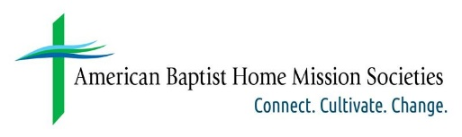

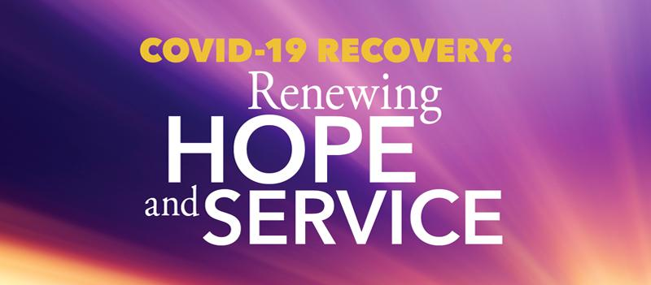**You Can Help Those Affected by Covid-19 Across the United States and Puerto Rico**

Help ABHMS to help those affected by COVID-19 across the United States and Puerto Rico by raising $1,000,000 through its One Great Hour of Sharing (OGHS) "COVID-19 Recovery: Renewing Hope and Service" campaign, on behalf of American Baptist Churches USA.

Cristal and Javier, a married couple in Puerto Rico, have been working remotely since the quarantine began. They find that they are saving on expenses such as gasoline and dining at restaurants. They are also members of a small church with limited financial resources. They have decided to coordinate with their pastor to identify fellow parishioners in need, mostly elderly members. Each week they will redirect the money they are saving to supply the needs of their brothers and sisters. In a moment like this, they are blessed and use their situation to bless others.

To give to OGHS for support of relief initiatives across the United States and Puerto Rico, donations can be made online, via your church, or check payable to American Baptist Home Mission Societies and mailed to the attention of Leda Carter at American Baptist Home Mission Societies, 1075 First Ave., King of Prussia, PA 19406. Write "OGHS-COVID Recovery: US & PR" on the memo line.

One hundred percent of donations go to relief efforts; no dollars are retained for administrative costs.

To hear more stories of how American Baptists are being affected by the Coronavirus, listen to a new podcast every week on abhms.org or ministrElife.org.

**An Update from The Moderator**

Dear Friends,

I ran into a high school classmate at Kroger. We had not crossed paths for at least two decades and immediately reached out to shake hands out of habit without considering the guidelines set out by the CDC. We did get a couple of concerned looks from other shoppers. I did not realize how much I miss the simple act of shaking hands with a friend. We are working on a plan to safely and responsibly reopen the doors of New Bethel Baptist Church.

The Church Council is working to follow guidelines and protocol established by the CDC, Gov. Holcomb’s office, Mayor Hogsett, and the Marion County Health De0partment. A church setting is unique as we gather in a confined area for an extended time period and lift our voices in song.

In talks with my school superintendent, we discussed the responsibility of making a decision that could have a major health impact on the community. The goal is to be able to continue to worship and keep all safe and healthy. We are looking forward to a large celebration when we return and gather together again.

We hope all understand the decision to remain closed at least through the month of July. Please continue to communicate with one another via email, text, and phone calls, as well as continue to worship with us on Sunday mornings. God will continue to work through us and bless us. Please look at the questions listed below. Please call your Deacon Flock Shepherd or Deacon Chair Sue Winton with your response to the f0ollowing:

**When would you be comfortable returning to a church setting**

**with masks required to attend worship?**

**a) Would you worship in the sanctuary if there were no singing**

**during the service?0**

**b) Do you plan to wait to attend service until there is a vaccine**

**for COVID – 19?**

**c) I am ready now**

Peace and Good Health, Kevin Winton