**Welcome to New Bethel Baptist Church**

**Trinity Sunday, June 7, 2020**

**Prelude** Dr. Christina Romero-Ivanova

\***Gathering Hymn** *Joy of My Desire*  #744

**\*Call to Worship**

Leader: For the “many-ness” of God’s creative splendor,

**Church: let us give thanks.**

Leader: Before Jesus’ humility and the power of Christ’s

commands,

**Church: let us stand in wonder.**

**L**eader: For the mystery of relationships — God’s with us

and ours with one another and our neighbors,

**Church: let us seek God’s holy wisdom.**

Leader: Come!

**Unison: Let us worship our Triune God.**

**\*Invocation and Lord’s Prayer** (*using “sins”*) Karen Pappas

**Scripture Reading** Genesis 1:1-2:4a Karen Pappas

**Worship Prayer**   Pastor Janet

**\*Hymn** *Instruments of Your Peace*#637

**Scripture Reflection**  Matthew 28:16-20 Pastor Janet

**\*Hymn** *Gather Us In* See Website

**Ministry Opportunities** Karen Pappas

How to Give Tithes and Offerings

*Doxology #815

*Prayer Karen Pappas

**Communion Hymn** *We Remember You*#459

**Communion** Pastor Janet

**\*Closing Hymn** *Blest Be the Tie That Binds*#426

**Birthdays and Anniversary Blessings** Julianne Thomas

**Postlude** Dr. Christina Romero-Ivanova

**Update to the NBBC Website**

Find Pastor Janet’s e-mail messages, Daily Scripture Readings, Online Giving, Today’s Thoughts, and other information about our online ministry on a tab entitled “Weekly Online Ministry” on the church website — http://www.newbethelbapt.org

**\*\*\*\*\*\*\*\*\*\*\*\*\*\*\*\*\*\*\***

**Thank You and Blessings to . . .**

* Thank you to Karen Pappas for her willingness to help lead worship.
* Thank you to the members and friend’s faithfulness in attendance and giving during our physical separation.

**\*\*\*\*\*\*\*\*\*\*\*\*\*\*\*\*\*\*\***

**Daily Scripture Readings for This Week**

Monday, June 8, 2020: Psalm 29; Job 38:39-39:12;

1 Corinthians 12:1-3

Tuesday, June 9, 2020: Psalm 29; Job 39:13-25;

1 Corinthians 12:4-13

Wednesday, June 10, 2020: Psalm 29; Job 39:26-40:5

John 14:25-26

Thursday, June 11, 2020: Psalm 116:1-2, 12-19; Genesis 21:1-7;

Hebrews 3:1-6 or Psalm 100; Exodus 4:18-23;

Hebrews 3:1-6

Friday, June 12, 2020: Psalm 116:1-2, 12-19; Genesis 24:1-9;

Acts 7:35-43 or Psalm 100; Exodus 4:27-31; Acts 7:35-43

Saturday, June 13, 2020: Psalm 116:1-2, 12-19; Genesis 24:10-52;

Mark 7:1-13 or Psalm 100; Exodus 6:28-7:13; Mark 7:1-13

Sunday, June 14, 2020: Genesis 18:1-15, 21:1-7; Psalm 116:1-2,

12-19; Exodus 19:2-8a; Psalm 100; Romans 5:1-8;

Matthew 9:35-10:8-23

**Welcome to New Bethel Baptist Church**

**We are blessed by your presence!**

**Trinity Sunday, June 7, 2020**

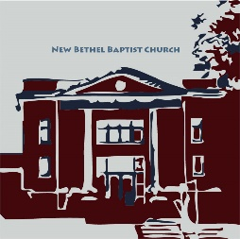

**Guests and Members:**  If you have questions or would like more information about New Bethel, please feel free to contact the church office. Thank you!

*An American Baptist*

*Congregation*

**\*\*\*\*\*\***

**All Are Welcome**

**Weekly Activities Online Only**

Wednesdays online Bible Study 10 a.m.

Wednesdays online Prayer meeting 7 p.m.

Thursdays online Book Discussion, *If Grace Is True,* 1 p.m.

10:30 a.m., Sunday Worship, live-stream only

**\*\*\*\*\*\***

**Contact Information**

New Bethel Baptist Church Website: www.newbethelbapt.org

8936 Southeastern Avenue E-mail: newbethelbapt@att.net

Indianapolis, IN 46239 Wi-fi password: NBBC8624381

317-862-4381 Instagram: NBBC.Wanamaker

YouTube: New Bethel Baptist

Church Wanamaker

https://facebook.com New Bethel Baptist.Wanamaker

Rev. Dr. Janet F. Hoover, Pastor

Jan Nagle, Secretary

Church Office Hours: contact Pastor or NBBC Secretary

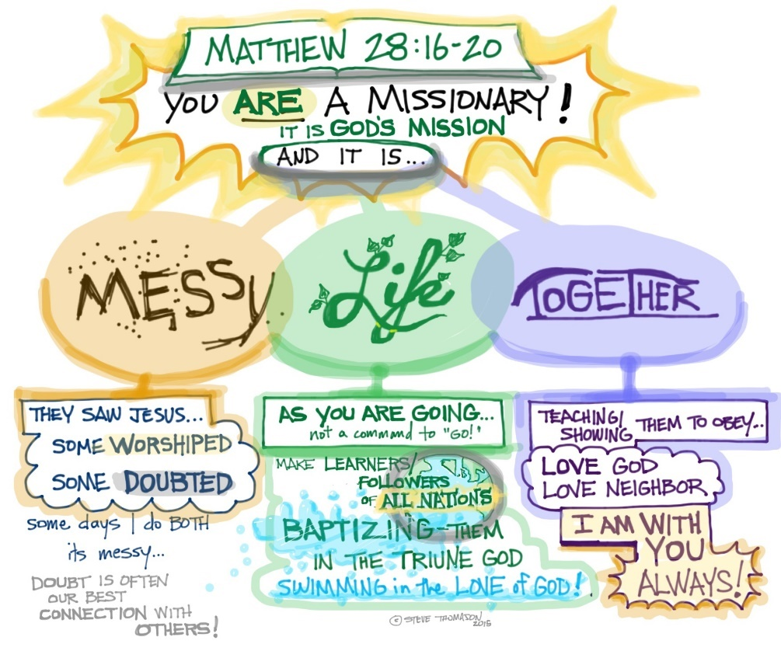

*Compassion asks us to go where it hurts, to enter into places of pain, to share in brokenness, fear, confusion, and anguish.*

*Compassion challenges us to cry out with those in misery, to mourn with those who are lonely, to weep with those in tears.*

*—* Henri J.M. Nouwen

**Congratulations!**

Dr. Christina Romero-Ivanova has been awarded the Indiana University Trustees Teaching Award! She will also have a publication coming out soon. We will send the link once it is out.

**\*\*\*\*\*\*\*\*\*\*\*\*\*\*\*\*\*\*\*\*\*\***

**Covid-19 Causes Changes**

The Center for Congregations is offering all of its workshops online and free-of-charge. To see what is being offered just go to the Center for Congregations website. Click on workshops at www.centerfor congregations.org to see your options.

**\*\*\***

The Lions Club has officially canceled the Old Settlers Day street fair for this year.

**\*\*\***

NBBC’s Strawberry Festival is cancelled for this year.

**\*\*\***

The day of the ABC-GI Annual Gathering has been changed to Sunday, August 2nd. We will be hosted by Lebanon First. If you have already sent in your registration, it will be held for the new date.

**\*\*\*\*\*\*\*\*\*\*\*\*\*\*\*\*\*\*\*\*\*\***

**Happening This Week**

Today Communion Sunday

Live-stream worship only

June 10 No Online Bible Study

7 p.m., Online Prayer Meeting using Zoom, general

connection information on website and in Today’s Thoughts; contact John Huddleston for the password

11 No Online Book Discussion

June 14 Live-stream worship only

June 21 Father’s Day

**Zoom Bible Study and Book Discussion Group**

To join Bible Study on Wednesdays at 10 a.m. or the discussion of the book *If Grace Is True* on Thursdays at 1 p.m., please contact me for connection information.

Godspeed,

Pastor Janet

**\*\*\*\*\*\*\*\*\*\*\*\*\*\*\*\*\*\*\*\*\*\***

**Worship Attendance for May 2020**

The month of May was live-streaming worship only, and attendance was about 332 with an average of about sixty-six people each week.

**\*\*\*\*\*\*\*\*\*\*\*\*\*\*\*\*\*\*\*\*\*\***

**Worship Music Copyright and Live-Streaming Permissions**

“Joy of My Desire” text and music by Jennifer Randolph;

“Instruments of Your Peace’’ text and music by Kirk and Deby

Dearman;

“Gather Us In” text and music by Marty Haugen;

“Doxology” text by Thomas Ken and music by *Genevan Psalter;*

“We Remember You” text and music by Kirk Dearman;

“Blest Be the Tie That Binds” text by John Fawcett and music by Johann

G. Naegeli.

All above selections ©1997 Word/Integrity

Used by Permission. CCLI License #1631733

“Window of the Seasons” by Jim Brickman;

“I Got Peace Like a River; I Give You Peace” by Jim Brickman;

“To a Wild Rose” by Edward MacDowell;

“Let All Things Now Living” by Faye Lopez;

“Nella Fantasia” by Ennio Morricone;

“How Beautiful” by Twila Paris;

“Turn Your Eyes Upon Jesus” by Helen Lemmel;

“Come and Sing Praises” by Morris Chapman and Greg Massanari.

Live-Streaming: Christian Copyright Solutions, WorshipCast,

License #10868

**Twelve Ways to Love Your Neighbor During COVID-19**

by Molly Stillman

1. If you have the ability to sew, make masks for those who need them.
2. Coordinate a neighborhood “social distancing” gathering. . . . just bring out a chair at the end of [the] driveway and laugh and talk with each other.
3. Become a pen pal for a grand-friend. . . . [write] letters of encouragement to people who are in nursing homes, assisted living facilities, etc. just trying to brighten their day!
4. Send a random postcard or . . . snail mail to [someone] you know could use a pick-me-up. … sending a letter or note to someone telling them why you are grateful for them could be just the message they need to hear at that moment!
5. Call and check in on friends or family members.
6. Contact your local food bank or food distribution center to find out what immediate needs they have.
7. Reach out to your church and find out if there is a family (or two) [that has] any immediate needs.
8. Offer to go grocery shopping or pickup groceries for a neighbor who is elderly, disabled, immune-compromised, a single parent, [those] out of work, etc.
9. Send a gift card to a local restaurant or restaurant delivery service to someone you know could use a blessing of a meal. This is really a double blessing because not only are you supporting a local business that could be hurting right now, but you are also blessing a family!
10. Take some sidewalk chalk and walk . . . your neighborhood and write encouraging verses of scripture, quotes, etc. to encourage others as they go about their day!
11. Offer to cut your neighbor’s grass or do any yard work that might need to be done.
12. Sponsor a child in poverty. The health systems of even the highest-income nations . . . have been pushed to the limits by this pandemic. And lower-income nations are far less equipped to deal with the consequences. There has never been a better time to connect with a child through a sponsorship program.

**Audio/Visual Grant Project Update**

New Bethel will soon welcome new technology and equipment to improve and enhance your worship experience! After much discussion amongst your lay-leaders, we have decided to hire Designed Sound & Audio to make the updates to our system.

This means that NBBC will soon be the owner of new equipment: a camcorder, two wireless mics, a computer, needed internet and electrical components, and a fancy-dancy camera.

The new wireless mics are set such that there will be no interference from others using radio signals in our area, such as the police.

The new camcorder will replace our ten-year-old camera. The old camcorder is still usable, but the technology has advanced so much that the old one is nearly obsolete.

The computer is needed to keep Rob from having to use his personal computer to run the audio/visual equipment.

The camera will hang in the sanctuary. It will be *especially* helpful when we reopen our facility and have some of you live-streaming from home and some of you in the sanctuary for worship. Also, the camera has programmable settings, meaning that it will not have to be adjusted manually throughout worship. Additionally, it will be easier to train new folks to run the camera.

This project = ~$8,000. The Center for Congregations Grant is worth $5,000, making our expense about $3,000.

I did not mention replacing the broken speakers. We tested the one we want, and it was great — no squeals or squeaks! But we need about $4,000 more to replace the speakers, and your leaders decided to wait on that purchase. In the meantime, you will notice two Fellowship Hall “speakers” on the platform in the sanctuary. This will be our “look” and sound until new speakers are purchased.

Let me know if you have questions or if you have about $4,000 looking for a place to call home! 😊

Blessings, Pastor Janet

***Dare to Be Nonviolent***

*We adopt the means of nonviolence*

*because our end is a community at peace with itself.*

*We will try to persuade with our words, but if our words fail,*

*we will try to persuade with our acts.*

— Dr. Martin Luther King, Jr.

**\*\*\*\*\*\*\*\*\*\*\*\*\*\*\*\*\*\*\*\*\*\***

**From ABC-GI Executive Minister Joan Freisen**

***As You Look to Re-Open Your Building***

While things change, they still stay the same. At the end of the week the stay-at-home order will be lifted for all of Indiana. And while you will have the freedom to gather once again, we urge great caution in moving too quickly.

Protecting vulnerable groups (those over sixty and those with medical conditions) is a key factor in making your decisions. We are anxious and ready to be gathered together for worship. We miss seeing one another! At the same time at least five of our churches will face the grief of having had members die from COVID-19 and caring for others who are sick.

Take things slow. Take precautions. Keep your masks and social distancing guidelines. Keep using on-line worship. All these things will help us be safe and healthy.

We are learning many ways to still be the church without meeting in our buildings. Others are seeing the care we have for our neighbors in providing food and other resources. God is using this time in ways we don't yet see.

A big thank you to those who have been providing extra funding for your church's ministry and are contributing to our regional work. Together we can do this!

Rev. Joan Friesen

**Here’s an Idea**

*From the Gottman Institute*

A positive need is an active want or replacement behavior — what you would like to happen, rather than what you would like to stop.

“I would like to have some quiet time to myself.” Instead of, “I need everybody to stop bothering me for just ONE second.”

“I would like you to help me do the dishes.” Instead of, “I want you to stop leaving dirty dishes in the sink.”

“I want a hug.” Instead of, “Don’t ignore me.”

Expressing a positive need helps take the guesswork out of exactly how your partner can shine for you. It’s also a great way to practice positivity and expressing wants.

**\*\*\*\*\*\*\*\*\*\*\*\*\*\*\*\*\*\*\*\*\*\***

**May Giving and Disbursements**

For the month of May, our giving and disbursements were as follows:

Month of May Year-To-Date

Tithes/Offerings $10,452.66 $54,253.73

Expenses Paid $12,015.70 $55,694.78

Gain/(Loss) ($1,563.04) ($1,441.05)

Budget Needs $12,044.17 $60,220.85

Remaining Balance

EYA Grant $0.00 $5,385.50

($1,000+$5,000)

EYA Expenses Paid $1,081.94 $4,303.56

Remaining Balance

Tech Grant ($5,000) $5,000.00 $5,000.00

Tech Expenses Paid $2,000.00 $3,000.00

If you have any questions, please contact me at 317-519-3347 or

e-mail me at njb46239@gmail.com

Janie Bryant, Treasurer

**ABC Camps Re-Imagined**

Regular camp may be cancelled but leaders have devised a new camp idea made to fit our current Covid-19 context. See the notice in this bulletin about “Camp Connect” for more information, and check the camp websites for more details.

**\*\*\*\*\*\*\*\*\*\*\*\*\*\*\*\*\*\*\*\*\*\***

**God’s Bounty Food Pantry**

COVID-19 has impacted God’s Bounty community mission. The mission is a drive-through for clients with volunteers working outside, and this probably will continue through June.

During the pandemic we have experienced a twenty-one percent increase in clients. Many of the clients are families with four to seven individuals in need.

God’s Bounty has been blessed by additional funds from Meijer, funds from a grant from Gleaners Regional Food Bank, and an additional donation via Midwest Food Bank. All of these have facilitated our ability to serve more clients.

Some of the churches sponsoring God’s Bounty have stepped up and increased donations. God’s Bounty can always use any additional donations from NBBC.

Also, some of our congregation members are volunteering to work in this difficult time, and others are committed to work and/or volunteer in the future as the grip of the pandemic and needed restrictions begin to relax.

If you can volunteer on Wednesdays from 6-7 p.m. to receive donations or Thursdays from 9-10 a.m. for the Gleaners Truck or anytime during 1-6:30 p.m. on Thursdays to serve clients, please let me know via e-mail at KPY6767@att.net or by phone 317-862-6767.

God Bless,

Paul Young

**From the Mailbox**

Thank you for your extra gift to the ABC-GI Greater Impact Endowment! You are helping us sow the seeds for ministry in the years to come. We greatly appreciate your generosity!

Blessings, Rev. Joan Friesen

***

My family and I thank all of you for the beautiful flower bouquet, cards, and thoughtful words of comfort you gave us following Phil’s death. My special thanks to Pastor Janet for doing double duty in my absence.

Jan Nagle

***

My New Bethel Family, I miss you all very much. I know you will be so glad to start coming back to church for services soon.

May God Bless You All,

Theresa Royalty

**\*\*\*\*\*\*\*\*\*\*\*\*\*\*\*\*\*\*\*\*\*\***



**A Message From ABC-USA**

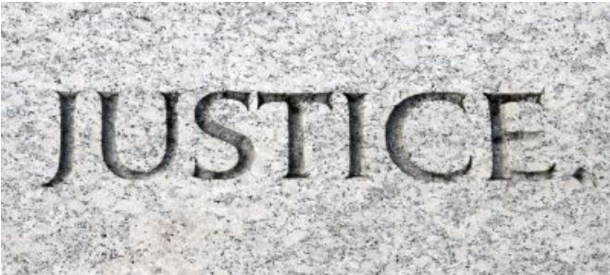Dear American Baptists,

The death of George Floyd has caused widespread pain, rage, protests, and violence in Minneapolis and across the United States. I appreciate the input received from officers of the Regional Executive Ministers Council, members of the National Executive Council, and others in constructing a response to this event. While American Baptists have never advocated violence, we grieve with those feeling the pent-up pain from years of racial discrimination and injustice. The horrifying video captured at the corner of Chicago Avenue and 38th Street in Minneapolis has released years of frustration that can never be fully understood by those who have not consistently lived with injustice historically and presently.

Acts of current racial injustice as well as the effects of historic racial injustices have been brought into the light in recent weeks as we recognize that African-Americans have been disproportionately impacted by COVID-19. In a recent study, the Centers for Disease Control found that 45% of individuals for whom race or ethnicity data was available were white, compared to 55% of individuals in the surrounding community and that 33% of hospitalized patients were black compared to 18% in the community. Unequal access to healthcare, jobs, education, and training have all been influenced by the racialized society in which we continue to live.

Unfortunately, acts of violence have been cast upon many ethnically distinct groups within our congregations and among our international partners. Many Chinese as well as Asian-Americans are being targeted, harassed, and even physically attacked because of comments made about COVID-19. In Malaysia, we are hearing reports of the government using information collected from the treatment of persons affected by COVID-19 for deportation despite earlier statements that no one who sought medical services for the coronavirus would be arrested based on their immigration status.

Racism and Xenophobia have deep roots in American history and culture, and wrongs cannot be righted overnight. While expeditious action is critical to the pursuit of justice for GeorgeFloyd, dialogue, conversation, systemic change, and continued acts of justice to curb the sources of prejudice and discrimination are needed.

In these tense times of ache and agony and stinging memories of bias and wrongdoing, we are called again to combat racism and resist violence. American Baptists have historically advocated against both violence as well as racial injustice. “Our denominational history is rich with resistance against violence. From Roger Williams speaking in defense of First Nations People, to the Abolitionists, down to Walter Rauschenbusch, and Martin Luther King, American Baptists in particular have been on the forefront for the cessation of violence and the coming of Shalom” (American Baptist Case Statement on Violence from the 2015 Mission Table). I am calling on people of faith to find the resources of the Spirit to calm their anger. “Lead a life worthy of the calling to which you have been called, with all humility and gentleness, with patience, bearing with one another in love, making every effort to maintain the unity of the Spirit in the bond of peace” (Ephesians 4:1-3, NASV).

Our denominational history is also rich in working toward justice in general and racial justice in particular. “Racial justice,” as defined in our 1989 ABCUSA policy statement, “is recognizing our oneness in Christ, confessing that we have not become what God wants us to be, and committing ourselves to pressing on to that mark of high calling by which we can become a liberating symbol to our nation and world of what it means to be the people of God. In so doing, we can challenge our nation to live up to its high purposes.”

“Thus says the Lord: Stand at the crossroads, and look, and ask for the ancient paths, where the good way lies; and walk in it, and find rest for your souls” (Jeremiah 6:16, NASV). I charge our American Baptist family to continue to search, advocate, and live where the good way lies.

Dr. C. Jeff Woods

Interim General Secretary

American Baptist Churches USA