**Welcome to New Bethel Baptist Church**

**Sunday, July 19, 2020**

**Prelude** Dr. Christina Romero-Ivanova

\***Gathering Hymn** *He Has Made Me Glad*  #214

**\*Call to Worship**

Leader: You are the sower, O God; we are the seed.

**People: God’s word is being sown in our lives this day**

**with the promise of new growth.**

Leader**:** You are the lover, O God; we are the beloved.

**People: God’s love blossoms in our lives with a beauty**

**greater than the lilies of the field.**

Leader: You are the healer, O God; we are the healed.

**People: God’s healing flows through our lives with every**

**beat of our heart.**

Leader: You are the Potter, O God, we are the clay.

**People: God’s hand fashions us to shine with the glory**

**of Christ’s light.**

**Unison: Come! Let us worship the one who sows us in**

**fields of love.**

**\*Invocation and Lord’s Prayer** (*using “sins”*) Karen Pappas

**Scripture Reading** Romans 8:1-11 Karen Pappas

**Worship Prayer**   Pastor Janet

**\*Hymn** *Come Holy Spirit*#382

**Children’s Message** Julianne Thomas

**Scripture Reflection**  Matthew 13:1-9, 18-23 Pastor Janet

**\*Hymn** *Holy, Holy, Holy! Lord God Almighty*  #3

**Ministry Opportunities** Karen Pappas

How to Give Tithes and Offerings

*Doxology #815

*Prayer Karen Pappas

**Benediction** Pastor Janet

**Postlude** Dr. Christina Romero-Ivanova

**Update to the NBBC Website**

Find Pastor Janet’s e-mail messages, Daily Scripture Readings, Online Giving, Today’s Thoughts, and other information about our online ministry on a tab entitled “Weekly Online Ministry” on the church website — http://www.newbethelbapt.org

**\*\*\*\*\*\*\*\*\*\*\*\*\*\*\*\*\*\*\***

**ABC-GI 2020 Annual Gathering**

The 2020 ABC-GI Annual Gathering will be a virtual gathering, hosted on Sunday, August 2nd at 6 p.m.by New Era Church at [www.nne.org](http://www.nne.org)

A downloadable worship guide will be available soon. Stay tuned for more details.

**\*\*\*\*\*\*\*\*\*\*\*\*\*\*\*\*\*\*\***

**Daily Scripture Readings for This Week**

Monday, July 20, 2020: Psalm 139:13-18; Genesis 32:3-21;

Revelation 14:12-20 or Psalm 75; Nahum 1:1-13

Tuesday, July 21, 2020: Psalm 139:13-18; Genesis 33:1-17;

Galatians 4:21-5:1 or Psalm 75; Zephaniah 3:1-13

Wednesday, July 22, 2020: Psalm 139:13-18; Genesis 35:16-29;

Matthew 12:15-21 or Psalm 75; Daniel 12:1-13

Thursday, July 23, 2020: Psalm 105:1-11, 45b; Genesis 29:1-8;

1 Corinthians 4:14-20 or Psalm 119:129-136;

1 Kings 1:28-37

Friday, July 24, 2020: Psalm 105:1-11, 45b; Genesis 29:9-14;

Acts 7:44-53 or Psalm 119:129-136; 1 Kings 1:38-48

Saturday, July 25, 2020: Psalm 105:1-11, 45b;

Genesis 29:31-30:24; Matthew 12:38-42 or

Psalm 119:129-136; 1 Kings 2:1-4

Sunday, July 26, 2020: Genesis 29:15-28; Psalm 105:1-11, 45b;

Psalm 128; 1 Kings 3:5-12; Psalm 119:129-136;

Romans 8:26-39; Matthew 13:31-33, 44-52

**Welcome to New Bethel Baptist Church**

**We are blessed by your presence!**

**Sunday, July 19, 2020**

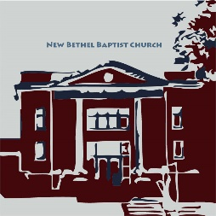

**Guests and Members:**  If you have questions or would like more information about New Bethel, please feel free to contact the church office. Thank you!

*An American Baptist*

*Congregation*

**\*\*\*\*\*\***

**All Are Welcome**

**Weekly Activities Online Only**

Wednesdays online Bible Study 10 a.m.

Thursdays online Book Discussion, *If Grace Is True,* 1 p.m.

10:30 a.m., Sunday Worship, live-stream only

**\*\*\*\*\*\***

**Contact Information**

New Bethel Baptist Church Website: www.newbethelbapt.org

8936 Southeastern Avenue E-mail: newbethelbapt@att.net

Indianapolis, IN 46239 Wi-fi password: NBBC8624381

317-862-4381 Instagram: NBBC.Wanamaker

YouTube: New Bethel Baptist

Church Wanamaker

https://facebook.com New Bethel Baptist.Wanamaker

Rev. Dr. Janet F. Hoover, Pastor

Jan Nagle, Secretary

Church Office Hours: contact Pastor or NBBC Secretary

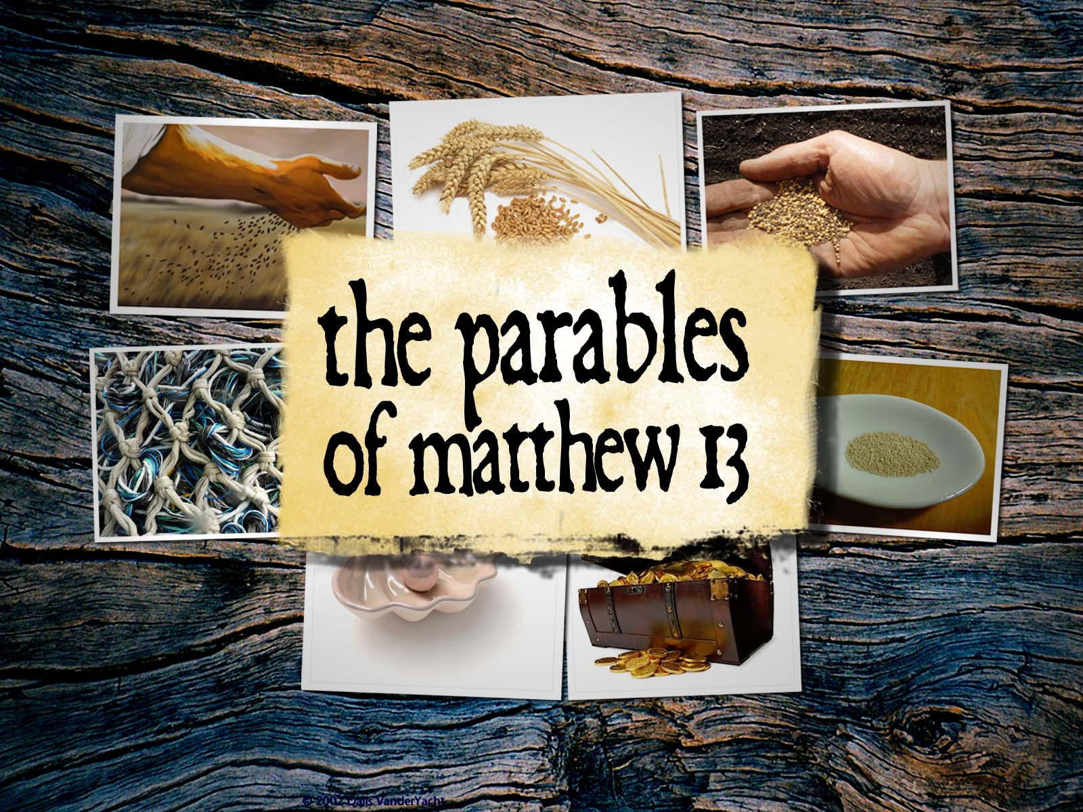

*The place God calls you to*

*is the place where your deep gladness*

*and the world's deep hunger* *meet.*

— Frederick Buechner

**Covid-19 Causes Changes**

The Center for Congregations is offering all of its workshops online and free-of-charge. To see what is being offered just go to the Center for Congregations website. Click on workshops at www.centerfor congregations.org to see your options.

**\*\*\*\*\*\*\*\*\*\*\*\*\*\*\*\*\*\*\*\*\*\***

*The price for real transformation is high.*

*It means that we have to change*

*our loyalties from power,*

*success, money, ego, and control*

*to the imitation of a Vulnerable God*

*where servanthood, surrender,*

*and simplicity reign.*

*—* Richard Rohr

**\*\*\*\*\*\*\*\*\*\*\*\*\*\*\*\*\*\*\*\*\*\***

*You must never be fearful*

*about what you are doing*

*when it is right.*

*—* Rosa Parks

**\*\*\*\*\*\*\*\*\*\*\*\*\*\*\*\*\*\*\*\*\*\***

**Happening This Week**

Today Live-stream worship only

22 10 a.m., Online Bible Study, contact Pastor for

connection information to Zoom, weekly

scriptures in bulletin and on website

23 1 p.m., Online Book Discussion, *If Grace Is True,*

contact Pastor for connection information to zoom

**Zoom Bible Study and Book Discussion Group**

To join Bible Study on Wednesdays at 10 a.m. or the discussion of the book *If Grace Is True* on Thursdays at 1 p.m., please contact me for connection information.

Godspeed, Pastor Janet

**\*\*\*\*\*\*\*\*\*\*\*\*\*\*\*\*\*\*\*\*\*\***

**Thank You and Blessings to . . .**

* Thank you to Julianne for re-potting the plants in the sanctuary.
* Thank you to Lori for ordering more masks and hand cleaner.

**\*\*\*\*\*\*\*\*\*\*\*\*\*\*\*\*\*\*\*\***

**Worship Music Copyright and Live-Streaming Permissions**

“He Has Made Me Glad” text and music by Leona Von Brethorst;

“Come, Holy Spirit’’ text by Gloria Gaither and William J. Gaither and

music by William J. Gaither;

“Holy, Holy, Holy! Lord God Almighty” text by Reginald Herber

and music by John B. Dykes;

“Doxology” text by Thomas Ken and music by *Genevan Psalter.*

All above selections ©1997 Word/Integrity

Used by Permission. CCLI License #1631733

“Breath of Heaven” by Jim Brickman;

“Faith” by Jim Brickman;

“Mountain Suite Overture” by Bill George, Dino Kartsonakis;

“Moment by Moment” by May W. Moody, Daniel W. Whittle;

“Majesty” by Jack W. Hayford;

“Let All Things Now Living” by Faye Lopez;

“Sun of My Soul” by Faye Lopez;

“Thy Word” by Amy Grant, Michael W. Smith;

“In Moments Like These” by David Graham.

Live-Streaming: Christian Copyright Solutions, WorshipCast,

License #10868



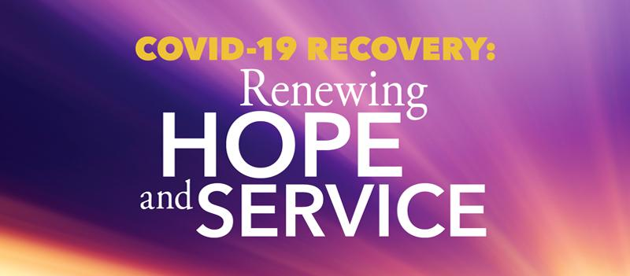**You Can Help Those Affected by Covid-19 Across the United States and Puerto Rico**

Help ABHMS to help those affected by COVID-19 across the United States and Puerto Rico by raising $1,000,000 through its One Great Hour of Sharing (OGHS) "COVID-19 Recovery: Renewing Hope and Service" campaign, on behalf of American Baptist Churches USA.

Cristal and Javier, a married couple in Puerto Rico, have been working remotely since the quarantine began. They find that they are saving on expenses such as gasoline and dining at restaurants. They are also members of a small church with limited financial resources. They have decided to coordinate with their pastor to identify fellow parishioners in need, mostly elderly members. Each week they will redirect the money they are saving to supply the needs of their brothers and sisters. In a moment like this, they are blessed and use their situation to bless others.

To give to OGHS for support of relief initiatives across the United States and Puerto Rico, donations can be made online, via your church, or check payable to American Baptist Home Mission Societies and mailed to the attention of Leda Carter at American Baptist Home Mission Societies, 1075 First Ave., King of Prussia, PA 19406. Write "OGHS-COVID Recovery: US & PR" on the memo line.

One hundred percent of donations go to relief efforts; no dollars are retained for administrative costs.

To hear more stories of how American Baptists are being affected by the Coronavirus, listen to a new podcast every week on abhms.org or ministrElife.org.

*No matter what happens, be gentle with yourself.*

— Jeanne de Chantal

**\*\*\*\*\*\*\*\*\*\*\*\*\*\*\*\*\*\*\*\*\*\***

To sign up visit the website by [*CLICKING HERE*](http://r20.rs6.net/tn.jsp?f=001i9sU9ZqjeFVJ15YEP6y-eSrpqCrbuGraA6LD2fozXjfQZCdMgYwg5mRBhLyRKpRmRfPQsxkvoNN_ux8uV8qgzLFdPg-dA0Gx1xFUeVXOopwpWzX8tt1kNneLNZoJ5on38W2h20bcUVgbv6ZkXjBmBn7EaZ6dCOv5iIlfoLCfndc=&c=4sueAw2VpYRSMBJJhvZeLBVysOD1EwSPa2efjMmj8gDFWsUEfQp8Ag==&ch=s_eqOV8s6l8u7NaYxftHCHJzy3NjLd152xJEphIREzjuXP5b9a8HPQ==)

If you have questions [*CLICK HERE*](mailto:indiancreek@abc-indiana.org) to send an email

[*CLICK HERE*](http://r20.rs6.net/tn.jsp?f=001i9sU9ZqjeFVJ15YEP6y-eSrpqCrbuGraA6LD2fozXjfQZCdMgYwg5qcdDH5Ajm_q8btSTcbnGSaX2K40FIDiOX4VwmNXmuUJ9v8q9rpCQiKx1dvxrx3gJLrIW_Waqu3RwXbxM1XJqUvr0YhEgIhuOg==&c=4sueAw2VpYRSMBJJhvZeLBVysOD1EwSPa2efjMmj8gDFWsUEfQp8Ag==&ch=s_eqOV8s6l8u7NaYxftHCHJzy3NjLd152xJEphIREzjuXP5b9a8HPQ==) for a promotional video about Camp connect

[*CLICK HERE*](http://r20.rs6.net/tn.jsp?f=001i9sU9ZqjeFVJ15YEP6y-eSrpqCrbuGraA6LD2fozXjfQZCdMgYwg5qcdDH5Ajm_qItOpf_5qvCgC1nZoS5_Vp7z1o8rgaTnB8ECmu8WtzezCYoju5_nTyPIY-_P--pwmlVZKaQONhexaXDB68HPtTnOWZ2NrrYiwcZDo0m8Sn80DP2T2DfLyoxCnVSCb0qRJI7ybEmq1WcJls3VoMbek6RM9oL5ErgJYT3Wq-nEc4bo=&c=4sueAw2VpYRSMBJJhvZeLBVysOD1EwSPa2efjMmj8gDFWsUEfQp8Ag==&ch=s_eqOV8s6l8u7NaYxftHCHJzy3NjLd152xJEphIREzjuXP5b9a8HPQ==) for info about the Senior High Camp Connect