**Welcome to New Bethel Baptist Church**

**Sunday, July 26, 2020**

**Prelude** Dr. Christina Romero-Ivanova

\***Gathering Hymn** *He Has Made Me Glad*  #214

**\*Call to Worship**

Leader: Holy one, we come before you with sighs too deep

for words.

**People: We come with hearts overwhelmed by the**

**world, by personal relationships, and by inward struggles.**

Leader**:** We come to praise your name and to be reassured

of your unending grace.

**People: In this time and place, open our hearts to your**

**presence.**

Leader: Open our ears to hear your word proclaimed.

**People: Open our eyes and our minds to you.**

**Unison:** **Praise the Lord!** **Let us worship our creator,**

**redeemer, and sustainer!**

**\*Invocation and Lord’s Prayer** (*using “sins”*) Karen Pappas

**Scripture Reading** Romans 8:26-39 Karen Pappas

**Licensing Julianne Thomas to the Christian Ministry**

Rev. Joan Friesen

**Worship Prayer**   Pastor Janet

**\*Hymn** *O Love That Will Not Let Me Go*#606

**Children’s Message** Julianne Thomas

**Scripture Reflection**  Matthew 13:31-33, 44-52 Pastor Janet

**\*Hymn** *How Great Thou Art* #147

**Ministry Opportunities** Karen Pappas

How to Give Tithes and Offerings

*Doxology #815

*Prayer Karen Pappas

**Benediction** Pastor Janet

**Postlude** Dr. Christina Romero-Ivanova

**Welcome, Rev. Joan Friesen**

We welcome ABC-GI Executive Minster Rev. Joan Friesen to NBBC. Rev. Friesen is presenting Julianne Thomas with her License for Christian Ministry.

**\*\*\*\*\*\*\*\*\*\*\*\*\*\*\*\*\*\*\***

**Update to the NBBC Website**

Find Pastor Janet’s e-mail messages, Daily Scripture Readings, Online Giving, Today’s Thoughts, and other information about our online ministry on a tab entitled “Weekly Online Ministry” on the church website — http://www.newbethelbapt.org

**\*\*\*\*\*\*\*\*\*\*\*\*\*\*\*\*\*\*\***

*We’re here for one thing, ultimately:*

*to learn how to love, because God is love.*

*Love is our origin, love is our ground,*

*and love is our destiny.*

* James Finley

**\*\*\*\*\*\*\*\*\*\*\*\*\*\*\*\*\*\*\***

**Daily Scripture Readings for This Week**

Monday, July 27, 2020: Psalm 65:8-13; Genesis 30:25-36;

James 3:13-18 or Psalm 119:121-128; 1 Kings 3:16-28

Tuesday, July 28, 2020: Psalm 65:8-13; Genesis 30:37-43;

Ephesians 6:10-18 or Psalm 119:121-128; 1 Kings 4:29-34

Wednesday, July 29, 2020: Psalm 65:8-13; Genesis 46:2-14:12;

Mark 4:30-34 or Psalm 119:121-128; Proverbs 1:1-7, 20-33

Thursday, July 30, 2020: Psalm 17:1-7, 15; Isaiah 14:1-2;

Philippians 4:10-15 or Psalm 145:8-9, 14-21;

Proverbs 10:1-5

Friday, July 31, 2020: Psalm 17:1-7, 15; Isaiah 41:8-10;

Romans 9:6-13 or Psalm 145:8-9, 14-21; Isaiah 51:17-23

Saturday, August 1, 2020: Psalm 17:1-7, 15; Genesis 31:1-21;

Matthew 7:7-11 or Psalm 145:8-9, 14-21; Isaiah 44:1-5

Sunday, August 2, 2020: Genesis 32:22-31; Psalm 17:1-7, 15;

Isaiah 55:1-5; Psalm 145:8-9, 14-21; Romans 9:1-5; Matthew 14:13-21

**Welcome to New Bethel Baptist Church**

**We are blessed by your presence!**

**Sunday, July 26, 2020**

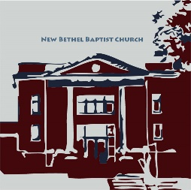

**Guests and Members:**  If you have questions or would like more information about New Bethel, please feel free to contact the church office. Thank you!

*An American Baptist*

*Congregation*

**\*\*\*\*\*\***

**All Are Welcome**

**Weekly Activities Online Only**

Wednesdays online Bible Study 10 a.m.

Thursdays online Book Discussion, *If Grace Is True,* 1 p.m.

10:30 a.m., Sunday Worship, live-stream only

**\*\*\*\*\*\***

**Contact Information**

New Bethel Baptist Church Website: www.newbethelbapt.org

8936 Southeastern Avenue E-mail: newbethelbapt@att.net

Indianapolis, IN 46239 Wi-fi password: NBBC8624381

317-862-4381 Instagram: NBBC.Wanamaker

YouTube: New Bethel Baptist

Church Wanamaker

https://facebook.com New Bethel Baptist.Wanamaker

Rev. Dr. Janet F. Hoover, Pastor

Jan Nagle, Secretary

Church Office Hours: contact Pastor or NBBC Secretary

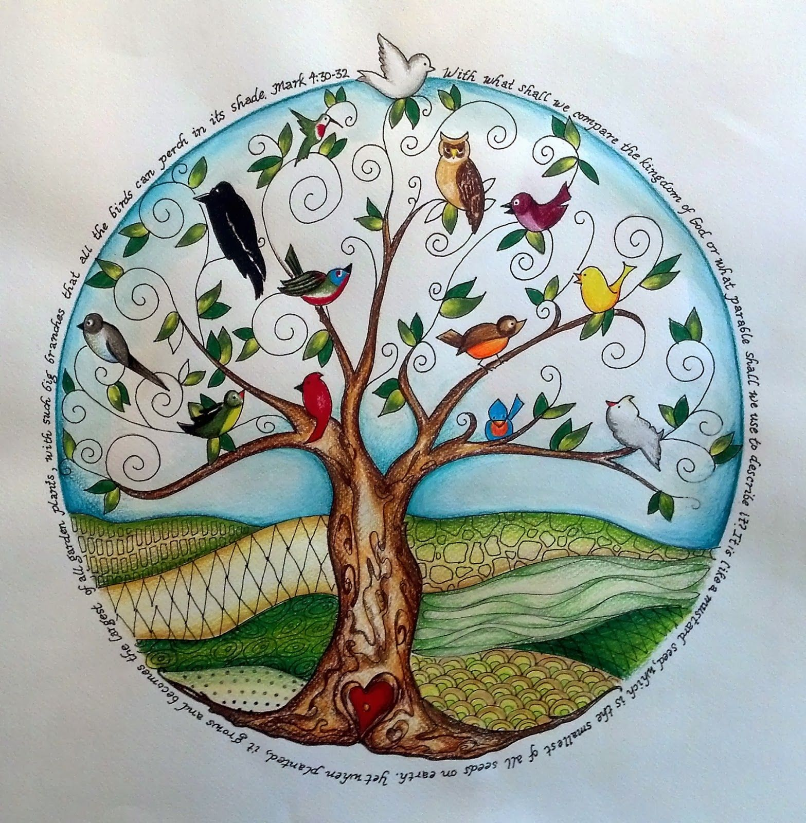

*The word “change” normally*

*refers to new beginnings.*

*But the mystery of transformation*

*more often happens*

*not when something new begins,*

*but when something old falls apart.*

— Richard Rohr

**Covid-19 Causes Changes**

The Center for Congregations is offering its workshops online and free-of-charge. To see what is being offered, go to the Center for Congregations website at www.centerfor congregations.org to see your options.

**\*\*\*\*\*\*\*\*\*\*\*\*\*\*\*\*\*\*\*\*\*\***

*As a spiritual practice, we can wake up to*

*the possibility of building a new order.*

*We can improvise those possibilities;*

*try them out in the creative microcosm*

*of a shared public life, realizing that our way*

*of life before the pandemic was not perfect.*

*—* Barbara Holmes

**\*\*\*\*\*\*\*\*\*\*\*\*\*\*\*\*\*\*\*\*\*\***

**ABC-GI 2020 Annual Gathering**

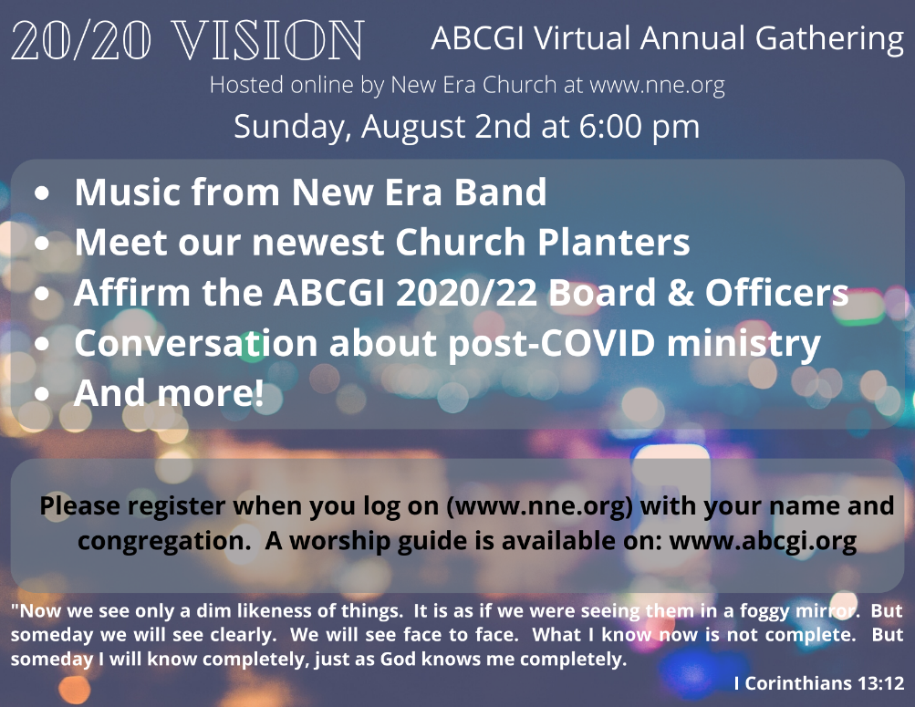

**Happening This Week**

Today Live-stream worship only

29 10 a.m., Online Bible Study, contact Pastor for

connection information to Zoom, weekly

scriptures in bulletin and on website

30 1 p.m., Online Book Discussion, *If God Is Love,*

contact Pastor for the Zoom connection

August 2 Live-stream worship only

Communion Sunday

6 p.m., ABC-GI Annual Meeting, virtual only at

www.nne.org, see more information in the ad elsewhere in the bulletin, including where to get a worship guide

5 10 a.m., Online Bible Study

6 1 p.m., Online Book Discussion

**\*\*\*\*\*\*\*\*\*\*\*\*\*\*\*\*\*\*\*\***

**Worship Music Copyright and Live-Streaming Permissions**

“He Has Made Me Glad” text and music by Leona Von Brethorst;

“O Love That Will Not Let Me Go’’ text by George Matheson and music

by Albert L. Peace;

“How Great Thou Art” text by Stuart K. Hine, Swedish Folk melody

adapted by Stuart K. Hine;

“Doxology” text by Thomas Ken and music by *Genevan Psalter.*

All above selections ©1997 Word/Integrity

Used by Permission. CCLI License #1631733

“Nella Fantasia” by Ennio Morricone;

“I Have Fixed My Mind” by David Huntsinger;

“Blessings” by Laura Story;

“Wanderlust” by Jim Brickman;

“Heartland” by Jim Brickman;

“Come and Sing Praises” by Morris Chapman, Greg Massanri;

“Great Are You, Lord” by Steve and Vikki Cook.

Live-Streaming: Christian Copyright Solutions, WorshipCast,

License #10868

*Joy does not simply happen to us.*

*We have to choose joy*

*and keep choosing it every day.*

* Henri Nouwen

**\*\*\*\*\*\*\*\*\*\*\*\*\*\*\*\*\*\*\*\*\*\***

**Covid and Worship Survey Results**

Many thanks to all of you who responded to the survey. Your input was greatly appreciated.

Where there were spouses or children involved in an answer, those individuals were included in the final number of respondents.

There were forty-five people involved in the responses to the survey which relates to seventy-five percent of our average congregation responding.

Only seven respondents answered all three questions. All others either referred to only one of the questions or wrote more personal comments.

**Would you attend Church without music?**

**Yes, I would: 10 No, I would Not: 1**

**Would you attend worship before there is a vaccine?**

**Yes: 3 No: 10**

**Are you ready now?**

**Yes: 17 No: 16**

With the recent rise of positive Covid-19 cases in Indiana, the question which comes to mind would be: those who responded “yes” that you wanted to return to worship in the sanctuary, would you still say “yes” to in-person worship?

Blessings to all,

Sue Winton, Deacon Chair

**Zoom Bible Study and Book Discussion Group**

To join Bible Study on Wednesdays at 10 a.m. or the discussion of the book *If God Is Love* on Thursdays at 1 p.m., please contact me for connection information.

Godspeed, Pastor Janet

**\*\*\*\*\*\*\*\*\*\*\*\*\*\*\*\*\*\*\*\*\*\***

**Retirement Announcement**

To: Rev. Dr. Janet F. Hoover

Date: July 13, 2020

Dear Rev. Hoover,

It has been a pleasure to work with you for the past few years and to be a dual member of New Bethel Baptist Church. I have enjoyed all my responsibilities and the people I have worked with in different areas of the church. I have learned a great deal from you about being a Church Secretary, a Trustee, and a member of the community. It is with sadness, but also with joy, that I write this letter of resignation about my upcoming second retirement. After my husband’s sudden death, my life changed, and new opportunities have opened up for me, and I feel the need to spread my wings and follow where I feel God is leading me. This resignation is not only for my church secretary job, but as the Church Council Secretary, Co-chair of the Event Team, and Trustee Secretary. My last day of employment will be August 14th, 2020.

Jan Nagle

**\*\*\*\*\*\*\*\*\*\*\*\*\*\*\*\*\*\*\*\*\*\***

**Congratulations!**

Lisa Caffrey received her certificate of completion at My Computer Career with an achievement as World Class IT Professional.

***

Dr. Christina Romero-Ivanova had another article published. Here is the link: <https://issuu.com/indianaliteracyjournal/docs/spring_2020_issue?fr=sNzM5YzE2MDg1Mjk>