**Welcome to New Bethel Baptist Church**

**Sunday, July 5, 2020**

**Prelude** Dr. Christina Romero-Ivanova

\***Gathering Hymn** *He Has Made Me Glad*  #214

**\*Call to Worship**

Leader: All the doubt in the world cannot wash away our

inheritance from God,

**People: an inheritance of love, refuge, and strength.**

**Unison: Come, let us worship the Lord.**

**\*Invocation and Lord’s Prayer** (*using “sins”*) Karen Pappas

**Scripture Reading** John 8:34-38 Karen Pappas

**Worship Prayer**   Pastor Janet

**\*Hymn** *It Is Well with My Soul*#705

**Scripture Reflection**  Galatians 5:1-25 Pastor Janet

**\*Hymn** *More About Jesus*  #560

**Ministry Opportunities** Karen Pappas

How to Give Tithes and Offerings

*Doxology #815

*Prayer Karen Pappas

**Communion Hymn** *Let Us Break Bread Together*#460

**Communion** Pastor Janet

**\*Closing Hymn** *Blest Be the Tie That Binds*#426

**Birthdays and Anniversary Blessings** Karen Pappas

**Postlude** Dr. Christina Romero-Ivanova

**Congratulations!**

Kevin Winton received Beech Grove Alumni Association Teacher of the Year Award on June 29th, 2020! The award is annually presented by Beech Grove Alumni Association. Way to go, Kevin!

**\*\*\*\*\*\*\*\*\*\*\*\*\*\*\*\*\*\*\***

*Faith is the word that describes*

*the direction our feet start moving*

*when we find that we are loved.*

*Faith is stepping out into*

*the unknown with nothing*

*to guide us but a hand*

*just beyond our grasp.*

— Frederick Buechner

**\*\*\*\*\*\*\*\*\*\*\*\*\*\*\*\*\*\*\***

**Daily Scripture Readings for This Week**

Monday, July 6, 2020: Genesis 27:30-46; Romans 1:18-25; or

Psalm 131; Jeremiah 27:1-11, 16-22

Tuesday, July 7, 2020: Genesis 29:1-14; Romans 3:1-8 or

Psalm 131; Jeremiah 28:10-17

Wednesday, July 8, 2020: Genesis 29:31-35; John 13:1-17 or

Psalm 131; Jeremiah 13:1-11

Thursday, July 9, 2020: Psalm 119:105-112; Exodus 3:1-6;

Romans 2:12-16 or Psalm 65:9-13; Isaiah 48:1-5

Friday, July 10, 2020: Psalm 119:105-112; Deuteronomy 32:1-10;

Romans 15:14-21 or Psalm 65:9-13; Isaiah 48:6-11

Saturday, July 11, 2020: Psalm 119:105-112; Isaiah 2:1-4;

John 12:44-50 or Psalm 65:9-13; Isaiah 52:1-6

Sunday, July 12, 2020: Genesis 25:19-34; Psalm 119:105-112;

Isaiah 55:10-13; Psalm 65:1-13; Romans 8:1-11;

Matthew 13:1-9, 18-23

**Welcome to New Bethel Baptist Church**

**We are blessed by your presence!**

**Sunday, July 5, 2020**

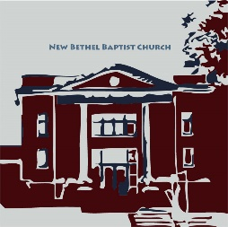

**Guests and Members:**  If you have questions or would like more information about New Bethel, please feel free to contact the church office. Thank you!

*An American Baptist*

*Congregation*

**\*\*\*\*\*\***

**All Are Welcome**

**Weekly Activities Online Only**

Wednesdays online Bible Study 10 a.m.

Thursdays online Book Discussion, *If Grace Is True,* 1 p.m.

10:30 a.m., Sunday Worship, live-stream only

**\*\*\*\*\*\***

**Contact Information**

New Bethel Baptist Church Website: www.newbethelbapt.org

8936 Southeastern Avenue E-mail: newbethelbapt@att.net

Indianapolis, IN 46239 Wi-fi password: NBBC8624381

317-862-4381 Instagram: NBBC.Wanamaker

YouTube: New Bethel Baptist

Church Wanamaker

https://facebook.com New Bethel Baptist.Wanamaker

Rev. Dr. Janet F. Hoover, Pastor

Jan Nagle, Secretary

Church Office Hours: contact Pastor or NBBC Secretary

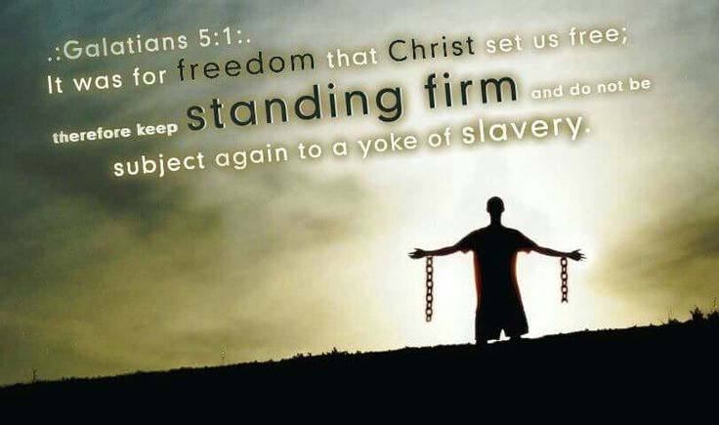

*The truth that makes men free*

*is for the most part the truth*

*which men prefer not to hear.*

*―* Herbert Agar

**Covid-19 Causes Changes**

The Center for Congregations is offering all of its workshops online and free-of-charge. To see what is being offered just go to the Center for Congregations website. Click on workshops at www.centerfor congregations.org to see your options.

**\*\*\*\*\*\*\*\*\*\*\*\*\*\*\*\*\*\*\*\*\*\***

**ABC-GI 2020 Annual Gathering**

The 2020 ABC-GI Annual Gathering will be a virtual gathering, hosted on Sunday, August 2nd at 6 p.m.by New Era Church at [www.nne.org](http://www.nne.org)

A downloadable worship guide will be available soon. Stay tuned for more details.

**\*\*\*\*\*\*\*\*\*\*\*\*\*\*\*\*\*\*\*\*\*\***

*To sacrifice something*

*is to make it holy*

*by giving it away for love.*

*—* Frederick Buechner

**\*\*\*\*\*\*\*\*\*\*\*\*\*\*\*\*\*\*\*\*\*\***

**Happening This Week**

Today Communion Sunday

Live-stream worship only

July 6-11 Church Secretary on vacation, please contact Pastor

Janet with any questions

8 10 a.m., Online Bible Study, contact Pastor for

connection information to Zoom, weekly

6:30 p.m., EYA Zoom meeting

scriptures in bulletin and on website

9 1 p.m., Online Book Discussion, *If Grace Is True,*

contact Pastor for connection information to zoom

**Zoom Bible Study and Book Discussion Group**

To join Bible Study on Wednesdays at 10 a.m. or the discussion of the book *If Grace Is True* on Thursdays at 1 p.m., please contact me for connection information.

Godspeed,

Pastor Janet

**\*\*\*\*\*\*\*\*\*\*\*\*\*\*\*\*\*\*\*\*\*\***

**Worship Music Copyright and Live-Streaming Permissions**

“He Has Made Me Glad” text and music by Leona Von Brethorst;

“It Is Well with My Soul’’ text by Horatio G. Spafford and music by

Philip P. Bliss;

“More About Jesus” text by Eliza E. Hewitt and music by

John R. Sweney;

“Let Us Break Bread Together: text and music a Traditional Spiritual,

arranged by Keith Phillips

“Doxology” text by Thomas Ken and music by *Genevan Psalter;*

“Blest Be the Tie That Binds” text by John Fawcett and music by

Johann G. Naegeli.

All above selections ©1997 Word/Integrity

Used by Permission. CCLI License #1631733

“Faith” by Jim Brickman;

“Tis So Sweet” by Jim Brickman;

“Angel’s Blessing” by Jim Brickman;

“Love Can Build a Bridge” by Naomi Judd, John Barlow Jarvis,

Paul Overstreet;

“In Times Like These” by Ruth Caye Jones;

“Side by Side” by Jeff Wood;

“Pass it On” by Kurt Kaiser;

“Come and Sing Praises” by Morris Chapman, Greg Massanari;

“The Worship Song” by Celeste Yohai;

“Great Are You, Lord” by Steve and Vikki Cook.

Live-Streaming: Christian Copyright Solutions, WorshipCast,

License #10868



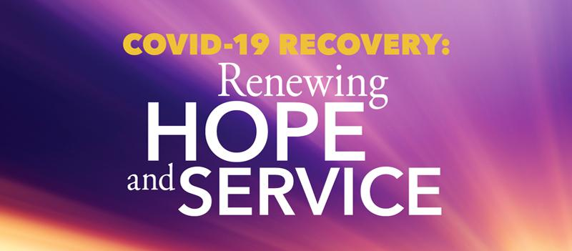**You Can Help Those Affected by Covid-19 Across the United States and Puerto Rico**

Help ABHMS to help those affected by COVID-19 across the United States and Puerto Rico by raising $1,000,000 through its One Great Hour of Sharing (OGHS) "COVID-19 Recovery: Renewing Hope and Service" campaign, on behalf of American Baptist Churches USA.

Cristal and Javier, a married couple in Puerto Rico, have been working remotely since the quarantine began. They find that they are saving on expenses such as gasoline and dining at restaurants. They are also members of a small church with limited financial resources. They have decided to coordinate with their pastor to identify fellow parishioners in need, mostly elderly members. Each week they will redirect the money they are saving to supply the needs of their brothers and sisters. In a moment like this, they are blessed and use their situation to bless others.

To give to OGHS for support of relief initiatives across the United States and Puerto Rico, donations can be made online, via your church, or check payable to American Baptist Home Mission Societies and mailed to the attention of Leda Carter at American Baptist Home Mission Societies, 1075 First Ave., King of Prussia, PA 19406. Write "OGHS-COVID Recovery: US & PR" on the memo line.

One hundred percent of donations go to relief efforts; no dollars are retained for administrative costs.

To hear more stories of how American Baptists are being affected by the Coronavirus, listen to a new podcast every week on abhms.org or ministrElife.org.

**An Update from The Moderator**

Dear Friends,

I ran into a high school classmate at Kroger. We had not crossed paths for at least two decades and immediately reached out to shake hands out of habit without considering the guidelines set out by the CDC. We did get a couple of concerned looks from other shoppers. I did not realize how much I miss the simple act of shaking hands with a friend. We are working on a plan to safely and responsibly reopen the doors of New Bethel Baptist Church.

The Church Council is working to follow guidelines and protocol established by the CDC, Gov. Holcomb’s office, Mayor Hogsett, and the Marion County Health Department. A church setting is unique as we gather in a confined area for an extended time period and lift our voices in song.

In talks with my school superintendent, we discussed the responsibility of making a decision that could have a major health impact on the community. The goal is to be able to continue to worship and keep all safe and healthy. We are looking forward to a large celebration when we return and gather together again.

We hope all understand the decision to remain closed at least through the month of July. Please continue to communicate with one another via email, text, and phone calls, as well as continue to worship with us on Sunday mornings. God will continue to work through us and bless us. Please look at the questions listed below. Please call your Deacon Flock Shepherd or Deacon Chair Sue Winton with your response to the following:

**When would you be comfortable returning to a church setting**

**with masks required to attend worship?**

**a) Would you worship in the sanctuary if there were no singing**

**during the service?**

**b) Do you plan to wait to attend service until there is a vaccine**

**for COVID – 19?**

**c) I am ready now.**

Peace and Good Health, Kevin Winton

**Thank You and Blessings to . . .**

* Thank you to Rob for all the time and effort he donates for our live streaming each Sunday.
* Thank you to all those who responded to the survey questions concerning the reopening of NBBC.
* Thank you to Bill and Rob for installing the sound equipment.

**\*\*\*\*\*\*\*\*\*\*\*\*\*\*\*\*\*\*\*\*\*\***

**Did You Lose?**

A set of 4 keys was turned into the church office. If you think they are yours, please call the church office and leave a message.

**\*\*\*\*\*\*\*\*\*\*\*\*\*\*\*\*\*\*\*\*\*\***

**June Giving and Disbursements**

For the month of May, our giving and disbursements were as follows:

2020 Finances and Attendance Month of June Year-To-Date

Tithes/Offerings $6,608.85 $60,862.58

Expenses Paid $9,964.02 $65,658.80

Gain/(Loss) ($3,355.17) ($4,796.22)

Budget Needs $12,044.17 $72,265.02

Average Weekly Worship Attendance in June was 62 each week.

Remaining Balance

EYA Grant ($1,000+$5,000) $0.00 $5,385.50

EYA Expenses Paid $1,081.94 $4,303.56

Remaining Balance

Tech Grant ($5,000) $5,000.00 $5,000.00

Tech Expenses Paid $2,000.00 $3,000.00

If you have any questions, please contact me at 317-519-3347 or

e-mail me at njb46239@gmail.com

Janie Bryant,

Treasurer

**Update to the NBBC Website**

Find Pastor Janet’s e-mail messages, Daily Scripture Readings, Online Giving, Today’s Thoughts, and other information about our online ministry on a tab entitled “Weekly Online Ministry” on the church website — http://www.newbethelbapt.org

**\*\*\*\*\*\*\*\*\*\*\*\*\*\*\*\*\*\*\*\*\*\***

To sign up visit the website by [*CLICKING HERE*](http://r20.rs6.net/tn.jsp?f=001i9sU9ZqjeFVJ15YEP6y-eSrpqCrbuGraA6LD2fozXjfQZCdMgYwg5mRBhLyRKpRmRfPQsxkvoNN_ux8uV8qgzLFdPg-dA0Gx1xFUeVXOopwpWzX8tt1kNneLNZoJ5on38W2h20bcUVgbv6ZkXjBmBn7EaZ6dCOv5iIlfoLCfndc=&c=4sueAw2VpYRSMBJJhvZeLBVysOD1EwSPa2efjMmj8gDFWsUEfQp8Ag==&ch=s_eqOV8s6l8u7NaYxftHCHJzy3NjLd152xJEphIREzjuXP5b9a8HPQ==)

If you have questions [*CLICK HERE*](mailto:indiancreek@abc-indiana.org) to send an email

[*CLICK HERE*](http://r20.rs6.net/tn.jsp?f=001i9sU9ZqjeFVJ15YEP6y-eSrpqCrbuGraA6LD2fozXjfQZCdMgYwg5qcdDH5Ajm_q8btSTcbnGSaX2K40FIDiOX4VwmNXmuUJ9v8q9rpCQiKx1dvxrx3gJLrIW_Waqu3RwXbxM1XJqUvr0YhEgIhuOg==&c=4sueAw2VpYRSMBJJhvZeLBVysOD1EwSPa2efjMmj8gDFWsUEfQp8Ag==&ch=s_eqOV8s6l8u7NaYxftHCHJzy3NjLd152xJEphIREzjuXP5b9a8HPQ==) for a promotional video about Camp connect

[*CLICK HERE*](http://r20.rs6.net/tn.jsp?f=001i9sU9ZqjeFVJ15YEP6y-eSrpqCrbuGraA6LD2fozXjfQZCdMgYwg5qcdDH5Ajm_qItOpf_5qvCgC1nZoS5_Vp7z1o8rgaTnB8ECmu8WtzezCYoju5_nTyPIY-_P--pwmlVZKaQONhexaXDB68HPtTnOWZ2NrrYiwcZDo0m8Sn80DP2T2DfLyoxCnVSCb0qRJI7ybEmq1WcJls3VoMbek6RM9oL5ErgJYT3Wq-nEc4bo=&c=4sueAw2VpYRSMBJJhvZeLBVysOD1EwSPa2efjMmj8gDFWsUEfQp8Ag==&ch=s_eqOV8s6l8u7NaYxftHCHJzy3NjLd152xJEphIREzjuXP5b9a8HPQ==) for info about the Senior High Camp Connect