**Welcome to New Bethel Baptist Church**

**Sunday, August 16, 2020**

**Prelude** Dr. Christina Romero-Ivanova

**Gathering Hymn** *Wonderful Words of Life*  #406

**Call to Worship**

Leader:  Come and let us worship the Lord our God

together.

**People:  We gather this way to honor the One who has**

**redeemed us.**

Leader:  Let us gather to receive and share the love poured

out upon us.

**People:  We celebrate God’s life-giving grace offered**

**through Christ.**

Unison:  Today, our Lord, we choose life. Today we choose

to worship You.

**Invocation and Lord’s Prayer** (*using “sins”*) Karen Pappas

**Scripture Reading** Philippians 4:8-9 Karen Pappas

**Worship Prayer**   Rev. Tom Bartley

**Hymn** *It is Well with My Soul* #705

**Children’s Message**

**Special Music** Dr. Christina Romero-Ivanova

**Scripture Reflection**  Deuteronomy 30:11-20 Rev. Tom Bartley

**Hymn** *The**Old Rugged Cross* #327

**Ministry Opportunities** Karen Pappas

Meditation on Tithes and Offerings

*Doxology #815

*Prayer Karen Pappas

**Benediction** Rev. Tom Bartley

**Postlude** Dr. Christina Romero-Ivanova

**Welcome, Rev. Tom Bartley**

We welcome Rev. Tom Bartley today. Tom is filling in for Pastor Janet while she is on vacation. We are glad to see you, Tom!

Rev. Bartley will provide for pastoral emergencies during Pastor Janet’s vacation.

**\*\*\*\*\*\*\*\*\*\*\*\*\*\*\*\*\*\*\***

*How do you know when the night is over*

*and the day has dawned?*

*an old rabbi asked his students.*

*It is when you can look into the face*

*of any man or woman and see there*

*the face of your brother or sister.*

*Because, if you cannot do that,*

*no matter how bright it is,*

*you are still in the night.*

*—* Author Unknown

**\*\*\*\*\*\*\*\*\*\*\*\*\*\*\*\*\*\*\***

**Daily Scripture Readings for This Week**

Monday, August 17, 2020: Psalm 130; Genesis 43:1-34;

Acts 15:1-21 or Psalm 87; 2 Kings 5:1-14

Tuesday, August 18, 2020: Psalm 130; Genesis 44:1-34;

Romans 11:13-29 or Psalm 87; Isaiah 43:8-13

Wednesday, August 19, 2020: Psalm 130; Genesis 45:16-28;

Matthew 8:1-13 or Psalm 87; Isaiah 66:18-23

Thursday, August 20, 2020: Psalm 124; Genesis 49:1-33;

1 Corinthians 6:1-11 or Psalm 138; Ezekiel 28:11-19

Friday, August 21, 2020: Psalm 124; Genesis 49:29-50:14;

2 Corinthians 10:12-18 or Psalm 138; Ezekiel 31:15-18

Saturday, August 22, 2020: Psalm 124; Genesis 50:15-26;

Matthew 16:5-12 or Psalm 138; Ezekiel 36:33-38

Sunday, August 23, 2020: Exodus 1:8-2:10; Psalm 124;

Isaiah 51:1-6; Psalm 138; Romans 12:1-8;

Matthew 16:13-20

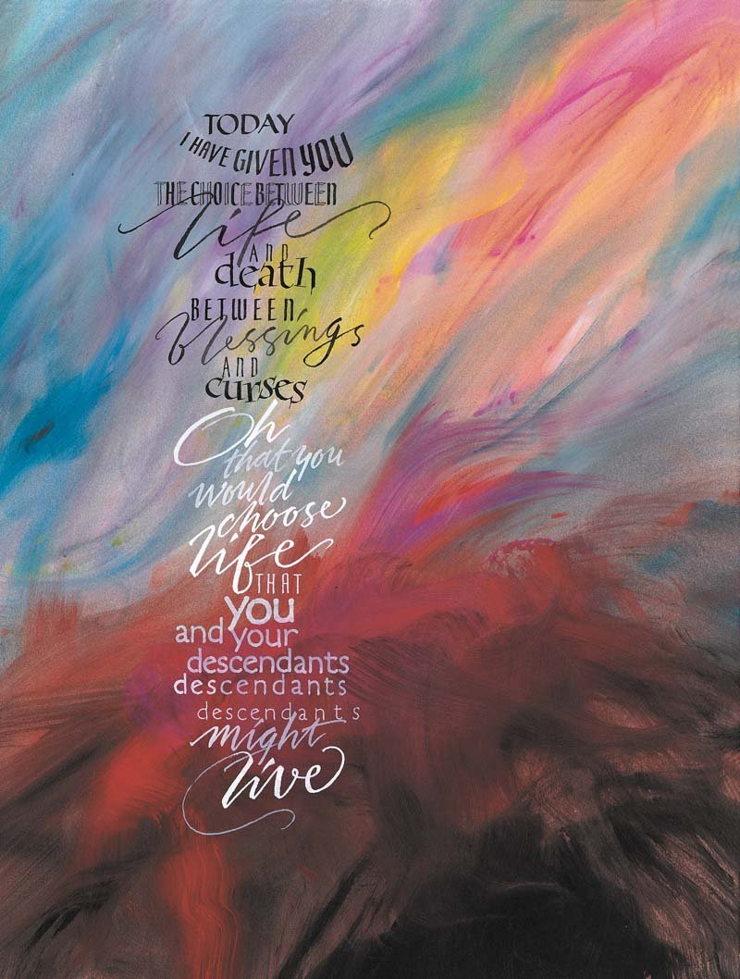**Welcome to New Bethel Baptist Church**

**We are blessed by your presence!**

**Sunday, August 16, 2020**

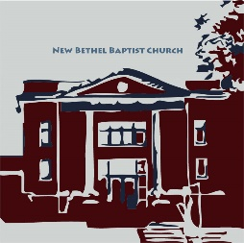**Guests and Members:**  If you have questions or would like more information about New Bethel, please feel free to contact the church office. Thank you!

*An American Baptist*

*Congregation*

**\*\*\*\*\*\***

**All Are Welcome**

**Weekly Activities Online Only**

Wednesdays online Bible Study 10 a.m., Contact Sue Winton

Thursdays online Book Discussion, *If God Is Love,* 1 p.m., Contact

Janie Bryant

Sunday Worship, 10:30 a.m., Live-stream Only

**\*\*\*\*\*\***

**Contact Information**

New Bethel Baptist Church Website: www.newbethelbapt.org

8936 Southeastern Avenue E-mail: newbethelbapt@att.net

Indianapolis, IN 46239 Wi-fi password: NBBC8624381

317-862-4381 Instagram: NBBC.Wanamaker

YouTube: New Bethel Baptist

Church Wanamaker

https://facebook.com New Bethel Baptist.Wanamaker

Rev. Janet F. Hoover, Pastor

Jan Nagle, Church Secretary

Church Office Hours: contact Pastor or NBBC Secretary

*Only when we are brave enough*

*to explore the darkness*

*will we discover*

*the infinite power of our light.*

—Brené Brown

**B.A.N.D. Concerts for Engaging Young Adults Initiative Pilot**

"Undeserved," the Praise Band from Crosspointe Biker Church in Connersville, will be playing on September 19th and October 17th from 3-7 p.m. in front of God's Bounty. We will have games on the lawn, and there will be a discounted meal for $2.50 available at Wheatley's. Folks will need to bring chairs and/or blankets and your own picnic meal if desired. B.A.N.D. stands for ***Boogie Around New Bethel Day.*** This is a Covid Safe event.

We are also in need of volunteers to help make sure we have everything covered. Please call or e-mail me if you can volunteer or have any questions.

Thanks, John Huddleston,

EYA Team Coordinator

**\*\*\*\*\*\*\*\*\*\*\*\*\*\*\*\*\*\*\*\*\*\***

|  |
| --- |
| Dear Friends,  Thank you NBBC! I appreciate your acknowledgement of my upcoming retirement--the notes and letters and the generous gift card. A special thank you to Staff Relations for their leadership and unwavering support over the years.  We are taking different paths now, and a bit sooner than anticipated. Nevertheless, I trust that with the Lord's help, all of us will find our way forward into whatever our unknown and blessed futures hold.  Take good care. Thank you again.  With grace and peace,  Pastor Janet |

**Happening This Week**

Today Live-stream worship only

Aug 19 10-11:30, Bible Study, contact Sue Winton

20 1-2:30 p.m., Book discussion Group, contact Janie

Bryant

Sept 19 3-7 p.m., B.A.N.D. Outdoor Concert

**\*\*\*\*\*\*\*\*\*\*\*\*\*\*\*\*\*\*\*\*\*\***

**Covid-19 Causes Changes**

The Center for Congregations is offering all of its workshops online and free-of-charge. To see what is being offered just go to the Center for Congregations website. Click on workshops at www.centerfor congregations.org to see your options.

**\*\*\*\*\*\*\*\*\*\*\*\*\*\*\*\*\*\*\*\***

**Worship Music Copyright and Live-Streaming Permissions**

“Wonderful Words of Life” text and music by Philip P. Bliss;

“It Is Well with My Soul’’ text by Horatio G. Spafford and music

By Philip P. Bliss;

“The Old Rugged Cross” text and music by George Bennard;

“Doxology” text by Thomas Ken and music by *Genevan Psalter.*

All above selections ©1997 Word/Integrity

Used by Permission. CCLI License #1631733

“What a Friend” by Charles C. Converse;

“Sweet Hour of Prayer” by William Bradbury, William W. Walford;

“Faith” by Jim Brickman;

“Angel’s Blessing” by Jim Brickman;

“It is Well” by Jim Brickman;

“All Creatures of Our God and King” by William H. Draper, Ken Barker,

Ralph Vaughan Williams, St. Francis of Assisi;

“All Things Bright and Beautiful” by Cecil F. Alexander, Martin Shaw.

Live-Streaming: Christian Copyright Solutions, WorshipCast,

License #10868