**Welcome to New Bethel Baptist Church**

**Sunday, August 2, 2020**

**Prelude** Dr. Christina Romero-Ivanova

\***Gathering Hymn** *Majesty*  #10

**\*Call to Worship**

Leader: Come, all who are weary.

**People: Christ strengthens us with love and grace.**

Leader**:** In this strength, we can do all things.

**Unison: We are here, ready to receive God’s blessings.**

**\*Invocation and Lord’s Prayer** (*using “sins”*) Karen Pappas

**Scripture Reading** Matthew 14:13-21 Karen Pappas

**Worship Prayer**   Pastor Janet

**\*Hymn**  *Be Thou My Vision*#562

**Children’s Sermon** Julianne Thomas

**Scripture Reflection**  Genesis 32:22-31 Pastor Janet

**\*Hymn** *Standing on the Promises* #410

**Ministry Opportunities** Karen Pappas

Birthdays and Anniversary Blessings

Meditation on Tithes and Offerings

*Doxology #815

*Prayer Karen Pappas

**Communion Hymn** *Come, Share the Lord*#462

**Communion** Pastor Janet

**\*Closing Hymn** *Blest Be the Tie That Binds*#426

**Postlude** Dr. Christina Romero-Ivanova

**Receipts for Person Protective Equipment (PPE)**

If you have purchased any PPE items for the church back as far as March 16th, please send the receipts to me at 5625 Blue Spruce Dr., Indy 46237 or to the church.

If you have already turned in your receipts for such items (hand sanitizers, masks, air purifier, etc.) for reimbursement, please let me know so I can pull your voucher and get those receipts that you attached.

I will be applying for grant funds through United Way for reimbursement to the church. You can turn in receipts dated March 16-August 15, 2020. The deadline for turning in your receipts is NO LATER THAN AUGUST 15th.

Thank you, Janie Bryant

**\*\*\*\*\*\*\*\*\*\*\*\*\*\*\*\*\*\*\***

**Daily Scripture Readings for This Week**

Monday, August 3, 2020: Psalm 17:1-7; Genesis 31:22-42;

Romans 1:8-15 or Psalm 78:1-8, 17-29;

Deuteronomy 8:1-10

Tuesday, August 4, 2020: Psalm 17:1-7, 15; Genesis 32:3-21;

Acts 2:37-47 or Psalm 78:1-8, 17-29; Deuteronomy 26:1-15

Wednesday, August 5, 2020: Psalm 17:1-7, 15; Isaiah 43:1-7;

Matthew 15:32-39 or Psalm 78:1-8, 17-29;

Exodus 16:2-15, 31-35

Thursday, August 6, 2020: Psalm 105:1-6, 16-22, 45b;

Genesis 35:22b-29; Acts 17:10-18 or Psalm 85:8-13;

1 Kings 18:1-16

Friday, August 7, 2020: Psalm 105:1-6, 16-22, 45b; Genesis 36:1-8;

Acts 18:24-28 or Psalm 85:8-13; 1 Kings 18:17-19, 30-40

Saturday, August 8, 2020: Psalm 105:1-6, 16-22, 45b;

Genesis 37:5-11; Matthew 16:1-4 or Psalm 85:8-13;

1 Kings 18:41-46

Sunday, August 9, 2020: Genesis 37:1-4, 12-28;

Psalm 105:1-6, 16-22, 45b; 1 Kings 19:9-18; Psalm 85:8-13; Romans 10:5-15; Matthew 14:22-33

**Welcome to New Bethel Baptist Church**

**We are blessed by your presence!**

**Sunday, August 2, 2020**

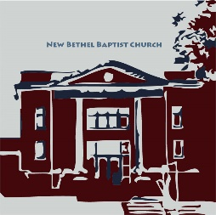

**Guests and Members:**  If you have questions or would like more information about New Bethel, please feel free to contact the church office. Thank you!

*An American Baptist*

*Congregation*

**\*\*\*\*\*\***

**All Are Welcome**

**Weekly Activities Online Only**

Wednesdays online Bible Study 10 a.m.

Thursdays online Book Discussion, *If Grace Is True,* 1 p.m.

10:30 a.m., Sunday Worship, live-stream only

**\*\*\*\*\*\***

**Contact Information**

New Bethel Baptist Church Website: www.newbethelbapt.org

8936 Southeastern Avenue E-mail: newbethelbapt@att.net

Indianapolis, IN 46239 Wi-fi password: NBBC8624381

317-862-4381 Instagram: NBBC.Wanamaker

YouTube: New Bethel Baptist

Church Wanamaker

https://facebook.com New Bethel Baptist.Wanamaker

Rev. Dr. Janet F. Hoover, Pastor

Jan Nagle, Secretary

Church Office Hours: contact Pastor or NBBC Secretary



*Prayer is sitting*

*in the silence*

*until it silences us,*

*choosing gratitude*

*until we are grateful,*

*and praising God*

*until we ourselves*

*are an act of praise.*

*Mature prayer always*

*breaks into gratitude.*

*—*Richard Rohr

**Thank You and Blessings!**

* Thank you to the donors for the new sanctuary speaker.
* Thank you to everyone who responded to the survey regarding returning to worship in person.
* Thank you to those who give us live streaming each week so we may worship together.

**\*\*\*\*\*\*\*\*\*\*\*\*\*\*\*\*\*\*\*\***

**Congratulations!**

Dr. Christina Romero-Ivanova has had another article published: <http://www.ccsenet.org/journal/index.php/hes/article/view/0/43335>

***

Kevin Winton has been nominated to be on the ABC-GI Board of Directors! An affirmation will happen at the Annual Gathering later today.

**\*\*\*\*\*\*\*\*\*\*\*\*\*\*\*\*\*\*\*\***

**Today is the ABC-GI 2020 Annual Gathering**

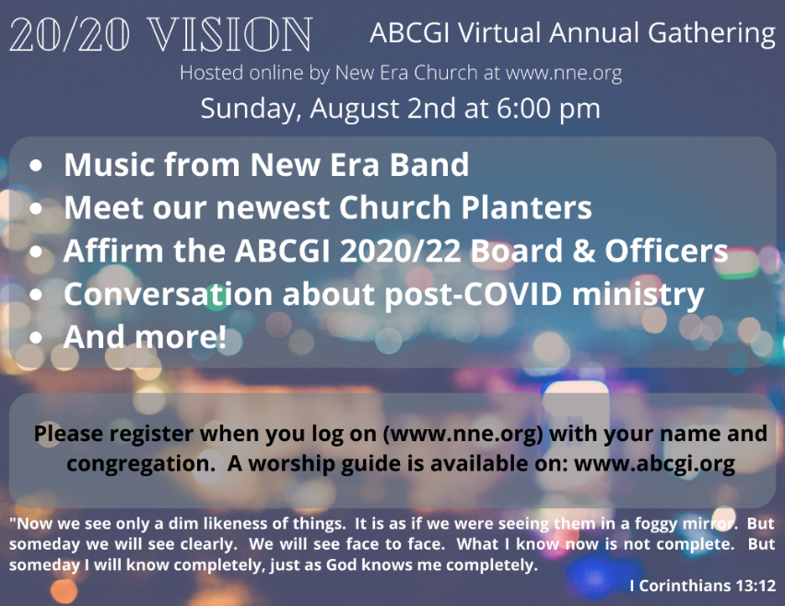**Covid-19 Causes Changes**

The Center for Congregations is offering all of its workshops online and free-of-charge. To see what is being offered just go to the Center for Congregations website. Click on workshops at www.centerfor congregations.org to see your options.

**\*\*\*\*\*\*\*\*\*\*\*\*\*\*\*\*\*\*\*\*\*\***

*The way to right wrongs*

*is to turn the light of truth upon them.*

*—* Ida B. Wells-Barnett

**\*\*\*\*\*\*\*\*\*\*\*\*\*\*\*\*\*\*\*\*\*\***

**Worship Music Copyright and Live-Streaming Permissions**

“Majesty” text and music by Jack W.Hayford;

“Be Thou My Vision’’ text by Mary E. Bryne and music

by David Allen;

“Standing on the Promises” text and music by R. Kelso Carter;

“Doxology” text by Thomas Ken and music by *Genevan Psalter.*

“Come, Share the Lord” text and music by Bryan Jefery Leech;

“Blest Be the Tie That Binds” text by John Fawcett and music by

Johann G. Naegeli.

All above selections ©1997 Word/Integrity

Used by Permission. CCLI License #1631733

“The Prayer” by Carole Bayer Sager, David Foster;

“He Is My Song” by Christina Romero, Mihaela Williams;

“A Quiet Place” by Ralph Carmichael;

“As Water to the Thirsty” by Timothy Dudley Smith, T. Brian Coleman;

“I Sing the Mighty Power of God” by Melody Bober;

“We Gather Together” by Melody Bober;

“Alleluia” by Jerry Sinclair;

“How Majestic is Your Name” by Michael W. Smith.

Live-Streaming: Christian Copyright Solutions, WorshipCast,

License #10868

**God’s Bounty Food Pantry**

God’s Bounty is a NBBC community mission, and NBBC has been supportive and commendable of this mission.

COVID-19 has impacted the methods and processes the pantry has been operating under, such as clients driving through for pick-up, and many volunteers have been playing it safe to stay healthy.

God has blessed God’s Bounty with increased support and donations via grants from Gleaners and Meijer (two from Meijer) and private donations. Borden’s Dairy is donating sixty gallons of milk per week.

The number of clients/families served continues to grow (2019 averaged 215 per month, and July 2020 was 318). This service to the community is fantastic, and NBBC is a party to this community mission.

NBBC’s opportunity to serve is the first Thursday of each month. If you are interested in volunteering on Thursday, August 6th, please contact me at 317-862-6767. We need help in the morning for the Gleaners truck unloading (currently 9-10 a.m. though that might change) and/or serving clients from 1-6:45 p.m.

Paul Young

NBBC Representative to God’s Bounty

**\*\*\*\*\*\*\*\*\*\*\*\*\*\*\*\*\*\*\*\***

**Happening This Week**

Today Communion Sunday

Live-stream worship only

5 10 a.m., Bible Study

6 6-7 p.m., God’s Bounty Donations

1 p.m., Book Discussion, *If God Is Love*

7 1-6 p.m., God’s Bounty Serves the Community

Dear Friends,

It has been a while since you have heard from me or other congregational leaders, but that doesn’t mean that nothing has been happening. Many important actions have been taken and continue to be taken — kind of like how a seed grows underground.

So here are the updates and the info you need to know . . .

1. Audio/Visual Equipment Grant Initiative

* We are waiting for delivery of our programmable camera to be hung in the rear of the sanctuary.
* NBBC still needs to purchase a new speaker to replace the dead one in the sanctuary.
* It would be extremely helpful and improve the sound quality significantly if purchasing and installing the new speaker was done before folks were worshipping both in-person and online.
* We received donations of $1,100 toward the new speaker.
* We need another $1,000 to make it happen.
* Can you give a little extra this month for the much-needed speaker?

2. Property Donated from Joe McCurdy

* NBBC owns the acreage donated by Mr. McCurdy.
* The plan is for NBBC to sell that land to the Cemetery. The details of the sales price and timing of payment have not been negotiated yet so watch for updates later this year.

3. Constitution

* This year was supposed to be the year to update and revise the Constitution.
* I suspect that this will not happen until 2021, mostly due to the gathering restrictions and the votes that will need to be taken.
* In the meantime, when necessary—and only when necessary—the Council is working outside of the Constitution because of the physical distancing requirements and the inability to gather and vote. No permanent changes have been made to any ministry or process in the church.

4. Engaging Young Adults Grant Initiative

* This Team continues to adjust, adapt, and revise their plans to engage Young Adults in an effective and safe manner. I am sure you will soon hear of their plans and how you might be helpful and/or participate.

5. PPP or Forgivable Loan from the Small Business Administration

* Preliminary paperwork has been submitted to our financial institution, Huntington Bank.
* The rules have changed since this program was initiated by the federal government, and adjustments to our application are being made accordingly.
* The amount of money that NBBC is eligible for is not yet determined, though I am sure you will hear more about this in the coming weeks.

6. Budget and Election of Lay-leaders for 2021

* Typically, we would be starting to put together a proposed budget for 2021. The budget-building process for 2021 will have to be changed in either small or large ways. Likewise, electing leaders for 2021 will have to be changed in either small or large ways.
* Watch for more information from Moderator Kevin Winton in the weeks ahead.

7. Gathering for In-person Worship

* About half of the people who answered the survey indicated that they wanted to be back in the sanctuary for face-to-face worship with no singing, masks, and social distancing.
* It is true that some congregations have and are taking a calculated risk and having people join together in person for worship.
* It looked like August might be when we could have a few folks in the sanctuary for face-to-face worship. Recently, however, Indiana is experiencing a rise in Covid cases.
* Please know that the Council is trying to discern how best to move forward and allow in-person worship while protecting as many people as possible.

8. Church Office Personnel

* As you know, our beloved Jan is retiring effective August 14th.
* Lori Chapman will be NBBC’s new church secretary.
* Jan will work with Lori from August 9-14th to get Lori oriented to the office. Lori will begin working in the office the following week.
* Watch for a notice from Staff Relations as to office hours and responsibilities.

9. Pastoral Leadership Now and Future

* My retirement is effective Friday September 4th. My last working day before taking several weeks of vacation is Friday, August 7th. I am on vacation from August 8th through September 4th.
* Rev. Tom Bartley will be leading worship and handling “most” pastoral care needs while I am on vacation.
* I say “most” with respect to Rev. Bartley because if someone in the congregation passes during my vacation and if the survivors of the deceased want me to officiate at a funeral or memorial service, I will do that. Additionally, with the blessing of Staff Relations and other parties, I am continuing to work with Christy and James and their wedding planning and with newly Licensed Julianne who will officiate at the wedding.
* Staff Relations and the Council are currently interviewing candidates for the Interim Pastor position. This is typically handled by the Pastoral Search Team; however, the Search Team was never fully constituted so Staff Relations and the Council are taking on this responsibility.

As you already knew, Covid has changed the way we do ministry, how we worship, and how decisions would typically be made and even what decisions are made. Nevertheless, your leaders are doing an excellent job—a stellar job—of filling in the gaps, and I encourage you to show your appreciation to them for their fine and wise work.

Covid has had its way with us of late—that is true. However, this is not time that we should waste. God is not done with NBBC yet—no way. There is no reason to despair or be frightened or full of anxiety.

Our Lord is the master of change—just look at nature!

Now is the time to remember your baptism and re-ground yourself with the Lord and your church family. It is the time to be intentional about showing care for your brothers and sisters in Christ. It is the time to allow the Lord to open your mind and heart to new ideas and people and ways of being church.

Now is the time to pray with the power of the Holy Spirit. Now is the time to be resilient, humble, patient, and sturdy as a cedar of Lebanon. Now is the time to gird your loins.

Micah 6:8 instructs us with plain language: “But he’s [God’s] already made it plain how to live, what to do, what God is looking for in men and women. It’s quite simple: Do what is fair and just to your neighbor, be compassionate and loyal in your love, And don’t take yourself too seriously — take God seriously.”

This, I believe, is my last article to write to you dear beloved community. I will hold you in my heart until I can no more. I love you dearly. I thank you for the privilege of being your pastor and serving the Lord with you.

With grace and peace,

PJ