**Welcome to New Bethel Baptist Church**

**Sunday, August 23, 2020**

**Prelude** Dr. Christina Romero-Ivanova

**Gathering Hymn** *Great Is Thy Faithfulness* #139

**Call to Worship**

Leader:  We are called into this Holy time by the One who loves us.

**People:  Lord, speak Your Word of life and love and we will be**

**a new people.**

Leader:  God is with us.  And the Spirit of the Lord is present in our

assembly.

**People:  May the Spirit move among us and restore the**

**wounded, heal the broken, and be present with those in**

**isolation.**

All:  Lord, we welcome You and Your Presence, which can change

our hearts. Make us a new creation as we worship you.

**Invocation and Lord’s Prayer** (*using “sins”*) Karen Pappas

**Scripture Reading** Mark 10:13-16 Karen Pappas

**Worship Prayer**   Rev. Tom Bartley

**Hymn** *Take My Life* #597

**Children’s Message**

**Scripture Reflection** Deuteronomy 6:4-9 Rev. Tom Bartley

**Hymn** *Amazing Grace* #343

**Ministry Opportunities** Karen Pappas

Meditation on Tithes and Offerings

*Doxology #815

*Prayer Karen Pappas

**Benediction** Rev. Tom Bartley

**Postlude** Dr. Christina Romero-Ivanova

**Welcome, Rev. Tom Bartley**

We welcome Rev. Tom Bartley today. Tom is filling in for Pastor Janet while she is on vacation. We are glad to see you, Tom!

Rev. Bartley will provide for pastoral emergencies during Pastor Janet’s vacation.

**\*\*\*\*\*\*\*\*\*\*\*\*\*\*\*\*\*\*\***

*Here is the world.*

*Beautiful and terrible things will happen.*

*Don't be afraid.*

*—Fredrick Buechner*

**\*\*\*\*\*\*\*\*\*\*\*\*\*\*\*\*\*\*\***

**Daily Scripture Readings for This Week**

**Monday, August 24, 2020**: [Psalm 8; Exodus 1:1-7; Romans 2:1-11](http://www.biblegateway.com/passage/?search=Psalm%208;%20Exodus%201:1-7;%20Romans%202:1-11)  
 or [Psalm 18:1-3, 20-32; 1 Samuel 7:3-13; Romans 2:1-11](http://www.biblegateway.com/passage/?search=Psalm%2018:1-3,%2020-32;%201%20Samuel%207:3-13;%20Romans%202:1-11)

**Tuesday, August 25, 2020**: Psalm 8; Exodus 2:11-15a;

Romans 11:33-36 or Psalm 18:1-3, 20-32;

Deuteronomy 32:18-20, 28-39; Romans 11:33-36

**Wednesday, August 26, 2020**: Psalm 8; Exodus 2:15b-22;

Matthew 26:6-13 or Psalm 18:1-3, 20-32; Isaiah 28:14-22;

Matthew 26:6-13

**Thursday, August 27, 2020**: Psalm 105:1-6, 23-26, 45b;

Exodus 2:23-24; Ephesians 5:1-6 or Psalm 26:1-8;

Jeremiah 14:13-18; Ephesians 5:1-6

**Friday, August 28, 2020**: Psalm 105:1-6, 23-26, 45b;

Exodus 3:16-22; 2 Thessalonians 2:7-12 or Psalm 26:1-8;

Jeremiah 15:1-9; 2 Thessalonians 2:7-12

**Saturday, August 29, 2020**: Psalm 105:1-6, 23-26, 45b;

Exodus 4:1- 9; Matthew 8:14-17 or Psalm 26:1-8;

Jeremiah 15:10-14; Matthew 8:14-17

Sunday, August 30, 2020: [Proper 17 (22)](https://lectionary.library.vanderbilt.edu/texts.php?id=157)

**Welcome to New Bethel Baptist Church**

**We are blessed by your presence!**

**Sunday, August 16, 2020**

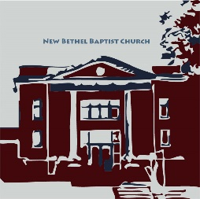**Guests and Members:**  If you have questions or would like more information about New Bethel, please feel free to contact the church office. Thank you!

*An American Baptist*

*Congregation*

**\*\*\*\*\*\***

**All Are Welcome**

**Weekly Activities Online Only**

Wednesdays online Bible Study 10 a.m., Contact Sue Winton

Thursdays online Book Discussion, *If God Is Love,* 1 p.m., Contact

Janie Bryant

Sunday Worship, 10:30 a.m., Live-stream Only

**\*\*\*\*\*\***

**Contact Information**

New Bethel Baptist Church Website: www.newbethelbapt.org

8936 Southeastern Avenue E-mail: newbethelbapt@att.net

Indianapolis, IN 46239 Wi-fi password: NBBC8624381

317-862-4381 Instagram: NBBC.Wanamaker

YouTube: New Bethel Baptist

Church Wanamaker

https://facebook.com New Bethel Baptist.Wanamaker

Rev. Janet F. Hoover, Pastor

Lori Chapman, Church Secretary

Church Office Hours: contact Pastor or NBBC Secretary

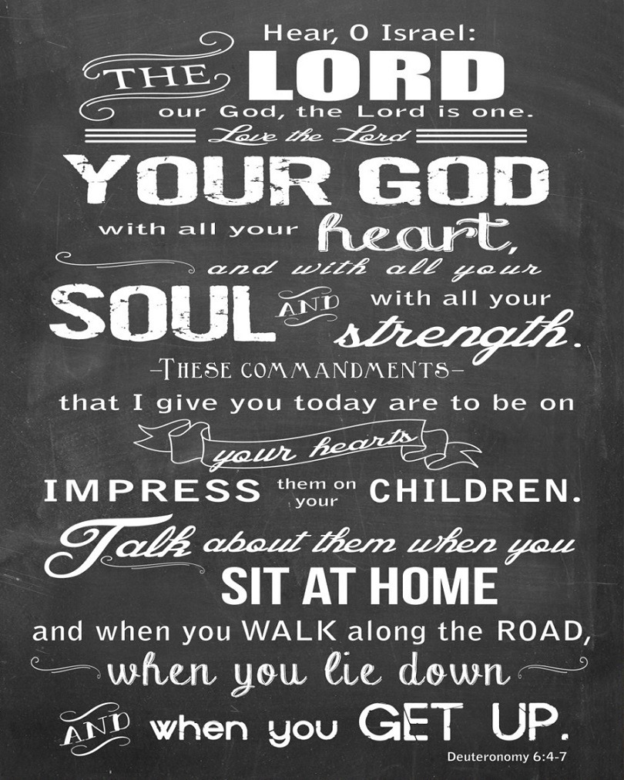

*Love is a powerful action. We seek wholeness in the love of God. We pursue it in a lifelong companion. We give it selflessly to our children and withhold it from our enemies.*

*Love is an action we take part in daily.*

*—Author Unknown*

**B.A.N.D. Concerts for Engaging Young Adults Initiative Pilot**

"Undeserved," the Praise Band from Crosspointe Biker Church in Connersville, will be playing on September 19th and October 17th from 3-7 p.m. in front of God's Bounty. We will have games on the lawn, and there will be a discounted meal for $2.50 available at Wheatley's. Folks will need to bring chairs and/or blankets and your own picnic meal if desired. B.A.N.D. stands for ***Boogie Around New Bethel Day.*** This is a Covid Safe event.

We are also in need of volunteers to help make sure we have everything covered. Please call or e-mail me if you can volunteer or have any questions.

Thanks, John Huddleston,

EYA Team Coordinator

**\*\*\*\*\*\*\*\*\*\*\*\*\*\*\*\*\*\*\*\*\*\***

|  |  |  |  |  |
| --- | --- | --- | --- | --- |
| |  |  | | --- | --- | |  |  | |  |  |   **ABWM Domestic Violence Prevention**  **Virtual Training**  **September 12th from 1-3 p.m.**  The training will enable clergy, church leaders, community groups and domestic violence educators to come together in a safe and intentional manner to learn ways to support and aid those in their communities that are suffering from domestic violence. Participants will gain knowledge, insight, and skills useful in addressing and preventing domestic violence.  Register online www.abwomensministries.org  $25 registration fee - scholarships are available  Questions: call (610) 768-2288 |

**Topics Covered**

* Biblical Exploration of Violence
* Defining Domestic Violence
* Characteristics of an Abuser
* COVID-19 and its impact of Domestic Violence
* Supporting Victims & Safety Planning

**Happening This Week**

Today Live-stream worship only

Aug 26 10-11:30 a.m., Bible Study, contact Sue Winton

27 1-2:30 p.m., Book discussion Group, contact Janie

Bryant

Sept 19 3-7 p.m., B.A.N.D. Outdoor Concert

**\*\*\*\*\*\*\*\*\*\*\*\*\*\*\*\*\*\*\*\*\*\***

**Covid-19 Causes Changes**

The Center for Congregations is offering all of its workshops online and free-of-charge. To see what is being offered just go to the Center for Congregations website. Click on workshops at www.centerfor congregations.org to see your options.

**\*\*\*\*\*\*\*\*\*\*\*\*\*\*\*\*\*\*\*\***

**Worship Music Copyright and Live-Streaming Permissions**

“Great Is Thy Faithfulness” text by, Thomas O. Chisholm; and music by William M. Runyan

“Take My Life’’ text by, Frances Ridley Havergal; and music

by Henry A. Cesar Malan;

“Amazing Grace” text by John Newton; John P. Rees; and music by Carrell and Clayton’s Virginia Harmony, arranged by Edwin O. Excell, O.D. Hall, Jr.;

“Doxology” text by Thomas Ken and music by *Genevan Psalter.*

All above selections ©1997 Word/Integrity

Used by Permission. CCLI License #1631733

“Let All Things Now Living” by Faye Lopez;

“Sun of My Soul” by, Faye Lopez;

“You are My Hiding Place” by Michael Ledner;

“As the Deer with Fairest Lord Jesus” by Mark Hayes;

“He Looked Beyond My Faults and Saw My Needs” by Bill George, Dino

Kartsonakis;

“The Worship Song” by Celeste Yohai,

Live-Streaming: Christian Copyright Solutions, WorshipCast, License #10868