**Welcome to New Bethel Baptist Church**

**Sunday, August 30, 2020**

**Prelude** *Morning Chimes* Bob Cook

**Gathering Hymn** *Come Thou Fount of Every Blessing* #11

**Vocal Call to Worship** *Must Be*

Must Be that the world is blind

Must be that the world is blind

I can’t believe that we could see some things and just go on with our lives.

Well it must be that the world is blind

Must be that the world’s gone dumb

Must be that the world’s gone dumb

I can’t believe that we could be so silent when we see what we might become.

Well it must be that the world is dumb

Must be that the world’s gone lame

Must be that the world’s gone lame

I can’t believe we could sit so still while the furious fan the flames

Well it must be that the world is lame.

Must be that the world is saved

Must be that the world is saved

The blind will see and the dumb will talk.

The chains will fall and the lame will walk

And the dead will rise from the grave

Well it must be that the world’s been saved

Must be that the world’s been saved.

**Invocation and Lord’s Prayer** (*using “sins”*) Karen Pappas

**Scripture Reading** Genesis 9:12-16 Karen Pappas

**Worship Prayer**   Rev. Tom Bartley

**Hymn** *Great is Thy Faithfulness*  #139

**Children’s Message**

**Special Music** Rev. Tom Bartley

**Scripture Reflection** John 8:1-11 Rev. Tom Bartley

**Hymn** *Holy, Holy, Holy* #3

**Ministry Opportunities** Karen Pappas

Meditation on Tithes and Offerings

*Doxology #815

*Prayer Karen Pappas

**Benediction** Rev. Tom Bartley

**Postlude** *Praise Medley*  Bob Cook

**\*\*\*\*\*\*\*\*\*\*\*\*\*\*\*\*\*\*\*\*\*\***

**Daily Scripture Readings for This Week**

Monday, August 31, 2020: Psalm 83:1-4, 13-18; Exodus 4:10-31;

Revelation 3:1-6; or Psalm 17; 2 Samuel 11:2-26; Revelation 3:1-6

Tuesday, September 1, 2020: Psalm 83:1-4, 13-18; Exodus 5:1-

6:13; Revelation 3:7-13; or Psalm 17; 2 Samuel 11:27b-

12:15; Revelation 3:7-13

Wednesday, September 2, 2020: Psalm 83:1-4, 13-18; Exodus 7:14-

25; Matthew 12:22-32; or Psalm 17; Jeremiah 17:5-18; Matthew 12:22-32

Thursday, September 3, 2020: Psalm 149; Exodus 9:1-7; 2

Corinthians 12:11-21 or Psalm 119:33-40; Ezekiel 24:1-14;

2 Corinthians 12:11-21

Friday, September 4, 2020: Psalm 149; Exodus 10:21-29; Romans

10:15b-21 or Psalm 119:33-40; Ezekiel 24:15-27; Romans

10:15b-21

Saturday, September 5, 2020: Psalm 149; Exodus 11:1-10; Matthew

23:29-36 or Psalm 119:33-40; Ezekiel 33:1-6; Matthew

23:29-36

Sunday, September 6, 2020: Proper 18 (23)

**Welcome to New Bethel Baptist Church**

**We are blessed by your presence!**

**Sunday, August 30, 2020**

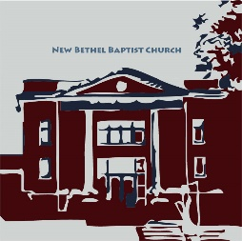**Guests and Members:**  If you have questions or would like more information about New Bethel, please feel free to contact the church office. Thank you!

*An American Baptist*

*Congregation*

**\*\*\*\*\*\***

**All Are Welcome**

**Weekly Activities Online Only**

Wednesdays online Bible Study 10 a.m., Contact Sue Winton

Thursdays online Book Discussion, *If God Is Love,* 1 p.m., Contact

Janie Bryant

Sunday Worship, 10:30 a.m., Live-stream Only

**\*\*\*\*\*\***

**Contact Information**

New Bethel Baptist Church Website: www.newbethelbapt.org

8936 Southeastern Avenue E-mail: newbethelbapt@att.net

Indianapolis, IN 46239 Wi-fi password: NBBC8624381

317-862-4381 Instagram: NBBC.Wanamaker

YouTube: New Bethel Baptist

Church Wanamaker

https://facebook.com New Bethel Baptist.Wanamaker

Rev. Dr. Janet F. Hoover, Pastor

Lori Chapman, Church Secretary

Church Office Hours: contact Pastor or NBBC Secretary

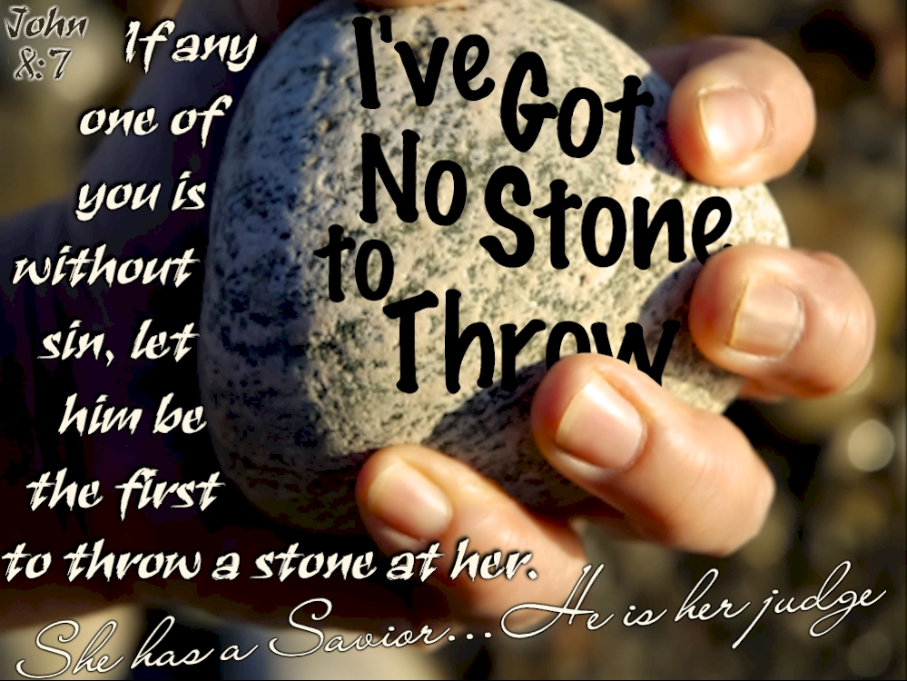

*Fear is a self-imposed prison that will keep you from becoming what God intends for you to be. You must move against it with the weapons of faith and love.*

—Rick Warren

**Welcome, Rev. Tom Bartley**

We welcome Rev. Tom Bartley today. Tom is filling in for Pastor Janet while she is on vacation. We are glad to see you, Tom!

Rev. Bartley will provide for pastoral emergencies during Pastor Janet’s vacation.

**\*\*\*\*\*\*\*\*\*\*\*\*\*\*\*\*\*\*\*\*\*\***

**Welcome, Bob Cook**

We welcome our guest pianist, Bob Cook today. We thank you for filling in while Christina is away.

**\*\*\*\*\*\*\*\*\*\*\*\*\*\*\*\*\*\*\*\*\*\***

**Wonderful, Exciting News!!!!**

Three members of our congregation have stepped forward to donate money toward the purchase of the last component of the sanctuary technical update, the speaker. The donations cover the remaining balance of the entire tech purchase and installation after monies from the grant, Trustee and Worship Team contributions, and a minimal withdrawal from available legacy funds have been applied. We will now have a completely new and updated audio/visual system to last for years to come.

Thank you, thank you, thank you donors for your generosity and faith and commitment to building a better New Bethel Baptist Church!

Janie Bryant

Treasurer

**\*\*\*\*\*\*\*\*\*\*\*\*\*\*\*\*\*\*\*\*\*\***

**Covid-19 Causes Changes**

The Center for Congregations is offering all its workshops online and free-of-charge. To see what is being offered just go to the Center for Congregations website. Click on workshops at www.centerfor congregations.org to see your options.

**God’s Bounty Food Pantry**

God’s Bounty is a NBBC community mission and COVID-19 has impacted the methods and processes the pantry has been operating under. NBBC’s opportunity for volunteers to support activities is on the first Thursday of each month and I need help. I need **man**power! Anyone who could assist by rolling carts with products out to the clients’ vehicles and transferring the products to the vehicle. Thank you to Don Parks and Greg West for being volunteers to serve clients and Mike Fengya for assisting with Gleaner’s trucks by representing our church during this time of COVID-19. God has blessed God’s Bounty, with increased donations and God’s Bounty service has increased. Please be a part of this mission. If you are interested in volunteering on Thursday, Sept. 3, please contact me at 317-862-6767. We need help in the morning for the Gleaners truck (approximately at 8:45-9:30 a.m.); or to serve clients from 1-3 p.m.; 3-5 p.m.; or 5-6:45 p.m.

Paul Young, NBBC’s Representative

**\*\*\*\*\*\*\*\*\*\*\*\*\*\*\*\*\*\*\*\*\*\***

**B.A.N.D. Concerts for Engaging Young Adults Initiative Pilot**

"Undeserved," the Praise Band from Crosspointe Biker Church in Connersville, will play on Sept. 19th and Oct. 17th from 3-7 p.m. in front of God's Bounty. We will have games on the lawn, and there will be a discounted meal for $2.50 available at Wheatley's. Folks will need to bring chairs and/or blankets and your own picnic meal if desired. B.A.N.D. stands for ***Boogie Around New Bethel Day.*** This is a Covid Safe event.

We also need volunteers to help make sure we have everything covered. Please call or e-mail me if you can volunteer or have any questions.

Thanks, John Huddleston,

EYA Team Coordinator

**Sacred Practices In A Virtual Age Workshop**

**Offered through Indianapolis Center for Congregations**

This event is in Zoom meeting. Everyone attending will be on camera and microphone.

In such an intense season on planet earth, pandemic, fear, racial unrest, we are all in desperate need of some holy space. The key is not to run away from the world, but get free enough to engage the world with empathy and compassion. You're invited to join liturgist, writer and pastor Aaron Niequist as he leads you through several spiritual practice exercises. You will experience several practices led by Aaron and will discuss those experiences to equip you to create your own practices.

**Date:**  Tuesday, September 1, 2020

**Time:** 11 a.m.-12:30 p.m. (Eastern)

**Cost:** free

**Best for:** Congregational leaders who plan services, lead small group or provide spaces for prayer and spiritual practice. The practices in this event are from the Christian faith tradition.

**Register online:** <https://centerforcongregations.org/workshop/sacred-practices-virtual-age>

**Outline of the online session:**

* Opening practice
* The gift of a practice-based faith
* Open conversation, Q&A
* Practice 1 (Sign of the Cross Meditation)
* Debrief practice together
* Practice 2 (The Examen) — teach and practice
* Debrief and close

**Happening This Week**

Today Live-stream worship only

Sept. 2 10-11:30 a.m., Bible Study, contact Sue Winton

3 1-2:30 p.m., Book discussion Group, contact

Janie Bryant

8:45-9:30 a.m. Donations-God's Bounty

1-3 p.m.; 3-5 p.m.; or 5-6:45 p.m.

Distribution of food-God's Bounty

**Looking Ahead**

Sept. 8 7 p.m. Council Meeting on Zoom

Sept 19 3-7 p.m., B.A.N.D. Outdoor Concert

**\*\*\*\*\*\*\*\*\*\*\*\*\*\*\*\*\*\*\*\*\*\***

*You cannot change any society unless you take responsibility for it, unless you see yourself as belonging to it, and responsible for changing it.*   
 —Grace Lee Boggs

**\*\*\*\*\*\*\*\*\*\*\*\*\*\*\*\*\*\*\*\***

**Worship Music Copyright and Live-Streaming Permissions**

“Come Thou Fount of Every Blessing’’ text by, Robert Robinson; and

music by, John Wyeth’s and Carl Seal;

“Must Be” text and music by, Lost and Found;

“Great is Thy Faithfulness” text by, Thomas O. Chisholm; and music

by, William M. Runyan;

“Holy, Holy, Holy!” text by, Reginald Heber; and music by, John B.

Dykes and Camp Kirkland;

“Doxology” text by, Thomas Ken and music b,y *Genevan Psalter.*

All above selections ©1997 Word/Integrity

Used by Permission. CCLI License #1631733

“Morning Chimes” by, Lorenz;

“Musettte” by, Young;

“Praise Medley” by, Fettke

Live-Streaming: Christian Copyright Solutions, WorshipCast, License #10868