**Welcome to New Bethel Baptist Church**

**Sunday, August 9, 2020**

**Prelude** Dr. Christina Romero-Ivanova

**Gathering Hymn** *Majesty*  #10

**Call to Worship**

Leader: How long, O Lord, must we isolate ourselves in our

homes?

**People: Be with us when we feel alone.**

Leader**:** How long must we fear the breath of our neighbor?

**People: Fill our mouths with your Spirit.**

Leader: It is with a heavy heart that we gather this way to

worship you.

**Unison: Be present with us as we worship in Spirit and**

**Truth.**

**Invocation and Lord’s Prayer** (*using “sins”*) Karen Pappas

**Scripture Reading** Exodus 33:18-20 Karen Pappas

**Worship Prayer**   Rev. Tom Bartley

**Hymn** *Living for Jesus*  #605

**Children’s Message**

**Scripture Reflection**  Romans 12:1-2 Rev. Tom Bartley

**Hymn** *Softly and Tenderly* #479

**Ministry Opportunities** Karen Pappas

Meditation on Tithes and Offerings

*Doxology #815

*Prayer Karen Pappas

**Benediction** Rev. Tom Bartley

**Postlude** Dr. Christina Romero-Ivanova

**Welcome, Rev. Tom Bartley**

We welcome Rev. Tom Bartley today. Tom is filling in for Pastor Janet while she is on vacation. We are glad to see you, Tom!

Rev. Bartley will provide for pastoral emergencies during Pastor Janet’s vacation.

**\*\*\*\*\*\*\*\*\*\*\*\*\*\*\*\*\*\*\***

**Thank You!**

I want to thank my church family at New Bethel Baptist Church for your kind words about my retirement and the wonderful gift card!

God Bless You All, Jan Nagle

**\*\*\*\*\*\*\*\*\*\*\*\*\*\*\*\*\*\*\***

*Each day comes bearing its own gifts.*

*Untie the ribbons.*

* W. J. Cameron

**\*\*\*\*\*\*\*\*\*\*\*\*\*\*\*\*\*\*\***

**Daily Scripture Readings for This Week**

Monday, August 10, 2020: Psalm 28; Genesis 37:29-36;

2 Peter 2:4-10 or Psalm 18:1-19; Genesis 7:11-8:5

Tuesday, August 11, 2020: Psalm 28; Genesis 39:1-23;

Romans 9:14-29 or Psalm 18:1-19; Genesis 19:1-29

Wednesday, August 12, 2020: Psalm 28; Genesis 40:1-23;

Matthew 8:23-27 or Psalm 18:1-19; Job 36:24-33, 37:14-24

Thursday, August 13, 2020: Psalm 133; Genesis 41:14-36;

Revelation 15:1-4 or Psalm 67; Isaiah 45:20-25

Friday, August 14, 2020: Psalm 133; Genesis 41:37-57;

Acts 14:19-28 or Psalm 67; Isaiah 63:15-19

Saturday, August 15, 2020: Psalm 133; Genesis 42:1-28;

Matthew 14:34-36 or Psalm 67; Isaiah 56:1-5

Sunday, August 16, 2020: Genesis 45:1-15; Psalm 133;

Isaiah 56:1,6-8; Psalm 67; Romans 11:1-2a, 29-32;

Matthew 15:10-28

**Welcome to New Bethel Baptist Church**

**We are blessed by your presence!**

**Sunday, August 9, 2020**

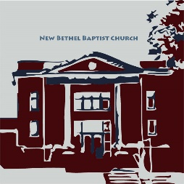**Guests and Members:**  If you have questions or would like more information about New Bethel, please feel free to contact the church office. Thank you!

*An American Baptist*

*Congregation*

**\*\*\*\*\*\***

**All Are Welcome**

**Weekly Activities Online Only**

Wednesdays online Bible Study 10 a.m., Contact Sue Winton

Thursdays online Book Discussion, *If God Is Love,* 1 p.m., Contact

Janie Bryant

Sunday Worship, 10:30 a.m., Live-stream Only

**\*\*\*\*\*\***

**Contact Information**

New Bethel Baptist Church Website: www.newbethelbapt.org

8936 Southeastern Avenue E-mail: newbethelbapt@att.net

Indianapolis, IN 46239 Wi-fi password: NBBC8624381

317-862-4381 Instagram: NBBC.Wanamaker

YouTube: New Bethel Baptist

Church Wanamaker

https://facebook.com New Bethel Baptist.Wanamaker

Rev. Janet F. Hoover, Pastor

Jan Nagle, Church Secretary

Church Office Hours: contact Pastor or NBBC Secretary

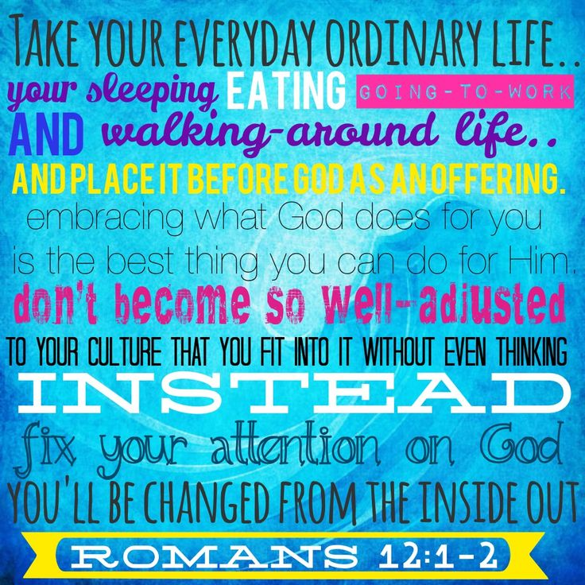

*We can collectively regain our faith*

*in the transformative power of love*

*by cultivating courage, the strength*

*to stand up for what we believe in,*

*to be accountable both*

*in word and deed.*

— Bell Hooks

**B.A.N.D. Concerts for Engaging Young Adults Initiative Pilot**

"Undeserved," the Praise Band from Crosspointe Biker Church in Connersville, will be playing on August 15th, September 19th, and October 17th from 3-7 p.m. in front of God's Bounty. We will have games on the lawn, and there will be a discounted meal for $2.50 available at Wheatley's. Folks will need to bring chairs and/or blankets and your own picnic meal if desired. B.A.N.D. stands for ***Boogie Around New Bethel Day.***

We are also in need of volunteers to help make sure we have everything covered. Please call or e-mail me if you can volunteer or have any questions.

Thanks, John Huddleston,

EYA Team Coordinator

**\*\*\*\*\*\*\*\*\*\*\*\*\*\*\*\*\*\*\*\*\*\***

**July Giving and Disbursements**

For July, our giving and disbursements were as follows:

2020 Finances and Attendance Month of July Year-To-Date

Tithes/Offerings $6,683.01 $67,545.59

Expenses Paid $12,093.16 $77,750.96

Gain/(Loss) ($5,410.15) ($10,205.37)

Budget Needs $12,044.17 $84,309.19

Average Weekly Worship Attendance in July was 75 each week.

Remaining Balance

EYA Grant ($1,000+$5,000) $0.00 $5,385.50

EYA Expenses Paid $1,081.94 $4,303.56

Remaining Balance

Tech Grant ($5,000) $5,000.00 $5,000.00

Tech Expenses Paid $2,000.00 $3,000.00

Any questions, please call me at 317-519-3347 or e-mail me at njb46239@gmail.com

Janie Bryant,

Treasurer

**Happening This Week**

Today Live-stream worship only

Aug 12 10-11:30, Bible Study, contact Sue Winton

13 1-2:30 p.m., Book discussion Group, contact Janie

Bryant

15 3-7 p.m., B.A.N.D. Outdoor Concert

**\*\*\*\*\*\*\*\*\*\*\*\*\*\*\*\*\*\*\*\*\*\***

**Covid-19 Causes Changes**

The Center for Congregations is offering all of its workshops online and free-of-charge. To see what is being offered just go to the Center for Congregations website. Click on workshops at www.centerfor congregations.org to see your options.

**\*\*\*\*\*\*\*\*\*\*\*\*\*\*\*\*\*\*\*\***

**Worship Music Copyright and Live-Streaming Permissions**

“Majesty” text and music by Jack W.Hayford;

“Living for Jesus’’ text by Thomas O. Chisholm and music

by C. Harold Lowden;

“Softly and Tenderly” text music by Will L. Thompson;

“Doxology” text by Thomas Ken and music by *Genevan Psalter.*

All above selections ©1997 Word/Integrity

Used by Permission. CCLI License #1631733

“Mountain Suite Overture” by Bill George, Dino Kartsonakis;

“Love Can Build a Bridge” by Naomi Judd, John Bartow Jarvis,

Paul Overstreet;

“I Got Peace Like a River/I Give You Peace” by Rollie Mains;

“Air on the G-String” by J. S. Bach;

“To a Wild Rose” by Edward MacDowell;

“As Water to the Thirsty” by Timothy Dudley Smith,

T. Brian Coleman;

“Unto the Hills” by John Campbell, James Bingham.

Live-Streaming: Christian Copyright Solutions, WorshipCast,

License #10868