**Welcome to New Bethel Baptist Church**

**Sunday, September 13, 2020**

**Prelude** Dr. Christina Romero-Ivanova

\***Gathering Hymn** *Come Thou Almighty King* #8

**\*Call to Worship**

Leader: Come, let us sing for joy to the Lord; let us shout aloud to

the Rock of our salvation.

**People: let us come before God with thanksgiving, with music**

**and song**

Leader: For the Lord is a great God

**People: The great King above all gods**

Leader: In those hands are the depths of the earth.

**People: And the mountain peaks belong to God**

*All: Come, let us worship and bow down in worship before the*

*Lord our Maker.*

**\*Invocation and Lord’s Prayer** (*using “sins”*) Julianne Thomas

**Scripture Reading** Exodus 4:1-10 Julianne Thomas

**Worship Prayer**   Julianne Thomas

**\*Hymn** *O Worship the King*#104

**Children’s Sermon**

**Scripture Reflection**  Mark 1:40-45 Rev. Tom Bartley

**\*Hymn** *Wonderful Words of Life*#406

**Ministry Opportunities** Julianne Thomas

Meditation on Tithes and Offerings

*Doxology #815

*Prayer Rev. Tom Bartley

**Benediction**

**Postlude** Dr. Christina Romero-Ivanova

**DAILY SCRIPTURE READINGS FOR THIS WEEK**

Monday, September 14, 2020: Psalm 77; Joshua 3:1-17; Hebrews

11:23-29 or Psalm 133; Genesis 48:8-22; Hebrews 11:23-29

Tuesday, September 15, 2020: Psalm 77; Nehemiah 9:9-15;

Romans 14:13-15:2 or Psalm 133; Genesis 49:29-50:14;

Romans 14:13-15:2

Wednesday, September 16, 2020: Psalm 77; 2 Kings 2:1-18; Mark

11:20-25 or Psalm 133; Genesis 50:22-26; Mark 11:20-25

Thursday, September 17, 2020: Psalm 105:1-6, 37-45; Exodus

15:22-27; 2 Corinthians 13:1-4 or Psalm 145:1-8; Nahum

1:1, 14-2:2; 2 Corinthians 13:1-4

Friday, September 18, 2020: Psalm 105:1-6, 37-45; Exodus 16:1-

21; 2 Corinthians 13:5-10 or Psalm 145:1-8; Nahum 2:3-13;

2 Corinthians 13:5-10

Saturday, September 19, 2020: Psalm 105:1-6, 37-45; Exodus

16:22-30; Matthew 19:23-30 or Psalm 145:1-8; Zephaniah

2:13-15; Matthew 19:23-30

Sunday, September 20, 2020: Proper 20 (25)

During the pandemic, we've moved our workshops to an online format. And they're free! Registration is available now at <https://centerforcongregations.org/workshops>

**Race is Fake; Racism is Real**

**Date: Thursday, September 17. 2020, from 1-2:30 p.m.**

It’s difficult and uncomfortable, but it’s time to talk about racism. Join us for the Race to Justice. In this workshop, you will learn the underlying definitions and distinctions between race and racism.

You will also learn how racism shows up in various personal and societal ways.

This event is part of the Learn and Lead Series: Race to Justice, led by subject matter expert on race and racism Dr. Michael R. Twyman.

**WELCOME TO NEW BETHEL BAPTIST CHURCH**

**We are blessed by your presence!**

**Sunday, September 13, 2020**

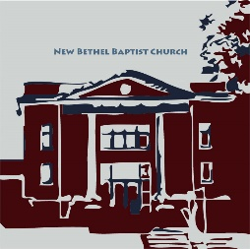

**GUEST AND MEMBERS:** If you have questions or would like more information about New Bethel, please feel free to contact the church office. Thank you!

*An American Baptist*

*Congregation*

**\*\*\*\*\*\***

**ALL ARE WELCOME**

**Weekly Activities Online Only**

Wednesdays online Bible Study 10 a.m., Contact Sue Winton

Thursdays online Book Discussion, *If God Is Love,* 1 p.m., Contact

Janie Bryant

Sunday Worship, 10:30 a.m., Live-stream Only

**\*\*\*\*\*\***

**CONTACT INFORMATION**

New Bethel Baptist Church Website: www.newbethelbapt.org

8936 Southeastern Avenue E-mail: newbethelbapt@att.net

Indianapolis, IN 46239 Wi-fi password: NBBC8624381

317-862-4381 Instagram: NBBC.Wanamaker

YouTube: New Bethel Baptist

Church Wanamaker

https://facebook.com New Bethel Baptist.Wanamaker

Rev. Tom Bartley, Interim Pastor

Lori Chapman, Church Secretary

Church Office Hours: Wednesday-Thursday from 4-6 p.m.

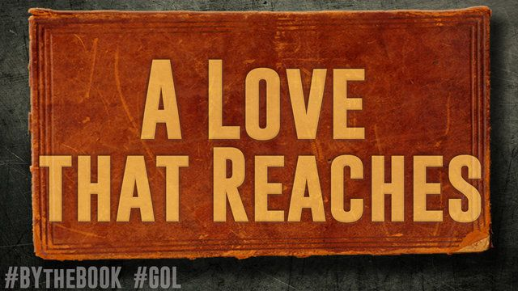

*Let us learn to live with kindness, to love everyone,*

*even when they do not love us.*

—Pope Francis

***Boogie Around New Bethel Day (*B.A.N.D.)**

**Concerts for Engaging Young Adults Initiative Pilot**



"Undeserved," the Praise Band from Crosspointe Biker Church in Connersville, will play on Sept. 19th and Oct. 17th from 4-7 p.m. (note time change) in front of God's Bounty Food Pantry. We will have games and there will be meals from Wheatley's offered. A free will offering is appreciated but not necessary. Please bring a non-perishable food item for God’s Bounty Food Pantry. Folks will need to bring chairs and/or blankets and your own picnic meal if desired. This is a Covid Safe event.

Please call or e-mail me if you can volunteer or have any questions.

Thanks, John Huddleston,

EYA Team Coordinator

**\*\*\*\*\*\*\*\*\*\*\*\*\*\*\*\*\*\*\*\*\*\***

**HISTORY OF BOY SCOUT TROOP 184**

Jim Winton will present the history of Boy Scout Troop 184 at the Franklin Township Historical Society at 1p.m. on Sunday, September 20th. The Historical Society is located on Franklin Road. The Troop was sponsored for a period of time by New Bethel Baptist.

**\*\*\*\*\*\*\*\*\*\*\*\*\*\*\*\*\*\*\*\*\*\***

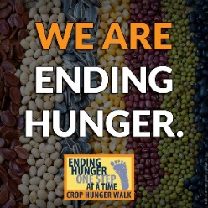

**2020 CROP WALK**

The 2020 Indianapolis Crop Walk will not be a community wide event, so I have decided to make Southeastway Park our location for the walk on Sunday, October 4th. Please let me know if you would like to join me as I intend to walk at least 4 miles and would like to continue New Bethel Baptist Church’s involvement with this important annual event. The needs of our world are only increasing, and this is another way we can minister both here and abroad in an attempt to end hunger.

Kevin Stone

Missions

**HAPPENING THIS WEEK**

**September**

Today 10:30 a.m. Live-stream Sunday worship only

15 10-11:30 a.m., Bible Study, contact Sue Winton

16 1-2:30 p.m., Book discussion Group, contact

Janie Bryant

**LOOKING AHEAD**

Sept. 19 4-7 p.m. p.m., B.A.N.D. Outdoor Concert

(note time changes)

**\*\*\*\*\*\*\*\*\*\*\*\*\*\*\*\*\*\*\*\*\*\***

|  |
| --- |
| **Worship Music Copyright & Live-Streaming permissions**  “Come Thou Almighty King” text by Anonymous; music by Felice de Giardini;  “O Worship the King” text by Robert Grant and David Guthrie; music by William Gardiner, Johann M. Haydn, and  Don Marsh;  “Wonderful Words of Life” text and music by Philip P. Bliss;  “Doxology” text by, Thomas Ken and music by,  Genevan Psalter.  **All above selections ©1997 Word/Integrity Used by Permission. CCLI License #1631733**  “I Have Fixed My Mind” by David Huntsinger;  “Nella Fantasia” by Ennio Morricone, Chiara Ferrau;  “Wanderlust” by Jim Brickman;  “Heartland” by Jim Brickman;  “Borders” by Jim Brickman;  “Great is Thy Faithfulness” by Thomas O. Chisholm,  William M. Runyan;  “Thy Word” by Amy Grant, Michael W. Smith  **Live-Streaming: Christian Copyright Solutions, WorshipCast, License #10868** |