**Welcome to New Bethel Baptist Church**

**Sunday, September 6, 2020**

**Prelude** Dr. Christina Romero-Ivanova

\***Gathering Hymn** *All Creatures of Our God and King*#63

**\*Call to Worship**

Leader:  We gather today to hear the message of God’s

extravagant grace.

People:  Pour your love out upon us this day, O Lord.

Leader:  God’s love for us knows no bounds. This love can

redeem and restore us.

People:  Lord, send your Spirit among this assembly, that

we might experience your love.

Leader:  God is with us.

All:  Reach into our hearts. Fill us with your love. Let our

lives be a word of comfort and hope to others.

**\*Invocation and Lord’s Prayer (***using “sins”*) Karen Pappas

**Scripture Reading** Genesis 2:4-9 Karen Pappas

**Worship Prayer**

**\*Hymn** *In the Garden*#635

**Children’s Sermon**

**Scripture Reflection**  Mark 4:1-20 Rev. Tom Bartley

**\*Hymn** *How Great Thou Art*#147

**Ministry Opportunities** Karen Pappas

Birthdays and Anniversary Blessings

Meditation on Tithes and Offerings

*Doxology #815

*Prayer Karen Pappas

**Communion Hymn** *Come to the Table*#464

**Communion** Rev. Tom Bartley

**\*Closing Hymn** *Blest Be the Tie That Binds*#426

**Postlude** Dr. Christina Romero-Ivanova

**\*\*\*\*\*\*\*\*\*\*\*\*\*\*\*\*\*\*\*\*\*\***

**Daily Scripture Readings for This Week**

Sunday, September 6, 2020: Proper 18 (23)

Monday, September 7, 2020: Psalm 121; Exodus 12:14-28;

1 Peter 2:11-17 or Psalm 119:65-72; Leviticus 4:27-31; 5:14-16; 1 Peter 2:11-17

Tuesday, September 8, 2020: Psalm 121; Exodus 12:29-42;

Romans 13:1-7 or Psalm 119:65-72; Deuteronomy17:2-13; Romans 13:1-7

Wednesday, September 9, 2020: Psalm 121; Exodus 13:1-10;

Matthew 21:18-22or Psalm 119:65-72;

Leviticus 16:1-5, 20-28; Matthew 21:18-22

Thursday, September 10, 2020: Psalm 114; Exodus 13:17-22; 1

John 3:11-16 or Psalm 103:8-13; Genesis 37:12-36;

1 John 3:11-16

Friday, September 11, 2020: Psalm 114; Exodus 14:1-18;

Acts 7:9-16 or Psalm 103:8-13; Genesis 41:53-42:17;

Acts 7:9-16

Saturday, September 12, 2020: Psalm 114; Exodus 15:19-21;

Matthew 6:7-15 or Psalm 103:8-13; Genesis 45:1-20;

Matthew 6:7-15

**Welcome to New Bethel Baptist Church**

**We are blessed by your presence!**

**Sunday, September 6, 2020**

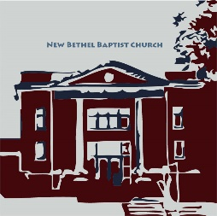

**Guests and Members:**  If you have questions or would like more information about New Bethel, please feel free to contact the church office. Thank you!

*An American Baptist*

*Congregation*

**\*\*\*\*\*\***

**All Are Welcome**

**Weekly Activities Online Only**

Wednesdays online Bible Study 10 a.m., Contact Sue Winton

Thursdays online Book Discussion, *If God Is Love,* 1 p.m., Contact

Janie Bryant

Sunday Worship, 10:30 a.m., Live-stream Only

**\*\*\*\*\*\***

**Contact Information**

New Bethel Baptist Church Website: www.newbethelbapt.org

8936 Southeastern Avenue E-mail: newbethelbapt@att.net

Indianapolis, IN 46239 Wi-fi password: NBBC8624381

317-862-4381 Instagram: NBBC.Wanamaker

YouTube: New Bethel Baptist

Church Wanamaker

https://facebook.com New Bethel Baptist.Wanamaker

Rev. Tom Bartley, Interim Pastor

Lori Chapman, Church Secretary

Church Office Hours: Wednesday - Thursday from 4-6 p.m.

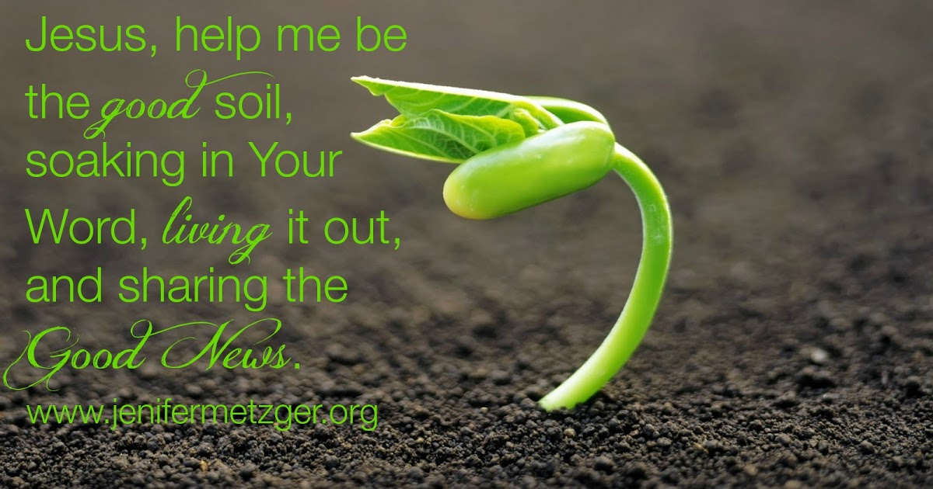

*Just try new things. Don't be afraid.*

*Step out of your comfort zones and soar, all right?*

—Author Unknown

**Welcome Interim Pastor**

New Bethel Baptist family would like to welcome this morning, Rev. Tom Bartley as our Interim Pastor. Tom and his family reside in Speedway, Indiana. He is a graduate of Wabash College and Christian Theological Seminary. He is presently a chaplain with Southern Care Hospice.  Welcome Pastor Tom.

Kevin Winton, Moderator

**\*\*\*\*\*\*\*\*\*\*\*\*\*\*\*\*\*\*\*\*\*\***

**Thank You**

My family and I would like to thank all who brought food for the Celebration of Life for my mother, Nita Louzon. We really appreciated your kind thoughts, prayers, and cards. The love of our extended family at NBBC was very helpful during our time of grief.

Laura Winton

**\*\*\*\*\*\*\*\*\*\*\*\*\*\*\*\*\*\*\*\*\*\***

*Essentially, all life depends upon the soil…There can be no life without soil and no soil without life; they have evolved together*

—Charles Kellogg

**\*\*\*\*\*\*\*\*\*\*\*\*\*\*\*\*\*\*\*\*\*\***

**B.A.N.D. Concerts for Engaging Young Adults Initiative Pilot**

"Undeserved," the Praise Band from Crosspointe Biker Church in Connersville, will play on Sept. 19th and Oct. 17th from 3-7 p.m. in front of God's Bounty. We will have games on the lawn, and there will be a discounted meal for $2.50 available at Wheatley's. Folks will need to bring chairs and/or blankets and your own picnic meal if desired. B.A.N.D. stands for ***Boogie Around New Bethel Day.*** This is a Covid Safe event.

We also need volunteers to help make sure we have everything covered. Please call or e-mail me if you can volunteer or have any questions.

Thanks, John Huddleston,

EYA Team Coordinator

**2020 Finances and Attendance**

|  |  |  |  |
| --- | --- | --- | --- |
|  | Month of August | Year-To-Date |  |
| Tithes/Offerings | $6,905.86 | $74,451.45 |  |
| Expenses Paid | $10,606.86 | $88,357.82 |  |
| Gain/(Loss) | ($3,701.00) | ($13,906.37) |  |
| Budget Needs | $12,044.17 | $96,353.36 |  |
| Average Weekly Worship Attendance 60 | |  |  |
|  |  |  |  |
|  |  | REMAINING BALANCE | |
| EYA Grant ($1,000+$5,000) | $0.00 | $5,385.50 |  |
| EYA Expenses Paid | $2,184.87 | $3,200.63 |  |
|  |  |  |  |
|  |  | REMAINING BALANCE | |
| Tech Grant ($5,000) |  | $5,000.00 |  |
| Tech Expenses Paid | $4,000.00 | $1,000.00 |  |
|  |  |  |  |
|  |  | REMAINING BALANCE | |
| PPP Grant (recvd Aug. 18, 2020) |  | $6,797.00 |  |
| Payroll 8-21-20 | $2,563.15 | $4,233.85 |  |

If you have any questions, please contact me at 317-519-3347 or

e-mail me at njb46239@gmail.com.

Janie Bryant, Treasurer

**Happening This Week**

Worship Music Copyright and Live-Streaming Permissions

“All Creatures of Our God and King’’ text by, William H. Draper;

and music by, Ralph Vaughan Williams and Ken Barker;

“In the Garden” text and music by, C. Austin Miles;

“How Great Thou Art” text by, Stuart K. Hine; and music

by, Stuart K. Hine and Eugene Thomas;

“Come to the Table” text by, Claire Cloninger; and music by,

Martin J. Nystrom

“Blest Be the Tie That Binds” text by, John Fawcett; and music by,

Johann G. Naegeli;

“Doxology” text by, Thomas Ken and music by, Genevan Psalter.

All above selections ©1997 Word/Integrity

Used by Permission. CCLI License #1631733

“You are My Hiding Place” by Michael Ledner;

“I Will Sing of My Redeemer” by P.P. Bliss, James Mcgranaham;

“He Looked Beyond My Faults and Saw My Needs” by Bill George,

Dino Kartsonakis;

“You are My Hiding Place” by Michael Ledner;

“As the Deer with Fairest Lord Jesus” by Mark Hayes;

“Sun of My Soul” by Faye Lopez;

“Let All Things Now Living” by Faye Lopez;

“How Beautiful” by Twila Paris

Live-Streaming: Christian Copyright Solutions, WorshipCast, License #10868

Today Communion Sunday

Live-stream worship only

Sept. 8 7 p.m. Council Meeting on Zoom

9 10-11:30 a.m., Bible Study, contact Sue Winton

10 1-2:30 p.m., Book discussion Group, contact

Janie Bryant

**Looking Ahead**

Sept. 19 3-7 p.m., B.A.N.D. Outdoor Concert

**\*\*\*\*\*\*\*\*\*\*\*\*\*\*\*\*\*\*\*\*\*\***

|  |
| --- |
| During the pandemic, we've moved our workshops to an online format. And they're free! Registration is available now at <https://centerforcongregations.org/workshops>  **Race is Fake; Racism is Real**  **Date: Thursday, September 17. 2020**  **Time:**1-2:30 p.m. (Eastern)  It’s difficult and uncomfortable, but it’s time to talk about racism. Join us for the Race to Justice.  In this workshop, you will learn the underlying definitions and distinctions between race and racism.  You will also learn how racism shows up in various personal and societal ways.  This event is part of the Learn and Lead Series: Race to Justice, led by subject matter expert on race and racism Dr. Michael R. Twyman. |