**Welcome to New Bethel Baptist Church**

**Sunday, November 1, 2020**

**Prelude** Dr. Christina Romero-Ivanova

\***Gathering Hymn**  *Here I am To Worship*

**\*Call to Worship**

Leader:  We have been called by God to gather together.

**People:  We have been called to be one in the Lord.**

Leader:  God loves us.  And this love calls us into communion.

**People:  We find strength in our union through Christ.**

Leader:  Let us join together in praise of our God.

*All:  It is right to give thanks and praise.*

**\*Invocation and Lord’s Prayer** (*using “sins”*) John Huddleston

**Scripture Reading** Genesis 1:26-31 John Huddleston

**Worship Prayer**

**\*Hymn** *Great is the Lord*#140

**Children’s Sermon**

**Scripture Reading** Isaiah 65:1-5a John Huddleston

**Special Music** *Need You Now* Dr. Christina Romero-Ivanova

**Scripture Reflection**  Mark 5:1-20 Rev. Tom Bartley

**\*Hymn** *Now I Belong to Jesus* #501

**Ministry Opportunities** John Huddleston

Birthdays and Anniversary Blessings

Meditation on Tithes and Offerings

*Doxology #815

*Prayer John Huddleston

**Communion Hymn** *Come, Share the Lord* #462

**Communion** Rev. Tom Bartley

**\*Closing Hymn** *Blest Be the Tie That Binds*#426

**Postlude** Dr. Christina Romero-Ivanova

**\*\*\*\*\*\*\*\*\*\*\*\*\*\*\*\*\*\*\*\*\*\***

**DAILY SCRIPTURE READINGS FOR THIS WEEK**

**Monday, November 2, 2020:** Psalm 128; Joshua 4:1-24; 1

Thessalonians 2:13-20, Psalm 5; Jeremiah 5:18-31; 1

Thessalonians 2:13-20

**Tuesday, November 3, 2020:** Psalm 128; Joshua 6:1-16, 20; Acts

13:1-12, Psalm 5; Lamentations 2:13-17; Acts 13:1-12

**Wednesday, November 4, 2020:** Psalm 128; Joshua 10:12-14;

Matthew 15:1-9, Psalm 5; Proverbs 16:21-33; Matthew 15:1-9

**Thursday, November 5, 2020:** Psalm 78:1-7; Joshua 5:10-12;

Revelation 8:6-9:12, Psalm 70; Amos 1:1-2:5; Revelation 8:6-

9:12

**Friday, November 6, 2020:** Psalm 78:1-7; Joshua 8:30-35;

Revelation 9:13-21, Psalm 70; Amos 3:1-12; Revelation 9:13-21

**Saturday, November 7, 2020:**Psalm 78:1-7; Joshua 20:1-9;

Matthew 24:1-14, Psalm 70; Amos 4:6-13; Matthew 24:1-14

**Sunday, November 8, 2020:** Psalm 128**,** Proverbs 17:1-5

**\*\*\*\*\*\*\*\*\*\*\*\*\*\*\*\*\*\*\*\*\*\***

**HAPPENING THIS WEEK**

Today 10:30 a.m. Live-stream/In Person Sunday worship

Nov. 4 10-11:30 a.m., Bible Study, contact Sue Winton

Nov. 5 1-2:30 p.m., Book discussion Group, contact

Janie Bryant

1-6:30 p.m. God’s Bounty Food Pantry serving

**LOOKING AHEAD**

Nov. 10 Zoom Council Meeting

**WELCOME TO NEW BETHEL BAPTIST CHURCH**

**We are blessed by your presence!**

**Sunday, November 1, 2020**

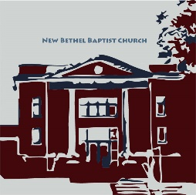**GUEST AND MEMBERS:** If you have questions or would like more information about New Bethel, please feel free to contact the church office. Thank you!

*An American Baptist*

*Congregation*

**\*\*\*\*\*\***

**ALL ARE WELCOME**

**Weekly Activities Online Only**

Wednesdays online Bible Study 10 a.m., Contact Sue Winton

Thursdays online Book Discussion, *If God Is Love,* 1 p.m., Contact

Janie Bryant

**\*\*\*\*\*\***

**CONTACT INFORMATION**

New Bethel Baptist Church Website: www.newbethelbapt.org

8936 Southeastern Avenue E-mail: newbethelbapt@att.net

Indianapolis, IN 46239 Wi-fi password: NBBC8624381

317-862-4381 Instagram: NBBC.Wanamaker

YouTube: New Bethel Baptist

Church Wanamaker

https://facebook.com New Bethel Baptist.Wanamaker

Rev. Tom Bartley, Interim Pastor

Lori Chapman, Church Secretary

Church Office Hours: Wednesday-Thursday from 4-6 p.m.

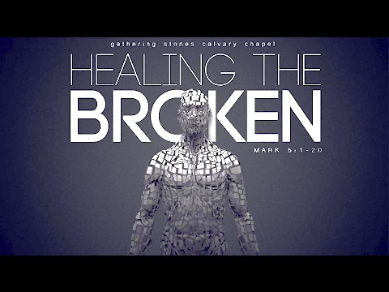

*One of the basic needs*

*of every human being*

*is the need to be loved,*

*to have our wishes and feelings*

*taken seriously,*

*to be validated*

*as people who matter.*

― Harold S. Kushner

**ORDER YOUR CHRISTMAS POINSETTIAS**

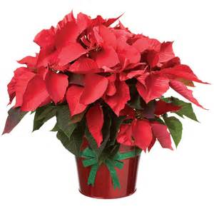It’s time to order your Christmas poinsettias!

Only **red** poinsettias are available this year. Order your poinsettias by **December 18th**.

Each poinsettia is **$12** and must be **paid at the time of order.** Please use this form to

reserve your poinsettia(s).

If you would like to honor, remember, and give to a shut with a poinsettia, be sure to include the person’s or family name below.

Please enclose the correct amount of money for your poinsettia(s) with this form and place your completed form and payment in an envelope and drop it in the offering bags. Please make all checks payable to New Bethel Baptist Church.

**I would like to order _____Poinsettia(s).**

**My Name: _____________________________________________**

**I want to remember or honor the following people:**

1. **________________________________________________**
2. **________________________________________________**
3. **________________________________________________**
4. **________________________________________________**

**The total amount enclosed is _______________________________**

Thank you,

Liz Ballard, Flower Committee

**Worship Music Copyright & Live-Streaming Permissions.**

“Here I am To Worship” text and music by

“Great is the Lord” text and music by Michael W. Smith and

Deborah D. Smith

“Now I Belong to Jesus” text and music by Norman J. Clayton

“Come, Share the Lord” text and music by Bryan Jeffery Leech

“Doxology” text by, Thomas Ken and music by, Genevan Psalter

**All above selections ©1997 Word/Integrity Used by Permission. CCLI License #1631733**

“In My Heart There Rings a Melody” by Elton M. Roth

“Majesty” by Jack W. Hayford

“You are My Hiding Place” by Michael Ledner, Mark Hayes

“Israel” by Jim Brickman

“Jesu” by Jim Brickman

“Angel's Blessing” by Jim Brickman

“Breath of Heaven” by Chris Eaton, Amy Grant

“It is Well” by Jim Brickman

“Need You Now” by Plumb

**Live-Streaming: Christian Copyright Solutions, WorshipCast, License #10868**

**\*\*\*\*\*\*\*\*\*\*\*\*\*\*\*\*\*\*\*\*\*\***

**2021 Church Offering Envelopes**

I am preparing to print the 2021 Church Offering Envelopes in house.

Please let me know if you would like to receive weekly giving or monthly giving envelopes. This will help me determine how many envelopes I need to print for each person.

If you currently do not receive church envelopes but would like to in 2021, please let me know by calling the church office at 317-862-4381 or e-mailing newbethelbapt@att.net.

Thank you,

Lori Chapman

Financial Secretary