**Welcome to New Bethel Baptist Church**

**Sunday, October 18, 2020**

**Prelude** Dr. Christina Romero-Ivanova

\***Gathering Hymn**  *How Great Is Our God*

**\*Call to Worship**

Leader: This is the day that the Lord has made.

**People: We will rejoice and be glad in it.**

Leader: Let us join together in worship of our God

**People: To tell of the greatness of our God.**

Leader: Today we praise you, O God, for your Presence that breaks

through the mundane moments of our life

**People: We celebrate your intervention in our lives this past**

**week**

*All: As you have been with us this week, watch over us today and*

*through the tomorrows. Bless us as we worship you in Spirit*

*and truth.*

**\*Invocation and Lord’s Prayer** (*using “sins”*) Karen Pappas

**Old Testament Scripture Reading** Genesis 1:14-19 Karen Pappas

**Worship Prayer**

**\*Hymn** *Tell Me the Story of Jesus* #295

**Children’s Sermon**

**Scripture Reflection**  Mark 3:20-34 Rev. Tom Bartley

**\*Hymn** *Higher Ground*#549

**Ministry Opportunities** Karen Pappas

Meditation on Tithes and Offerings

*Doxology #815

*Prayer Karen Pappas

**Benediction**

**Postlude** Dr. Christina Romero-Ivanova

**DAILY SCRIPTURE READINGS FOR THIS WEEK**

**Monday, October 19, 2020:** Psalm 63:1-8; Exodus 40:34-38;

Revelation 18:1-10, 19-20; Psalm 98; Daniel 3:1-18

**Tuesday, October 20, 2020:** Psalm 63:1-8; Numbers 12:1-9;

Revelation 18:21-24; Psalm 98; Daniel 3:19-30; Revelation

18:21-24

**Wednesday, October 21, 2020:** Psalm 63:1-8; Numbers 13:1-2, 17-

14:9; Matthew 17:22-27; Psalm 98; Daniel 6:1-28

**Thursday, October 22, 2020:** Psalm 90:1-6, 13-17; Deuteronomy

31:14-22; Titus 1:5-16; Psalm 1; Numbers 5:5-10; Titus 1:5-

16

**Friday, October 23, 2020:** Psalm 90:1-6, 13-17; Deuteronomy 32:1-

14, 18; Titus 2:7-8, 11-15; Psalm 1; Deuteronomy 9:25-10:5;

Titus 2:7-8, 11-15

**Saturday, October 24, 2020:** Psalm 90:1-6, 13-17; Deuteronomy

32:44-47; John 5:39-47; Psalm 1; Proverbs 24:23-34; John

5:39-47

**Sunday, October 25, 2020:** Psalm 62; John 4:1-10

**\* * * * * * \***

*The measure of intelligence is the ability to change.*

—Albert Einstein

**\* * * * * * \***

**WELCOME TO NEW BETHEL BAPTIST CHURCH**

**We are blessed by your presence!**

**Sunday, October 18, 2020**

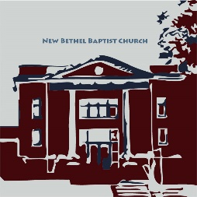**GUEST AND MEMBERS:** If you have questions or would like more information about New Bethel, please feel free to contact the church office. Thank you!

*An American Baptist*

*Congregation*

**\*\*\*\*\*\***

**ALL ARE WELCOME**

**Weekly Activities Online Only**

Wednesdays online Bible Study 10 a.m., Contact Sue Winton

Thursdays online Book Discussion, *If God Is Love,* 1 p.m., Contact

Janie Bryant

Sunday Worship, 10:30 a.m., Live-stream Only

**\*\*\*\*\*\***

**CONTACT INFORMATION**

New Bethel Baptist Church Website: www.newbethelbapt.org

8936 Southeastern Avenue E-mail: newbethelbapt@att.net

Indianapolis, IN 46239 Wi-fi password: NBBC8624381

317-862-4381 Instagram: NBBC.Wanamaker

YouTube: New Bethel Baptist

Church Wanamaker

https://facebook.com New Bethel Baptist.Wanamaker

Rev. Tom Bartley, Interim Pastor

Lori Chapman, Church Secretary

Church Office Hours: Wednesday-Thursday from 4-6 p.m.

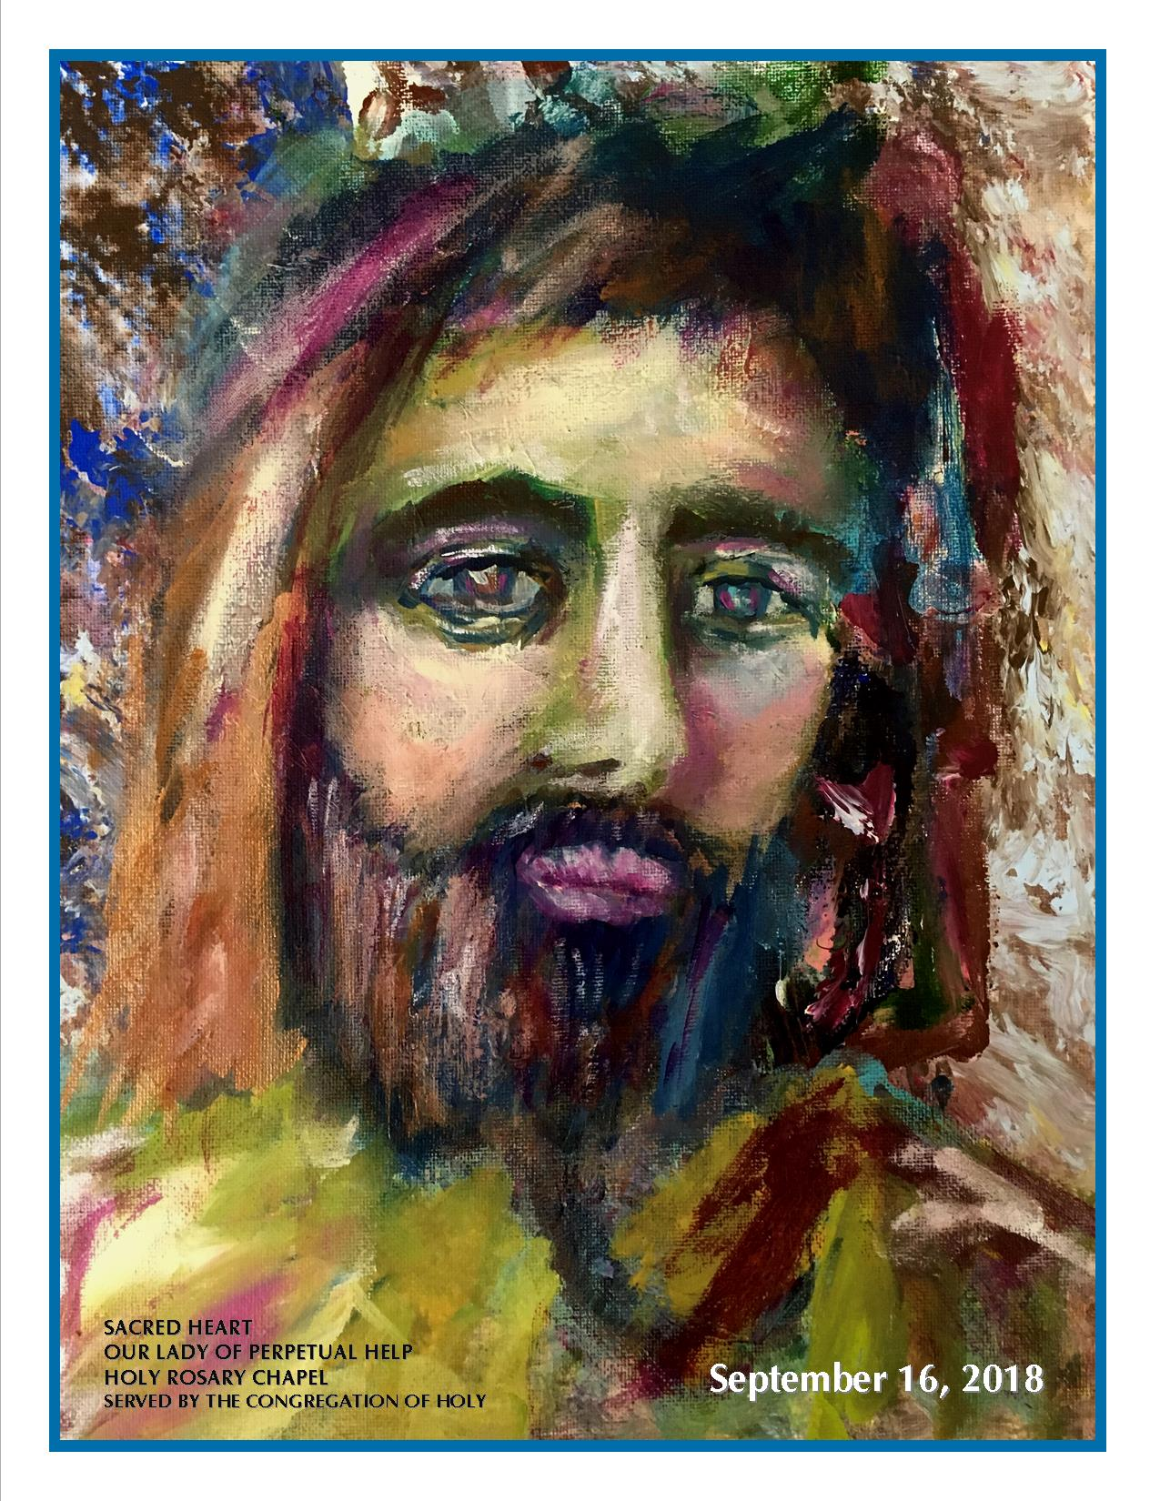

***Mark 3:28-30****“Listen to this carefully. I’m warning you. There’s nothing done or said that can’t be forgiven. But if you persist in your slanders against God’s Holy Spirit, you are repudiating the very One who forgives, sawing off the branch on which you’re sitting, severing by your own perversity all connection with the One who forgives.” He gave this warning because they were accusing him of being in league with Evil.*

### **Addiction Webinar Series: A Call to Action**

**A Call to Action: Addressing Unique Treatment and Recovery Needs of Women in Addiction**

October 22, 2020; 9:00 p.m. Eastern

 In 2018, 32.1 million adult women had a mental and/or substance use disorder, yet there was still a large gap evident in addressing treatment needs of women (Substance Abuse & Mental Health Services Administration, 2018).

If one was to examine development and implementation of addictions treatment and recovery programs in response to those women who make the courageous decision to seek help in breaking free from addiction, one might ponder how treatment providers go about designing treatment programs for men and designing treatment programs for women. Do men and women receive the same treatment? Are women pigeon-holed into treatment programs designed for men because a drug is a drug, what difference does it make? Are any considerations made in response to gender? If so, what considerations are made? How are these considerations implemented?

This webinar will seek to answer these and other questions to assist participants in having greater insight into and perspective on treatment and recovery for women who seek help for substance abuse.   
Guest Presenter: Dr. Brenda Edwards

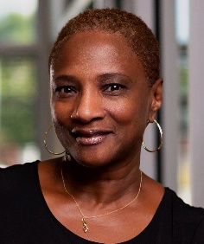Dr. Brenda Edwards is a Counselor Educator and a Psychotherapist. She specializes in Addictions Counseling and enjoys supporting and empowering women in recovery. Dr. Edwards holds a Doctorate in Education, a State License as a Professional Counselor, and a Certification as a Master Addictions Counselor.

For more information and to register online go to: [www.abwomensministries.org/webinars](http://www.abwomensministries.org/webinars)

**HAPPENING THIS WEEK**

October

Today 10:30 a.m. Live-stream Sunday worship only

10-11:30 a.m., Bible Study, contact Sue Winton

1-2:30 p.m., Book discussion Group, contact

Janie Bryant

**Worship Music Copyright & Live-Streaming Permissions**

“How Great Is Our God” text and music by, Chris Tomlin;

“Tell Me the Story of Jesus”text by, Franny J. Crosby; music by,

John R. Sweney;

“Higher Ground” text by, Johnson Oatman, Jr.; music by, Charles H.

Gabriel;

“Doxology” text by, Thomas Ken and music by, Genevan

Psalter.

**All above selections ©1997 Word/Integrity Used by Permission. CCLI License #1631733**

“Love Can Build a Bridge” by Naomi Judd, John Barlow Jarvis, Paul

Overstreet, Bill George, Dino Kartsonakis;

“He Looked Beyond My Faults and Saw My Needs” by Bill George,

Dino Kartsonakis;

“In the Sweet By and By by” Bill George, Dino Kartsonakis;

“Mountain Suite Overture” by Bill George, Dino Kartsonakis;

“As the Deer with Fairest Lord Jesus” by Mark Hayes;

“You are My Hiding Place” by Michael Ledner, Mark Hayes;

“Side by Side” by Jeff Wood;

“He's Got the Whole World in His Hands: by John T. Benson, Jr.

**Live-Streaming: Christian Copyright Solutions, WorshipCast, License #10868**