**Welcome to New Bethel Baptist Church**

**Sunday, October 25, 2020**

**Prelude** Dr. Christina Romero-Ivanova

**Special Gathering Hymn** *How Great Is Our God*

\***Gathering Hymn**  *Victory In Jesus* #353

**\*Call to Worship**

Leader: Call out to the Lord in your trouble, and you will be delivered

through your distress.

**People: Our Lord can calm the storm with a whisper and relieve**

**the sea of its fury.**

Leader: We can rejoice when the storm grows calm and we are

brought to a place of safety.

**People: We give thanks to God, for the unfailing love that leads**

**us through the storms of life.**

*All: Speak to our hearts this day and calm the storms that surge*

*inside us.*

**\*Invocation and Lord’s Prayer** (*using “sins”*) Karen Pappas

**Scripture Reading** Genesis 1:20-25 Karen Pappas

**Worship Prayer**

**\*Hymn** *Standing on the Promises* v. 1,2,4,5#410

**Children’s Sermon**

**Scripture Reflection**  Mark 4:35-41 Rev. Tom Bartley

**\*Hymn** *Softly and Tenderly*#479

**Ministry Opportunities** Karen Pappas

Meditation on Tithes and Offerings

*Doxology #815

*Prayer Karen Pappas

**Benediction**

**Postlude** Dr. Christina Romero-Ivanova

**DAILY SCRIPTURE READINGS FOR THIS WEEK**

Monday, October 26, 2020: Psalm 119:41-48 ; Numbers 33:38-39;

James 2:8-13, or Psalm 119:41-48; Deuteronomy 6:1-9, 20-

25

Tuesday, October 27, 2020: Psalm 119:41-48; Exodus 34:29-35;

James 2:14-26 or Psalm 119:41-48; Deuteronomy 10:10-22

Wednesday, October 28, 2020: Psalm 119:41-48; Deuteronomy

26:16-27:7 ; Matthew 19:16-22 or Psalm 119:41-48; Proverbs

16:1-20; Matthew 19:16-22

Thursday, October 29, 2020: Psalm 107:1-7, 33-37; Joshua 1:1-11;

Romans 2:17-29 or Psalm 43; 1 Samuel 2:27-36; Romans

2:17-29

Friday, October 30, 2020: Psalm 107:1-7, 33-37; Joshua 2:1-14; 2

Peter 2:1-3 or Psalm 43; Ezekiel 13:1-16; 2 Peter 2:1-3

Saturday, October 31, 2020: Psalm 107:1-7, 33-37; Joshua 2:15-24;

Matthew 23:13-28 or Psalm 43; Malachi 1:6-2:9; Matthew

23:13-28

Sunday, November 1, 2020: James 2:8-13, James 2:14-26

**\*\*\*\*\*\*\*\*\*\***

**2021 Church Offering Envelopes**

I am preparing to print the 2021 Church Offering Envelopes in house.

Please let me know if you would like to receive weekly giving or monthly giving envelopes. This will help me determine how many envelopes I need to print for each person.

If you currently do not receive church envelopes but would like to in 2021, please let the church office know by calling 317-862-4381 or e-mailing newbethelbapt@att.net.

Thank you,

Lori Chapman

Financial Secretary

**WELCOME TO NEW BETHEL BAPTIST CHURCH**

**We are blessed by your presence!**

**Sunday, October 25, 2020**

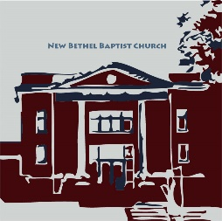**GUEST AND MEMBERS:** If you have questions or would like more information about New Bethel, please feel free to contact the church office. Thank you!

*An American Baptist*

*Congregation*

**\*\*\*\*\*\***

**ALL ARE WELCOME**

**Weekly Activities Online Only**

Wednesdays online Bible Study 10 a.m., Contact Sue Winton

Thursdays online Book Discussion, *If God Is Love,* 1 p.m., Contact

Janie Bryant

Sunday Worship, 10:30 a.m., Live-stream Only

**\*\*\*\*\*\***

**CONTACT INFORMATION**

New Bethel Baptist Church Website: www.newbethelbapt.org

8936 Southeastern Avenue E-mail: newbethelbapt@att.net

Indianapolis, IN 46239 Wi-fi password: NBBC8624381

317-862-4381 Instagram: NBBC.Wanamaker

YouTube: New Bethel Baptist

Church Wanamaker

https://facebook.com New Bethel Baptist.Wanamaker

Rev. Tom Bartley, Interim Pastor

Lori Chapman, Church Secretary

Church Office Hours: Wednesday-Thursday from 4-6 p.m.

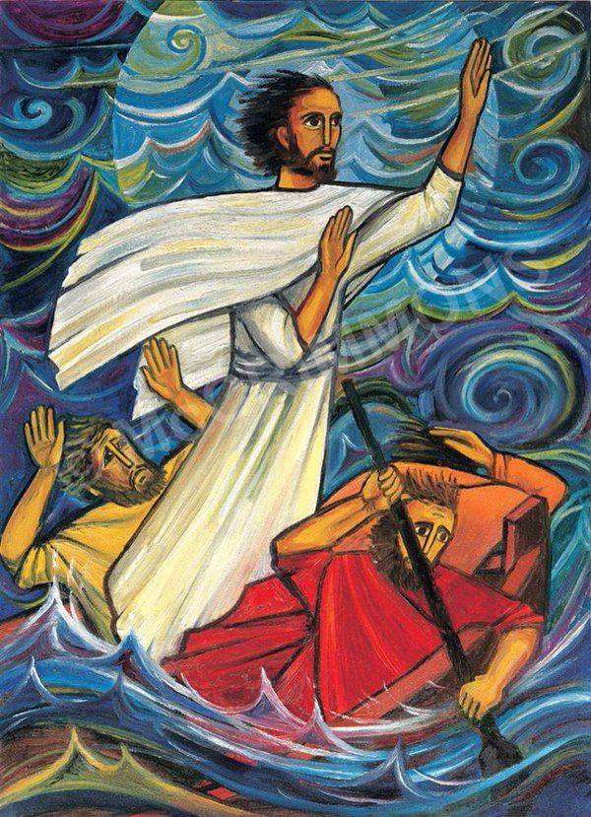

**Mark 4:35-38 35**That day when evening came, he said to his disciples, “Let us go over to the other side.” **36**Leaving the crowd behind, they took him along, just as he was, in the boat. There were also other boats with him. **37**A furious squall came up, and the waves broke over the boat, so that it was nearly swamped. **38**Jesus was in the stern, sleeping on a cushion. The disciples woke him and said to him, “Teacher, don’t you care if we drown?”

**HAPPENING THIS WEEK**

**Today** 10:30 a.m. Live-stream Sunday worship only

10-11:30 a.m., Bible Study, contact Sue Winton

1-2:30 p.m., Book discussion Group, contact

Janie Bryant

**29**  1-6:30 p.m. God's Bounty Open to serve

**LOOKING AHEAD**



**Sunday, November 1, 2020**

**November 1, 2020**

10:30 a.m. Live-stream / In-Person Communion

Sunday worship

**\*\*\*\*\*\*\*\*\*\*\*\*\*\*\*\*\*\*\*\*\*\***

|  |  |
| --- | --- |
|  |  |
|  |  |

**ORDER YOUR CHRISTMAS POINSETTIAS**

**Starting Next Sunday, November 1**



It’s time to order your Christmas poinsettias!

Only **red** poinsettias are available this year. Order your poinsettias by **Friday,** **December 18th**.

Each poinsettia is **$12** and must be **paid at the**

**time of order.**

Next Sunday, November 1 we will have a form in the bulletin for you to fill out and turn in. Please use this form to reserve your poinsettia(s).

Please enclose the correct amount of money for your poinsettia(s) with your form and place your completed form and payment in an envelope and drop it in the offering or mail it to the church office. Please make all checks payable to New Bethel Baptist Church.

Worship Music Copyright & Live-Streaming Permissions.

“How Great Is Our God” text and music by, Chris Tomlin;

“Victory In Jesus” text and music by, Eugene M. Bartlett;

“Standing on the Promises” text by, R. Kelso Carter music by, R.

Kelso Carter and Tom Ferrke;

“Softly and Tenderly” text and music by, Will L. Thompson;

“Doxology” text by, Thomas Ken and music by, Genevan

Psalter.

All above selections ©1997 Word/Integrity Used by Permission. CCLI License #1631733

“I have Fixed My Mind” by David Huntsinger

“Nella Fantasia” by Ennio Morricone, Chiara Ferrau

“Wanderlust” by Jim Brickman

“Heartland” by Jim Brickman

“Borders” by Jim Brickman

“Hero's Dream” by Jim Brickman

“Great are You, Lord” by Steve & Vikki Cook

“Pass it On” by Kurt Kaiser

Live-Streaming: Christian Copyright Solutions, WorshipCast, License #10868

**\*\*\*\*\*\*\*\*\*\*\*\*\*\*\*\*\*\*\*\*\*\***

“The greatest discovery of all time is that a person

can change his future by merely changing his attitude”

—Oprah Winfrey.

**\*\*\*\*\*\*\*\*\*\*\*\*\*\*\*\*\*\*\*\*\*\***

**THANK YOU**

Thank you to Pastor Tom and the Worship Team for all their time and effort that goes into bring online worship to us at home.