**Welcome to New Bethel Baptist Church**

**Thursday, December 24, 2020**

**Christmas Eve**

**Welcome and Announcement**

**Invocation**

**Hymn** *O Come, All Ye Faithful* #249

**Scripture Reading** Luke 1:26-38- Announcement

**Lighting of First Advent Candle**

**Hymn**  *O Come O Come Emmanuel* #245

**Special Music** *O Holy Night*

John Huddleston

**Scripture Reading** Matthew 1:18-25- Birth of Jesus

**Lighting of Second Advent Candle**

**Hymn** *O Little Town of Bethlehem* #250

**Special Music** Rev. Tom Bartley

**Scripture Reading** Luke 2:8-20- Shepherds and Angels

**Lighting of Third Advent Candle**

**Hymn** *Angels We Have Heard on High* #278

**Special Music** *Breath of Heaven*

Dr. Christina Romero-Ivanova

**Scripture Reading** Matthew 2:1-12- Magi

**Lighting of Fourth Advent Candle**

**Special Music** *Do You Hear What I hear*

Phil Morgan and Karen Pappas

**Reflection** Rev. Tom Bartley

**Scripture** John 1:1-18- Logos

**Lighting of the Christ Candle**

**Hymn** *Silent Night* #253

**Benediction**

*\*\*\*\*\*\*\*\*\*\*\*\*\*\*\*\*\**

*If you feel led to give an offering to New Bethel Baptist Church,*

*Please give online or mail your offering to*

*Janie Bryant or the Church.*

*\*\*\*\*\*\*\*\*\*\*\*\*\*\*\*\**

***Merry Christmas!***

**WELCOME TO NEW BETHEL BAPTIST CHURCH**

**We are blessed by your presence!**

**December 24, 2020**

**Christmas Eve**

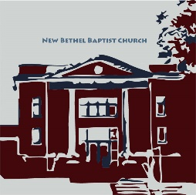

**GUEST AND MEMBERS:** If you have questions or would like more information about New Bethel, please feel free to contact the church office. Thank you!

*An American Baptist*

*Congregation*

**\*\*\*\*\*\***

**ALL ARE WELCOME**

**Weekly Activities Online Only**

Wednesdays online Bible Study 10 a.m., Contact Sue Winton

Thursdays online Book Discussion, *If God Is Love,* 1 p.m., Contact

Janie Bryant

Sunday Worship, 10:30 a.m., Live-stream Only

**\*\*\*\*\*\***

**CONTACT INFORMATION**

New Bethel Baptist Church Website: www.newbethelbapt.org

8936 Southeastern Avenue E-mail: newbethelbapt@att.net

Indianapolis, IN 46239 Wi-fi password: NBBC8624381

317-862-4381 Instagram: NBBC.Wanamaker

YouTube: New Bethel Baptist

Church Wanamaker

https://facebook.com New Bethel Baptist.Wanamaker

Rev. Tom Bartley, Interim Pastor

Lori Chapman, Church Secretary

Church Office Hours: Wednesday-Thursday from 4-6 p.m.

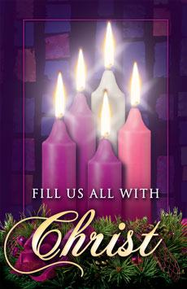

Worship Music Copyright and Live-Streaming Permissions

“O Come, All Ye Faithful” text by John Francis Wade and Frederick

Oakeley; music by John Francis Wade and Tom Fettke

“O Come O Come Emmanuel” text by Latin Hymn, Psalteriolum

Cantionum Catholicarum, 1710; translated by John M. Neale;

music by Thomas Helmore

“O Holy Night” text by John S. Dwight; music by Adolphe Adam

“O Little Town of Bethlehem” text by Phillips Brooks; music by

Lewis H. Redner

“Breath of Heaven” text and music by Amy Grant and Chris Eaton

“Do You Hear What I hear” text and music by Noel Regney & Gloria

Shayne

“Silent Night” text by Joseph Mohr and John F. Young and music by

Franz Gruber

“Angels We Have Heard on High” text by Traditional French carol;

music by Ken Barker

All above selections ©1997 Word/Integrity Used by Permission.

CCLI License #1631733

“Jesu” by Jim Brickman

“Sussex Carol with It Came Upon a Midnight Clear” by Tom Fettke

“Rise Up, Shepherd, and Follow with Behold the Star” by Tom Fettke

“O Come, Little Children with Still, Still, Still” Pachelbel's Canon by

Tom Fettke

“O Come, O Come Immanuel” by Veni Emmanuel

Sing We Now of Christmas with the First Noel by Tom Fettke

Live-Streaming: Christian Copyright Solutions, WorshipCast,

License #10868