**Welcome to New Bethel Baptist Church**

**Sunday, December 6, 2020**

**Prelude** Paula Phelan

\***Gathering Hymn**  *Come Thou long expected Jesus* #244

**\*Call to Worship**

One: God offers us the gift of peace.

**Many: We accept God's gift of peace and take it into our hearts**

**and minds.**

One: What shall we do with this gift we are given?

**Many: We will share the gift of peace to our world.**

One: How will we share this gift we are given?

*All: We will show kindness and understanding. We will promote the*

*welfare of our neighbors. We will be love in a world that*

*needs more love.*

**Advent Reading/Lighting of Advent Candle**

**Advent Prayer**

**Advent Song** *Let There Be Peace on Earth*

**Old Testament Scripture Reading** Isaiah 7:14 Karen Pappas

**Worship Prayer**

**\*Hymn** *O Come O Come Emmanuel*#245

**Children’s Sermon**

**Scripture Reading** Luke 1:57-80 Karen Pappas

**Scripture Reflection**  Rev. Tom Bartley

**\*Hymn** *O Little Town of Bethlehem*#250

**Ministry Opportunities** Karen Pappas

Birthdays and Anniversary Blessings

Meditation on Tithes and Offerings

*Doxology #815

*Prayer with Lord’s Prayer Karen Pappas

**Communion Hymn** *You Are My All in All*  #583

**Communion** Rev. Tom Bartley

**\*Closing Hymn** *Blest Be the Tie That Binds*#426

**Postlude** Paula Phelan

**HAPPENING THIS WEEK**

Today 10:30 a.m. Live-stream Sunday worship only

10-11:30 a.m., Bible Study, contact Sue Winton

1-2:30 p.m., Book discussion Group, contact

Janie Bryant

**\*\*\*\*\*\*\*\*\*\*\*\*\*\*\*\*\*\*\*\*\*\***

**DAILY SCRIPTURE READINGS FOR THIS WEEK**

**Monday, December 7, 2020**: Psalm 27; Isiah 267-15; Acts 2:37-42

**Tuesday, December 8, 2020:** [Psalm 27; Isaiah 4:2-6; Acts 11:1-18](http://www.biblegateway.com/passage/?search=Psalm%2027;%20Isaiah%204:2-6;%20Acts%2011:1-18)

**Wednesday, December 9, 2020:** Psalm 27; Malachi 2:10-3:1; Luke

1:5-17

**Thursday, December 10, 2020:** Psalm 126; Habakkuk 2:1-5;

Philippians 3:7-11

**Friday, December 11, 2020:** Psalm 126; Habakkuk 3:2-6;

Philippians 3:12-16

**Saturday, December 12, 2020:** Psalm 126; Habakkuk 3:13-19;

Matthew 21:28-32

**Sunday, December 13, 2020:** Isaiah 61:1-4, 8-11; Psalm 126; Luke

1:46b-55; 1 Thessalonians 5:16-24; John 1:6-8, 19-28

**WELCOME TO NEW BETHEL BAPTIST CHURCH**

**We are blessed by your presence!**

**Sunday, December 6, 2020**

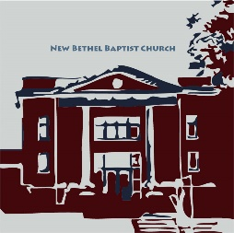**GUEST AND MEMBERS:** If you have questions or would like more information about New Bethel, please feel free to contact the church office. Thank you!

*An American Baptist*

*Congregation*

**\*\*\*\*\*\***

**ALL ARE WELCOME**

**Weekly Activities Online Only**

Wednesdays online Bible Study 10 a.m., Contact Sue Winton

Thursdays online Book Discussion, *If God Is Love,* 1 p.m., Contact

Janie Bryant

Sunday Worship, 10:30 a.m., Live-stream Only

**\*\*\*\*\*\***

**CONTACT INFORMATION**

New Bethel Baptist Church Website: www.newbethelbapt.org

8936 Southeastern Avenue E-mail: newbethelbapt@att.net

Indianapolis, IN 46239 Wi-fi password: NBBC8624381

317-862-4381 Instagram: NBBC.Wanamaker

YouTube: New Bethel Baptist

Church Wanamaker

https://facebook.com New Bethel Baptist.Wanamaker

Rev. Tom Bartley, Interim Pastor

Lori Chapman, Church Secretary

Church Office Hours: Wednesday-Thursday from 4-6 p.m.

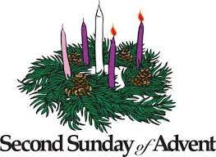

**ORDER YOUR CHRISTMAS POINSETTIAS**

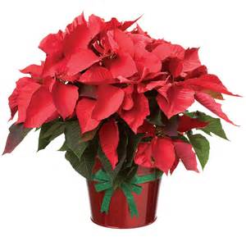It’s time to order your Christmas poinsettias!

Only **red** poinsettias are available this year.

Each poinsettia is **$12** and must be **paid at the time of order.** Please use this form to

reserve your poinsettia(s).

If you would like to honor, remember, and give to a shut with a poinsettia, be sure to include the person’s or family name below.

Please enclose the correct amount of money for your poinsettia(s) with this form and place your completed form and payment in an envelope and drop it in the offering bags. Please make all checks payable to New Bethel Baptist Church.

**I would like to order _____Poinsettia(s).**

**My Name: _____________________________________________**

**I want to remember or honor the following people:**

1. **________________________________________________**
2. **________________________________________________**
3. **________________________________________________**
4. **________________________________________________**

**The total amount enclosed is _______________________________**

Thank you,

Liz Ballard, Flower Committee

**Worship Music Copyright & Live-Streaming Permissions.**

“Come Thou long expected Jesus”

“O Come O Come Emmanuel”

“O Little Town of Bethlehem”

“Let There Be Peace on Earth”

“You Are My All in All”

“Doxology” text by, Thomas Ken and music by, Genevan Psalter

“Blest Be he Tie That Binds” words by John Fawcett; music by Johann G. Naegeli, Lowell Mason

**All above selections ©1997 Word/Integrity Used by Permission. CCLI License #1631733**

“You are My Hiding Place” by Michael Ledner;

“The Worship Song” by Celeste Yohai;

“Jesu” by Jim Brickman;

“Angel's Blessing” by Jim Brickman;

“Breath of Heaven” by Chris Eaton, Amy Grant;

“The First Nowell” by Traditional;

“In Dulci Jubilo” by Bartholomew Gesius;

“O Holy Night” by Adolphe Adam

**Live-Streaming: Christian Copyright Solutions, WorshipCast, License #10868**

**\*\*\*\*\*\*\*\*\*\*\*\*\*\*\*\*\*\*\*\*\*\***

*We can believe that God is present and still be either six feet away or in the safety of our homes on Sunday morning. The church will always be the church no matter how physically close its members are. God isn’t just found in the confines of a physical church building — God meets us where we are.*

—Miguel Petrosky