**Welcome to New Bethel Baptist Church**

**Sunday, January 10, 2021**

**Prelude** Dr. Christina Romero-Ivanova

\***Gathering Hymn**  *Mighty to Save*

*Jesus Messiah*

**\*Call to Worship**

One:  Be still and know that the Lord is God

**Many:  God has made us. We belong to God**

One:  God is our refuge and strength, an ever-present help in time of trouble

**Many:  We will not be afraid, for the Lord our God is with us**

*All:  Even though the earth gives way, and the mountains fall into the sea we will remember that God is the Almighty, our fortress in times of trouble.*

**\*Invocation and Lord’s Prayer (***using “sins”*) Karen Pappas

**Scripture Reading** Judges 3:12-23 Karen Pappas

**Worship Prayer**

**\*Hymn** *For the Beauty of the Earth*#182

**Children’s Sermon**

**Scripture Reflection**  Mark 7:1-23 Rev. Tom Bartley

**\*Hymn** *Have Thine Own Way, Lord* #591

**Ministry Opportunities** Karen Pappas

Meditation on Tithes and Offerings

*Doxology #815

*Prayer Karen Pappas

**Benediction** Rev. Tom Bartley

**Postlude**  Dr. Christina Romero-Ivanova

*\*\*\*\*\*\*\*\*\*\*\*\*\*\*\*\*\*\*\*\**

**Retired Ministers and Missionaries Offering (RMMO):**

As we begin 2021, we are thankful for many things. We are very thankful for our retired ministers and missionaries who dedicated their lives to spreading the Gospel of Jesus Christ with others.

We now have an opportunity to show our appreciation with these wonderful men and women by donating to the RMMO Offering. The thank you gifts to our American Baptist Pastors were reduced by 4% in 2020.

Just add your RMMO offering to your regular giving and mark on the envelope or in the comments section of PayPal what part of your offering you want to give for RMMO.

Your expression of love and thankfulness will be very much appreciated.

**-New Bethel Baptist Church Board of Missions**

*\*\*\*\*\*\*\*\*\*\*\*\**

*“Love is the purity of the sweet, clean, and angelic feeling of a heart in which the evil cannot enter.”*

― Ehsan Sehgal

*************

**Worship Music Copyright and Live-Streaming Permissions**

“Doxology” text by Thomas Ken and music by *Genevan Psalter*

“Mighty to Save”

“Jesus Messiah”

“For the Beauty of the Earth”

“Have Thine Own Way, Lord”

All above selections ©1997 Word/Integrity Used by Permission.

CCLI License #1631733

Live-Streaming: Christian Copyright Solutions, WorshipCast,

License #10868

***WELCOME TO NEW BETHEL BAPTIST CHURCH***

**We are blessed by your presence!**

**Sunday, January 10, 2021**

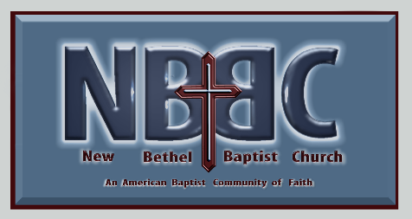**GUESTS AND MEMBERS:** If you have questions or would like more information about New Bethel, please feel free to contact the church office. Thank you!

**\*\*\*\*\*\***

**ALL ARE WELCOME**

**Weekly Activities Online Only**

Wednesdays online Bible Study 10 a.m., Contact Sue Winton

Thursdays online Book Discussion, *If God Is Love,* 1 p.m., Contact

Janie Bryant

Sunday Worship, 10:30 a.m., Live-stream Only

**\*\*\*\*\*\***

**CONTACT INFORMATION**

New Bethel Baptist Church **Website:** www.newbethelbapt.org

8936 Southeastern Avenue **E-mail:** newbethelbapt@att.net

Indianapolis, IN 46239 **Wi-fi password:** NBBC8624381

317-862-4381 **Instagram:** NBBC.Wanamaker

**YouTube:** New Bethel Baptist

Church Wanamaker

New Bethel Baptist.Wanamaker



Rev. Tom Bartley, Interim Pastor

Lori Chapman, Church Secretary

Church Office Hours: Wednesday-Thursday from 4-6 p.m.

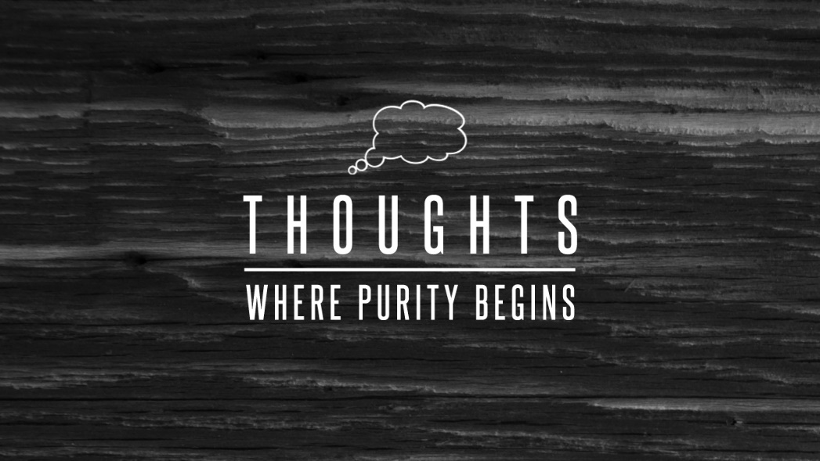

*“One must be a sea, to receive a polluted stream without becoming impure.”*

― Friedrich Nietzsche, Thus Spoke Zarathustra