**Welcome to New Bethel Baptist Church**

**Sunday, January 17, 2021**

**Prelude** Dr. Christina Romero-Ivanova

\***Gathering Hymn**  *10,000 Reasons*

**\*Call to Worship**

One: Welcome to this time and space, Our Lord.

**Many: We welcome your Presence to this assembly.  May the**

**breath of the Spirit share your Word with us.**

One: The Spirit of the Lord is With us.  God is present as we worship.

**Many: We bring to worship our cares and concerns, our hopes**

**and our dreams.**

One: The Lord hears our prayers, and responds with grace and love.

*All: Thanks be to God, for our prayers are heard and answered.  We*

*praise you for your steadfast love.*

**\*Invocation and Lord’s Prayer (***using “sins”*) Karen Pappas

**Scripture Reading** Judges 4:1-10 Karen Pappas

**Worship Prayer**

**\*Hymn** *To God be the Glory* #56

**Children’s Sermon**

**Scripture Reflection**  Mark 7:24-30 Rev. Tom Bartley

**\*Hymn** *The Solid Rock* #526

**Ministry Opportunities** Karen Pappas

Meditation on Tithes and Offerings

*Doxology #815

*Prayer Karen Pappas

**Benediction** Rev. Tom Bartley

**Postlude**  Dr. Christina Romero-Ivanova

Dear Friends,

The NBBC Book Study Group will be starting book, If the Church Were Christian, by Philip Gulley next Thursday.  The group meets online on **Thursday mornings at 10 a.m.**

If you need some inspiration and want to be; more connected with other people in these challenging COVID times, **let me know.  This group is for you!**

I will be sure that you get an invitation to the group via email.  You may order the book from Amazon.com.

We welcome all of you to join us.

Happy 2021,

Barbara

*\*\*\*\*\*\*\*\*\*\*\*\*\*\*\*\*\*\*\*\**

**Retired Ministers and Missionaries Offering (RMMO):**

As we begin 2021, we are thankful for many things. We are very thankful for our retired ministers and missionaries who dedicated their lives to spreading the Gospel of Jesus Christ with others.

We now have an opportunity to show our appreciation with these wonderful men and women by donating to the RMMO Offering. The thank you gifts to our American Baptist Pastors were reduced by 4% in 2020.

Just add your RMMO offering to your regular giving and mark on the envelope or in the comments section of PayPal what part of your offering you want to give for RMMO.

Your expression of love and thankfulness will be very much appreciated.

New Bethel Baptist Church Board of Missions

**WELCOME TO NEW BETHEL BAPTIST CHURCH**

**We are blessed by your presence!**

**Sunday, January 17, 2021**

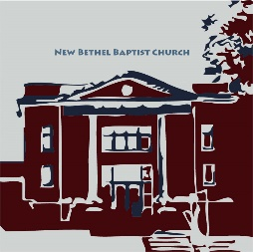

**GUEST AND MEMBERS:** If you have questions or would like more information about New Bethel, please feel free to contact the church office. Thank you!

*An American Baptist*

*Congregation*

**\*\*\*\*\*\***

**ALL ARE WELCOME**

**Weekly Activities Online Only**

Wednesdays online Bible Study 10 a.m., Contact Sue Winton

Thursdays online Book Discussion, *If God Is Love,* 1 p.m., Contact

Janie Bryant

Sunday Worship, 10:30 a.m., Live-stream Only

**\*\*\*\*\*\***

**CONTACT INFORMATION**

New Bethel Baptist Church Website: www.newbethelbapt.org

8936 Southeastern Avenue E-mail: newbethelbapt@att.net

Indianapolis, IN 46239 Wi-fi password: NBBC8624381

317-862-4381 Instagram: NBBC.Wanamaker

YouTube: New Bethel Baptist

Church Wanamaker

https://facebook.com New Bethel Baptist.Wanamaker

Rev. Tom Bartley, Interim Pastor

Lori Chapman, Church Secretary

Church Office Hours: Wednesday-Thursday from 4-6 p.m.

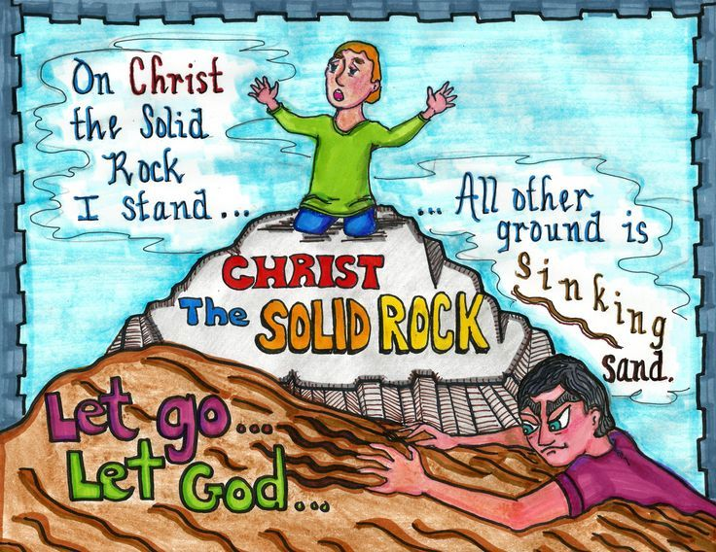

**Virtual Meeting**

The all-church meeting that was postponed from January 16 has been moved to a virtual meeting on Saturday, January 30 at 2 p.m. In an effort to keep our members safe during the Covid-19 pandemic, this meeting has been moved from in person to a Zoom meeting. Anyone interested in participating in the session can do so by reaching out to the church office with an appropriate email address by Sunday, January 24. Invitations will be sent out to those church members and other interested parties based solely upon these responses. Voice messages can be left by calling the church office at 317-862-4381 or by emailing Lori Chapman in the church office at [newbethelbapt@att.net](mailto:newbethelbapt@att.net).

***********

**Happening This Week**

Today 10:30 a.m. Live-stream Sunday worship only

Wednesday 10-11:30 a.m., Bible Study, contact Sue Winton

Thursday 1-2:30 p.m., Book discussion Group, contact

Janie Bryant

**\*\*\*\*\*\*\*\*\*\*\*\*\***

**Thank You**

Dear Church family,

Thank you all for the generous staff Christmas gift. It was much appreciated.

And thank you for all you cards, prayers, and phone calls during my dad’s illness and after his death. Thank you to Pastor Tom for visiting with my dad when we came home to hospice.

Lori Chapman

*\*\*\*\*\*\*\*\*\*\*\*\*\*\*\*\*\*\*\*\**

*Attacks can come in many forms: rumors, notes, and other ways. When we invest our time in small talk (gossip), we can only accomplish small things, if anything.*

—[David DeNotaris](https://www.wow4u.com/ddenotaris/)

*\*\*\*\*\*\*\*\*\*\*\*\*\*\*\*\*\*\*\*\**

**Daily Prayer Calendar**

**Monday, January 18, 2021**: [Psalm 86; 1 Samuel 9:27-10:8; 2 Corinthians 6:14-7:1](http://www.biblegateway.com/passage/?search=Psalm%2086;%201%20Samuel%209:27-10:8;%202%20Corinthians%206:14-7:1)

**Tuesday, January 19, 2021**: [Psalm 86; 1 Samuel 15:10-31; Acts 5:1-11](http://www.biblegateway.com/passage/?search=Psalm%2086;%201%20Samuel%2015:10-31;%20Acts%205:1-11)

**Wednesday, January 20, 2021**: [Psalm 86; Genesis 16:1-14; Luke 18:15-17](http://www.biblegateway.com/passage/?search=Psalm%2086;%20Genesis%2016:1-14;%20Luke%2018:15-17)

**Thursday, January 21, 2021**: [Psalm 62:5-12; Jeremiah 19:1-15; Revelation 18:11-20](http://www.biblegateway.com/passage/?search=Psalm%2062:5-12;%20Jeremiah%2019:1-15;%20Revelation%2018:11-20)

**Friday, January 22, 2021**: [Psalm 62:5-12; Jeremiah 20:7-13; 2 Peter 3:1-7](http://www.biblegateway.com/passage/?search=Psalm%2062:5-12;%20Jeremiah%2020:7-13;%202%20Peter%203:1-7)

**Saturday, January 23, 2021**: [Psalm 62:5-12; Jeremiah 20:14-18; **Sunday, January 24, 2021:** Luke 10:13-16](http://www.biblegateway.com/passage/?search=Psalm%2062:5-12;%20Jeremiah%2020:14-18;%20Luke%2010:13-16); [Jonah 3:1-5, 10](https://lectionary.library.vanderbilt.edu/texts.php?id=62#hebrew_reading); [Psalm 62:5-12](https://lectionary.library.vanderbilt.edu/texts.php?id=62#psalm_reading); [1 Corinthians 7:29-31](https://lectionary.library.vanderbilt.edu/texts.php?id=62#epistle_reading); [Mark 1:14-20](https://lectionary.library.vanderbilt.edu/texts.php?id=62#gospel_reading)

Worship Music Copyright and Live-Streaming Permissions

All above selections ©1997 Word/Integrity Used by Permission.

CCLI License #1631733

Joyful, Joyful, We Adore Thee by Ludwig Van Beethoven,

Melody Bober

He is Exalted by Twila Paris, Melody Bober

Israel by Jim Brickman, Ayn Kelohanu

Angel's Blessing by Jim Brickman

Wherever You Go by Jim Brickman

Pass it On by Kurt Kaiser

My Peace by Keith Routledge

Live-Streaming: Christian Copyright Solutions, WorshipCast,

License #10868