**Welcome to New Bethel Baptist Church**

**Epiphany, Sunday, January 3, 2021**

**Prelude** Brittany Lovko Copeland

\***Gathering Hymn**  *Blessed Be Your Name*

**\*Call to Worship**

One: This is a new year.  Filled with hopes and possibilities.

**Many: This is a new year.  And we will choose to praise our God.**

One: Today we pledge ourselves to our God.

**Many: We choose to serve our God in 2021.**

*All: Today Lord, we start this new year with you.  Today we commit*

*ourselves into serving your kingdom.  Receive glory as we*

*worship you this day.*

**\*Invocation and Lord’s Prayer** (*using “sins”*) Karen Pappas

**Scripture Reading** Judges 2:10-19 Karen Pappas

**Worship Prayer**

**\*Hymn** *There’s Something About that Name*#83

**Children’s Sermon**

**Scripture Reflection**  Mark 6:45-56 Rev. Tom Bartley

**\*Hymn** *Away in a Manger* #262

**Ministry Opportunities** Karen Pappas

Meditation on Tithes and Offerings

*Doxology #815

*Prayer Karen Pappas

**Communion Hymn** *Come to the Table* #464

**Communion** Rev. Tom Bartley

**\*Closing Hymn** *Blest Be the Tie That Binds*#426

**Postlude**  Brittany Lovko Copeland

*\*\*\*\*\*\*\*\*\*\*\*\*\*\*\*\*\*\*\*\**

**DAILY SCRIPTURE READINGS FOR THIS WEEK**

Monday, January 4, 2021: Psalm 110; Proverbs 3:1-12;

James 4:11-17

Tuesday, January 5, 2021: Psalm 110; Proverbs 22:1-9; Luke 6:27-31

Wednesday, January 6, 2021: Isaiah 60:1-6; Psalm 72:1-7, 10-14;

  Ephesians 3:1-12; Matthew 2:1-12

Thursday, January 7, 2021: Psalm 29; 1 Samuel 3:1-21;

Acts 9:10-19a

Friday, January 8, 2021: Psalm 29; 1 Samuel 16:1-13;

1 Timothy 4:11-16

Saturday, January 9, 2021: Psalm 29 ; 1 Kings 2:1-4, 10-12;

Luke 5:1-11

Sunday, January 10, 2021: Genesis 1:1-5; Psalm 29; Acts 19:1-7;

Mark 1:4-11

*\*\*\*\*\*\*\*\*\*\*\*\*\*\*\*\*\*\*\*\**

*Spite does not pay.*

*It goes around and misses the object that you aim* [for]

*and comes back and zaps you.*

*And you're the one who pays for it.*

— Isabel Wilkerson

*\*\*\*\*\*\*\*\*\*\*\*\*\*\*\*\*\*\*\*\**

**Thank You!**

A big thank you to Brittany Lovko Copeland for filling in while Christina is out this week!

**WELCOME TO NEW BETHEL BAPTIST CHURCH**

**We are blessed by your presence!**

**Sunday, January 3, 2021**

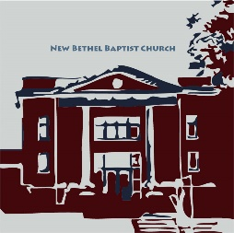

**GUEST AND MEMBERS:** If you have questions or would like more information about New Bethel, please feel free to contact the church office. Thank you!

*An American Baptist*

*Congregation*

**\*\*\*\*\*\***

**ALL ARE WELCOME**

**Weekly Activities Online Only**

Wednesdays online Bible Study 10 a.m., Contact Sue Winton

Thursdays online Book Discussion, *If God Is Love,* 1 p.m., Contact

Janie Bryant

Sunday Worship, 10:30 a.m., Live-stream Only

**\*\*\*\*\*\***

**CONTACT INFORMATION**

New Bethel Baptist Church Website: www.newbethelbapt.org

8936 Southeastern Avenue E-mail: newbethelbapt@att.net

Indianapolis, IN 46239 Wi-fi password: NBBC8624381

317-862-4381 Instagram: NBBC.Wanamaker

YouTube: New Bethel Baptist

Church Wanamaker

https://facebook.com New Bethel Baptist.Wanamaker

Rev. Tom Bartley, Interim Pastor

Lori Chapman, Church Secretary

Church Office Hours: Wednesday-Thursday from 4-6 p.m.

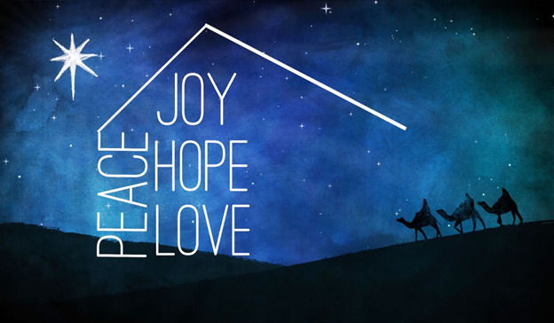

*An epiphany enables you to*

*sense creation*

*not as something completed,*

*but as constantly becoming,*

*evolving, ascending.*

*This transports you from*

*a place where there is nothing new*

*to a place where there is nothing old,*

*where everything renews itself,*

*where heaven and earth rejoice as*

*at the moment of creation.*

— Abraham Isaac Kook

**Retired Ministers and Missionaries Offering (RMMO):**

As we begin 2021, we are thankful for many things. We are very thankful for our retired ministers and missionaries who dedicated their lives to spreading the Gospel of Jesus Christ with others.

We now have an opportunity to show our appreciation with these wonderful men and women by donating to the RMMO Offering. The thank you gifts to our American Baptist Pastors were reduced by 4% in 2020.

Just add your RMMO offering to your regular giving and mark on the envelope or in the comments section of PayPal what part of your offering you want to give for RMMO.

Your expression of love and thankfulness will be very much appreciated.

**-New Bethel Baptist Church Board of**

**Missions**

***********

**HAPPENING THIS WEEK**

Today 10:30 a.m. Live-stream Sunday worship only

Wednesday 10-11:30 a.m., Bible Study, contact Sue Winton

Thursday 1-2:30 p.m., Book discussion Group, contact

Janie Bryant

**Worship Music Copyright and Live-Streaming Permissions**

“Doxology” text by Thomas Ken and music by *Genevan Psalter*

“Blest Be the Tie That Binds” words by John Fawcett, music by

Johann G. Naegeli, Lowell Mason

“Blessed Be Your Name”

“There Is Something About That Name”

“Away in a Manger”

“Come to the Table”

All above selections ©1997 Word/Integrity Used by Permission.

CCLI License #1631733

Live-Streaming: Christian Copyright Solutions, WorshipCast,

License #10868