**Welcome to New Bethel Baptist Church**

**Sunday, January 31, 2021**

**Prelude** Dr. Christina Romero-Ivanova

\***Gathering Hymn**  *Beautiful Scandalous Night*

**\*Video Call to Worship**

**\*Invocation and Lord’s Prayer (***using “sins”*) Karen Pappas

**Scripture Reading** Judges 6:1-10 Karen Pappas

**Worship Prayer**

**\*Hymn** *What A Friend We Have in Jesus* **#** 630

**Children’s Sermon**

**Scripture Reflection**  Mark 8:11-26 Rev. Tom Bartley

**\*Hymn** *In the Garden* #635

**Ministry Opportunities** Karen Pappas

Meditation on Tithes and Offerings

*Doxology #815

*Prayer Karen Pappas

**Benediction** Rev. Tom Bartley

**Postlude**  Dr. Christina Romero-Ivanova

**Retired Ministers and Missionaries Offering (RMMO)**

As we begin 2021, we are thankful for many things. We are very thankful for our retired ministers and missionaries who dedicated their lives to spreading the Gospel of Jesus Christ with others.

We now have an opportunity to show our appreciation with these wonderful men and women by donating to the RMMO Offering. The thank you gifts to our American Baptist Pastors were reduced by 4% in 2020.

Just add your RMMO offering to your regular giving and mark on the envelope or in the comments section of PayPal what part of your offering you want to give for RMMO.

Your expression of love and thankfulness will be very much appreciated.

New Bethel Baptist Church Board of Missions

*\*\*\*\*\*\*\*\*\*\*\*\*\*\*\*\*\*\*\*\**

**Worship Music Copyright and Live-Streaming Permissions**

All above selections ©1997 Word/Integrity Used by Permission.

CCLI License #1631733

See hymns within the bulletin listed.

*\*\*\*\*\*\*\*\*\*\*\*\*\*\*\*\*\*\*\*\**

Live-Streaming: Christian Copyright Solutions, WorshipCast,

License #10868

**WELCOME TO NEW BETHEL BAPTIST CHURCH**

**We are blessed by your presence!**

**Sunday, January 31, 2021**

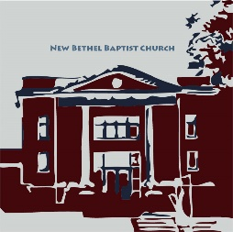

**GUEST AND MEMBERS:** If you have questions or would like more information about New Bethel, please feel free to contact the church office. Thank you!

*An American Baptist*

*Congregation*

**\*\*\*\*\*\***

**ALL ARE WELCOME**

**Weekly Activities Online Only**

Wednesdays online Bible Study 10 a.m., Contact Sue Winton

Thursdays online Book Discussion, *If God Is Love,* 1 p.m., Contact

Janie Bryant

Sunday Worship, 10:30 a.m., Live-stream Only

**\*\*\*\*\*\***

**CONTACT INFORMATION**

New Bethel Baptist Church Website: www.newbethelbapt.org

8936 Southeastern Avenue E-mail: newbethelbapt@att.net

Indianapolis, IN 46239 Wi-fi password: NBBC8624381

317-862-4381 Instagram: NBBC.Wanamaker

YouTube: New Bethel Baptist

Church Wanamaker

https://facebook.com New Bethel Baptist.Wanamaker

Rev. Tom Bartley, Interim Pastor

Lori Chapman, Church Secretary

Church Office Hours: Wednesday-Thursday from 4-6 p.m.

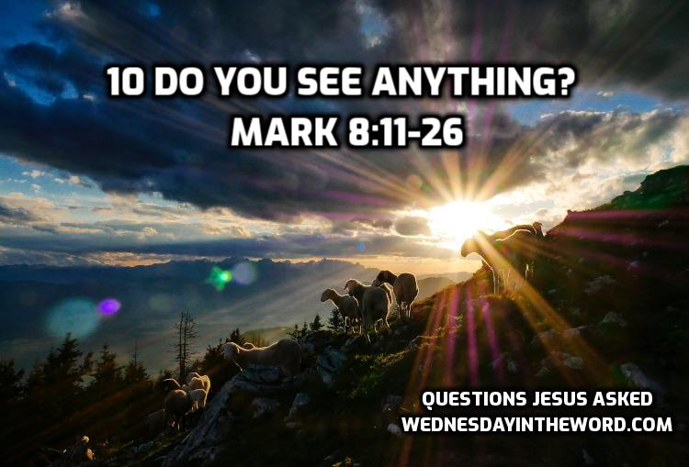

*Faith and prayer are the vitamins of the soul; we cannot live in health without them.*

—Mahalia Jackson

**Daily Prayer Calendar**

**Sunday, January 31, 2021**: Deuteronomy 18:15-20; Psalm 111, 1 Corinthians 8:1-13; Mark 1:21-28

**Monday, February 1, 2021**: Psalm 35:1-10; Numbers 22:1-21; Acts 21:17-26

**Tuesday, February 2, 2021**: Psalm 35:1-10; Numbers 22:22-

28; 1 Corinthians 7:32-40

**Wednesday, February 3, 2021**: Psalm 35:1-10; Jeremiah

29:1-14; Mark 5:1-20

**Thursday, February 4, 2021**: Psalm 147:1-11, 20c; Proverbs

12:10-21; Galatians 5:2-15

**Friday, February 5, 2021**: Psalm 147:1-11, 20c; Job 36:1-23;

1 Corinthians 9:1-16

**Saturday, February 6, 2021**: Psalm 147:1-11, 20c; Isaiah

46:1-13; Matthew 12:9-14

*\*\*\*\*\*\*\*\*\*\*\*\*\*\*\*\*\*\*\*\**

**Happening This Week**

Today 10:30 a.m. Live-stream Sunday worship only

Wednesday 10-11:30 a.m., Bible Study, contact Sue Winton

Thursday 1-2:30 p.m., Book discussion Group, contact

Janie Bryant

7 p.m. Pastor’s Bible Study Group on Zoom