**Welcome to New Bethel Baptist Church**

**Sunday, February 14, 2021**

**Prelude** Dr. Christina Romero-Ivanova

\***Gathering Hymn**  *Amazing Love*

**\*Video Call to Worship**

**\*Invocation and Lord’s Prayer (***using “sins”*) Karen Pappas

**Scripture Reading** Psalm 100: 1-5 Karen Pappas

**Worship Prayer**

**\*Hymn** *They Will Know We are Christians by Our Love*#429

**Children’s Sermon**

**Scripture Reflection**  I Corinthians 13:1-13 Rev. Tom Bartley

**\*Hymn**  *The Bond of Love* #423

**Ministry Opportunities** Karen Pappas

Meditation on Tithes and Offerings

*Doxology #815

*Prayer Karen Pappas

**Benediction**

**Postlude**  Dr. Christina Romero-Ivanova

*\*\*\*\*\*\*\*\*\*\*\*\*\*\*\*\*\*\*\*\**

**Happening This Week**

Today 10:30 a.m. Live-stream Sunday worship only

Thursday 10-11:30 a.m., Book discussion Group, contact

Janie Bryant

Thursday 7 p.m. Pastor’s Bible Study Group on Zoom

**Daily Prayer Calendar**

Monday, February 15, 2021: Psalm 110:1-4; Exodus 19:7-25;

Hebrews 2:1-4

Tuesday, February 16, 2021: Psalm 110:1-4; Job 19:23-27; 1 Timothy

3:14-16

Wednesday, February 17, 2021: Joel 2:1-2, 12-17 or Isaiah 58:1-12;

Psalm 51:1-17; 2 Corinthians 5:20b-6:10; Matthew 6:1-6, 16-

21

Thursday, February 18, 2021: Psalm 25:1-10; Daniel 9:1-14; 1 John

1:3-10

Friday, February 19, 2021: Psalm 25:1-10; Daniel 9:15-25a; 2

Timothy 4:1-5

Saturday, February 20, 2021: Psalm 25:1-10; Psalm 32; Matthew 9:2-

13

Sunday, February 21, 2021: Genesis 9:8-17; Psalm 25:1-10 ;1 Peter

3:18-22; Mark 1:9-15

*\*\*\*\*\*\*\*\*\*\*\*\*\*\*\*\*\*\*\*\**

**Worship Music Copyright and Live-Streaming Permissions**

All above selections ©1997 Word/Integrity Used by Permission.

CCLI License #1631733

See hymns within the bulletin listed.

*\*\*\*\*\*\*\*\*\*\*\*\*\*\*\*\*\*\*\*\**

“Jesu: by Jim Brickman;

“Angel's Blessing” by Jim Brickman;

“Wherever You Go” by Jim Brickman;

“Faith” by Jim Brickman;

“Winter Peace” by Jim Brickman;

“Love of My Life” by Jim Brickman;

“We Shall Behold Him” by Dottie Rambo;

“You Are My Hiding Place” by Michael Ledner;

Live-Streaming: Christian Copyright Solutions, WorshipCast,

License #10868

**WELCOME TO NEW BETHEL BAPTIST CHURCH**

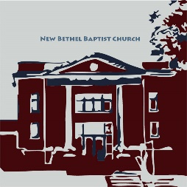**We are blessed by your presence!**

**GUEST AND MEMBERS:** If you have questions or would like more information about New Bethel, please feel free to contact the church office. Thank you!

*An American Baptist*

*Congregation*

**\*\*\*\*\*\***

**ALL ARE WELCOME**

**Weekly Activities Online Only**

**Thursdays** online Zoom Book Discussion, *If God Is Love,* 10 a.m.,

Contact Janie Bryant

**Thursdays** online Pastor’s Bible Study Group, 7 p.m. on Zoom,

Contact Janie Bryant, or Pastor Tom if you would like to join.

**Sunday Worship**, 10:30 a.m., Live-stream Only

**\*\*\*\*\*\***

**CONTACT INFORMATION**

New Bethel Baptist Church Website: www.newbethelbapt.org

8936 Southeastern Avenue E-mail: newbethelbapt@att.net

Indianapolis, IN 46239 Wi-fi password: NBBC8624381

317-862-4381 Instagram: NBBC.Wanamaker

YouTube: New Bethel Baptist

https://facebook.com Church Wanamaker

New Bethel Baptist.Wanamaker

Rev. Tom Bartley, Interim Pastor

Lori Chapman, Church Secretary

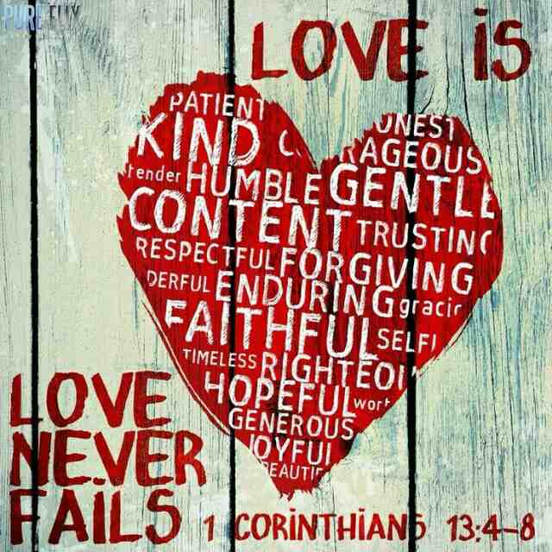

 “Love is the only force capable of transforming an enemy into a friend.”

*- Martin Luther King Jr.*