**Welcome to New Bethel Baptist Church**

**Sunday, February 28, 2021**

**Prelude** Dr. Christina Romero-Ivanova

\***Gathering Hymn**  *O Worship the King vs. 1-2,5* #104

**\*Call to Worship**

One:  We greet you Lord, on this morning you have given to us.

**Many: We praise you for the opportunity to worship.**

One:  You alone are worthy of glory. You alone are worthy of praise.

**Many:  We are here to praise you as the God of Life and Love.**

**You are responsible for our new life.**

One:  Let your Spirit join with ours in worship.

**Many:  Sanctify our assembly through your presence.**

*All:  Transform us as we worship. Renew our hearts through praise.*

**Lenten Reading**

**\*Invocation and Lord’s Prayer (***using “sins”*) Karen Pappas

**Scripture Reading** Judges 6:25-32 Karen Pappas

**Worship Prayer**

**\*Hymn** *To God Be the Glory* #56

**Children’s Sermon**

**Scripture Reflection**  Mark 9:2-13 Rev. Tom Bartley

**\*Hymn**  *How Great Thou Art* #147

**Ministry Opportunities** Karen Pappas

Meditation on Tithes and Offerings

*Doxology #815

*Prayer Karen Pappas

**Benediction**

**Postlude**  Dr. Christina Romero-Ivanova

**Happening This Week**

Today 10:30 a.m. Live-stream Sunday worship only

Thursday 10-11:30 a.m., Book discussion Group, contact

Janie Bryant

Thursday 7 p.m. Pastor’s Bible Study Group on Zoom

March 9 Council Meeting via Zoom

*\*\*\*\*\*\*\*\*\*\*\*\*\*\*\*\*\*\*\*\**

**Daily Prayer Calendar**

* **Monday, March 1, 2021**: Psalm 105:1-11, 37-45; Genesis 21:1-7; Hebrews 1:8-12
* **Tuesday, March 2, 2021**: Psalm 105:1-11, 37-45; Genesis 22:1-19; Hebrews 11:1-3, 13-19
* **Wednesday, March 3, 2021**: Psalm 105:1-11, 37-45; Jeremiah 30:12-22; John 12:36-43
* **Thursday, March 4, 2021**: Psalm 19; Exodus 19:1-9a; 1 Peter 2:4-10
* **Friday, March 5, 2021**: Psalm 19; Exodus 19:9b-15; Acts 7:30-40
* **Saturday, March 6, 2021**: Psalm 19; Exodus 19:16-25; Mark 9:2-8
* **Sunday, March 7, 2021:** Exodus 20:1-7; Psalm19; I Corinthians 1:18-25; John 2:13-22

**WELCOME TO NEW BETHEL BAPTIST CHURCH**

**We are blessed by your presence!**

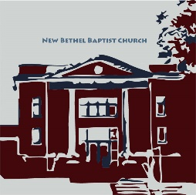

**GUEST AND MEMBERS:** If you have questions or would like more information about New Bethel, please feel free to contact the church office. Thank you!

*An American Baptist*

*Congregation*

**\*\*\*\*\*\***

**ALL ARE WELCOME**

**Weekly Activities Online Only**

**Thursdays** online Zoom Book Discussion, *If God Is Love,* 10 a.m.,

Contact Janie Bryant

**Thursdays** online Pastor’s Bible Study Group, 7 p.m. on Zoom,

Contact Janie Bryant, or Pastor Tom if you would like to join.

**Sunday Worship**, 10:30 a.m., Live-stream Only

**\*\*\*\*\*\***

**CONTACT INFORMATION**

New Bethel Baptist Church Website: www.newbethelbapt.org

8936 Southeastern Avenue E-mail: newbethelbapt@att.net

Indianapolis, IN 46239 Wi-fi password: NBBC8624381

317-862-4381 Instagram: NBBC.Wanamaker

YouTube: New Bethel Baptist

Church Wanamaker

https://facebook.com New Bethel Baptist.Wanamaker

Rev. Tom Bartley, Interim Pastor

Lori Chapman, Church Secretary

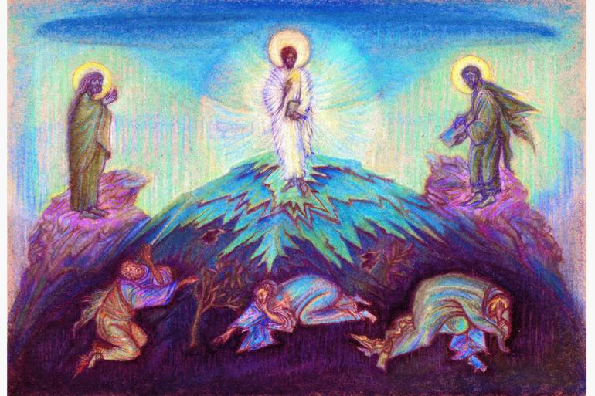

“And the day came when the risk to remain tight in a bud was more painful than the risk it took to blossom.”  
 ― Anais Nin

**Worship Music Copyright and Live-Streaming Permissions**

All above selections ©1997 Word/Integrity Used by Permission.

CCLI License #1631733

See hymns within the bulletin listed.

*\*\*\*\*\*\*\*\*\*\*\*\*\*\*\*\*\*\*\*\**

“Little Star” by Jim Brickman

“Winter Peace” by Jim Brickman

“You Never Know” by Jim Brickman

“Heartland” by Jim Brickman

“He is Our Peace” by Kandela Groves

“Side by Side” by Jeff Wood, Paul Johnson

Live-Streaming: CCS, WorshipCast, License #10868