**Welcome to New Bethel Baptist Church**

**Maundy Thursday, April 1, 2021**

**7 p.m.**

**Welcome and Greeting**

**\*Call to Worship**

One: Welcome to you who call upon the name of Christ.

We gather tonight to recall the story of the night Jesus was betrayed. Are you prepared to come to the feast of Jesus, the Christ, whose life was poured out for you?

**Many:  By the grace of God, we are.**

One:  Are you able to watch with Jesus at prayer in the garden --

indeed, to struggle yourselves to be in unity with God's will for you?

**Many:  By the grace of God, we are.**

One:  Then let us praise God, even in this hour of darkness!

***All:  God of all grace and steadfast love,******greatly is your name to be***

***praised in all the earth.******Bring us to this occasion of remembrance with open hearts!***

**Hymn**  *The Old Rugged Cross #327*

**Lenten Meditation**

**The Extinguishing of the Lights**

**Reader 1:**  Pilate condemns Jesus, John 19:13-16

**Hymn**  *Hallelujah! What a Savior* #311

**Reader 2:**  Soldiers Mock Jesus, Mark 15:16-20

**Reflection**

**Reader 1:**  Simon carries Jesus cross, Matthew 27:32-33

**Hymn** *Jesus Paid it All* #305

**Reader 2:**  Jesus and Mary, John 19:25-27

**Reader 1:**  Jesus and the Women, Luke 23:27-31

**Reflection**

**Reader 2:** Soldiers take Jesus’ clothes, Luke 23:34

**Reader 1:**  Jesus is crucified, John 19:16b-19

**Hymn** *Were You There* # 315

**Reader 2:**  Jesus dies on the cross, Mark 15:33-37

**Reader 1:**  Jesus is laid in the tomb, Matthew:27:57-60

**Final reading:**  The Light, John 1:5

**Extinguishing of the Light**

*There is no Benediction or postlude for this service is not complete. We invite you to the resolution of this service on Sunday morning at 10:30 a.m.

**WELCOME TO NEW BETHEL BAPTIST CHURCH**

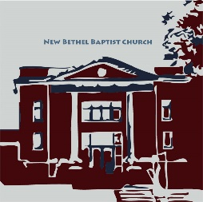**We are blessed by your presence!**

**GUEST AND MEMBERS:** If you have questions or would like more information about New Bethel, please feel free to contact the church office. Thank you!

*An American Baptist*

*Congregation*

**\*\*\*\*\*\***

**ALL ARE WELCOME**

**Weekly Activities Online Only**

**Thursdays** online Zoom Book Discussion, *If God Is Love,* 10 a.m.,

Contact Janie Bryant

**Thursdays** online and in-person Pastor’s Bible Study Group, 7 p.m. on Zoom, Contact Janie Bryant, or Pastor Tom if you would like to join.

**Sunday Worship**, 10:30 a.m., Live-stream Only

**\*\*\*\*\*\***

**CONTACT INFORMATION**

New Bethel Baptist Church **Website:** www.newbethelbapt.org

8936 Southeastern Avenue **E-mail:** newbethelbapt@att.net

Indianapolis, IN 46239 **Wi-fi password:** NBBC8624381

317-862-4381 **Instagram:** NBBC.Wanamaker

https://facebook.com**YouTube:** New Bethel Baptist Church Wanamaker

New Bethel Baptist.Wanamaker

Rev. Tom Bartley, Interim Pastor

Lori Chapman, Church Secretary

**Maundy Thursday**

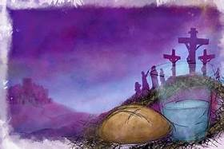

**Engaging Young Adults Grant Ended**

The Engaging Young Adults Team decided to end the grant process. We made this decision for several reasons:

* Difficulty of completing projects due to COVID 19 restrictions.
* Current conflict within the New Bethel Baptist Church congregation.
* Financial considerations.

We will not need to repay The Center for Congregations any of the grant money that we have already spent.

The EYA Team put a lot of time, energy, and prayer into this project. We thank all of you for your participation through attending information sessions, completing surveys, brainstorming ideas for ways to engage young adults and praying.

EYA/Strategic Planning Team

*\*\*\*\*\*\*\*\*\*\*\*\*\*\*\*\*\*\*\*\**

**Worship Music Copyright and Live-Streaming Permissions**

**All above selections ©1997 Word/Integrity Used by Permission.**

**CCLI License #1631733**

See hymns listed within the bulletin

*\*\*\*\*\*\*\*\*\*\*\*\*\*\*\*\*\*\*\*\**

**Live-Streaming: CCS, WorshipCast, License #10868**

**Saturday, April 3rd 10 a.m.**

**for ages 1-12**

**EASTER**



**Bunny Bag**

**Drive-Thru**

**The Easter Bunny will be in New Bethel Baptist Church parking lot to wave while we hand out goodie bags to the kids in your car.**

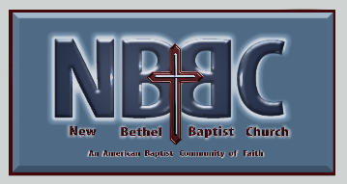New Bethel Baptist Church

8936 Southeastern Avenue

Indianapolis, IN 46239

[www.newbethelbapt.org](http://www.newbethelbapt.org)

317-862-4381

This is a free community event. Our volunteers will follow all required sanitation practices in preparation for and during this event.