**Welcome to New Bethel Baptist Church**

**Communion Sunday, March 7, 2021**

**Prelude** Dr. Christina Romero-Ivanova

\***Gathering Hymn**  *Thy Word*  #184

**\*Call to Worship**

One:  The Lord is our shepherd, we have nothing to fear  
**Many:  Through the cold and the snow, we will trust in the Lord**.  
One:  God is protector from dangers unseen  
**Many:  Through vaccines and medical advice, we will trust in the**

**Lord.**  
One:  God’s plans for us are to be saved, rescued, and ushered into

new life.   
**All:  In these coming days may we experience this new life that is**

**offered through Christ.**

**Lenten Reading**

**\*Invocation and Lord’s Prayer (***using “sins”*) Karen Pappas

**Scripture Reading** Judges 6:33-40 Karen Pappas

**Worship Prayer**

**\*Hymn** *To God Be the Glory*#56

**Children’s Sermon**

**Scripture Reflection** Exodus 20:1-17 Rev. Kim Miller

**\*Hymn**  *Find us Faithful* #456

**Ministry Opportunities** Karen Pappas

Meditation on Tithes and Offerings

*Doxology #815

*Prayer Karen Pappas

**Communion Hymn** *Come Share the Lord* #462 

**Communion**

**\*Closing Hymn** *Blest Be the Tie That Binds* #425

**Postlude**  Dr. Christina Romero-Ivanova

*\*\*\*\*\*\*\*\*\*\*\*\*\*\*\*\*\*\*\*\**

**Happening This Week**

Today 10:30 a.m. Live-stream Sunday worship only

Thursday 10-11:30 a.m., Book discussion Group, contact

Janie Bryant

Thursday 7 p.m. Pastor’s Bible Study Group on Zoom

March 9 Council Meeting via Zoom

*\*\*\*\*\*\*\*\*\*\*\*\*\*\*\*\*\*\*\*\**

**Daily Prayer Calendar**

* **Monday, March 1, 2021**: [Psalm 105:1-11, 37-45; Genesis 21:1-7; Hebrews 1:8-12](http://www.biblegateway.com/passage/?search=Psalm%20105:1-11,%2037-45;%20Genesis%2021:1-7;%20Hebrews%201:8-12)
* **Tuesday, March 2, 2021**: [Psalm 105:1-11, 37-45; Genesis 22:1-19; Hebrews 11:1-3, 13-19](http://www.biblegateway.com/passage/?search=Psalm%20105:1-11,%2037-45;%20Genesis%2022:1-19;%20Hebrews%2011:1-3,%2013-19)
* **Wednesday, March 3, 2021**: [Psalm 105:1-11, 37-45; Jeremiah 30:12-22; John 12:36-43](http://www.biblegateway.com/passage/?search=Psalm%20105:1-11,%2037-45;%20Jeremiah%2030:12-22;%20John%2012:36-43)
* **Thursday, March 4, 2021**: [Psalm 19; Exodus 19:1-9a; 1 Peter 2:4-10](http://www.biblegateway.com/passage/?search=Psalm%2019;%20Exodus%2019:1-9a;%201%20Peter%202:4-10)
* **Friday, March 5, 2021**: [Psalm 19; Exodus 19:9b-15; Acts 7:30-40](http://www.biblegateway.com/passage/?search=Psalm%2019;%20Exodus%2019:9b-15;%20Acts%207:30-40)
* **Saturday, March 6, 2021**: [Psalm 19; Exodus 19:16-25; Mark 9:2-8](http://www.biblegateway.com/passage/?search=Psalm%2019;%20Exodus%2019:16-25;%20Mark%209:2-8)
* **Sunday, March 7, 2021:** [Exodus 20:1-17](https://lectionary.library.vanderbilt.edu/texts.php?id=73#hebrew_reading); [Psalm 19](https://lectionary.library.vanderbilt.edu/texts.php?id=73#psalm_reading); [1 Corinthians 1:18-25](https://lectionary.library.vanderbilt.edu/texts.php?id=73#epistle_reading); [John 2:13-22](https://lectionary.library.vanderbilt.edu/texts.php?id=73#gospel_reading)

**WELCOME TO NEW BETHEL BAPTIST CHURCH**

**We are blessed by your presence!**

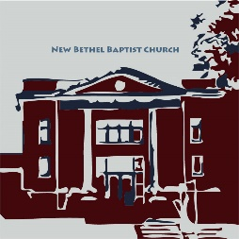

**GUEST AND MEMBERS:** If you have questions or would like more information about New Bethel, please feel free to contact the church office. Thank you!

*An American Baptist*

*Congregation*

**\*\*\*\*\*\***

**ALL ARE WELCOME**

**Weekly Activities Online Only**

**Thursdays** online Zoom Book Discussion, *If God Is Love,* 10 a.m.,

Contact Janie Bryant

**Thursdays** online Pastor’s Bible Study Group, 7 p.m. on Zoom,

Contact Janie Bryant, or Pastor Tom if you would like to join.

**Sunday Worship**, 10:30 a.m., Live-stream Only

**\*\*\*\*\*\***

**CONTACT INFORMATION**

New Bethel Baptist Church **Website:** www.newbethelbapt.org

8936 Southeastern Avenue **E-mail:** newbethelbapt@att.net

Indianapolis, IN 46239 **Wi-fi password:** NBBC8624381

317-862-4381 **Instagram:** NBBC.Wanamaker

**YouTube:** New Bethel Baptist Church Wanamake

https://facebook.com New Bethel Baptist.Wanamaker

Rev. Tom Bartley, Interim Pastor

Lori Chapman, Church Secretary

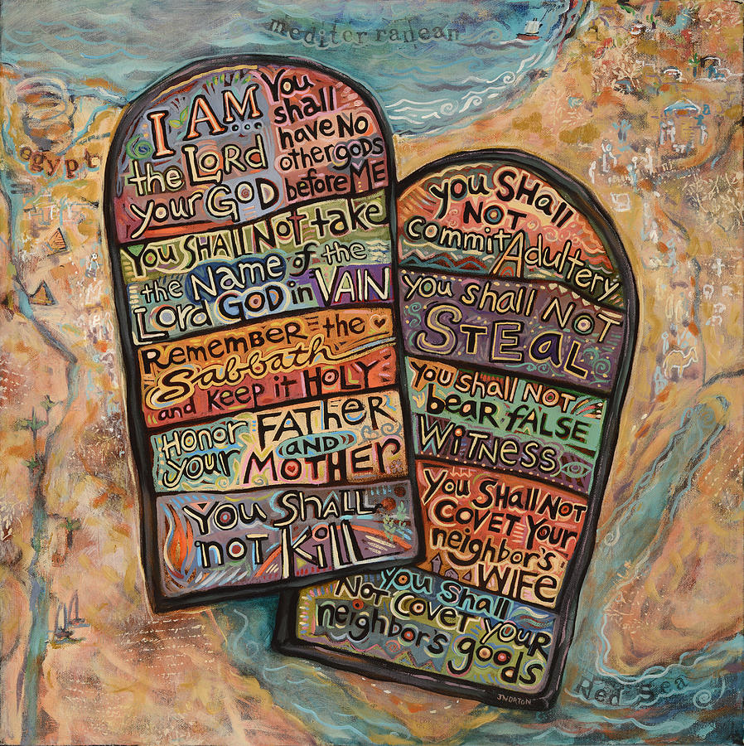

**God’s Bounty Food Pantry**

God’s Bounty service to the community has been remarkable; however, has slowed down since the first of the year. GBFP still needs assistance. Any donations and volunteer support are greatly appreciated and needed. The pantry needs NBBC volunteers for 4 March 2021. Please contact me to volunteer this week. (Paul Young; [KPY6767@att.net](mailto:KPY6767@att.net); 317 862-6767).

The Meijer Simply Give Winter Program has been announced and is currently open **(Sunday, February 14, 2021, through Saturday, April 10, 2021).**  The Double Match Days will be held on **Saturday, March 13, 2021, and Saturday, April 3, 2021.**  There are numerous ways to contribute through in-store, pantry, or through the church or a pantry representative or myself can purchase cards.

Due to our current method of distribution GBFP needs more plastic shopping bags for use to prepare distribution to clients. Please save and bring in the bags to the church or pantry.

Paul Young

*\*\*\*\*\*\*\*\*\*\*\*\*\*\*\*\*\*\*\*\**

**Worship Music Copyright and Live-Streaming Permissions**

All above selections ©1997 Word/Integrity Used by Permission.

CCLI License #1631733

See hymns within the bulletin listed.

*\*\*\*\*\*\*\*\*\*\*\*\*\*\*\*\*\*\*\*\**

“Jesu” by Jim Brickman

“Angel's Blessing” by Jim Brickman

“Wherever You Go” by Jim Brickman

“Faith” by Jim Brickman

“How Beautiful” by Twila Paris

“Humble Thyself” by Bob Hudson

“Turn Your Eyes Upon Jesus” by Helen Lemmel

Live-Streaming: CCS, WorshipCast, License #10868