**Welcome to New Bethel Baptist Church**

*Third Sunday of Easter,* **April 18, 2021**

**Prelude** Dr. Christina Romero-Ivanova

\***Gathering Hymn**  I’m Trading My Sorrows

*Call to Worship

One:  The Lord has called us here for a purpose.

**Many:  We are gathered to praise our Lord.**

One:  For the Lord is a good God, full of grace and mercy.

**Many:  God loves us allows us to live a new life.**

***All:  Today we celebrate the new life we have through Christ***

***Jesus.  We praise God for the gift of new life.***

**\*Invocation and Lord’s Prayer (***using “sins”*) Karen Pappas

**Scripture Reading** Judges 10:6-16 Karen Pappas

**Worship Prayer**

**\*Hymn** *Jesus Is All the World To Me* #512

**Children’s Sermon**

**Special Music** *Thy will be Done* Dr. Christina Romero-Ivanova

**Scripture Reflection** Matthew 26:50-54 Rev. Tom Bartley

“What Would Jesus Do in the Face of Violence?”

**\*Hymn**  *I’ll Go Where You Want Me To Go* #668

**Ministry Opportunities** Karen Pappas

Meditation on Tithes and Offerings

*Doxology #815

*Prayer Karen Pappas

**\*Benediction**

**Postlude**  Dr. Christina Romero-Ivanova

**Happening This Week**

Today 10:30 a.m. Live-stream Sunday worship only

Thursday 10-11:30 a.m., Book discussion Group, contact

Janie Bryant

Thursday 7 p.m. Pastor’s Bible Study Group on Zoom

*\*\*\*\*\*\*\*\*\*\*\*\*\*\*\*\*\*\*\*\**

**Daily Prayer Calendar**

**Sunday, April 18, 2021 -** Easter 3: Acts 3:12-19; Psalm 4;

1 John 3:1-7; Luke 24:36b-48

**Monday, April 19, 2021:** Psalm 150; Jeremiah 30:1-11a;

1 John 3:10-16

**Tuesday, April 20, 2021:** Psalm 150; Hosea 5:15-6:6; 2 John 1-6 **Wednesday, April 21, 2021:** Psalm 150; Proverbs 9:1-6;

Mark 16:9-18

**Thursday, April 22, 2021:** Psalm 23; Genesis 30:25-43;

Acts 3:17-26

**Friday, April 23, 2021:** Psalm 23; Genesis 46:28-47:6; Acts 4:1-4

**Saturday, April 24, 2021:** Psalm 23; Genesis 48:8-19; Mark 6:30-34

**WELCOME TO NEW BETHEL BAPTIST CHURCH**

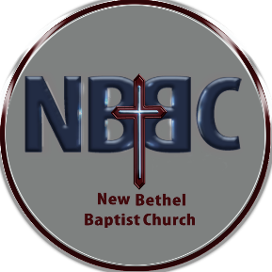 **We are blessed by your presence!**

**GUEST AND MEMBERS:** If you have questions or would like more information about New Bethel, please feel free to contact the church office. Thank you!

*An American Baptist*

*Congregation*

**\*\*\*\*\*\***

**ALL ARE WELCOME**

**Weekly Activities Online Only**

**Thursdays** online Zoom Book Discussion, *If God Is Love,* 10 a.m.,

Contact Janie Bryant

**Thursdays** online Pastor’s Bible Study Group, 7 p.m. on Zoom,

Contact Janie Bryant, or Pastor Tom if you would like to join.

**Sunday Worship**, 10:30 a.m., Live-stream and In-Person

**\*\*\*\*\*\***

**CONTACT INFORMATION**

New Bethel Baptist Church **Website:** www.newbethelbapt.org

8936 Southeastern Avenue **E-mail:** newbethelbapt@att.net

Indianapolis, IN 46239 **Wi-fi password:** NBBC8624381

317-862-4381 **Instagram:** NBBC.Wanamaker

**YouTube:** New Bethel Baptist Church Wanamaker

https://facebook.com New Bethel Baptist.Wanamaker

Rev. Tom Bartley, Interim Pastor

Lori Chapman, Church Secretary

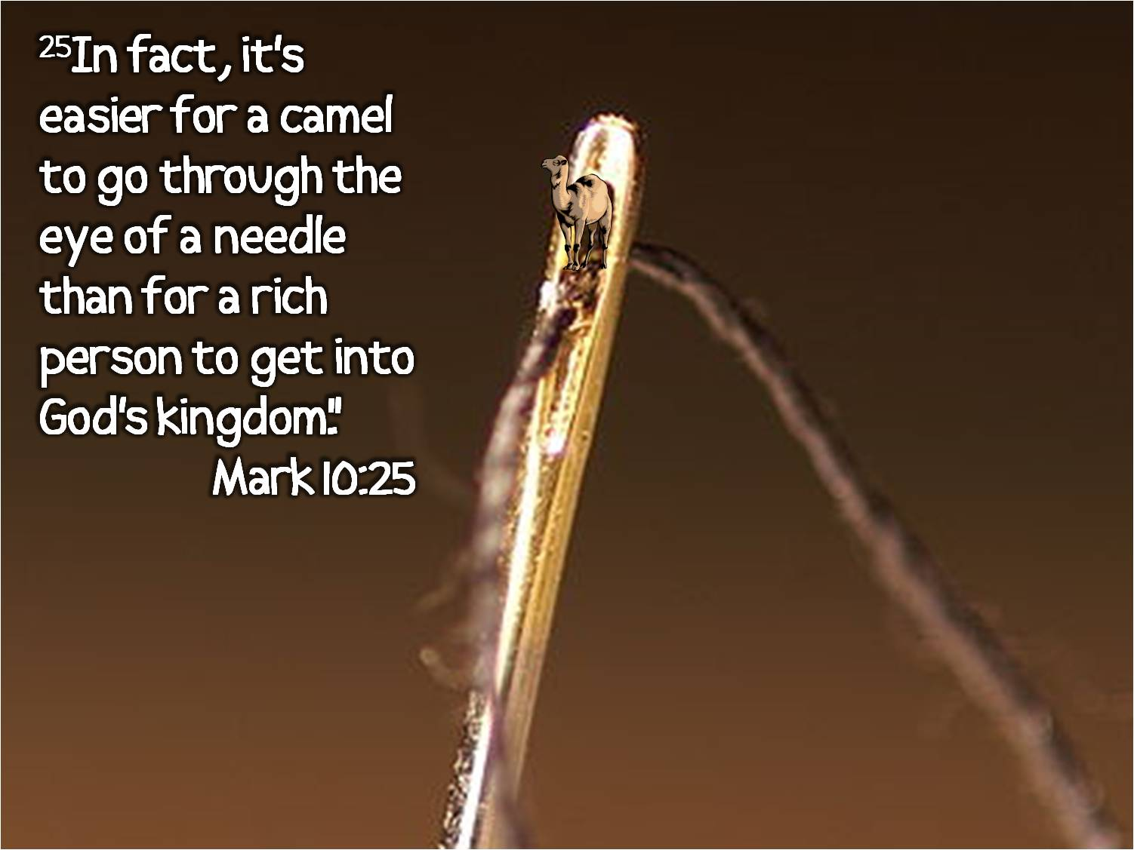

**Worship Music Copyright and Live-Streaming Permissions**

**All above selections ©1997 Word/Integrity Used by Permission.**

**CCLI License #1631733**

See hymns within the bulletin listed.

*\*\*\*\*\*\*\*\*\*\*\*\*\*\*\*\*\*\*\*\**

“He is Exalted” by Twila Paris, Melody Bober;

“Joyful, Joyful We Adore Thee” by Ludwig Van Beethoven,

Melody Baber;

“I Sing the Mighty Power of God” by Gesangbuch der Iterzogl,

Melody Bober;

“Give Me Jesus” by Melody Bober;

“Christ The Lord Is Risen Today” by Lyra Davidica, Melody Bober;

“Jesus, Name Above All Names” by Naida Hearn;

“He is Our Peace: by Kandela Groves

**Live-Streaming: CCS, WorshipCast, License #10868**

