**Welcome to New Bethel Baptist Church**

*Fourth Sunday of Easter,* **April 25, 2021**

**Prelude** Dr. Christina Romero-Ivanova

\***Gathering Hymns**  *I Lift My Hands*

*Amazing Grace my chains are gone*

**\*Call to Worship**

One:  Surely the Presence of the Lord is in this place.

**Many:  We can feel the mighty power and the grace.**

One: I see glory reflected on the faces of those present.

**Many:  Glory to God.  Glory from God.**

One:  Let us worship our God.

***All:  Holy God, receive our offering of praise this day.***

**\*Invocation and Lord’s Prayer (***using “sins”*) Karen Pappas

**Scripture Reading** Judges 13:1-7 Karen Pappas

**Worship Prayer**

**\*Hymn** *Make Me a Blessing*#670

**Children’s Sermon**

**Worship Hymn**  *Take My Life and Let it Be Consecrated* #597

**Scripture Reflection** Mark 10:32-45 Rev. Tom Bartley

**\*Hymn**  *Here I Am, Lord* #589

**Ministry Opportunities** Karen Pappas

Meditation on Tithes and Offerings

*Doxology #815

*Prayer Karen Pappas

**\*Benediction**

**Postlude**  Dr. Christina Romero-Ivanova

**Happening This Week**

Today 10:30 a.m. Live-stream and In-Person Sunday worship

Thursday 10-11:30 a.m., Book discussion Group, contact

Janie Bryant

Thursday 7 p.m. Pastor’s Bible Study on In-Person and Zoom

*\*\*\*\*\*\*\*\*\*\*\*\*\*\*\*\*\*\*\*\**

**Daily Prayer Calendar**

**Sunday, April 25, 2021 - Easter 4:** Mark, Evangelist Acts 4:5-12

Psalm 23 1 John 3:16-24 John 10:11-18 Readings for Mark,

Evangelist Isaiah 52:7-10 Psalm 57 2 Timothy 4:6-11, 18

Mark 1:1-155

**Monday, April 26, 2021:** Psalm 95 1 Samuel 16:1-13 1 Peter 5:1-5

**Tuesday, April 27, 2021:** Psalm 95 1 Chronicles 11:1-9 Revelation

7:13-17

**Wednesday, April 28, 2021:** Psalm 95 Micah 7:8-20 Mark 14:26-31 **Thursday, April 29, 2021**: Psalm 22:25-31 Amos 8:1-7 Acts 8:1b-8

**Friday, April 30, 2021:** Psalm 22:25-31 Amos 8:11-13 Acts 8:9-25

**Saturday, May 1, 2021 – Philip and James, Apostles:** Psalm 22:25-

31 Amos 9:7-15 Mark 4:30-32

**Worship Music Copyright and Live-Streaming Permissions**

**All above selections ©1997 Word/Integrity Used by Permission.**

**CCLI License #1631733**

See hymns within the bulletin listed.

*\*\*\*\*\*\*\*\*\*\*\*\*\*\*\*\*\*\*\*\**

“Faith” by Jim Brickman

“Amazing Grace” by Jim Brickman

“'Tis So Sweet” by Jim Brickman

“Morning has Broken” by Jim Brickman

“It is Well” by Jim Brickman

“Angel's Blessing” by Jim Brickman

“This is My Father's World” by Maltbie Babcock, Franklin Sheppard

“I'll Fly Away” by Albert E. Brumley

**Live-Streaming: CCS, WorshipCast, License #10868**

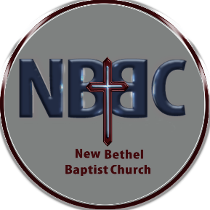**WELCOME TO NEW BETHEL BAPTIST CHURCH**

**We are blessed by your presence!**

**GUEST AND MEMBERS:** If you have questions or would like more information about New Bethel, please feel free to contact the church office. Thank you!

*An American Baptist*

*Congregation*

**\*\*\*\*\*\***

**ALL ARE WELCOME**

**Weekly Activities Online Only**

**Thursdays** online Zoom Book Discussion, *If God Is Love,* 10 a.m.,

Contact Janie Bryant

**Thursdays** online Pastor’s Bible Study Group, 7 p.m. on Zoom and

In-Person. Contact Janie Bryant, or Pastor Tom if you would

like to join.

**Sunday Worship**, 10:30 a.m., Live-stream and In-Person

**\*\*\*\*\*\***

**CONTACT INFORMATION**

New Bethel Baptist Church **Website:** www.newbethelbapt.org

8936 Southeastern Avenue **E-mail:** newbethelbapt@att.net

Indianapolis, IN 46239 **Wi-fi password:** NBBC8624381

317-862-4381 **Instagram:** NBBC.Wanamaker

**YouTube:** New Bethel Baptist Church Wanamaker

https://facebook.com New Bethel Baptist.Wanamaker

Rev. Tom Bartley, Interim Pastor

Lori Chapman, Church Secretary

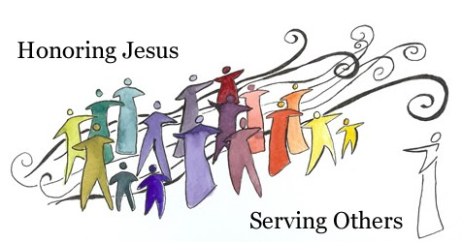

“Concern for the people should burn like

the fire of God in your veins.”  
 ― Abhijit Naska